

**Tuberculosis in Kent and Medway**

Health Needs Assessment – 2024

 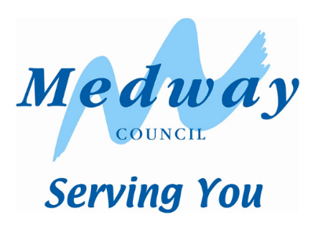

**Contents**

**Acknowledgements** 5

**Key stakeholders** 5

**Authors** 5

**Glossary of abbreviations** 6

**Executive Summary** 8

**1.0 Introduction** 15

**1.1 Background** 15

**1.1.1 National context** 15

**1.1.2 Local context** 16

**1.2 Aim and objectives** 17

**1.2.1 Aim** 17

**1.2.2 Objectives** 17

**2.0 Methodology** 18

**2.1 Methods** 18

**2.1.1 Quantitative methods** 18

**2.1.2 Qualitative methods** 18

**2.2 Governance** 19

**2.3 Limitations** 19

**2.4 Data governance** 19

**3.0 Epidemiology** 20

**3.1 Kent & Medway population** 20

**3.1.1 Geography** 20

**3.1.2 Age, gender, ethnicity** 20

**3.1.3 Deprivation** 24

**3.1.4 Migration** 24

**3.1.5 Prison population** 27

**3.1.6 People experiencing homelessness** 27

**3.1.7 Gypsy, Roma and Traveller (GRT) population** 28

**3.2 TB Epidemiology** 29

**3.2.1 Annual incidence** 29

**3.2.2 Age and sex** 32

**3.2.3 Place of birth, time since entry and ethnicity** 32

**3.2.4 Occupation** 35

**3.2.5 Social risk factors** 36

**3.2.6 Deprivation** 38

**3.2.7 Paediatric cases** 39

**3.2.8 Summary of TB epidemiology** 39

**3.3 Clusters and Outbreaks** 41

**3.3.1 UKHSA health protection team activity** 41

**3.3.2 Clusters** 41

**3.4 Cohort review** 44

**3.4.1 Site of disease** 44

**3.4.2 HIV co-infection** 44

**3.4.3 Co-morbidities** 45

**3.4.4 Culture confirmation** 46

**3.4.5 Mycobacterium species** 48

**3.4.6 Drug susceptibility testing** 48

**3.4.7 Contact tracing** 49

**3.4.8 Enhanced case management** 51

**3.4.9 Directly observed therapy (DOT) and video observed therapy (VOT)** 52

**3.4.10 Treatment outcomes at 12 Months** 53

**3.4.11 Treatment outcomes for CNS, spinal, miliary and cryptic TB disease cases** 56

**3.4.12 Deaths** 56

**3.4.13 Treatment delay** 57

**3.4.14 Other delays** 60

**3.4.15 Summary of cohort review** 61

**4.0 Service provision** 62

**4.1 Commissioning** 62

**4.2 Acute and community TB services** 63

**4.2.1 Overview of services** 63

**4.2.2 Referrals** 65

**4.2.3 Delays** 66

**4.2.4 Contact screening** 68

**4.2.5 High risk populations** 68

**4.2.6 Latent TB infection (LTBI)** 70

**4.2.7 Staffing** 71

**4.2.8 Resources** 72

**4.2.9 Multi-drug resistant TB** 73

**4.2.10 BCG provision** 73

**4.2.11 Perspectives – consultants and specialist nurses** 74

**4.2.12 Perspectives – service users** 75

**4.2.13 Summary of acute and community TB services** 75

**4.3 Getting It Right First Time (GIRFT)** 77

**4.3.1 Epidemiology** 77

**4.3.2 Diagnosis** 78

**4.3.3 Management of TB** 78

**4.3.4 Contact tracing** 79

**4.3.6 Staffing** 80

**4.3.7 Organisational support and infrastructure** 80

**5.0 Inclusion health groups (IHG)** 81

**5.1 Migrant Population** 81

**5.1.1 Epidemiology and risk factors** 81

**5.1.2 Active TB screening** 82

**5.1.3 Latent TB screening** 82

**5.1.4 Asylum seekers - adults** 84

**5.1.5 Asylum seekers - children** 86

**5.2 Prison population** 88

**5.3 People experiencing homelessness** 88

**5.4 Summary of IHG populations** 89

**6.0 Evidence** 91

**7.0 Summary and conclusions** 92

**Table of Recommendations** 93

**Appendices** 102

**Appendix A – Service mapping questionnaire** 102

# **Acknowledgements**

Many thanks to all stakeholders who participated in the development of this health needs assessment (HNA).

## **Key stakeholders**

|  |  |
| --- | --- |
| **Organisation** | **Key Contacts** |
| UK Health Security Agency (UKHSA) South East Health Protection Team | Claire Winslade, Alexis Stevens |
| UK Health Security Agency (UKHSA) Field Services | Charlotte Anderson, Jacqui Carless, Lamya Kanfoudi |
| Kent County Council (KCC) | Ellen Schwartz, Audrey Beadle |
| Kent Public Health Observatory (KPHO) | Mark Chambers, Joshua Stroud, Laura Sims |
| UK Health Security Agency (UKHSA) | Eliza Alexander |
| Medway Council | Dawn Bisset |
| NHS Kent & Medway Integrated Care Board (ICB) | Sue Luff |
| Kent Community Health Foundation Trust (KCHFT) | Marianne Stoneman, Sarah Murphy |
| Medway NHS Foundation Trust | Jo Mabonga, Mikaela Gabatin |
| Maidstone and Tunbridge Wells NHS Trust | Frances Guyatt |
| South East Strategic Partnership for Migration | Roy Millard, Susan Fawcus |
| NHS Kent and Medway, Looked after Children and UASC | Nancy Sayer, Rosaleen O’Doherty |
| Whitehouse Surgery & Napier Barracks | Gareth O’Neill |
| NHS England South East | Saloni Zaveri, Tom Addey |

## **Authors**

This report was prepared by Stephanie Newton, Public Health Registrar, Kent County Council and supervised by Claire Winslade, Consultant in Health Protection, South East Health Protection Team, UKHSA and Ellen Schwartz, Deputy Director of Public Health, Kent County Council.

# **Glossary of abbreviations**

|  |  |
| --- | --- |
| A&E | Accident & Emergency |
| BCG | Bacillus Calmette-Guérin |
| BTS | British Thoracic Society |
| CCG | Clinical Commissioning Group |
| CIMS | Case and Incident Management System |
| CIPFA | Chartered Institute of Public Finance & Accounting |
| CNS | Central Nervous System |
| DGS | Dartford and Gravesham NHS Trust |
| DNA | Did not attend |
| DOT | Directly Observed Therapy |
| DVH | Darent Valley Hospital |
| ECM | Enhanced Case Management |
| EKHUFT | East Kent Hospitals NHS Foundation Trust |
| GRT | Gypsy, Roma and Traveller |
| HNA | Health Needs Assessment |
| HPT | Health Protection Team |
| GIRFT | Getting It Right First Time |
| H-CLIC | Homelessness Case Level Information Collection |
| HIV | Human Immunodeficiency Virus |
| HMP | His Majesty’s Prison |
| ICB | Integrated Care Board |
| IGRA | Interferon Gamma Release Assay |
| IHA | Initial Health Assessment |
| IHG | Inclusion Health Group |
| IMD | Index of Multiple Deprivation |
| K&M | Kent and Medway (ICB-level area) |
| KCHFT | Kent Community Health Foundation trust |
| KPHO | Kent Public Health Observatory |
| LA | Local Authority |
| LSOA | Lower Super Output Area |
| LTBI | Latent TB Infection |
| LTLA | Lower Tier Local Authority |
| MDRTB | Multi-Drug Resistant TB |
| MDT | Multi-Disciplinary Team |
| Medway | Medway NHS Foundation Trust |
| MOA | Memorandum Of Understanding |
| MTW | Maidstone and Tunbridge Wells NHS Trust |
| NHSE | NHS England |
| NICE | National Institute For Health and Care Excellence |
| NRPF | No Recourse to Public Funds |
| NTBS | National TB Surveillance System |
| OHID | Office for Health Improvement and Disparities |
| ONS | Office for National Statistics |
| PCR | Polymerase Chain Reaction |
| QEQM | Queen Elizabeth the Queen Mother Hospital |
| RCN | Royal College of Nursing |
| SE-TBCB | South East TB Control Board |
| SOP | Standard Operating Procedure |
| SRF | Social Risk Factor |
| TB | Tuberculosis |
| UASC | Unaccompanied Asylum Seeking Children |
| UCLH | University College London Hospitals NHS Foundation Trust |
| UKHSA | UK Health Security Agency |
| VOT | Video Observed Therapy |
| WGS | Whole-Genome Sequencing |
| WHH | William Harvey Hospital |
| WHO | World Health Organization |
| WTE | Whole Time Equivalent |

# **Executive Summary**

Worldwide, TB is the second leading cause of death from a single infectious agent, after COVID-19. England is a low-incidence country with incidence falling since 2011. However, the COVID-19 pandemic had a significant impact on the detection and control of TB, leading to missed or delayed diagnosis and delayed initiation of treatment. In England in 2023, TB notification rates increased by 11.0% compared with 2022, the largest year-on-year increase in the current reporting period (2000 to 2023), although rates are still below the peak of 2011. England is currently not on track to achieve the targets set in 2015 by WHO’s End TB Strategy.

NHSE and UKHSA’s TB Action Plan for England aims to improve the prevention, detection and control of TB in England, with a focus on inclusion health groups and use of system-wide approaches to address health inequalities. The South East region has four TB networks, one of which is Kent and Medway. This network provides a forum for all stakeholders responsible for the management and reduction of TB incidence in their populations. The aim is for a HNA to be produced for each ICS-level area, to support development of a local strategic action plan and achievement of the aims of the national action plan.

When compared to England overall, K&M is a low incidence area for TB, however the complexity of the cases is high.

**Kent & Medway Population**

Kent and Medway (K&M) covers a large geographical area in the South East, with around 1.9 million people. It borders London, has a diverse population, and has large coastal and rural areas. The mean age of residents in Kent is 41.7 years, there are a higher proportion of over 65-year-olds, and a smaller proportion of young adults, compared to the South East and England. The most common ethnicity is white, making up 88.7% of K&M’s population, however there is wide variation in ethnicity between districts.

Deprivation varies across K&M, with the highest levels seen in some of the East Kent coastal regions and some urban areas, particularly Swale, Medway, Dartford and Gravesham. The number of people living in K&M is about 1.9million, which is expected to grow by 23% to 2.1 million in 2031, faster than the England average.

Between 2021 and 2022, 7,100 people migrated into K&M from outside of the UK, the highest net international migration for a decade. As of 30th September 2023, there were 971 supported asylum seekers (those receiving Section 95 Support from the government) in K&M, with the most common nationalities in accommodation settings being Afghanistan, Iran and Eritrea. The prison population in 2023/24 was 20,875 people (1.11% of the population), the majority of whom were male between 30 and 49 years of age. Over a quarter (26.8%) of the prison population were foreign nationals (compared to 11.2% in England), a higher proportion, likely due to Maidstone prison being primarily for foreign nationals. In 2019/20, K&M had the highest rate of hospital admissions for homeless people in the South East, and admission numbers have remained relatively static in subsequent years. Between January to March 2024, there was a rise of 11.4% in the number of households assessed as homeless in England, compared to the same period in 2023.

**TB Epidemiology**

TB incidence in England has declined over the past ten years. During the COVID-19 pandemic there was a drop in incidence, and a subsequent rise since. K&M is a low-incidence area, however there is variation with higher rates in the districts of Gravesham, Dartford, Medway and Ashford and a higher number of TB cases in deprived areas within districts.

TB cases are more commonly males aged 30-39 years and most cases are in people not born in the UK. For those not born in the UK, most cases were in those who have been in the UK for >10 years. In 2023, the proportion of cases in those in the UK for <2 years was at its highest for the past decade, which could represent active TB in migrants who did not have pre-entry screening.

Just under 18% of adult cases in K&M worked in healthcare (including community care) or education or were students, representing a risk of transmission to vulnerable people in these settings.

K&M has a high proportion of TB cases with at least one social risk factor (17.83% vs. 10.90% in the South East), and this proportion has increased in the last decade. The most common social risk factors were drug misuse, homelessness, prison incarceration and alcohol misuse, and almost 40% of those with social risk factors had more than one, highlighting the complexity of cases. Cases with social risk factors were more likely to be male, of white ethnicity and UK-born compared to the overall cases. KCHFT (East Kent) and MTW TB services saw a higher proportion of cases with social risk factors.

A small proportion of TB cases are in children (4.48%); however, the majority were UK-born, indicating transmission within K&M.

**Clusters and Outbreaks**

For cases in a setting of concern, such as a school, workplace, prison or healthcare setting, the UKHSA health protection team will work with TB services and other stakeholders to manage the public health risk. A TB incident may be declared if additional screening or provision of inform and advice letters are required. The number of TB incidents in the South East increased in every HPT between 2022 and 2023, although the smallest increase was seen in Kent (9%).

TB whole-genome sequencing (WGS) is used for TB diagnosis and investigation of TB clusters, which are groups of strains with closely related genomes. WGS clusters can then be explored to understand if the cases have an epidemiological link. Identifying clusters gives an opportunity to find transmission chains whereby public health control measures can be targeted, to reduce further transmission. Several clusters of public health importance have been detected in the last ten years in K&M. Whilst cases were linked by geography, it was not always possible to identify exact sources or places of transmission. Some of the identified places of transmission and population groups involved have been in a hospital, amongst people using cannabis, in the homeless population and amongst migrants from the same country. Two clusters of significance have been described in Section 3.3.2 to understand the public health challenges in investigation and management of TB.

**Cohort Review**

The clinical features of TB cases in K&M were similar to the South East overall with pulmonary TB making up 57.7% of cases and co-morbidities present in 17.4% of cases, with diabetes being the most common. The vast majority of cases with unknown HIV status were offered a HIV test. Nearly all cases were caused by Mycobacterium tuberculosis.

Culture confirmation was achieved in 80% of pulmonary TB cases in 2023, meeting the TB action plan target. However, in non-pulmonary cases culture confirmation proportions were lower than both the South East and England, and have decreased since 2021. Of those with a culture confirmation, 96.5% had drug susceptibility testing for all four first-line agents. There have only been 7 MDR-TB cases in K&M since 2014.

K&M TB services identify close contacts in a high proportion of pulmonary TB cases, compared to the South East average, although this remains below the TB action plan target. In 2023, 89% of cases had at least 1 contact identified, and 40% of cases had 5 or more contacts identified.

A high proportion of cases in K&M (71.6% in 2022) require enhanced case management and this proportion has risen since 2018. In comparison, in 2022 this was 41.6% in the South East and 43.2% in England. A higher proportion of cases were also offered DOT/VOT in K&M compared to the South East. This places a large burden on TB services, particularly for specialist TB nurses who provide the case management.

The proportion of drug-sensitive TB cases in K&M completing treatment has increased since 2022 and is now higher than the South East average. K&M met the TB action plan target of 90% treatment completion in 2021 and 2022. In 2022, the highest treatment completion proportions were seen in cases managed by KCHFT (East and North Kent). Medway’s treatment completion has improved since a low in 2016. Treatment completion was lowest in men, over 65-year-olds, UK-born cases, cases with white ethnicity and cases with at least 1 social risk factor.

Delays in both diagnosis and treatment are often seen in K&M, with less than one third of cases treated within 2 months of onset of symptoms, as recommended. A higher proportion of cases were treated >4 months after onset of symptoms in K&M compared to both the South East and England. Cases managed by MTW had the longest median duration from onset of symptoms to treatment, at 119 days. Longer durations were seen for cases over 65 years, UK-born cases and those of white ethnicity.

The median time between symptom onset and first presentation to a health service was 25 days, and the time between first presentation and the referral being received by a TB service was 32 days, indicating opportunities for raising awareness of TB symptoms and early diagnosis in both the population and healthcare professionals.

**Commissioning**

Active TB treatment services are commissioned by the ICB. In Medway and West Kent, TB services are provided as part of the acute trust’s respiratory departments, with no specific commissioning from the ICB for TB in place. In North and East Kent, there is a community TB nurse-led service, commissioned through KCHFT. Patients also see consultants in the respiratory departments of acute trusts in North and East Kent. When incidents occur with the requirement for mass screening, this is usually carried out by the TB nursing teams. When this is not possible, for example due to high numbers requiring screening, an external agency may be commissioned by the ICB, but there is no set policy for this currently. Even when an external agency is commissioned, a considerable amount of support is required from the TB nursing teams working alongside the external agency.

For LTBI screening and treatment, there is limited capacity within pathology and long waits for treatment in some areas. KCHFT are also not commissioned to manage LTBI cases and support them with completion of treatment. There is no commissioning in place for LTBI screening of migrants from high-incidence countries.

For complex TB cases, there is a lack of pathways and funding agreements to support incentive payments, hardship funds and support those with no recourse to public funds (NRPF). Historically, these have been agreed on a case-by-case basis. There is no specifically commissioned outreach service for groups at a higher risk of TB, with outreach activity only carried out by the TB services in each area.

For TB services in acute trusts, funding pathways are unclear. Providers have also raised concern about insufficient funding to deliver TB services in line with the national TB action plan. Given the concern about the cohesiveness of the system for TB in K&M and inequality in provision of TB services across the ICB area, system workshops have taken place to review this. Work is underway to ensure services are aligned with the national TB action plan and national service specification. A local service specification will be developed, with the aim of addressing the gaps outlined above. A local TB action plan for K&M will also be developed.

**Acute and community TB services**

Hospitals are broadly located in geographical areas of high TB incidence, but the two hospital sites in East Kent cover a large area which may introduce accessibility issues for TB cases. There are high DNA rates (28% in KCHFT) for cases attending clinics.

Referral pathways to TB services vary between areas. Formal pathways directly to TB services from primary care, A&E, radiology and histopathology are not in place in several areas. This can contribute to delays in diagnosis and treatment, along with delays caused by cases being referred initially to other specialties. KCHFT has a website which provides information on how to refer to the service.

There was a recognition amongst all TB services of a lack of awareness of TB signs and symptoms in both the population of K&M and healthcare professionals. All services provide teaching or training to healthcare professionals in K&M; however, this is often ad-hoc and not as part of a regular programme.

Diagnostic delays are introduced due to tests being couriered and processed in neighbouring trusts. As tests cannot be done rapidly in-house in Medway and East Kent, smears can take up to 5 days and PCR tests up to 7 days to receive results in these trusts.

Timely appointments in acute trusts are generally achieved for active TB cases, often by providing ad-hoc appointments outside of clinic times. However, this can be affected by a lack of cover during times of annual leave, and result in consultants attending TB clinics during their leave. MTW have a weekly MDT allowing cases to be discussed and investigations actioned whilst waiting for an initial consultant appointment. There are long delays for LTBI cases, particularly in North and East Kent. Capacity within the workforce and lack of resources to address delays were acknowledged as barriers.

Whilst the cohort review data shows that TB services in K&M are achieving better identification of contacts than the South East, there is a lack of data on the proportion of contacts eligible for screening who attend for testing. Lack of support (particularly for new-entrant migrants) and transport issues were identified as barriers. All services conduct home visits for active TB cases (KCHFT routinely, and Medway and MTW when required) which does allow contact screening at home to take place. There is no SOP or formal pathway for funding available for incidents requiring mass contact screening.

Some outreach work is done by TB services, however there is no service in place for finding and treating inclusion health group patients who may be at a higher risk of TB and less likely to present to services. Referral and treatment pathways are in place for prisons in K&M, but not for other high-risk populations. KCHFT have good links with services to support high-risk populations, given they are a community-based trust. A lack of social care support for K&M’s high number of complex cases was identified by all services. None of the services have funding for incentives to support enhanced case management and help cases complete their treatment. Sometimes nurses will self-fund small support items, such as food, coffee and toiletries.

LTBI cases are managed by the TB service in MTW and Maidstone. In North and East Kent, the TB specialist nurses work in a separate NHS trust to the consultants. Here, cases are started on treatment by consultants in the acute trust, but KCHFT TB specialist nurses are not commissioned to manage LTBI cases and do not have the capacity currently to do so. This means cases are not supported to complete their treatment. There is a lack of data around completion rates, and it is unclear if cases are formally reviewed at the end of their treatment across all services in K&M.

Good clinical management and working relationships between TB nurses and consultants are in place and contribute to the excellent treatment outcomes for active TB in K&M. A lack of capacity in the workforce was identified, along with no cross-cover arrangements between services to cover both incidents and staff sickness or annual leave. All services did not think clinical staffing was sufficient, especially considering the increasing complexity of cases in K&M, and the lack of LTBI case management. Issues with funding and time available for training, along with a lack of opportunity and progression for TB specialist nurses was raised. Consultants and administrative staff in the acute trusts often support general respiratory work and the BCG vaccination, meaning there can be issues finding dedicated time for TB work.

In terms of resources, there is insufficient clinic room space for TB clinics in MTW and EKHUFT. DOT is used by Medway and MTW, but cases eligible cannot always access it due to staffing issues. VOT allows all cases who require enhanced case management to receive it in KCHFT and MTW. VOT is not currently commissioned in Medway, although this is planned.

BCG vaccination for infants is delivered by the TB service in KCHFT and Medway with established SOPs available. In MTW the service is delivered by paediatrics. Vaccinations for over 1 year-olds tend to be opportunistic and KCHFT are not commissioned to provide this, although they can usually support with vaccinations. In 2022/23, both Kent and Medway local authority areas achieved a slightly higher coverage than for the South East overall and Medway had a higher coverage than for England overall.

**Getting It Right First Time**

GIRFT is a national programme in England designed to improve patient care by reducing unwarranted variations in clinical practice. TB services completed questionnaires in 2023 and were subsequently provided with a data pack showing how their questionnaire answers compare with the overall national response.

K&M cases had a similar age/sex profile to England overall, but were more likely to be of white ethnicity (39% vs. 21% in England) and UK-born (32% vs. 21% in England).

K&M ICB was the 2nd highest ICB for percentage of cases offered ECM (75%). Of those with ECM, 42% received the highest level (level 3), compared to 16% in England overall. K&M was also the 2nd highest ICB for proportion of cases offered and receiving DOT. For social risk factors, K&M ranked highly for proportions of cases with a history of alcohol misuse (2nd highest ICB), drug misuse (6th highest) and imprisonment (6th highest). KCHFT East Kent ranked highest of the K&M TB services for drug misuse (13% of cases), MTW and Maidstone for alcohol misuse (28% and 24%) and KCHFT North Kent for imprisonment (14%).

All notified TB cases had a test performed (includes culture, PCR, microscopy, histology or chest X-ray) in every TB service, however there were fewer PCR results available for K&M cases compared to England (84% vs. 67%). Smears are available 24/7 in Medway and KCHFT North Kent. Compared to other TB services in England, 40% had 24/7 availability.

There are high treatment completion rates for K&M, with 88% completion at 12 months compared to 68% in England. Services generally had good access to information in other languages. There are good links in place for connecting socially complex cases to other services supporting with issues such as housing and access to benefits in KCHFT North and East Kent, but not in MTW and Medway.

K&M had long delays in treatment compared to other ICBs. For days between symptom onset and treatment, K&M was 6th highest for pulmonary cases (86 days) and 4th highest for non-pulmonary cases (98 days) between 2019 and 2022. Delays following diagnosis were not as significant, being 13th highest for proportion of cases with over 2 weeks from diagnosis to treatment (9%), indicating the need for improvements in recognition of TB symptoms in both the population and healthcare professionals to promote earlier diagnosis.

K&M were amongst the best ICBs for the number of contacts identified per case, being the 4th highest for proportions of cases with more than 5 contacts identified (26.09% of cases) and 4th highest for more than 10 contacts (9%). Of the ICBs where information was available (38/42), K&M was 4th lowest for the proportion of contacts starting treatment for LTBI (42%). To put this into perspective, 16% of adult contacts screened had LTBI in 2022. K&M has no LTBI screening programme in place, in line with 35.4% of ICBs. Of the ICBs where information was available (38/42), K&M was the lowest for the proportion of adults with LTBI completing treatment (42%), although there were variations between services.

A lack of service specification in MTW and no regular meetings with management in Medway and MTW were identified. Three of the four TB services did not agree there was sufficient funding in place to deliver NICE guidance, the TB action plan or the local service specification. There were mixed views on whether support was provided to manage outbreaks and if external funding was provided, highlighting inconsistencies and unclear pathways. SOPs that are compliant with national guidelines were not in place for LTBI or for screening healthcare workers (except in Medway).

**Inclusion health groups**

People in IHG populations have disproportionately poorer health outcomes with the highest TB rates in England in 2021 for asylum seekers, people experiencing homelessness and prisoners.

People born in a high TB incidence country are at highest risk of developing active TB in the UK and this risk continues many years after arrival to the UK. Migrants arriving by unofficial routes and by government supported humanitarian pathways and resettlement schemes do not have access to pre-entry screening for active pulmonary TB. This should be done on registration with primary care services during an initial health check, however it is unclear how often this happens and if TB is prioritised during these health checks. There is no commissioned outreach service working across K&M with asylum seekers to screen for active TB in adults, aside from at Napier Barracks where there is an outreach clinic run by a nurse practitioner. Unaccompanied asylum seeking children have an initial health assessment by a community paediatrician and are referred to TB services for active TB screening, however this is not formally commissioned in North and East Kent.

There is no LTBI testing programme available for migrants from high incidence countries in K&M. Modelling based on the NHSE LTBI testing and treatment programme (available in some areas of the country) gave estimated figures of 6,414 migrants per year who would be identified for LTBI testing, an uptake of 404 migrants, resulting in 83 positive LTBI cases per year. However, there was considerable uncertainty in the modelling, especially for the number of migrants who would be identified each year, and the uptake, given it was based on very low rates seen in 2021 (6.29% in five nearest neighbour CCGs vs. the target of 25%). For asylum seekers who do test positive for LTBI, they often move out of the area before treatment can commence. Completion of treatment is likely to be an issue given the lack of commissioning for TB services to support cases, and long waits to start treatment for LTBI in North and East Kent.

Asylum seekers face additional barriers and issues relating to TB identification and treatment including barriers registering with a GP and keeping an appointment, language barriers, frequent relocation, difficulty travelling to hospital appointments, lack of TB awareness in asylum accommodation staff, a lack of social support required for compliance with testing and treatment, stigma amongst the cohort and a lack of sharing of information between agencies within the system.

People in contact with the criminal justice system face a number of health challenges including issues with transfer of health information between services, difficulty maintaining continuity of care due to transfers between settings, high levels of homelessness and financial hardship on release from prison, high levels of stigma and a lack of trust in institutions and officials. All new prisoners should be screened for symptoms of active TB, with cases referred to the health protection team and managed with directly observed therapy. In K&M, HMP Maidstone has a commissioned screen and treat service in place for LTBI.

For people experiencing homelessness, poor living conditions, an increased risk of co-morbidities and malnutrition and other social risk factors such as alcohol and drug dependence are more likely, increasing the risk of TB infection. They may face multiple barriers accessing healthcare due to a lack of a fixed address and problems attending appointments and adhering to TB treatment, including inability to store medications. Clear pathways should be in place for people experiencing homelessness with active TB to receive state-funded accommodation during their treatment. For those with NRPF, lack of housing presents a significant challenge, which should be addressed between TB teams, commissioners and the local authority.

# **1.0 Introduction**

## **1.1 Background**

Worldwide, tuberculosis (TB) is the second leading cause of death from a single infectious agent, after COVID-19.

England is a low incidence country, with a TB notification rate of 8.5 per 100,000 population in 2023[1], below the World Health Organization (WHO)’s threshold for high incidence of 10 per 100,000 population[2].

The incidence of TB in England had fallen significantly since 2011, with most new cases of active TB in people born outside the UK. However, the COVID-19 pandemic in 2020 had a significant impact on the detection and control of TB, leading to missed or delayed diagnoses and delayed initiation of treatment[3]. The WHO reports that in 2022, 7.5 million people were recorded as newly diagnosed with TB[4]. This is the highest number since global monitoring began in 1995 and probably includes those whose diagnosis was delayed in the pandemic. In England in 2023, TB notification rates increased by 11.0% compared with 2022, the largest year-on-year increase in the current reporting period (2000 to 2023), although rates are still below the peak of 2011[5].

The WHO released an [End TB Strategy](https://iris.who.int/bitstream/handle/10665/331326/WHO-HTM-TB-2015.19-eng.pdf?sequence=1)[6] in 2015, with the aim of ending the global TB epidemic. For England, this means a reduction in TB notification rate to 1.05 per 100,000 population, by 2035, and as of 2022, England was not on track to achieve this target.

### **1.1.1 National context**

TB rates in England are highest in large urban areas such as London, with most cases in people born outside the UK. TB is associated with health inequalities and disproportionately affects those from the most deprived populations. For TB cases in those born in the UK, social risk factors are more commonly seen, such as drug misuse and homelessness which disproportionately affect people who are socially excluded, known as inclusion health groups (IHGs)[7].

NHS England and the UK Health Security Agency (UKHSA) jointly developed the [TB Action Plan for England, 2021-2026](https://www.gov.uk/government/publications/tuberculosis-tb-action-plan-for-england/tuberculosis-tb-action-plan-for-england-2021-to-2026) with the aim of improving the prevention, detection and control of TB in England[8]. This plan builds upon the previous Collaborative TB Strategy[9], 2015-2020 and supports reduction in TB incidence and transmission to allow the UK to meet the WHO elimination targets by 2035. The plan outlines a need to focus on inclusion health groups and use system-wide approaches to address health inequalities.

Throughout, this Health Needs Assessment (HNA) has used a wide range of sources of UK and international policy, strategy and toolkits/guidance relating to TB, to help identify unmet needs and to inform the recommendations made. These are referenced in Section 6.0. Local HNAs are recommended by the National Institute for Health and Care Excellence (NICE)[10] to ensure services are commissioned based on local needs.

NHS England’s (NHSE) Getting it Right First Time (GIRFT) programme[11] is designed to improve treatment and care by reviewing health services in England. Whilst undertaking this HNA, GIRFT data gathering and deep dive meetings were in progress across Kent and Medway. Some of the findings from these surveys and discussions have been included in the HNA, where relevant.

### **1.1.2 Local context**

The Collaborative TB Strategy, 2015-2020[12] established several multi-agency regional TB Control Boards. The South East TB Control Board (SE-TBCB) was established in 2022, resulting from a split from the existing South TB Control Board into South East and South West to account for the large geography and differences in incidence. The SE-TBCB meets twice per year and is co-chaired by UKHSA and NHSE. It has representatives from stakeholders across public health including integrated care boards (ICBs) and local authorities (LAs).

The SE-TBCB brings together the four TB networks in the South East to provide a forum for all stakeholders responsible for the management and reduction of TB incidence in their populations. The four networks are Surrey and Sussex, Kent and Medway, Thames Valley and Hampshire and Isle of Wight. Each network has regular meetings, including cohort reviews to systematically review all TB cases notified in a 3 to 4-month period and their treatment outcomes and contact screening. Common themes arising from these cases are discussed with planned follow-up actions. Ownership and responsibility of the actions in the national TB action plan lie with the individual organisations who make up membership of the networks and control board. NHS England and the ICBs are responsible for commissioning of TB services, whilst the UKHSA provides expertise and advice to support commissioners and providers. Local authorities can support a whole systems approach to TB control, along with the Director of Public Health’s responsibility for the protection of the local population from risks to its health, including from infectious disease[13].

The South East region includes six ICBs and the aim is for a HNA to be produced, covering each ICB area, in order to develop a locally relevant strategic action plan to support achievement of the aims of the national action plan in the South East.

Kent and Medway (K&M) covers a large geographical area in the South East, with around 1.9 million people. K&M borders London, has a diverse population, and has large coastal and rural areas. It includes two local authorities (Kent County Council and Medway Council) and city, borough and district councils[14].

K&M ICB holds responsibility for the commissioning and planning of NHS services, including TB services, and ensuring the delivery of the Integrated Care Strategy[15], produced by NHS Kent and Medway, Kent County Council and Medway Council. Outcomes of the strategy of particular relevance to this HNA including tackling the wider determinants to prevent ill health, reducing inequalities and improving health and care services.

When compared to England overall, K&M is a low incidence area for TB, however the complexity of the cases is high. The last TB HNA for K&M was carried out in 2016 and was the first TB HNA for the area, providing a baseline for health needs and gaps in service provision.

## **1.2 Aim and objectives**

### **1.2.1 Aim**

The aim of this HNA is to identify how to address unmet need in the treatment, control and prevention of TB across K&M. This HNA is focussed at an ICB level but incorporates national and regional comparators and more granular local data, for example for TB services by catchment area.

### **1.2.2 Objectives**

This HNA attempts to achieve the above aim through the following objectives:

* To **describe the** **epidemiology** of TB in K&M through review and presentation of data from multiple sources
* To **review key service provision and health outcome indicators** from cohort review
* To **review current TB service provision** across K&M
* To **identify areas of need** with reference to epidemiological characteristics and performance indicators
* To **identify unmet health needs** (through both data and insight from professionals and services users) **and gaps in service provision**
* To **reflect upon service user perceptions** of TB services
* **To make recommendations and propose actions** to address identified need with reference to the Tuberculosis (TB): action plan for England, 2021 to 2026[16]

# **2.0 Methodology**

## **2.1 Methods**

### **2.1.1 Quantitative methods**

A quantitative analysis of routine TB surveillance data was performed. The main source of data used was the National TB Surveillance System (NTBS)[17], or pre 2021 legacy databases (the Enhanced TB Surveillance system and the London TB register). All people diagnosed with TB in England must be notified through NTBS. The data was extracted from NTBS by the TB team in Field Services, UKHSA South East and London. There were two dates of extraction, the first in May 2024, and the second in August 2024 (for data presented in section 3.4.14). The extraction included all TB notifications made to NTBS between 01/01/2014 and 31/12/2023, where the case was resident in either K&M ICB geography or the South East UKHSA region at the time of notification.

Where England data is presented, this was obtained from the UKHSA’s TB in England, 2023 report[18], which provides data up to the end of 2022. Incidence data was obtained from the Office of Health Improvement and Disparities (OHID)’s Fingertips public health data[19]. Vaccination data was from NHS England’s Childhood Vaccination Coverage Statistics[20].

Clusters and outbreaks data were obtained from UKHSA’s HP Zone and Case and Incident Management System (CIMS), both of which are used by the UKHSA South East Health Protection Teams (HPT) to manage infectious disease cases and incidents. CIMS replaced HP Zone as the case and incident management system in the South East in July 2024.

Data on the K&M population was extracted, collated and presented in graphs and tables by the Kent Public Health Observatory (KPHO). Sources of data included the Office for National Statistics (ONS)’ Census[21] and Population estimates[22], the Government’s Offender management statistics[23] and Homelessness Case Level Information Collection (H-CLIC)[24] and data from Kent Analytics. Modelling of latent TB infection (LTBI) screening was completed by KPHO and used data from the NHS England (NHSE) LTBI programme[25] which included estimates of eligible migrant numbers from Flag 4 GP Registration Data. The document was formatted and quality assured by KPHO.

### **2.1.2 Qualitative methods**

A service mapping questionnaire (Appendix A) was designed to understand the current provision of TB inpatient and outpatient care in K&M, provision of facilities, local pathways and any gaps in the service delivery. Questions included were based on the guidance for services set out in the national service specification, NICE guidelines[26] and the TB action plan[27]. The questionnaires were completed by local healthcare staff delivering TB care between July and September 2024. Questionnaire responses were extracted, collated and summarised. Some of the findings from GIRFT surveys and deep dives have been used, along with themes discussed at the network’s regular cohort reviews captured in logs from each meeting.

Other key stakeholders were contacted by email and virtual meetings were arranged to discuss the TB landscape in Kent and to collect their views on what works well and what could be improved. These conversations have been summarised within the HNA.

## **2.2 Governance**

This HNA was produced on behalf of the K&M TB Network upon request from the South East TB Control Board (SE-TBCB). Its results and findings will be presented to the Health Protection Board and the K&M TB Network who will then share their recommendations to the SE-TBCB. The ownership for recommendations will be held by the individual organisations making up members of the network and control board, with oversight from the SE-TBCB.

## **2.3 Limitations**

For quantitative methods, the NTBS dataset was the main data source used. The NTBS system only records data on notified cases of TB, therefore any cases that were not notified would not be included in the analysis. De-notified cases, such as those where the infective agent was identified as non-tuberculosis mycobacterium after initial notification are also excluded from these data.

Data fields were generally entered as correct at the time of initial notification, except for TB service which is the most recent TB service to care for the patient. Whilst the data extract included all the people resident in the ICB at the time of notification, it should be noted that it is possible that TB teams may have changed the location data if cases have moved.

The NTBS does not contain data on certain variables (such as length of patient’s stay in hospital and clinic attendance). Not all data fields are completed in NTBS and therefore counts (n) and proportions (%) were generally calculated using only cases where data were recorded. Therefore, the denominator may change.

The data included was extracted as a snapshot from a live database. As a result, data provided for this analysis were provisional and may differ from published and future reports. Due to some small numbers in the data, findings should be interpreted with caution.

The questionnaire (Appendix A) was used as a pragmatic tool to provide an overview of inpatient and outpatient TB services in K&M and allow for broad comparison between areas to gather information within staffing and timeframe constraints. The findings of the questionnaire are taken to be an accurate reflection of the TB services at the time of completion. However, it is recognised that for any not entirely objective questions, responses may reflect only the perspective of the respondent, and services may have changed since completion.

Quantitative data on clusters wasn’t routinely available for the HNA, given the cluster detection system is currently paused whilst the system is redesigned. Data on WGS clusters is still available on request where there are concerns that a case may be part of a cluster, to support public health management.

## **2.4 Data governance**

All data used in this report were anonymised and handled securely. Data extracts were transported in an anonymised form on secure email server and stored on secure password-protected computer drives. Analysis of the epidemiology report was carried out using Microsoft Excel for Microsoft 365.

# **3.0 Epidemiology**

## **3.1 Kent & Medway population**

In this section, K&M’s population is described, according to several different demographics. There is a focus on populations that are at a higher risk of TB infection, including vulnerable migrants, the prison population and the homeless population.

### **3.1.1 Geography**

K&M is divided into four broad areas (Figure 1), each with a health and care partnership[28]. West Kent is comprised of the districts of Maidstone, Sevenoaks, Tonbridge and Malling and Tunbridge Wells. East Kent is comprised of the districts of Ashford, Canterbury, Dover, Folkestone and Hythe and Thanet. Maidstone has the largest population, and Gravesham the smallest[29]. The population varies by age, ethnicity and deprivation between its district areas, with significant health inequalities observed across K&M.

**Figure 1: Map of health and care partnerships in Kent and Medway**

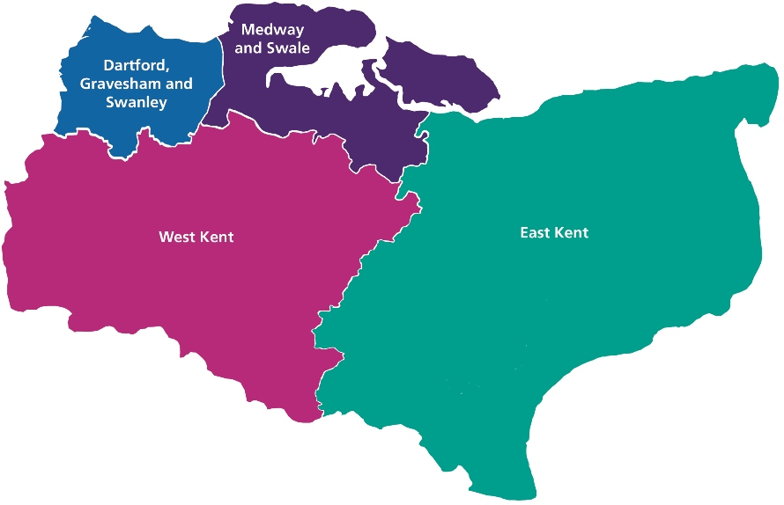

*Source: NHS Kent and Medway[30]*

### **3.1.2 Age, gender, ethnicity**

The mean age of residents in Kent is 41.7 years, older than the national average[31]. There are a higher proportion of over 65-year-olds, and a smaller proportion of young adults, compared to the South East and England (Figure 2). There are more females than males in K&M.

**Figure 2: Population pyramid, K&M, South East and England, 2021**

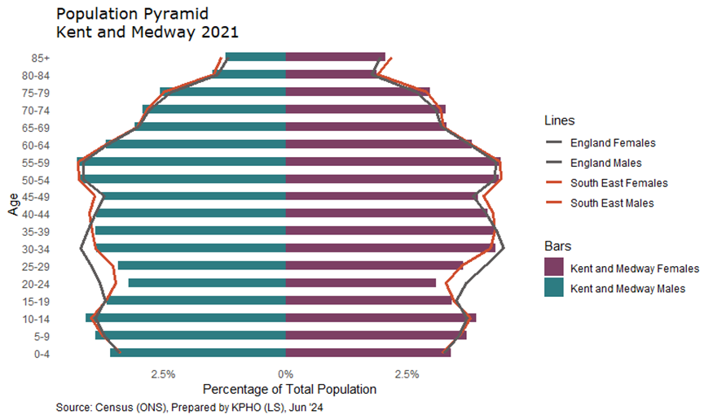

East Kent’s coastal districts have higher proportions of older adults compared to the Kent average, whilst Dartford and Gravesham’s population is younger, and Canterbury has a large proportion of students (Figure 3).

**Figure 3: Population Pyramid, Kent Districts and Medway, 2021**

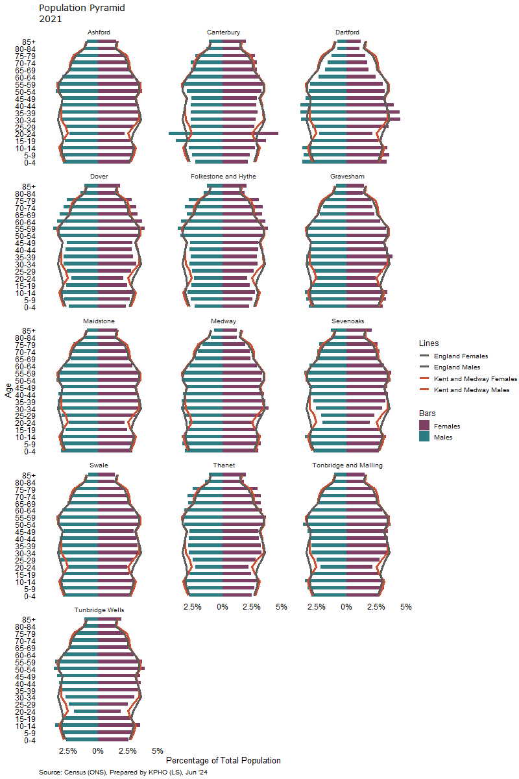

The most common ethnicity is White, making up 88.7% of K&M’s population, followed by Asian (4.4%), Black (2.6%) and Other (1.2%). This compares to a White ethnicity proportion of 89.4% in the South East and 86.3% in England and Wales. There is wide variation in ethnicity between districts, as shown in Figure 4.

**Figure 4: Ethnicity Breakdown in Kent Districts and Medway, South East and England, 2022**

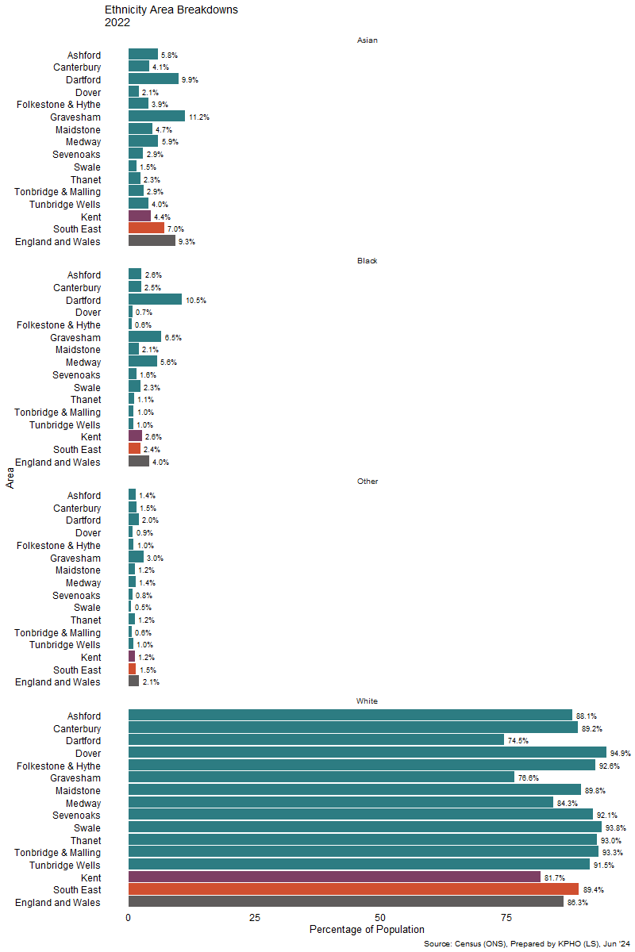

### **3.1.3 Deprivation**

Deprivation can be measured using the Index of Multiple Deprivation (IMD)[32]. Here, each Lower Super Output Area (LSOA) in England is ranked by its relative level of deprivation to other areas, taking into account seven domains, including income, employment, education, health, crime, barriers to housing and services and living environment. IMD rankings can be divided into deciles, ranging from the most deprived 10% to the least deprived 10%.

Deprivation varies across K&M, with the highest levels seen in some of the East Kent coastal regions and some urban areas, particularly Swale, Medway, Dartford and Gravesham (Figure 5). Thanet has 21% of its population living in the bottom 10% of the most deprived areas nationally[33].

**Figure 5: Index of Multiple Deprivation (IMD) 2019 by Lower Super Output Area, K&M weighted Deciles**

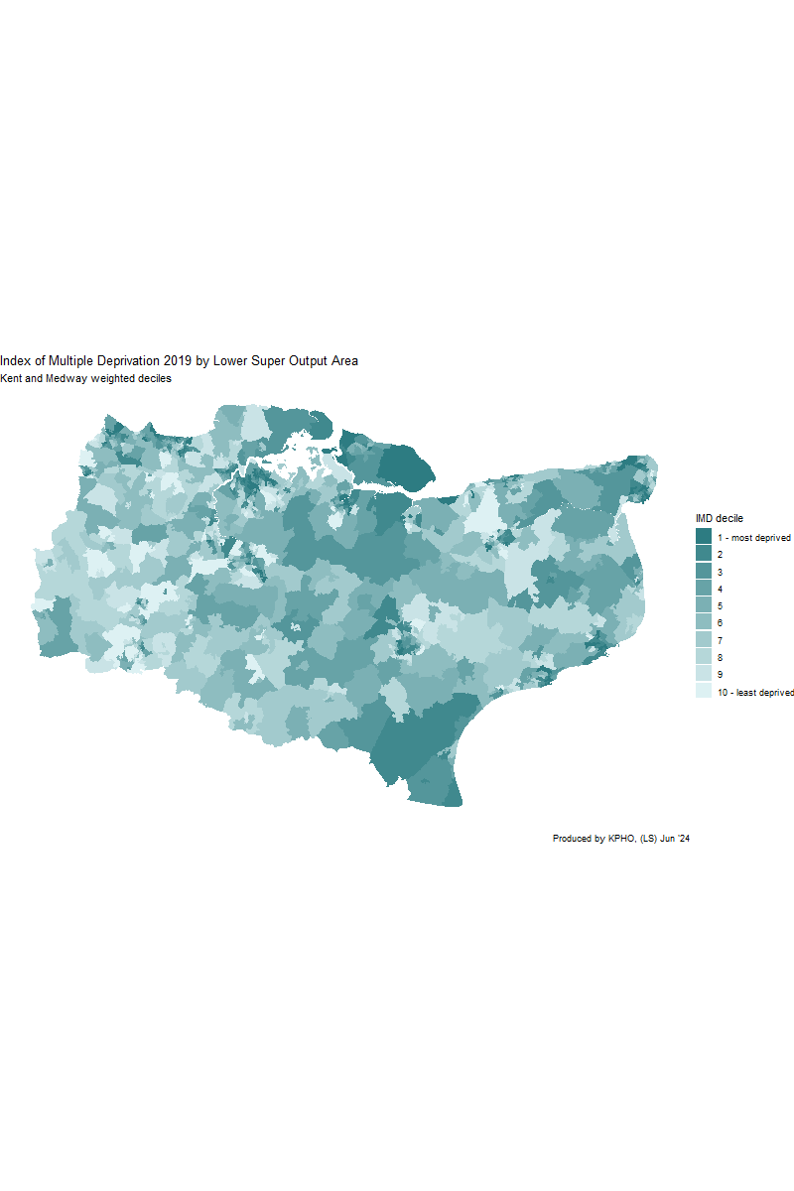

### **3.1.4 Migration**

The number of people living in K&M is about 1.9million, which is expected to grow by 23% to 2.1 million in 2031, faster than the England average[34]. Between 2021 and 2022, K&M’s population grew by 15,900 people (0.85% of the total population), with 91.4% of the growth due to net migration. Of the net migration, 7,100 people migrated into K&M from outside of the UK, the highest net international migration for a decade.

In 2021/22, K&M had 0.9% net migrants as a proportion of their total population, which was the same as England overall. This proportion varies by district (Figure 6), with the highest net migrant proportions in Maidstone, and Gravesham having negative net migrant proportions (more people moving out than coming in).

**Figure 6: Net migrants as a proportion of the total population in each Kent district, 2021/22**

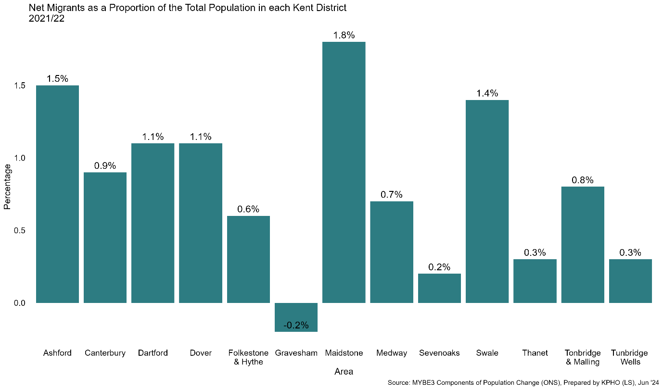

In 2021, the highest proportion of international migrants to K&M were from the Middle East and Asia (34.9%), followed by Europe (32.9%) and Africa (20.9%), as shown in Figure 7.

**Figure 7: Proportion (%) of migrants in Kent and Medway, by country of origin,**

**2021**

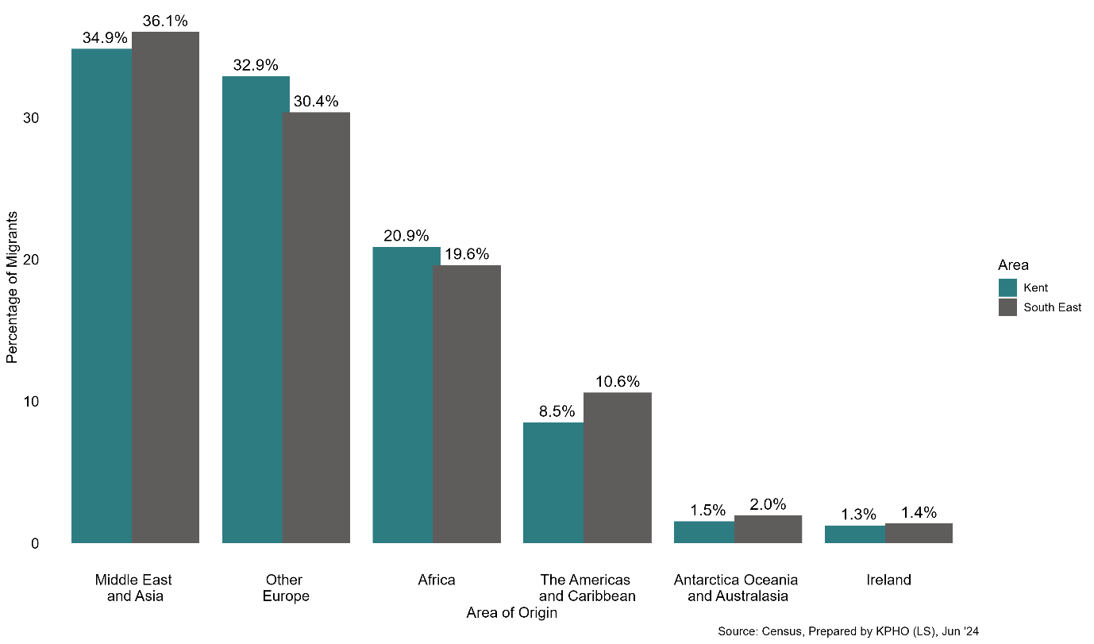

Vulnerable migrants[35] are those who may have increased health needs associated with their experiences before, during or after migration, including asylum seekers, refugees and unaccompanied children.

As of 30th September 2023, there were 9,169 supported asylum seekers in the South East[36]. Supported asylum seeker is defined here as those receiving Section 95 Support from the government, which includes accommodation and financial support for those who have made an asylum claim and do not yet have a decision on their case. In the South East, supported asylum seekers were most commonly from Iran (15.3%), Iraq (10.5%) and Afghanistan (9.9%).

In K&M, as of 30th September 2023, there were 971 supported asylum seekers[37]. The districts of Folkestone and Hythe and Ashford had the highest number of supported asylum seekers (370 and 201). In K&M in 2022, the most common countries of origin of asylum seekers in accommodation settings were Afghanistan (13.4%), Iran (12.2%) and Eritrea (8.8%), as shown in Figure 8. Other immigration groups of note include those in the Homes for Ukraine and Afghan Resettlement Programme[38]. Across all three groups (asylum seekers, Ukraine and Afghan resettlement), the K&M population was 5,431 (0.29% of the population). Further information on TB in migrants is covered in Section 5.0.

**Figure 8: Proportion (%) of asylum seekers in accommodation settings in Kent and Medway, by country of origin, 2022**

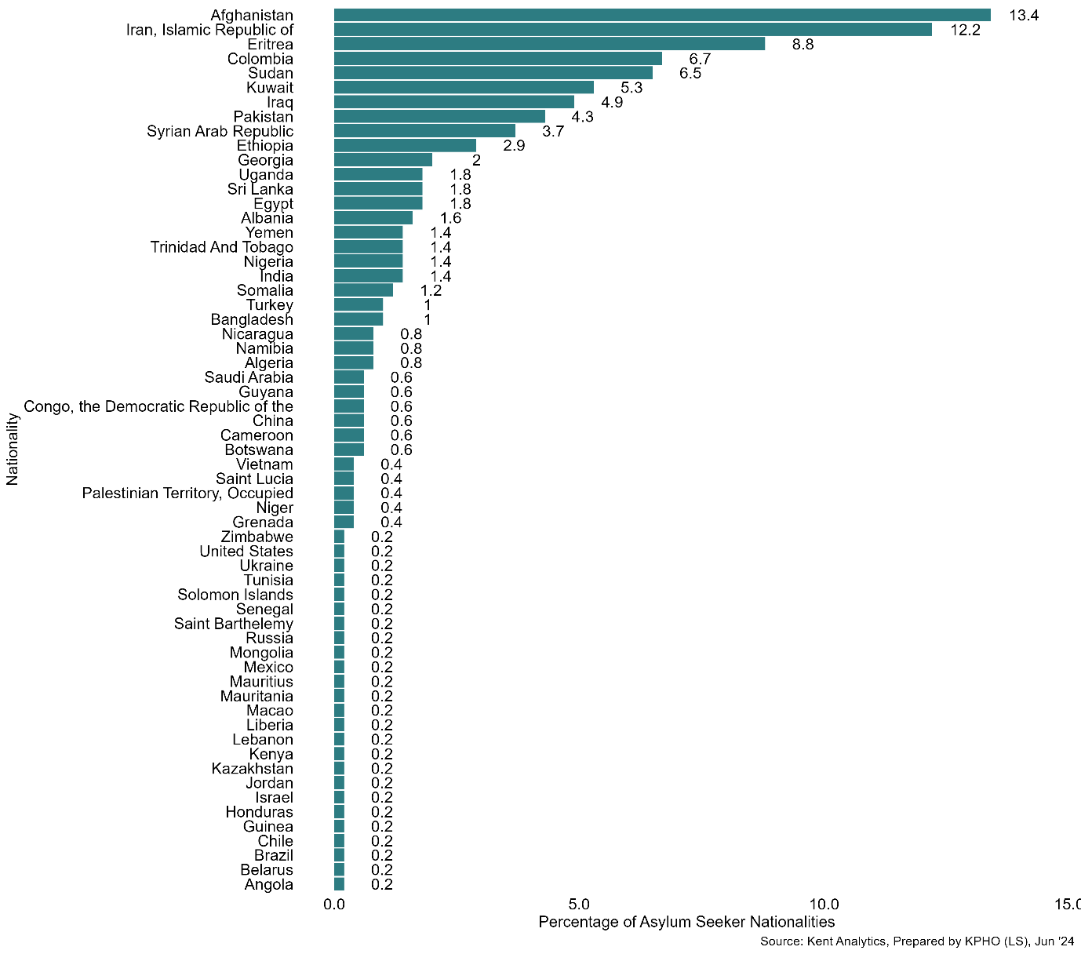

### **3.1.5 Prison population**

People in contact with the criminal justice system encompasses those who are currently serving a sentence in prison and those who are under supervision of probation services. They often experience multiple complex health and social care needs. In 2023/24 the prison population in K&M was 20,875 people, representing 1.11% of K&M’s population, which compares to 1.67% for England[39]. There are seven prisons in Kent, located in Maidstone, Swale and Medway. Six are adult prisons and one is a Young Offender Institution.

As of June 2024, 97.8% of the prison population were male, and the majority aged between 30 and 49 years of age, similar to the proportions for England. In K&M, 26.8% of the prison population were foreign nationals, which is a larger proportion than for England (11.2%) (Figure 9). Maidstone prison is for foreign nationals and houses 15% of the K&M prison population, explaining the higher proportions in K&M compared to England. Further information on TB in the prison population is covered in Section 5.0.

**Figure 9: Nationality of prison populations in K&M and England, 2023/24**

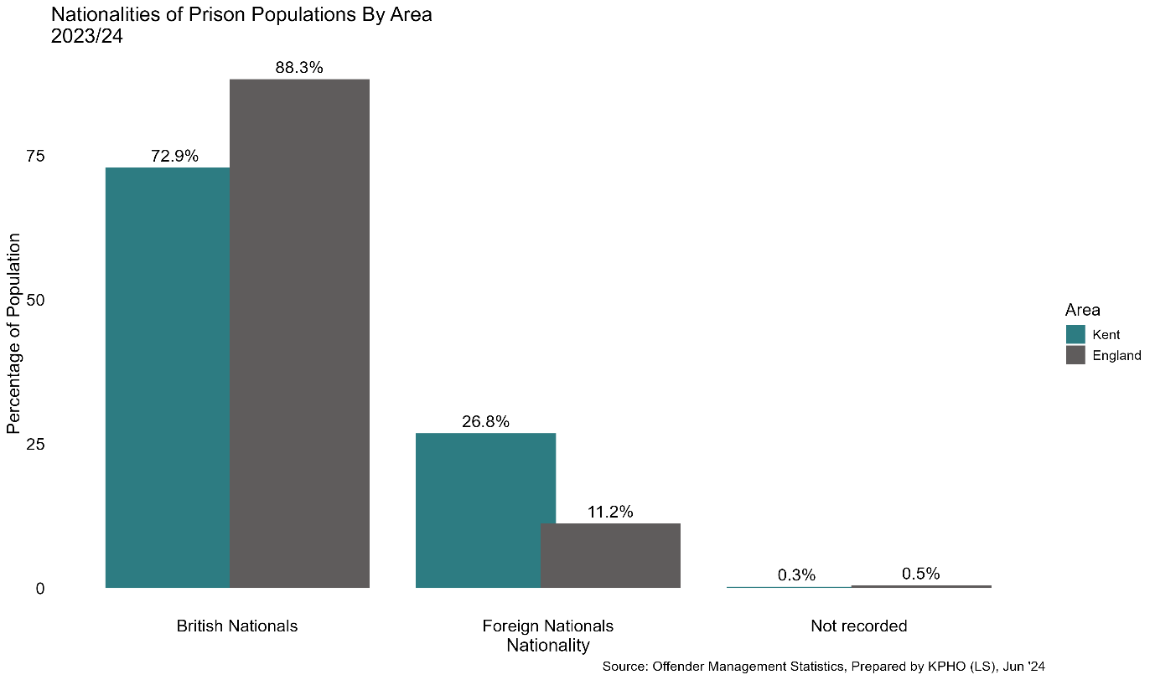

### **3.1.6 People experiencing homelessness**

Homelessness is associated with poor health outcomes and a higher mortality risk. The Homelessness Case Level Information Collection (H-CLIC) data system for LAs can be used to understand the homelessness profile of K&M. It provides data on the number of households owed prevention or relief duties, which are reasonable steps the LA has to take to help prevent people becoming homeless, or to help secure accommodation for those who are homeless. Between January to March 2024, there was a rise of 11.4% in the number of households assessed as homeless in England, compared to the same period in 2023[40].

Figure 10 shows the proportion of households owed a homelessness duty from the LA. Whilst K&M’s overall proportion was slightly lower than the England proportion, there was a higher proportion of households owed a duty in Gravesham (1.6%), Medway (1.6%), Maidstone (1.4%), Thanet (1.4%), Dartford (1.3%) and Swale (1.3%). Further information on TB in the homeless population is covered in Section 5.0.

**Figure 10: Proportion (%) of households in each district of K&M, and England, owed a duty in 2022/23**

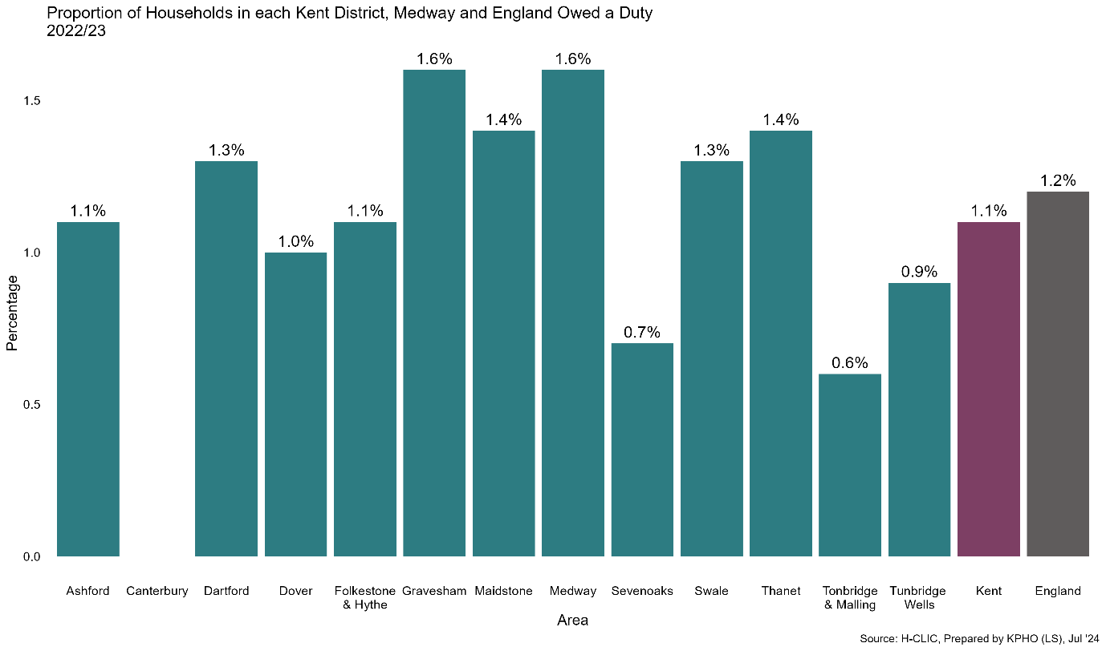

*Note: Canterbury did not provide data for 2022/23*

OHID South East conducted experimental data analysis using Hospital Episode Statistics to understand hospital admissions for people experiencing homelessness at an ICB level[41]. In 2019/20, Kent & Medway ICB (along with Sussex ICB) had the highest rate of admissions for homeless people in the South East, and admission numbers have remained relatively static in subsequent years.

### **3.1.7 Gypsy, Roma and Traveller (GRT) population[42]**

GRT people have significantly poorer health outcomes and more self-reported symptoms of ill-health than the general population of England. Kent has a higher proportion of people identifying as Gypsy and Irish Traveller, with 5,405 people (0.3% of the population) at the time of the 2021 Census, compared to 0.1% of the England population. Maidstone, Swale and Ashford rank in the top five of England local authority districts with the highest proportion of people from the Gypsy or Irish Traveller ethnic groups. In the 2021 Census, 2,255 people identified as Roma (0.1%), compared to 0.2% in England. A [health needs assessment conducted in 2023](https://www.kpho.org.uk/__data/assets/word_doc/0003/154803/Gypsy-Roma-Traveller-HNA-2023.docx)[43] highlighted the poorer health outcomes and barriers to healthcare identified by GRT people, along with recommendations to improve the health of this population group.

## **3.2 TB Epidemiology**

In this section TB epidemiology data is presented. All data presented is from NTBS[44], unless otherwise specified in the text.

### **3.2.1 Annual incidence**

The incidence of TB (three-year average) in England and K&M has decreased in the last decade (Figure 11). In 2020-22, the incidence in K&M was 4.7 per 100,000 population, compared to 7.6 per 100,000 in England. The target for England set by the WHO’s end TB strategy[45] is a rate of 1.05 per 100,000 population.

Following a drop in incidence in 2020, associated with the COVID-19 pandemic, a rise in incidence has been seen both nationally and globally with higher rates in the first two quarters of 2024, when compared with the pre-pandemic year of 2019[46]. The number of TB cases in K&M decreased during 2020 and has subsequently risen, reflecting the national trend (Figure 12). In 2023, there were 105 cases in K&M, with 81 cases in Kent and 22 in Medway.

**Recommendation:** Monitor annually the incidence in K&M following a rise in cases since 2020 to understand if this rise shows a return to pre-pandemic baseline or the start of an upward trend as seen nationally.

**Recommendation:** Consider partnering with a ICB or TB service in a high incidence area outside of K&M to encourage shared learning. This could be done at regional level via the TBCB.

**Figure 11: Incidence of TB (three-year average) in K&M and England, 2000-02 and 2020-22**

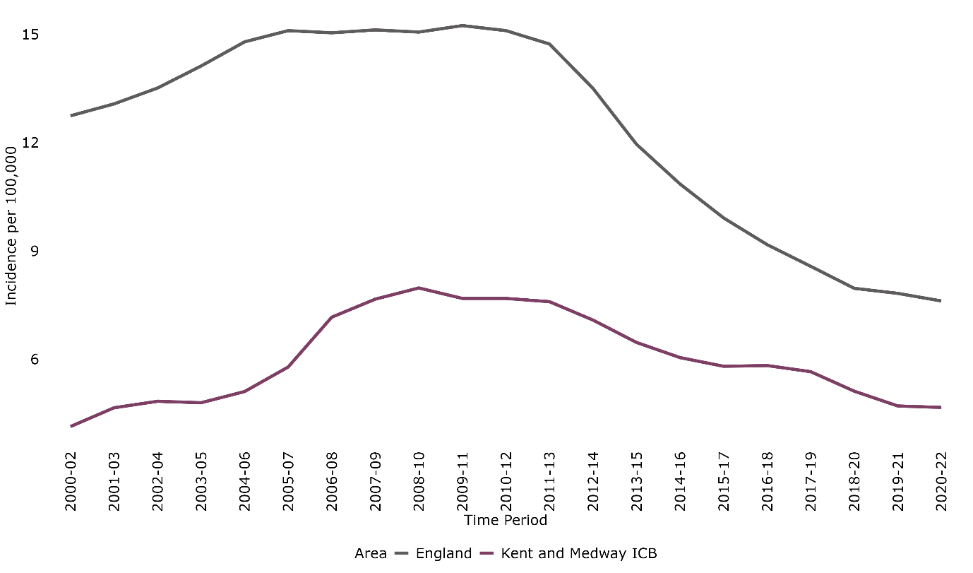

*Source: Fingertips, prepared by KPHO (LS), November 2024 [47]*

**Figure 12: Number of TB cases in Kent and Medway Local Authorities, 2014 to 2023**

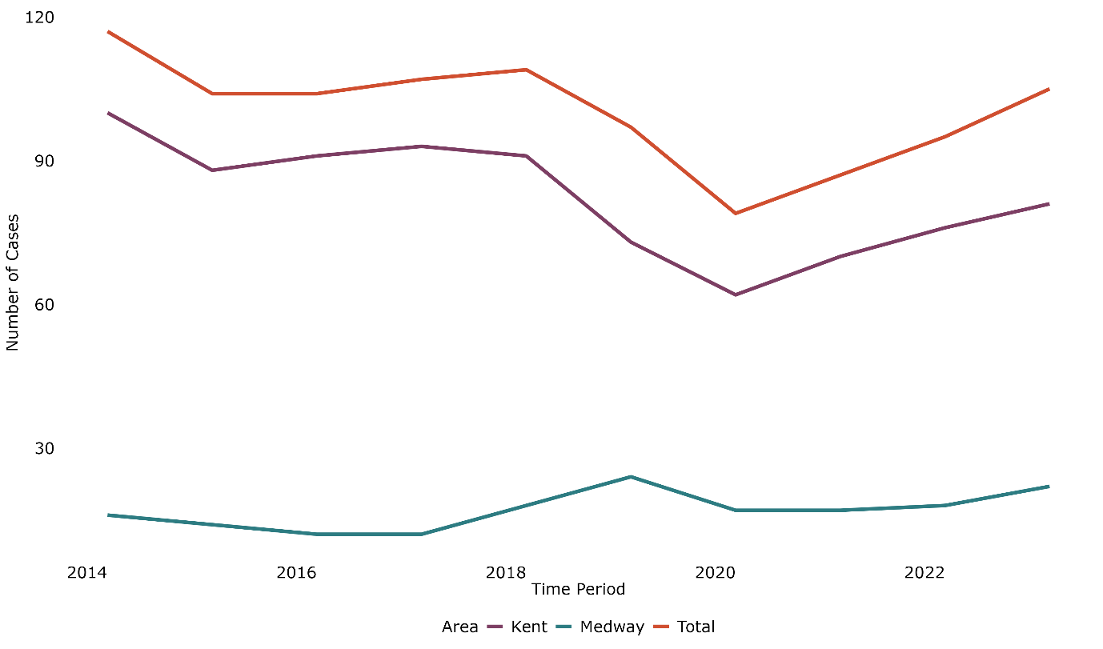

*Source: NTBS, prepared by KPHO (LS), November 2024*

*Note: excludes cases where local authority data was not available.*

The incidence of TB varies across the South East, and within Kent & Medway, as shown in Figure 13. In Kent & Medway, the highest rates are seen in the districts of Gravesham (>=12 per 100,000) and Dartford, Medway and Ashford (6 to 8 per 100,00). Lowest rates are seen in Sevenoaks and Tonbridge and Malling (<3 per 100,000).

**Figure 13: Three-year average annual TB incidence rate by Lower Tier Local Authority (LTLA), South East England, 2021 to 2023**

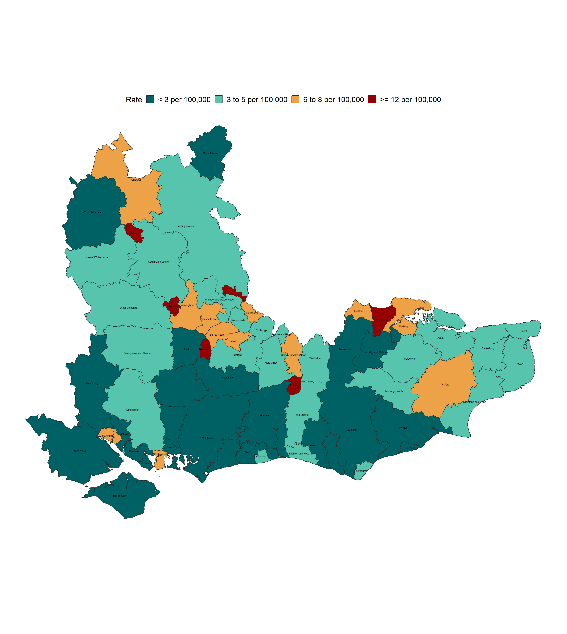

*Figure prepared by UKHSA Field Service, South East and London team*

TB services in K&M include Kent Community Health NHS Foundation Trust (KCHFT) which is split into North and East Kent, Maidstone and Tunbridge Wells NHS Trust (MTW) and Medway NHS Foundation Trust (Medway).

The number of TB cases varied by TB service, with KCHFT East Kent having the most cases each year (except for 2019) (Table 1).

**Table 1: Annual TB cases notified for each TB service in K&M, from 2014 to 2023**

|  |  |  |  |  |  |  |
| --- | --- | --- | --- | --- | --- | --- |
|  | TB Service | | | | |  |
| **Year** | **KCHFT (East Kent)** | **KCHFT (North Kent)** | **MTW** | **Medway** | **Other** | Total |
| 2014 | 40 | 24 | 23 | 16 | 14 | 117 |
| 2015 | 36 | 18 | 26 | 19 | 5 | 104 |
| 2016 | 37 | 26 | 15 | 14 | 12 | 104 |
| 2017 | 36 | 21 | 23 | 18 | 9 | 107 |
| 2018 | 32 | 22 | 23 | 20 | 12 | 109 |
| 2019 | 18 | 24 | 18 | 26 | 11 | 97 |
| 2020 | 24 | 13 | 14 | 17 | 11 | 79 |
| 2021 | 26 | 21 | 12 | 20 | 8 | 87 |
| 2022 | 31 | 20 | 17 | 19 | 8 | 95 |
| 2023 | 27 | 25 | 20 | 25 | 8 | 105 |
| Total | 307 | 214 | 191 | 194 | 98 | 1004 |

*Note*: *The TB service refers to the latest TB service listed as being responsible for the patient’s care. Therefore some patients may have previously been diagnosed or treated in a K&M TB service and subsequently moved or been transferred to another service outside of K&M, as represented by Other.*

### **3.2.2 Age and sex**

In 2023, 57.14% (60/105) of TB cases in K&M were male, with the median age at notification of 37 years. This is a similar breakdown to the South East overall, where for 2023, 54.07% (292/540) of TB cases were male, with the median age at notification of 39 years.

Data from 2023 is in line with previous years, where cases were most commonly male within the 30-39 age bracket (Figure 14). This is not reflective of the underlying K&M population, which has a slightly larger proportion of females than males, with the largest age groups being 10–14-year-olds and 50–59-year-olds, as shown in Figure 2 in section 3.1.2.

**Figure 14: Total number of TB cases, by age and sex, 2014 to 2023**

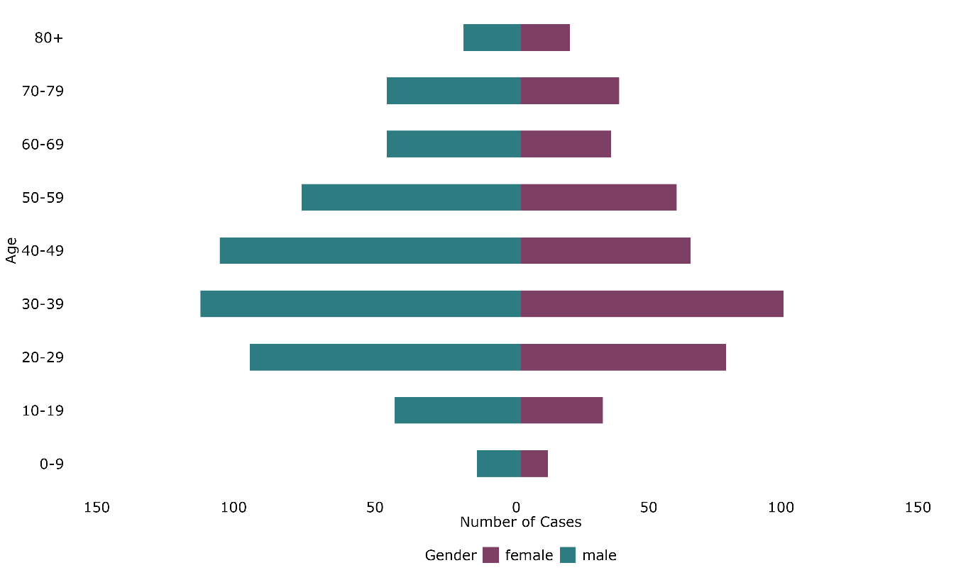

*Source: NTBS, prepared by KPHO (LS), November 2024*

### **3.2.3 Place of birth, time since entry and ethnicity**

Between 2014 and 2023, in K&M, 66.33% of TB cases were non-UK born (where data was available for place of birth). In 2023, 75.24% (79/105) of TB cases were non-UK born in K&M, compared to 79.44% (429/538) of cases in the South East. This is in line with national figures which has seen the incidence of TB in non-UK born populations rise between 2017 and 2022[48].

For the TB cases born outside of the UK in K&M (where data was available for place of birth and years since entry), the years since entry to the UK is shown in Figure 15. The largest proportion of cases are in non-UK born people who have been in the UK for >10 years. The highest proportion of cases in those who have entered the UK recently (<2 years) was seen in 2023. This may represent active TB in migrants who did not have pre-entry screening. In England, the number of individuals born outside the UK notified with TB within 5 years of entry to the UK increased by almost 2-fold when comparing 2023 with 2019, with the largest increase in those who had entered the UK recently (<2 years)[49].

**Recommendation:** The highest proportion of cases in those who have entered the UK recently (<2 years) was seen in 2023 in K&M. Monitor this proportion to understand if cases are rising in this cohort as this may represent active TB in migrants who did not have pre-entry screening.

**Figure 15: Years since entry to the UK by proportion of cases (%) ,2014 to 2023**

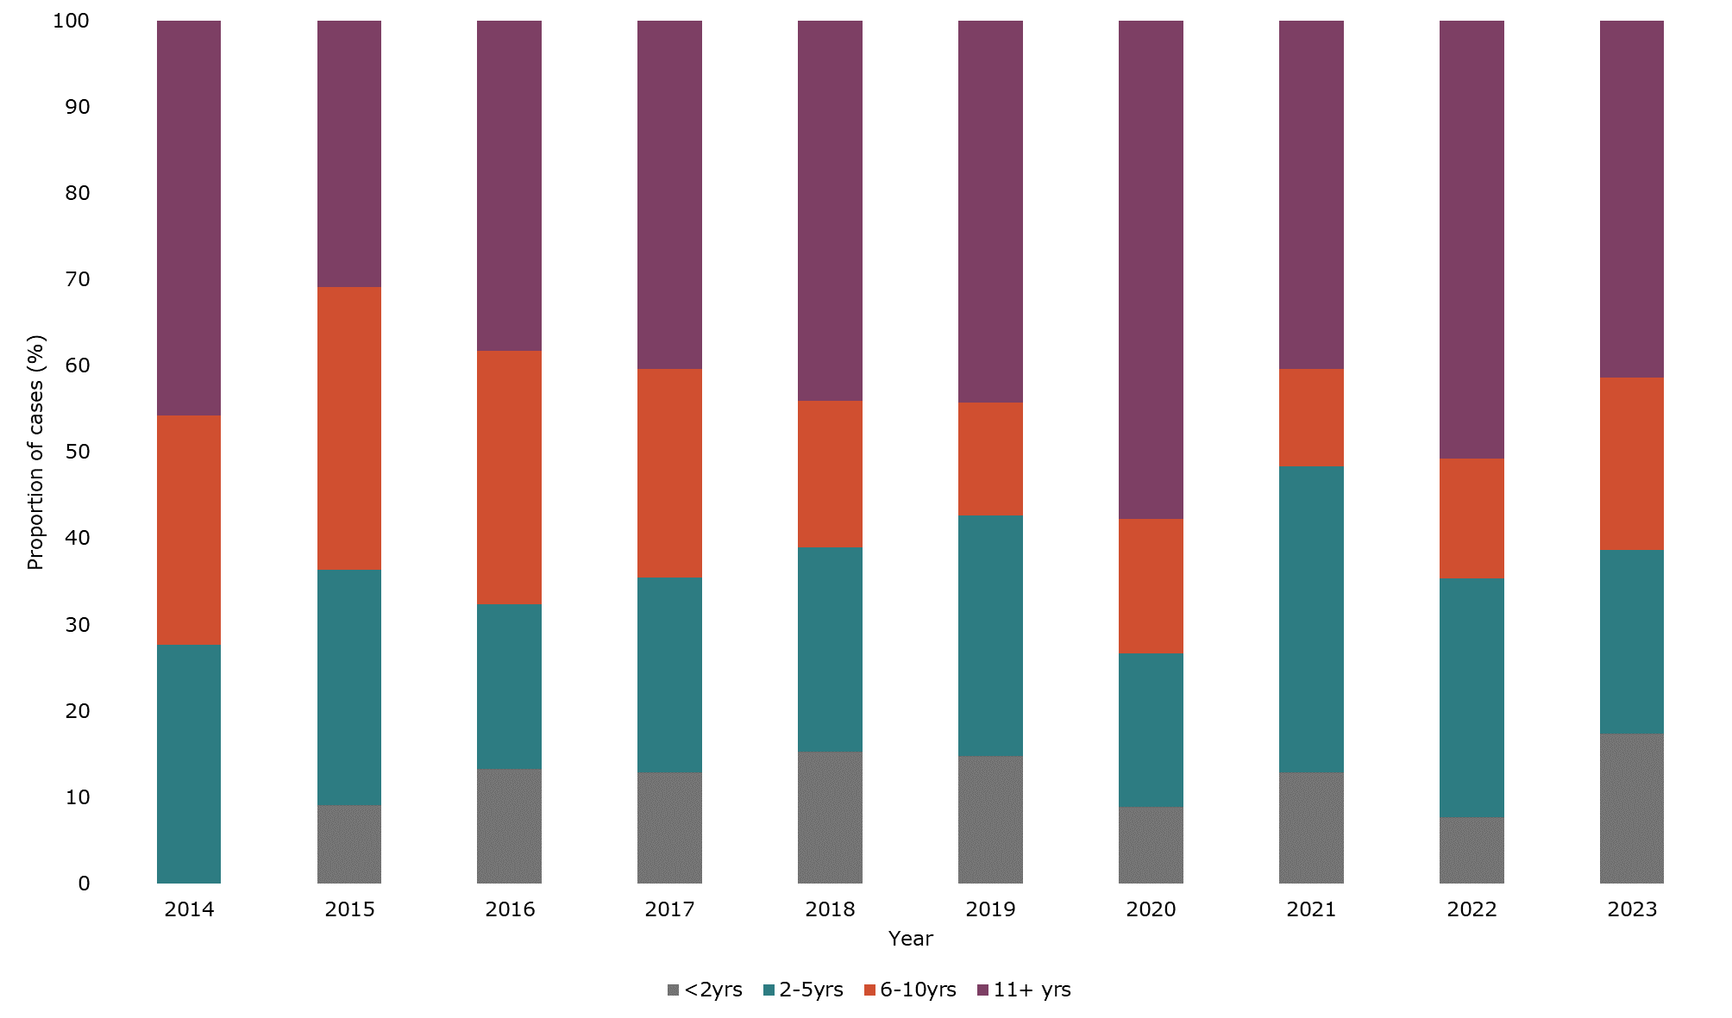

*Source: NTBS, prepared by KPHO (LS), November 2024*

*Note: excludes cases where place of birth and years since entry data was not available.*

Between 2014 and 2023, in K&M, the most common ethnicity for UK born cases was white, making up 77.91% (261/335) of cases, compared to 15.20% (100/658) of non-UK born cases. For non-UK born cases, the most common ethnicity was Indian (26.60%, 175/658), followed by mixed/other (24.77%, 163/658), black African (18.69%, 123/658) and white (15.20%, 100/658) and Figure 16 and 17 show the number of cases by ethnicity for UK born and non-UK born cases (where ethnicity was known and where cases were >4).

**Figure 16 – Number of UK born TB cases, by ethnicity, 2014 to 2023**

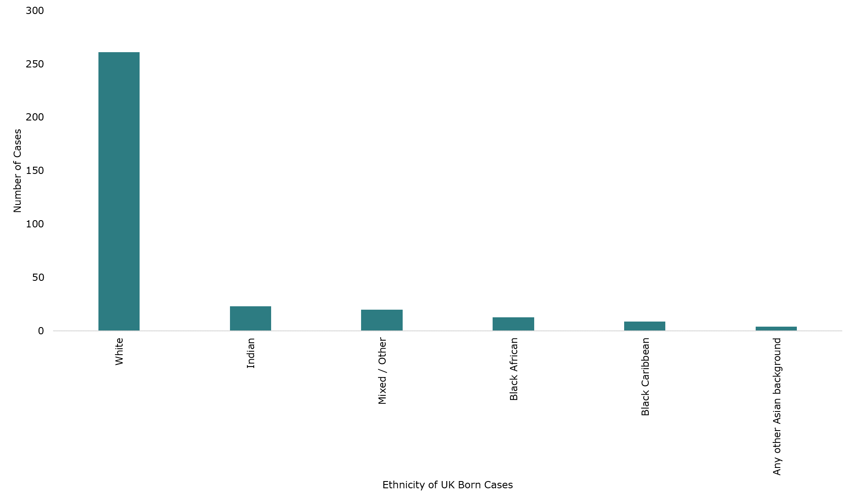

*Source: NTBS, prepared by KPHO (LS), November 2024*

*Note: excludes cases where ethnicity data was not available, or where cases were <5.*

**Figure 17 - Number of non-UK born TB cases, by ethnicity, 2014 to 2023**

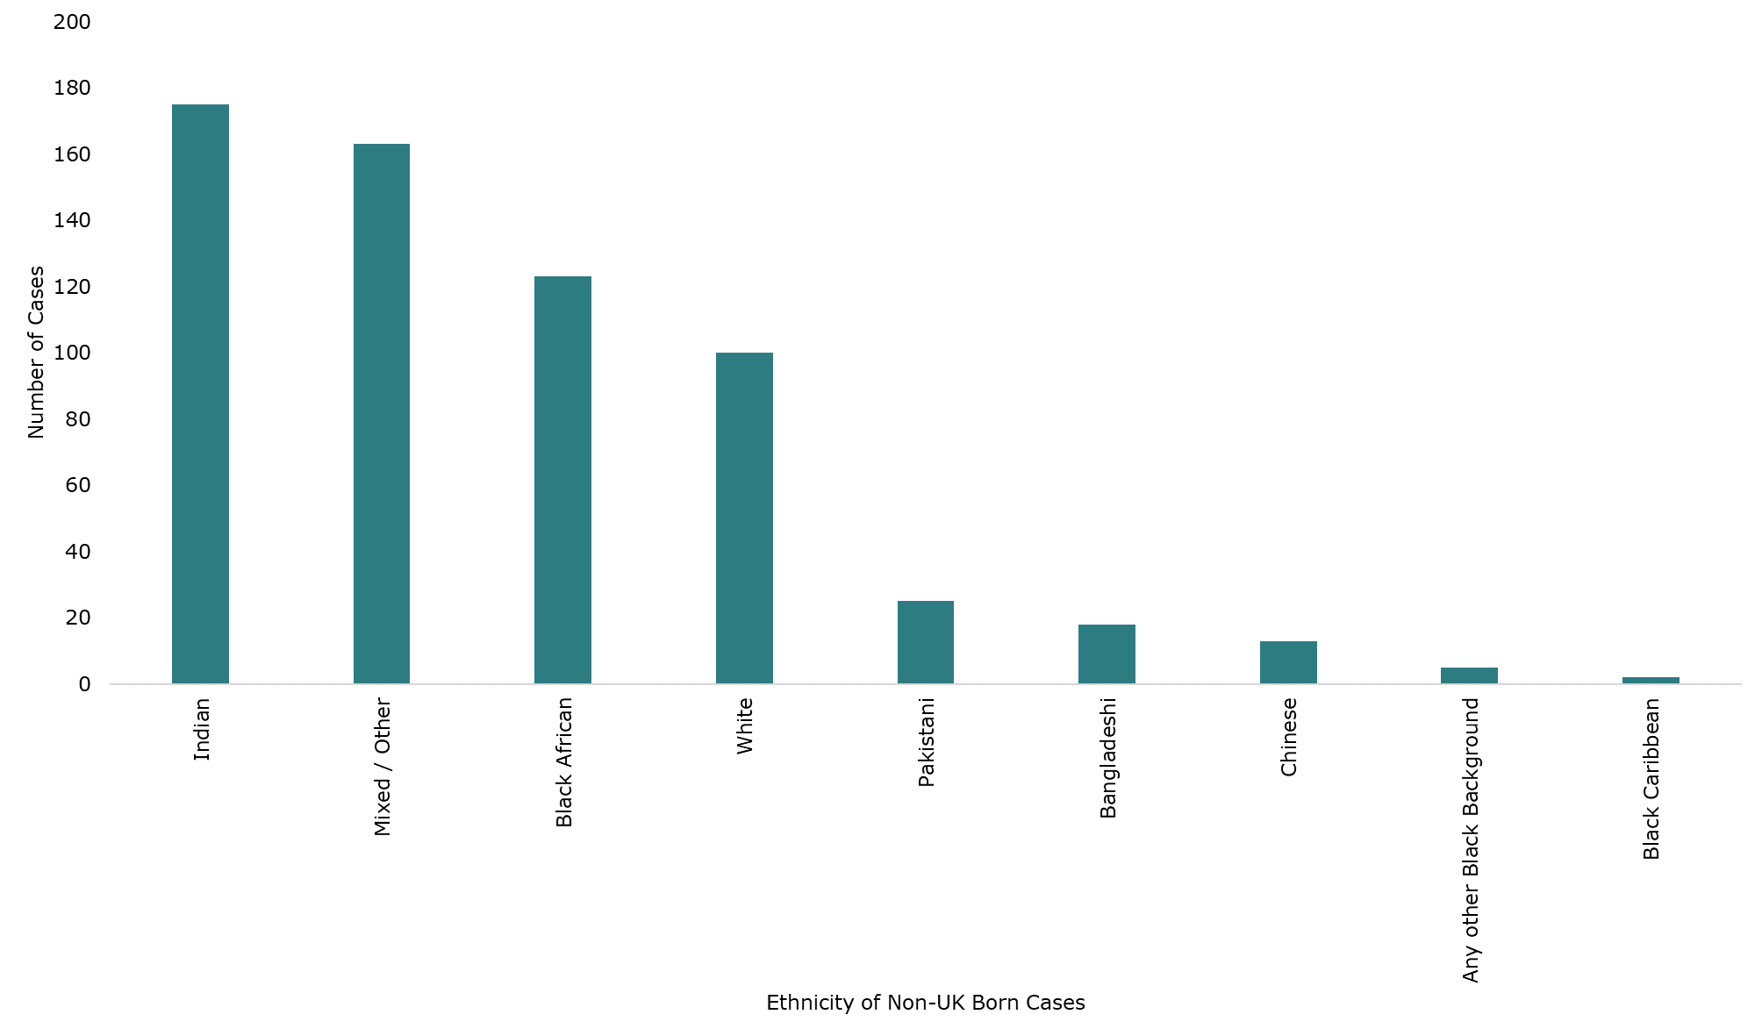

*Source: NTBS, prepared by KPHO (LS), November 2024*

*Note: excludes cases where ethnicity data was not available, or where cases were <5.*

### **3.2.4 Occupation**

Between 2014 and 2023, in K&M, for adult TB cases (15 years and older), where occupation was recorded, 7.34% (68/926) of TB cases were in those in education (students or teachers), and 10.58% (98/926) were in healthcare workers (community care workers, dentists, doctors, nurses and other healthcare workers) (Figure 18), representing a risk of transmission to vulnerable people in these settings. Of the TB cases in healthcare workers, 27.56% (27/98) were nurses, 14.29% (14/98) community care workers and 13.27% (13/98) doctors (Figure 19).

**Recommendation**: Focus awareness raising of symptoms and early diagnosis interventions in healthcare, social care and education settings. This could take place as part of World TB Day communications.

The national TB service specification states that all healthcare workers should have been assessed for active and latent TB as part of the occupational health check. It is unclear from the data above if TB was diagnosed during these checks, if a lack of health check has contributed to healthcare workers developing active TB whilst in employment, or if latent TB was diagnosed and individuals chose not to undertake treatment, which is not compulsory. Further engagement with occupational health departments would be helpful to understand this and ensure all potential employees are sufficiently screened.

**Recommendation:** Engage with occupational health departments to understand where issues may arise in pre-employment screening for active and latent TB. Explore the options for ensuring screening takes place, including reviewing existing service specifications.

**Figure 18 – TB cases aged 15 years and older, by occupation category (%), in Kent and Medway, 2014 to 2023**

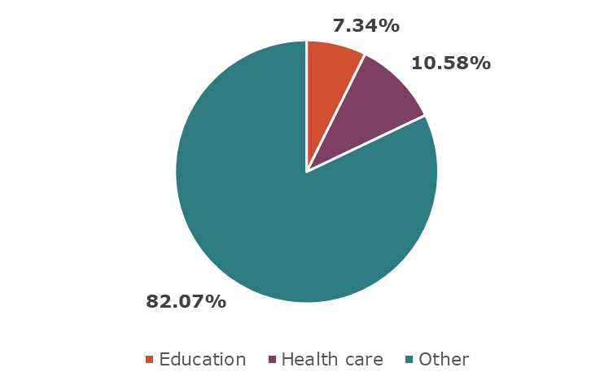

*Source: NTBS, prepared by KPHO (LS), November 2024*

*Note: excludes cases where occupation data was not available. Other includes those who are unemployed and retired.*

**Figure 19 – TB cases in healthcare workers, by occupation (%), in Kent and Medway, 2014 to 2023**

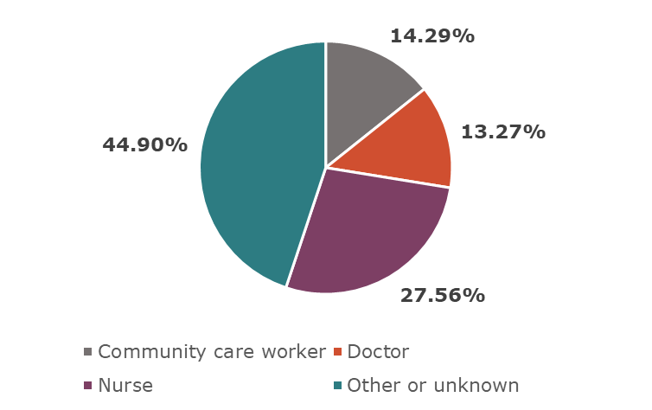

*Source: NTBS, prepared by KPHO (LS), November 2024*

### **3.2.5 Social risk factors**

Social determinants of health[50] are the conditions in which people are born, live and work, and these influence health inequalities. TB infection is associated with many social determinants of health. Social risk factors (SRF) are those that can lead to people experiencing social exclusion, stigma and discrimination, resulting in barriers in access to healthcare and poor health outcomes[51]. These factors are often intersecting, worsening inequalities for people experiencing them. Population groups who are more likely to have social risk factors are often referred to as inclusion health groups (IHGs) and these are discussed further in Section 5.0. The social risk factors collected in NTBS data include those with a history of or current alcohol/drug misuse, homelessness, prison incarceration, mental health issues, asylum seekers and immigration detainees. The risk factors of mental health issues, asylum seekers and immigration detainees have only been collected since mid-2021.

Between 2014 and 2023, 17.83% (179/1004) of all TB cases in K&M had a social risk factor. This compares to 10.90% (579/5311) of TB cases in the South East overall. As shown in Figure 20, the proportion of TB cases in K&M with social risk factors has increased over time. The addition of data collection on mental health issues, asylum seekers and immigration detainees will account for some of the increase in proportion seen, however there were only 37 cases with these social risk factors reported (3.69%).

**Figure 20 - % of TB cases with a social risk factor in Kent and Medway, 2014 to 2023**

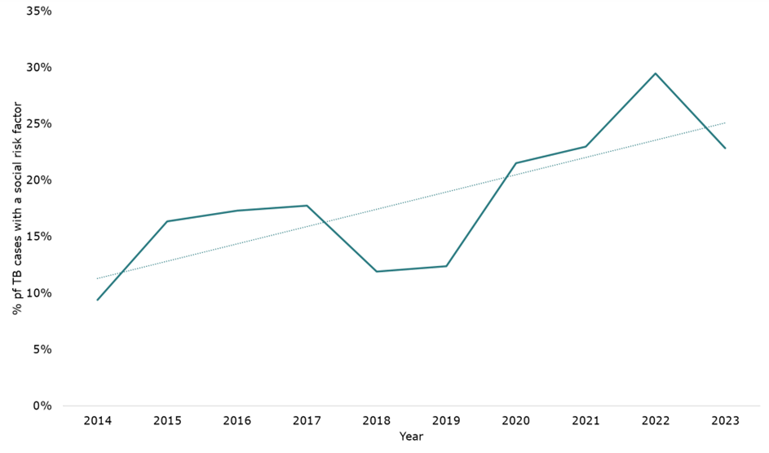

*Source: NTBS, prepared by KPHO (LS), November 2024*

**Recommendation:** To consider introducing active case finding outreach services in K&M, such as the UCLH Find & Treat service (and other examples can be found in the [TB IHG toolkit](https://www.gov.uk/government/publications/tackling-tb-in-inclusion-health-groups-toolkit-for-a-multi-agency-approach/tackling-tb-in-inclusion-health-groups-a-toolkit-for-a-multi-agency-approach)), to identify more undiagnosed TB cases, particularly in inclusion health groups. This is likely to be of benefit, given the high proportion of socially complex cases identified in K&M.

When considering the proportion of people with TB with at least one social risk factor for each UKHSA region in England, the South East had the highest proportion in 2022, although proportions have fluctuated over time (Table 2).

**Table 2 – Proportion of people with TB aged 15 years or more with at least one social risk factor by UKHSA region, England.**

|  |  |  |  |  |  |
| --- | --- | --- | --- | --- | --- |
| **UKHSA Region** | 2018 (%) | 2019 (%) | 2020 (%) | 2021 (%) | 2022 (%) |
| South East | 10.0 | 11.0 | 11.0 | 10.4 | 18.9 |
| London | 16.5 | 17.6 | 17.0 | 17.7 | 17.3 |
| West Midlands | 16.0 | 17.8 | 11.0 | 18.7 | 18.9 |
| North West | 11.4 | 11.1 | 11.0 | 12.7 | 14.3 |
| East Midlands | 14.9 | 14.3 | 14.0 | 10.7 | 14.4 |
| East of England | 13.9 | 12.4 | 12.0 | 12.4 | 15.5 |
| Yorkshire and the Humber | 11.4 | 15.7 | 11.0 | 14.5 | 17.9 |
| South West | 10.0 | 15.9 | 19.0 | 11.3 | 17 |
| North East | 17.2 | 18.4 | 18.0 | 25.3 | 16.4 |

*Note: data from Tuberculosis in England, 2023 report[52]*

The most common social risk factors recorded for TB cases with at least one social risk factor in K&M between 2014 and 2023 were drug misuse (36.31%, 65/179), homelessness (35.20%, 63/179), prison incarceration (33.52%, 60/179) and alcohol misuse (32.40%, 58/179). Of the TB cases with social risk factors, 39.11% (70/179) had more than one risk factor, demonstrating the high proportion of cases with multiple risk factors who are more likely to require enhanced support from TB services.

The demographics of TB cases with social risk factors, compared with the total TB cases between 2014 and 2023 in K&M are shown in Table 3. Cases with social risk factors were more likely to be male, of white ethnicity and UK-born compared to the overall cases. There was no difference in median age of cases when comparing total TB cases and those with social risk factors (both 40 years). KCHFT (East Kent) and MTW TB services saw a higher proportion of cases with social risk factors than average (Table 4).

**Recommendation**: TB prevention and early diagnosis should be focussed in areas and population groups where social risk factors for TB infection are highest, including drug and alcohol misuse, homelessness, prisoners and deprived areas.

**Table 3: Proportion of total TB cases and cases with at least one social risk factor, by demographic, in K&M, between 2014 and 2023**

|  |  |  |
| --- | --- | --- |
| **Demographic** | **Proportion of total TB cases (%)** | **Proportion of cases with at least one social risk factor (%)** |
| Male sex | 58.47% | 85.47% |
| White ethnicity | 36.35% | 55.87% |
| Non-UK born | 66.33% | 51.96% |

**Table 4: Number and proportion (%) of TB cases with social risk factors, for each TB service in K&M, between 2014 to 2023**

|  |  |
| --- | --- |
| **TB Service** | **Proportion of cases with at least one social risk factor, n (%)** |
| KCHFT (East Kent) | 65/307 (21.17%) |
| KCHFT (North Kent) | 27/214 (12.62%) |
| Medway | 23/194 (11.86%) |
| MTW | 44/191 (23.04%) |
| Other | 20/98 (20.41%) |
| Total | 179/1004 (17.83%) |

*Note: The TB service refers to the latest TB service listed as being responsible for the patient’s care. Therefore some patients may have previously been diagnosed or treated in a K&M TB service and subsequently moved or been transferred to another service outside of K&M, as represented by Other.*

### **3.2.6 Deprivation**

Deprivation is associated with TB infection, through various risk factors for infection and transmission, including crowded and poorly ventilated living and working environments and undernutrition[53].

Within K&M, between 2014 to 2023, the highest number of cases were living in an area in IMD decile 2 (158/1004) and the lowest in IMD decile 10 (44/1004), showing an overall negative trend when moving from most (decile 1) to least (decile 10) deprived deciles (Figure 21).

**Figure 21: Number of TB cases in Kent and Medway by IMD Decile, 2014 to 2023**

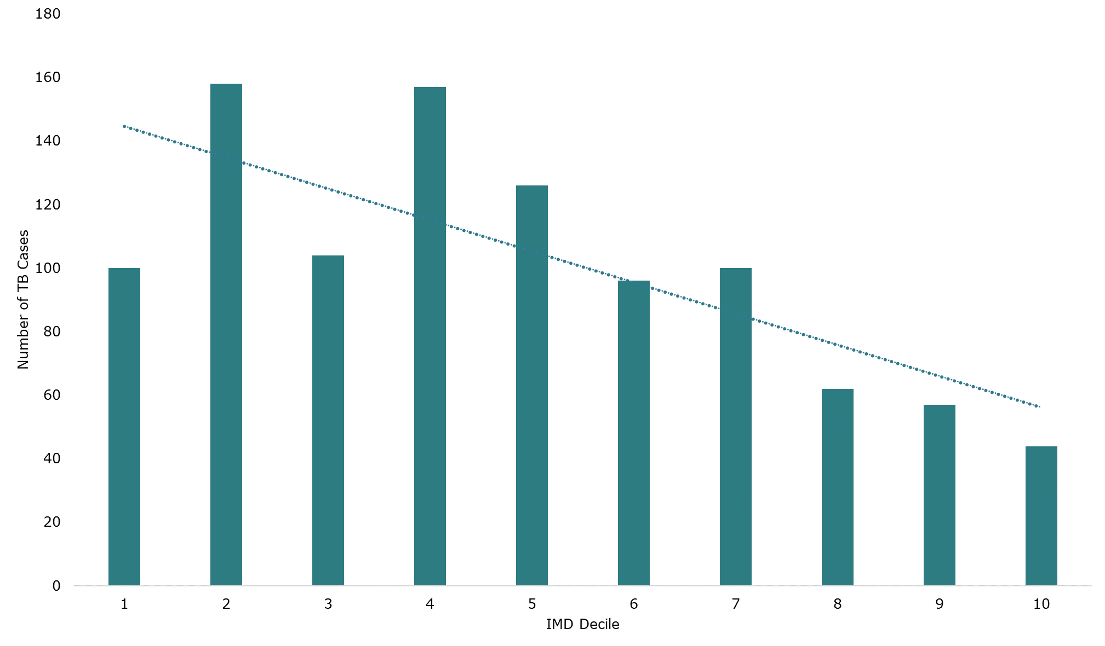

*Source: NTBS, prepared by KPHO (LS), November 2024*

*Note: IMD ranking for the first hospital the case was treated at was used for cases with no fixed abode. The English Indices of Deprivation 2019 decile rankings were used[54].*

**Recommendation**: TB prevention and early diagnosis should be focussed in areas and population groups where social risk factors for TB infection are highest, including drug and alcohol misuse, homelessness, prisoners and deprived areas.

### **3.2.7 Paediatric cases**

For the purpose of reporting epidemiology, a paediatric case is defined as <15 years. This is in line with national reporting and data reported to the WHO. Older children aged 15 years or over have a similar TB risk and clinical presentation to adults (aged 18 years or over)[55].

The number of paediatric cases of TB in K&M are small, with 45 cases between 2014 and 2023, representing 4.48% (45/1004) of all cases. Of those 45 cases, 51.11% were male (23/45), with a median age of 6 years. Most cases (46.67%, 21/45) were of white ethnicity, followed by mixed/other ethnicity (24.44%, 11/45) and black African (11.11%, 5/45). Most were UK-born (71.11%, 32/45) indicating transmission within K&M.

There were 26 cases aged 15 to 17 between 2014 and 2023.

### **3.2.8 Summary of TB epidemiology**

TB incidence in England has declined over the past ten years. During the COVID-19 pandemic there was a drop in incidence, and a subsequent rise since. K&M is a low-incidence area, however there is variation with higher rates in the districts of Gravesham, Dartford, Medway and Ashford and a higher number of TB cases in deprived areas within districts.

TB cases are more commonly males aged 30-39 years and most cases are in people not born in the UK. For those not born in the UK, most cases were in those who have been in the UK for >10 years. In 2023, the proportion of cases in those in the UK for <2 years was at its highest for the past decade, which could represent active TB in migrants who did not have pre-entry screening.

Just under 18% of adult cases in K&M worked in healthcare (including community care) or education or were students, representing a risk of transmission to vulnerable people in these settings.

K&M has a high proportion of TB cases with at least one social risk factor (17.83% vs. 10.90% in the South East), and this proportion has increased in the last decade. The most common social risk factors were drug misuse, homelessness, prison incarceration and alcohol misuse, and almost 40% of those with social risk factors had more than one, highlighting the complexity of cases. Cases with social risk factors were more likely to be male, of white ethnicity and UK-born compared to the overall cases. KCHFT (East Kent) and MTW TB services saw a higher proportion of cases with social risk factors.

A small proportion of TB cases are in children (4.48%); however, the majority were UK-born, indicating transmission within K&M.

## **3.3 Clusters and Outbreaks**

### **3.3.1 UKHSA health protection team activity**

All active TB cases must be notified to NTBS. For cases in a setting of concern, such as a school, workplace, prison or healthcare setting, the TB service will notify the local health protection team (HPT) and they will work together with other stakeholders to manage the public health risk. A TB incident may be declared if additional screening or provision of inform and advice letters are required. The number of TB incidents managed by HPTs in the South East are shown in Table 5. Incidents increased in every HPT in the South East between 2022 and 2023, although the smallest increase was seen in Kent.

**Table 5 – number of TB incidents, by South East HPT, 2022 to 2023**

|  |  |  |  |
| --- | --- | --- | --- |
|  | 2022 | 2023 | 22-23 increase (%) |
| Kent HPT | 22 | 24 | 9% |
| Surrey and Sussex HPT | 13 | 19 | 46% |
| Hampshire and Isle of Wight HPT | 7 | 11 | 57% |
| Thames Valley HPT | 17 | 38 | 124% |
| Overall | 59 | 92 | 56% |

**Recommendation**: Monitor and report at network meetings the number of yearly TB incidents managed by the HPT and TB services. Given the impact of incidents on TB services workloads, a sustained increase in incidents will require enhanced resources.

The annual WHO World TB Day provides an opportunity for awareness raising. Communication from the UKHSA each year uses World TB Day to remind the public and healthcare professionals of TB symptoms and the importance of early diagnosis, using case studies to highlight this[56].

**Recommendations**: To increase communications about TB symptoms and signs to the K&M population, with targeting to the groups at increased risk identified in the epidemiology and cohort data. Targeting could be achieved by directing communications to organisations and those working with high risk groups, using World TB Day as an annual reminder.

### **3.3.2 Clusters**

TB whole-genome sequencing (WGS) is used for TB diagnosis and investigation of TB clusters, which are groups of strains with closely related genomes. WGS clusters can then be explored to understand if the cases have an epidemiological link. Identifying clusters gives an opportunity to detect transmission chains whereby public health control measures can be targeted, to reduce further transmission[57].

Quantitative data on clusters wasn’t routinely available for the HNA, given the cluster detection system is currently paused whilst the system is redesigned. Data on WGS clusters is still available on request where there are concerns that a case may be part of a cluster, to support public health management.

Several clusters of public health importance have been detected in the last ten years in K&M. Whilst cases were linked by geography, it was not always possible to identify exact sources or places of transmission. Some of the identified places of transmission and population groups involved have been in a hospital, amongst people using cannabis, in the homeless population and amongst migrants from the same country. The following clusters have been summarised here as they demonstrated specific challenges in terms of investigation and management.

**Cluster in a migrant community**

This was a TB cluster of cases in mostly adult males from the same country, with eleven cases, mostly in Medway. A review of the cases identified lots of interconnections between them, including accommodation, education settings and workplaces.

An incident meeting agreed several actions:

* The LA explored routes of transmission within accommodation settings via the housing teams and social care.
* Mass screenings of two classes attending the education setting were required, resulting in screening of 46 individuals across 5 TB teams. There were no positive cases detected, however over a third of individuals did not attend for screening.
* The education setting was contacted to explore awareness raising around TB and to try to engage with the students to find out about existing groups they attend or social support they may be receiving.
* GP practices in the local area were contacted to remind them to have a low threshold for referring high-risk individuals from this community for LTBI screening.
* Workplaces were contacted to raise awareness of TB.

This was a challenging cluster to manage for several reasons. Cases often presented late and were usually living in shared accommodation with several other people in a household or employed at workplaces with large numbers of potential contacts. The TB teams reported it took a long time to build trust with the cases and for them to disclose contacts and living arrangements. No community leaders could be identified, nor community social places where individuals would meet, making it difficult to build links in the community. Contacts identified at the workplace would not give permission for their contact details to be shared, making contact tracing very difficult. This cluster also highlighted the importance of new entrant screening for both active and latent TB in migrants. Involvement of social workers may have also supported with compliance with the TB team, and building trust to disclose information that was needed to ensure a thorough public health response.

**Cluster in the homeless community**

This is a cluster of cases linked to the homeless community that has been intermittent in East Kent since 2013. There have been 14 cases and 5 contacts identified with TB caused by Mycobacterium africanum, an uncommon species that can cause severe disease. There were also links to prisons and associated social risk factors of drug and alcohol use.

A mass screening event took place in 2014 in which 71 people were screened. This event took a long time to organise and required multiple meetings and a high administrative burden on the health protection team. Initially a plan for providing financial incentives and transportation to the hospital for blood tests and chest x-rays was discussed. This was challenging given the approvals needed for funding and there was a subsequent lack of uptake in the population. A screening event was therefore arranged with mobile X-ray and sputum screening provided by the University College London Hospitals NHS Foundation Trust (UCLH) Find and Treat service, and Interferon Gamma Release Assay (IGRA) blood tests by Oxford Immunotec. This event was funded by the Clinical Commissioning Group (CCG) in place at the time, but took several months to organise given a lack of agreed funding pathways being in place. A local homeless charity provided support to those requiring further testing, however engagement was intermittent, and follow-up leading to one TB diagnosis took many months. Four people had positive blood tests for latent TB infection (LTBI) but did not attend for treatment and were lost to follow up.

In 2023, two new cases linked to the cluster were identified. Identifying and engaging with contacts of the cases was difficult resulting in the need for two further screening events at homeless outreach locations, with 42 people screened at the first and 23 people screened at the second. Several people were identified with abnormal chest X-rays who attended follow-up where TB was ruled out. Several people also had positive IGRA blood tests suggesting LTBI, who are in the process of being follow up. Several known contacts did not engage with screening. Engagement for screening and treatment of LTBI has been difficult in this population, highlighting the challenges in those with social risk factors and the need for funding for enhanced social support for IHGs.

**Recommendation**: The clusters described here provide further evidence of the link between TB and social risk factors and the need for TB prevention strategies to target those in IHGs. Specific recommendations are outlined in Section 5.0.

## **3.4 Cohort review**

The cohort review is a systematic review of all TB cases notified in a 3 to 4-month period, to review outcomes for those patients and identify issues arising in the area. Outputs from cohort review are recommended by NICE to feed into local HNAs[58]. In Kent & Medway ICB, the cohort review happens every 4 months and is attended by the UKHSA South East HPT, Kent and Medway LAs, the ICB, TB service leads and clinicians and microbiologists. An epidemiological report and an action log with issues identified are circulated to the network after each meeting.

**Recommendation**: Continue regular network meetings and cohort review, to discuss common themes arising from cases and ensure timely regular review of action logs. Where required, escalate issues to the TBCB for further support.

### **3.4.1 Site of disease**

Between 2014 and 2023, in K&M, 57.47% (577/1004) of TB cases were pulmonary, 42.43% (426/1004) extra-pulmonary and 0.20% (2/1004) unknown (Figure 22). For 2023, in K&M, 52.38% (55/105) of cases were pulmonary, compared to 47.96% (259/540) in the South East.

**Figure 22 – Number of TB cases in Kent and Medway, by site of disease, 2014 to 2023**

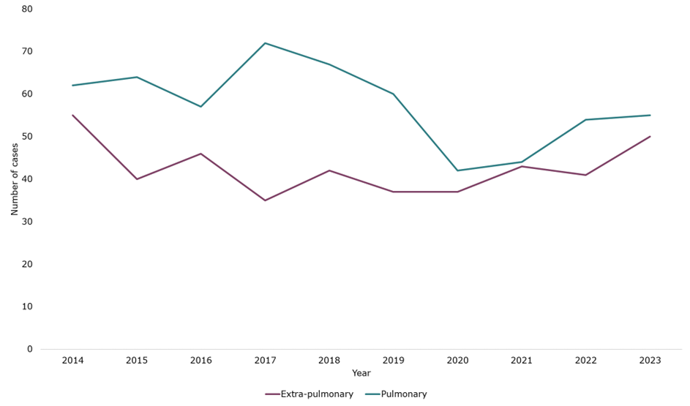

*Source: NTBS, prepared by KPHO (LS), November 2024*

### **3.4.2 HIV co-infection**

Untreated HIV infection increases the risk of developing active TB disease. Between 2014 and 2023 in K&M, 860 cases (860/1004, 85.66%) were offered a HIV test and completed it (Table 6). Results of these tests are not recorded in NTBS. Prior to a HIV test being offered, HIV status was already known in 64 cases (64/1004, 6.37%). The proportion offered a HIV test and completing it in K&M has fluctuated yearly between 79.49% and 90.38% (Figure 23). In the South East, between 2014 and 2023, 85.28% (4529/5311) of cases were offered a HIV test and completed it.

When considering the proportion of cases with unknown HIV status offered a HIV test, in 2022, this was 97.65% (83/85) in K&M, 98.86% (432/437) in the South East and 98.2% in England overall[59].

**Table 6 – Number and proportion (%) of all TB cases in K&M, according to whether a HIV test was offered, 2014 to 2023.**

|  |  |
| --- | --- |
| **HIV test offered** | **Number of cases (n, %)** |
| HIV status already known | 64 (6.37%) |
| HIV test not offered | 22 (2.19%) |
| HIV test offered and completed | 860 (85.66%) |
| HIV test offered but not completed | 28 (2.79%) |
| HIV test offered but refused | 9 (0.90%) |
| Unknown | 21 (2.09%) |

**Figure 23: Proportion (%) of TB cases in Kent and Medway offered and completed a HIV test, per year, 2014 to 2023**

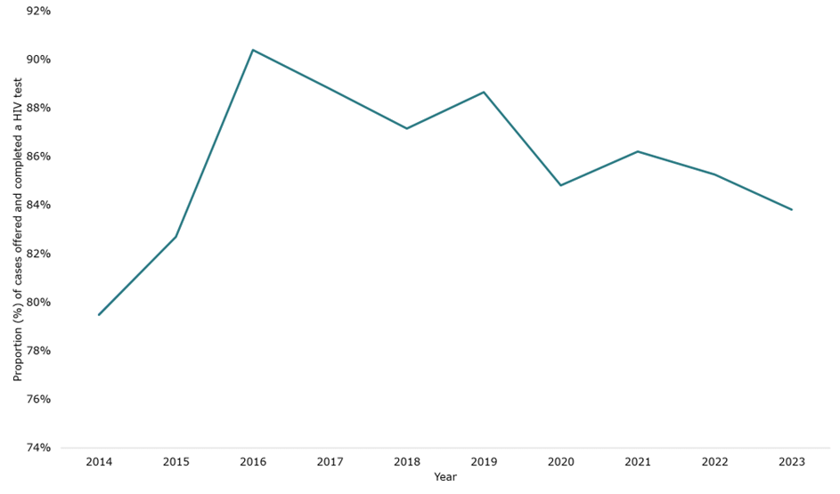

*Source: NTBS, prepared by KPHO (LS), November 2024*

**Recommendation**: To ensure all people with TB are offered a HIV test.

### **3.4.3 Co-morbidities**

Data on co-morbidities has been collected routinely since 2016, and includes diabetes, hepatitis B, hepatitis C, chronic liver disease, chronic renal disease and immunosuppression. Co-morbidities may affect TB susceptibility, treatment strategies and outcomes[60].

Between 2014 and 2023, 175 cases (175/1004, 17.43%) were known to have one of the above co-morbidities. Where data was recorded, the number and proportion of cases with each co-morbidity in K&M is shown in Table 7. The most common co-morbidity was diabetes (10.62%), followed by immunosuppression (4.95%). In the South East, between 2014 and 2023, 18.83% (1000/5311) were known to have a co-morbidity.

**Table 7: Number and proportion (%) of cases with a co-morbidity, in K&M, between 2014 and 2023**

|  |  |  |  |
| --- | --- | --- | --- |
| **Co-morbidity** | **No. of cases** | **Proportion (%)** | **Total (with data recorded)** |
| Diabetes | 88 | 10.62% | 829 |
| Hepatitis B | 10 | 1.22% | 823 |
| Hepatitis C | 10 | 1.22% | 823 |
| Chronic liver disease | 8 | 0.97% | 825 |
| Chronic kidney disease | 18 | 2.19% | 823 |
| Immunosuppression | 41 | 4.95% | 828 |

*Note: does not included cases where co-morbidity wasn’t recorded.*

### **3.4.4 Culture confirmation**

NICE recommends that all suspected TB cases provide samples for microbiological diagnosis[61]. Presented in this section is data from NTBS, where a culture test result was confirmed by the reference laboratory.

Figure 24 shows the proportion (%) of cases confirmed with a culture result, between 2014 and 2023 in K&M. A higher proportion of pulmonary TB cases were confirmed with a culture, compared to non-pulmonary cases, and this trend has remained largely stable over the last decade, aside from a drop during the COVID-19 pandemic in 2020. The TB action plan currently sets a target of increasing culture confirmation proportions for pulmonary cases to 80% by 2025, this was met by K&M in 2023.

When compared to the South East and England (Table 8) in 2022, proportions are similar, except for a low proportion in non-pulmonary cases in K&M. The 2023 data shows the proportion has continued to drop for non-pulmonary cases, with only 30.00% confirmed. It is unclear from the data if this is due to samples not being taken or due to samples not being sent to microbiology for culture.

**Recommendation**: Explore the reasons for decreasing rates of culture confirmation in non-pulmonary TB cases, with a view to increasing rates where possible. There are good culture confirmation rates for pulmonary TB cases in K&M, with over 80% confirmed in K&M in 2023.

When looking at all TB cases being managed by K&M TB services, the proportion (%) of all cases culture confirmed has fluctuated with no clear pattern by TB service or year (Figure 25). This is likely to be a reflection of the relatively small number of cases each year, whereby some years there may be a higher proportion of non-pulmonary cases that are less likely to be culture confirmed. All services have achieved over 80% culture confirmation on several occasions.

**Figure 24 – Proportion (%) of cases confirmed with a culture result from the reference laboratory, for all cases, pulmonary cases and non-pulmonary cases in Kent and Medway, 2014 to 2023**

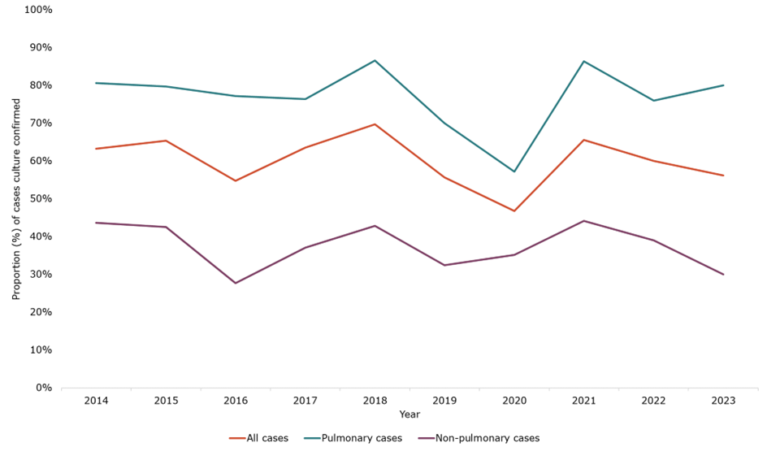

*Source: NTBS, prepared by KPHO (LS), November 2024*

**Table 8 – proportion (%) of cases confirmed with a culture result from the reference laboratory, for all cases, pulmonary cases and non-pulmonary cases in K&M, South East and England in 2022**

|  |  |  |  |
| --- | --- | --- | --- |
|  | **All cases (%)** | **Pulmonary cases (%)** | **Non-pulmonary cases (%)** |
| K&M | 60.0% | 75.9% | 39.0% |
| South East | 58.6% | 69.4% | 47.5% |
| England[62] | 62.6% | 75.6% | 46.9% |

**Figure 25 – Proportion (%) of all cases managed by a Kent and Medway TB service, confirmed with a culture result from the reference laboratory, by service, 2014 and 2023**

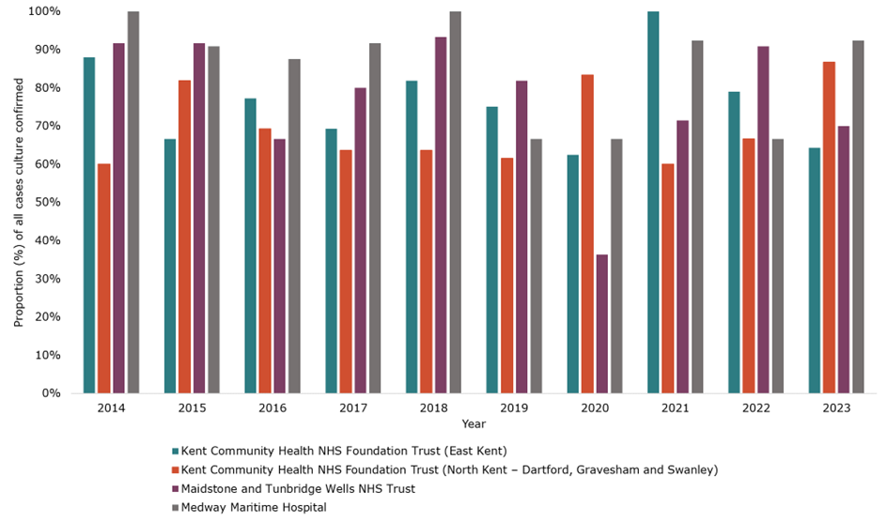

*Source: NTBS, prepared by KPHO (LS), November 2024*

*Note*: *The TB service refers to the latest TB service listed as being responsible for the patient’s care. Therefore some patients may have previously been diagnosed or treated in a K&M TB service and subsequently moved or been transferred to another service outside of K&M, not shown here.*

### **3.4.5 Mycobacterium species**

In K&M between 2014 and 2023, of all the cases with culture confirmation (607/1004), the majority were Mycobacterium tuberculosis (95.55%, 580/607), followed by a small number of Mycobacterium africanum or Mycobacterium bovis cases (3.62% 22/607). Five cases (0.82%) were recorded as Mycobacterium tuberculosis complex without further information available on the species. The South East overall had 97.57% of cases with culture confirmation being Mycobacterium tuberculosis, a similar proportion to K&M.

### **3.4.6 Drug susceptibility testing**

For cases with culture confirmation, drug susceptibility testing for the first line agents of rifampicin, isoniazid, pyrazinamide, and ethambutol are undertaken. This is normally done by WGS, but where this does not give complete results, conventional phenotypic drug susceptibility testing is also used[63].

Between 2014 and 2023, in K&M, of all the cases with culture confirmation (607/1004), 99.01% (601/607) had results for isoniazid and rifampicin, and 96.54% (586/607) had results for all first line agents.

There were 7 multi-drug resistant (MDR) TB cases in K&M between 2014 and 2023 (Table 9). MDR TB cases are defined as those resistant to rifampicin, with or without isoniazid resistance[64]. There were 45 MDR cases across the South East between 2014 and 2023 (1.39%, 45/3245). This appears to be slightly lower than the England proportion which has varied from 1.5% to 2.1% between 2011 and 2022[65].

**Table 9 – number of cases resistant to each first-line agent, in K&M, between 2014 and 2023.**

|  |  |
| --- | --- |
| **Agent** | **Number of cases resistant** |
| Isoniazid | 52 |
| Rifampicin | 7 |
| Ethambutol | 10 |
| Pyrazinamide | 9 |
| Multi-drug resistant (resistant to isoniazid and rifampicin) | 7 |

*Note: Only includes cases with culture confirmation.*

### **3.4.7 Contact tracing**

Assessment and screening of close contacts of TB cases is required to interrupt chains of transmission by identifying contacts with undiagnosed active TB, identifying latent infection whereby chemoprophylaxis can be given to prevent active disease, and providing vaccination for those eligible[66]. The TB action plan[67] sets a target of 90% of pulmonary or infectious TB cases to have a minimum of 5 close contacts identified and screened.

The number of contacts identified for each case has been recorded in NTBS since 2018. In K&M since 2018, the proportion (%) of pulmonary cases where contacts have been recorded has increased (Figure 26). For the purpose of looking at number of contacts identified, data from 2019 onwards has been presented in Figures 27 and 28 but should be interpreted with caution given the change over time in data completeness.

Between 2021 and 2023, the proportion (%) of all pulmonary cases with 1 or more contacts identified was consistently above 80% in both the South East and K&M (Figure 27). As expected, between 2019 and 2023 the proportion (%) of all pulmonary cases with 5 or more contacts identified was lower, however K&M cases consistently had a higher proportion of contacts identified (Figure 28). In 2023, 40.00% (22/55) of cases had 5 or more contacts identified in K&M, compared to 29.7% (77/259) in the South East overall. This is far below the TB action plan target of 90%.

**Recommendation**: TB services in K&M are identifying a high proportion of close contacts (40%) compared to other ICB areas and should continue aiming to identify 5 or more contacts in pulmonary TB cases, where possible.

**Figure 26 – Proportion (%) of Pulmonary cases where contacts have been recorded, in Kent and Medway, 2018 to 2023**

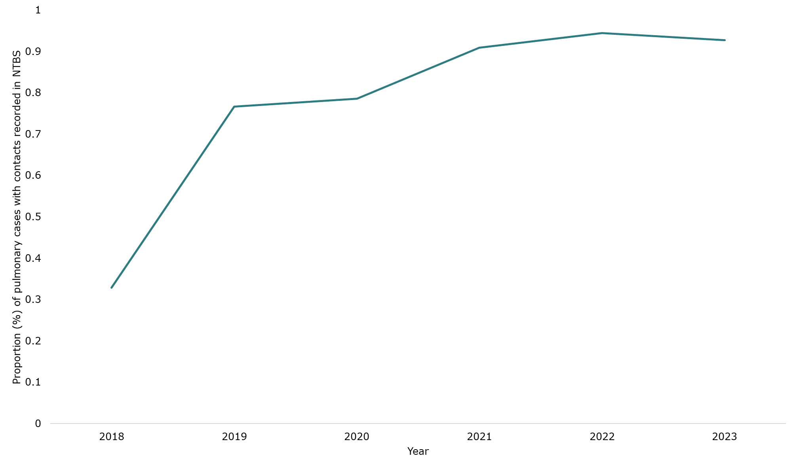

*Source: NTBS, prepared by KPHO (LS), November 2024*

**Figure 27: Proportion (%) of all pulmonary cases with 1 or more contacts identified in Kent, Medway and the South East, 2019 to 2023**

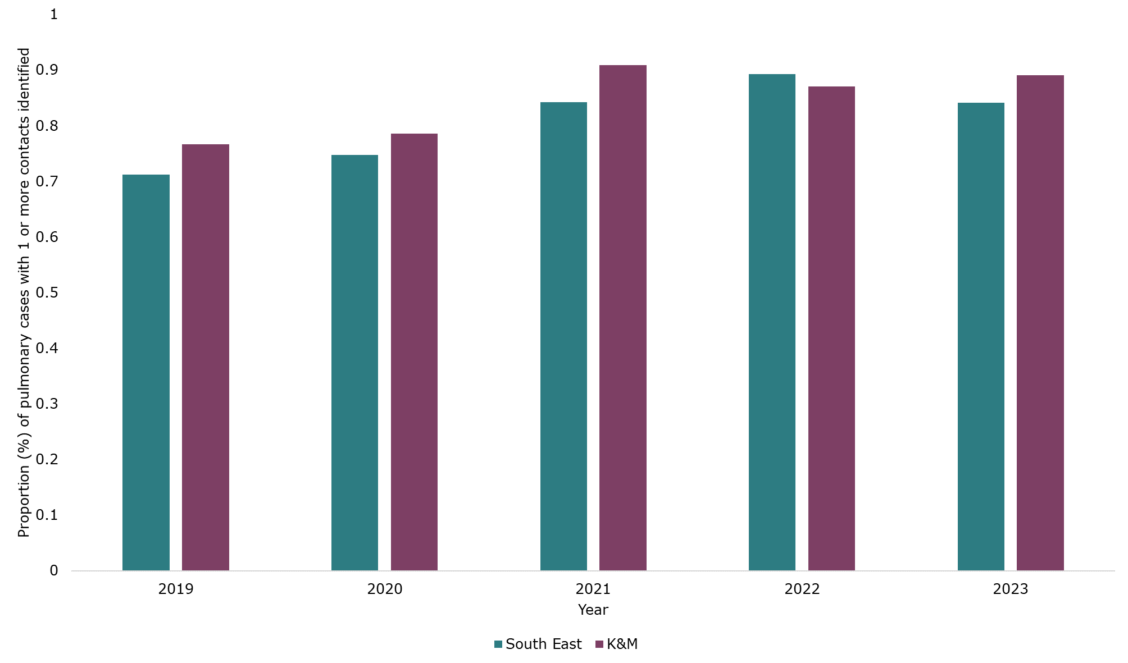

*Source: NTBS, GOV.UK, prepared by KPHO (LS), November 2024*

**Figure 28: Proportion (%) of all pulmonary cases with 5 or more contacts identified in Kent, Medway and the South East, 2019 to 2023**

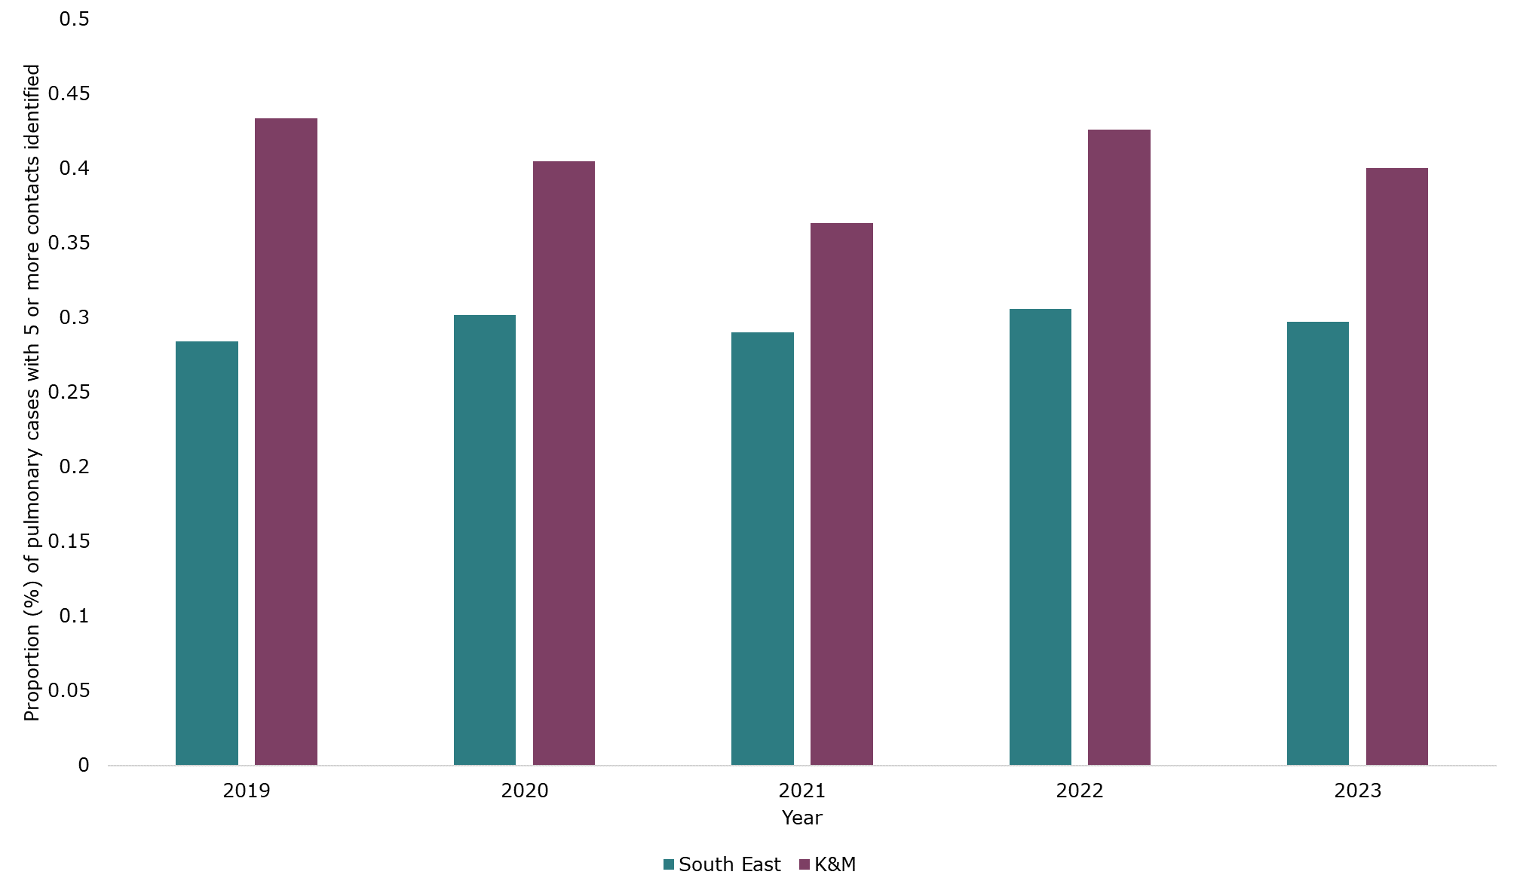

*Source: NTBS, GOV.UK, prepared by KPHO (LS), November 2024*

### **3.4.8 Enhanced case management**

The RCN’s case management tool[68] gives recommendations for when individuals receiving treatment for TB should have enhanced case management (ECM). There are three levels for ECM, ranging from level 1 for people with clinical and/or social issues which impact on treatment, level 2 for people with complex issues and level 3 for people with very complex issues[69]. NICE advises that TB case managers have responsibility for coordinating care for those receiving ECM, recommending 1 whole time equivalent (WTE) case manager per 20 incident cases[70].

This data has been routinely collected since mid-2021 in NTBS. Figure 29 shows the proportion of cases requiring ECM (where data was recorded), between 2018 and 2023 for K&M and the South East. Whilst the overall proportion requiring ECM in the South East has declined over time, it has continued to rise in K&M. In 2022, 71.58% (68/95) of cases required ECM in K&M, compared to 41.60% in the South East and 43.2% in England overall[71]. This places a large burden on TB services, particularly for specialist TB nurses who provide the case management.

**Recommendation**: Ensure all TB services have the resources required, including sufficient TB case managers, and DOT/VOT availability to support the high proportion of cases requiring enhanced case management.

**Figure 29: Proportion (%) of TB cases requiring ECM in Kent, Medway and the South East,**

**2018 to 2023**

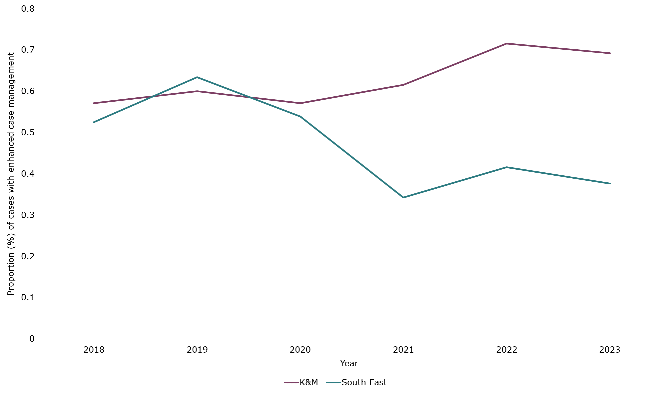

*Source: NTBS, GOV.UK, prepared by KPHO (LS), November 2024*

*Note: does not include cases where data on ECM was not recorded.*

When considering national figures in 2022, the South East had the third highest proportion of cases with ECM in England, after London and the North West[72].

### **3.4.9 Directly observed therapy (DOT) and video observed therapy (VOT)**

People with very complex clinical and or social issues that may impact on treatment are likely to be offered directly observed therapy (DOT) or more recently video observed therapy (VOT). This supports patients to complete the lengthy treatment courses for TB, preventing treatment failure, development of MDR-TB and spread of infection[73].

In NTBS, this has only been consistently recorded since 2021. A higher proportion of cases were offered DOT/VOT in K&M, compared to the South East overall (Table 10), reflecting the higher proportion of cases requiring ECM in K&M. The majority of cases offered DOT/VOT received it.

When considering national figures in 2022, the South East had the third highest proportion of cases offered DOT/VOT in England, after London and the West Midlands[74].

**Table 10: Number and proportions (%) of TB cases where DOT/VOT was offered and received, in K&M and the South East, 2021 to 2023**

|  |  |  |  |  |
| --- | --- | --- | --- | --- |
|  | **Kent & Medway** | | **South East** | |
|  | **Offered DOT/VOT, n (%)** | **Of those offered, received DOT/VOT, n (%)** | **Offered DOT/VOT, n (%)** | **Of those offered, received DOT/VOT, n (%)** |
| 2021 | 26/80 (32.50%) | 22/26 (84.62%) | 72/395 (18.23%) | 60/72 (83.33%) |
| 2022 | 34/95 (35.79%) | 28/34 (82.35%) | 92/474 (19.41%) | 75/92 (81.52%) |
| 2023 | 25/103 (24.27%) | 18/25 (72.00%) | 70/529 (13.23%) | 49/70 (70.00%) |

*Note: does not included cases where data on DOT/VOT was not recorded.*

### **3.4.10 Treatment outcomes at 12 Months**

For treatment outcomes at 12 months, cases from 2023 were not included, as many cases did not yet have outcomes reported. Rifampicin resistant, multi-drug resistant and central nervous system (CNS), spinal, miliary and cryptic TB disease cases were also not included, given they have an expected treatment duration longer than 12 months. This is in line with national reporting.

Between 2014 and 2022, 83.67% (671/802) of TB cases in K&M completed treatment and 7.23% (58/802) died (Table 11). The proportion of cases who completed treatment is shown for each year between 2014 and 2022 for K&M, compared to the South East overall in Figure 30. In 2022, both K&M and the South East proportions completing treatment were higher than the England average of 84.2%[75]. The TB action plan[76] sets a target of 90% treatment completion for drug sensitive cases by 2026, K&M met this target in 2021 and 2022. Whilst the proportion lost to follow-up was low for K&M at 3.62%, this should remain a focus.

**Table 11 – Treatment outcome at 12 months for K&M cases, 2014 to 2022**

|  |  |  |
| --- | --- | --- |
| **Treatment outcome** | **Number of cases** | **% of cases** |
| Completed* | 671 | 83.67% |
| Died | 58 | 7.23% |
| Lost to follow-up | 29 | 3.62% |
| Still on treatment | 35 | 4.36% |

*Note: does not include cases from 2023, rifampicin resistant, multi-drug resistant and CNS, spinal, miliary and cryptic TB disease cases. Categories with <10 cases have been hidden to ensure anonymity of data therefore total is <100%.*

*\*Completed includes both treatment outcomes completed and cured:  
Completed = A TB patient who completed treatment without evidence of failure BUT with no record to show that culture results in the last month of treatment and on at least one previous occasion were negative, either because tests were not done or because results are unavailable*

*Cured = A pulmonary TB patient with bacteriologically confirmed TB at the beginning of treatment who was culture-negative in the last month of treatment and on at least one previous occasion (where patient took at least 80% of the prescribed number of doses).*

**Figure 30 – Proportion (%) of cases who completed treatment, for Kent, Medway and the South East overall, 2014 to 2022**

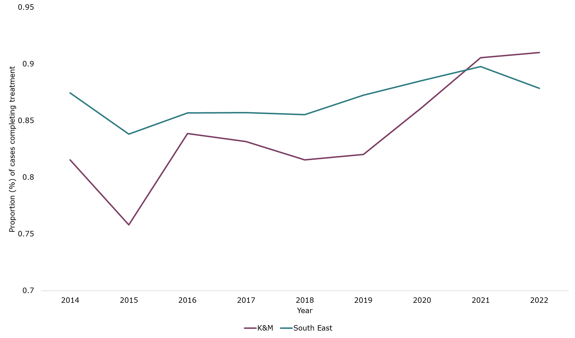

*Source: NTBS, prepared by KPHO (LS), November 2024*

*Note: does not include cases from 2023, rifampicin resistant, multi-drug resistant and CNS, spinal, miliary and cryptic TB disease cases*

**Recommendation**: TB services are achieving high treatment completion for active TB cases. The national action plan sets a target of 90% treatment completion for drug sensitive cases by 2026, K&M met this target in 2021 and 2022. Improvements should be targeted toward groups with lower treatment completion, including men, over 65-year-olds, UK-born cases, cases with white ethnicity and cases with at least 1 social risk factor.

**Recommendation:** Whilst the proportion lost to follow-up is low for K&M, this should remain a focus, given the risk of community transmission of TB in those who do not complete treatment.

The proportion of cases who completed treatment is shown for TB services in K&M in Figure 31. In 2022, KCHFT (East Kent) had 96.67% completion, KCHFT (North Kent) 94.74%, Medway 88.89% and MTW 87.50%. Medway’s treatment completion proportion has improved from a low of 58.33% in 2016.

**Figure 31 – Proportion (%) of cases who completed treatment, for TB services in Kent and Medway, 2014 to 2022**

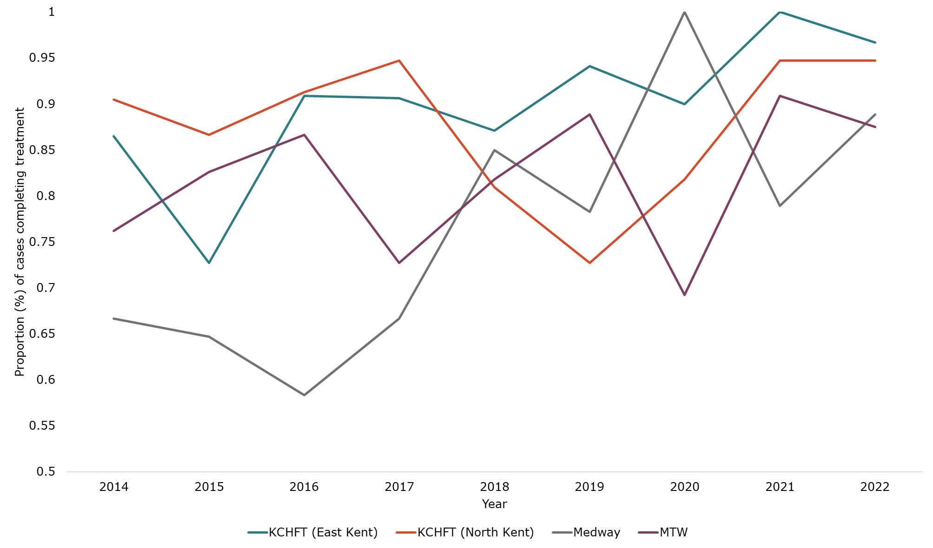

*Source: NTBS, prepared by KPHO (LS), November 2024*

*Note: does not include cases from 2023, rifampicin resistant, multi-drug resistant and CNS, spinal, miliary and cryptic TB disease cases*

Treatment completion according to various demographics were compared in Table 12. There were a lower proportion of cases completing treatment in men, over 65-year-olds, UK-born cases, cases with white ethnicity and cases with at least 1 social risk factor. No pattern was seen for deprivation.

The TB action plan sets a target of increasing by 5% a year the number of people with a social risk factor who complete treatment using 2020 to 2021 as a baseline[77]. The proportion of people with a social risk factor (SRF) completing treatment in 2020 in K&M was 68.75% and in 2021 was 86.67%. Given the small number of cases in K&M it is difficult to establish a baseline for this locally.

**Table 12 – number and proportion of TB cases completing treatment, according to demographic, for K&M cases, 2014 to 2022**

|  |  |
| --- | --- |
| **Demographic** | **Completed treatment, n (%)** |
| Female | 288/328 (87.80%) |
| Male | 383/474 (80.80%) |
| 0-14 yrs | 30/35 (85.71%) |
| 15 – 64 yrs | 557/634 (87.85%) |
| 65+ yrs | 84/133 (63.16%) |
| Not UK-born | 457/522 (87.55%) |
| UK-born | 213/272 (78.31%) |
| White ethnicity | 228/297 (76.77%) |
| Indian ethnicity | 137/158 (86.71%) |
| Black African ethnicity | 93/105 (88.57%) |
| No SRF | 555/659 (84.22%) |
| At least 1 SRF | 116/143 (81.12%) |
| IMD quintile 1 (most deprived) | 171/211 (81.04%) |
| IMD quintile 2 | 167/198 (84.34%) |
| IMD quintile 3 | 160/182 (87.91%) |
| IMD quintile 4 | 112/135 (82.96%) |
| IMD quintile 5 (least deprived) | 61/76 (80.26%) |

*Note: IMD ranking for the first hospital the case was treated at was used for cases with no fixed abode. Does not include cases from 2023, rifampicin resistant, multi-drug resistant and CNS, spinal, miliary and cryptic TB disease cases.*

**Recommendation**: To increase the number of cases with a social risk factor who complete treatment. A target of 5% a year is recommended by the national action plan, although K&M’s treatment completion rates (81% for those with a SRF vs. 84% for those without) are higher than the England average so this is unlikely to be appropriate. The completion rates should be monitored annually.

### **3.4.11 Treatment outcomes for CNS, spinal, miliary and cryptic TB disease cases**

Between 2014 and 2022, there were 93 cases with CNS, spinal, miliary or cryptic TB disease cases. The majority of cases completed treatment (77.42%), however 15.05% of cases died (Table 13). The proportion who died in the previous cohort of cases (non-rifampicin resistant, multi-drug resistant and CNS, spinal, miliary and cryptic TB disease cases) was 7.23%, suggesting poorer outcomes for those with CNS, spinal, miliary and cryptic disease.

**Table 13 – last recorded treatment outcomes for K&M cases with CNS, spinal, miliary or cryptic TB disease, 2014 to 2022**

|  |  |  |
| --- | --- | --- |
| **Treatment outcome** | **Number of cases** | **% of cases** |
| Completed* | 72 | 77.42% |
| Died | 14 | 15.05% |
| Lost to follow-up | 5 | 5.38% |

*Note: Categories with <5 cases have been hidden to ensure anonymity of data therefore total is <100%.*

*\*Completed = A TB patient who completed treatment without evidence of failure BUT with no record to show that culture results in the last month of treatment and on at least one previous occasion were negative, either because tests were not done or because results are unavailable.*

### **3.4.12 Deaths**

When considering all TB cases between 2014 and 2023, the last recorded treatment outcome was extracted. There were 76 recorded deaths in K&M during this time (76/1004, 7.57%), although it should be noted that outcomes for 2023 cases were often not recorded. The South East proportion of deaths overall was slightly lower at 4.20% (223/5311). In most deaths, the relationship between TB infection and death was unknown (Table 14). The median age at death was 69.5 years.

**Table 14: Relationship between TB infection and death, for all TB cases in K&M, 2014 to 2023**

|  |  |
| --- | --- |
| **Relationship between TB infection and death** | **Number of cases (n, %)** |
| Caused or Contributed to death | 16 (21.05%) |
| Incidental to death | 8 (10.53%) |
| Unknown | 52 (68.42%) |
| **Total deaths** | **76 (100.00%)** |

*Note: if a case died within 12 months of start of treatment and the death was linked to TB, the outcome may still show death even where the case was previously considered to have completed treatment.*

### **3.4.13 Treatment delay**

In K&M, between 2014 and 2023, 93.82% (942/1004) cases had data recorded on time from symptoms to treatment. Treatment delay is defined as >2 months between symptom onset and the start of treatment[78].

For all cases where data was recorded, between 2014 and 2023 in K&M, 26.96% (254/942) of cases were treated in <2 months, with 28.34% (267/942) experiencing a delay of 2-4 months, and 44.69% (421/942) experiencing a delay of over 4 months. The median duration from symptom onset to treatment was 103 days.

Treatment delay for pulmonary cases only is shown in Table 15, where delays were better than for all cases, but with still less than a third of cases treated in <2 months from symptoms onset. The median duration from symptom onset to treatment was 92 days.

**Table 15 – number and proportion (%) of pulmonary TB cases in K&M, by symptom onset to treatment duration, from 2014 to 2023**

|  |  |  |  |
| --- | --- | --- | --- |
| **Year** | **0-2 months*, n (%)** | **2-4 months**, n (%)** | **>4 months***, n (%)** |
| 2014 | 17/58 (29.31%) | 18/58 (31.03%) | 23/58 (39.66%) |
| 2015 | 21/58 (36.21%) | 14/58 (24.14%) | 23/58 (39.66%) |
| 2016 | 19/54 (35.19%) | 17/54 (31.48%) | 18/54 (33.33%) |
| 2017 | 19/71 (26.76%) | 17/71 (23.94%) | 35/71 (49.30%) |
| 2018 | 26/65 (40.00%) | 17/65 (26.15%) | 22/65 (33.85%) |
| 2019 | 18/59 (30.51%) | 19/59 (32.20%) | 22/59 (37.29%) |
| 2020 | 11/41 (26.83%) | 15/41 (36.59%) | 15/41 (36.59%) |
| 2021 | 14/42 (33.33%) | 12/42 (28.57%) | 16/42 (38.10%) |
| 2022 | 16/50 (32.00%) | 14/50 (28.00%) | 20/50 (40.00%) |
| 2023 | 12/46 (26.09%) | 17/46 (36.96%) | 17/46 (36.96%) |
| **Overall** | 173/544 (31.80%) | 160/544 (29.41%) | 211/544 (38.79%) |

*Note: does not include cases where symptom onset to treatment data was not recorded.*

*\*0-2 months = <61 days  
**2-4 months = 61 to 121 days  
***4+ months = >121 days*

For 2022, treatment delay for pulmonary cases is shown for K&M, the South East and England overall in figure 32. K&M has a lower proportion of pulmonary cases receiving treatment <2 months from onset and a higher proportion receiving treatment >4 months than both the South East and England.

**Figure 32 – Proportion (%) of pulmonary TB cases, by symptom onset to treatment duration, in Kent, Medway, the South East and England, 2022**

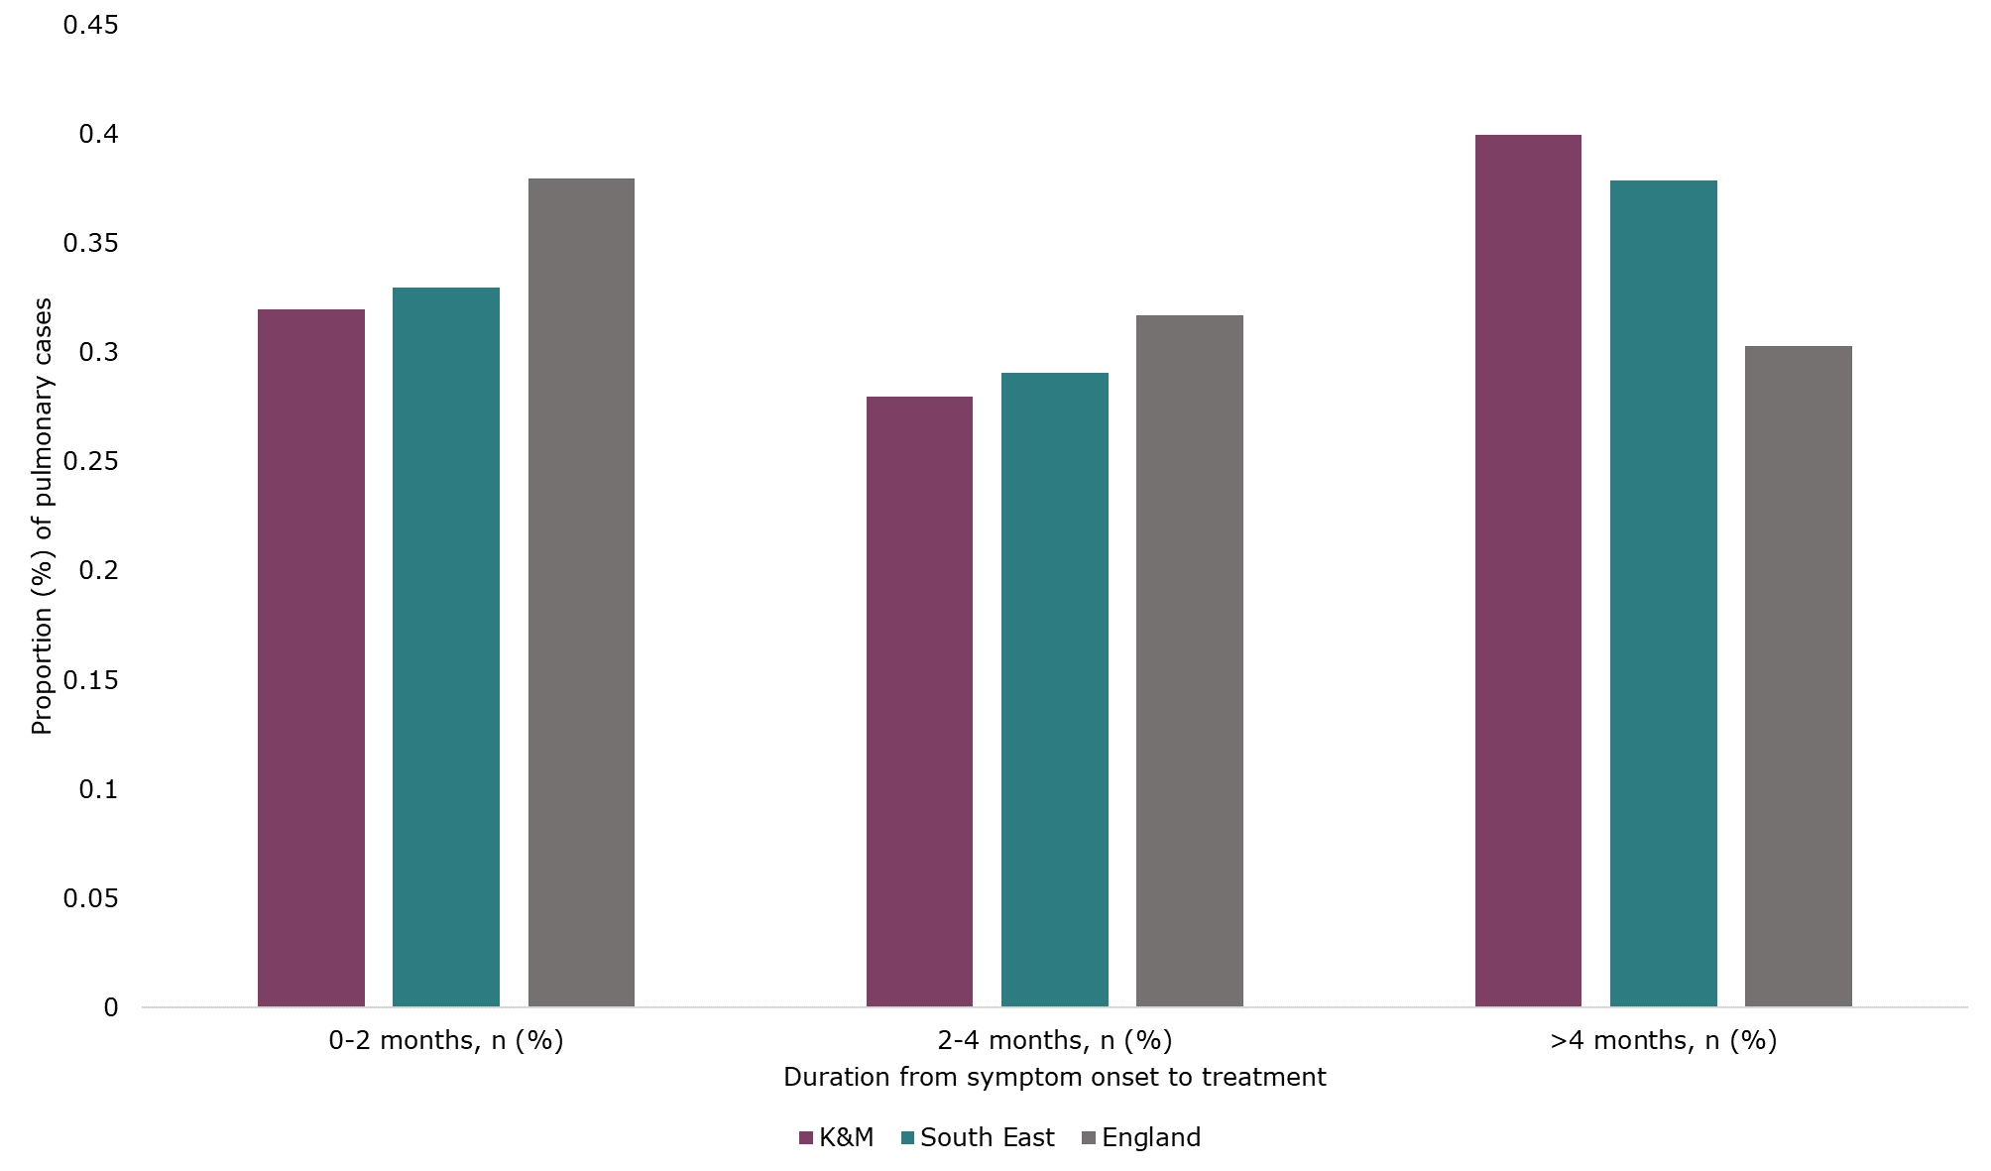

*Source: NTBS and TB treatment and outcomes, GOV.UK***[79]***, prepared by KPHO (LS), November 2024*

*Note: does not include cases where symptom onset to treatment data was not recorded.*

**Recommendation:** Ongoing review of cases with delays in cohort review meetings, to discuss and implement local actions to reduce delays. Annual monitoring of delay data to understand where delays occur and to review if local actions are effective.

**Recommendation**: Improve public awareness of TB symptoms, to encourage engagement with healthcare professionals and early diagnosis. This could take place as part of World TB Day communications.

**Recommendation:** To increase education and training about TB symptoms and signs to healthcare professionals to improve early diagnosis. Ideally a regular programme of education activities, including induction training for primary care, A&E and secondary care departments who may be involved in TB recognition and diagnosis. This may require increased resources and staffing for the TB services to deliver this routinely.

For all pulmonary cases in K&M, between 2014 and 2023, Medway was the TB service with the lowest median duration between symptom onset and treatment, at 77.5 days, and MTW had the longest duration at 119 days (Table 16).

**Table 16 – median duration from symptoms onset to treatment for pulmonary TB cases in K&M, by TB service, between 2014 and 2023**

|  |  |  |
| --- | --- | --- |
| **TB Service** | **Cases (n)** | **Median duration (days)** |
| KCHFT (East Kent) | 178 | 95 |
| KCHFT (North Kent) | 105 | 81 |
| Medway | 108 | 77.5 |
| MTW | 109 | 119 |
| Other | 44 | 92 |
| Total | 544 | 92 |

*Note: does not include cases where symptom onset to treatment data was not recorded. The TB service refers to the latest TB service listed as being responsible for the patient’s care. Therefore some patients may have previously been diagnosed or treated in a K&M TB service and subsequently moved or been transferred to another service outside of K&M, as represented by Other.*

Table 17 shows treatment delays and median durations between symptom onset to treatment for pulmonary TB cases in K&M, by various demographics. A higher proportion of delays over 4 months was seen for cases who were female, 65 years or older, UK-born, white ethnicity or with at least one social risk factor. There were large differences in median duration from symptom onset to treatment when considering age, place of birth and ethnicity. No pattern was seen for deprivation.

Factors associated with increased treatment delays over 4 months in England pulmonary TB cases between 2020 to 2022 were older age and UK born. Males had a decreased risk of treatment delay compared with females[80].

**Table 17 - treatment delays and median durations between symptom onset to treatment for pulmonary TB cases in K&M, by sex, age, place of birth, ethnicity and social risk factors (SRF), 2014 to 2023**

|  |  |  |  |  |
| --- | --- | --- | --- | --- |
| **Demographic** | **0-2 months, n (%)** | **2-4 months, n (%)** | **>4 months, n (%)** | **Median duration (days)** |
| Female | 65/210 (30.95%) | 60/210 (28.57%) | 85/210 (40.48%) | 95.5 |
| Male | 108/334 (32.34%) | 100/334 (29.94%) | 126/334 (37.72%) | 92 |
| 0-14 yrs | 20/32 (62.5%) | 7/32 (21.88%) | 5/32 (15.63%) | 42 |
| 15 – 64 yrs | 132/418 (31.58%) | 128/418 (30.62%) | 158/418 (37.80%) | 90.5 |
| 65+ yrs | 21/94 (22.34%) | 25/94 (26.60%) | 48/94 (51.06%) | 124 |
| Not UK-born | 113/320 (35.31%) | 99/320 (30.94%) | 108/320 (33.75%) | 78 |
| UK-born | 60/224 (26.79%) | 61/224 (27.23%) | 103/224 (45.98%) | 105.5 |
| White ethnicity | 67/264 (25.38%) | 76/264 (28.79%) | 121/264 (45.83%) | 105.5 |
| Indian ethnicity | 23/74 (31.08%) | 24/74 (32.43%) | 27/74 (36.49%) | 78.5 |
| Black African ethnicity | 26/67 (38.81%) | 24/67 (35.82%) | 17/67 (25.37%) | 76 |
| No SRF | 137/418 (32.78%) | 120/418 (28.71%) | 161/418 (38.52%) | 92 |
| At least 1 SRF | 36/126 (28.57%) | 40/126 (31.75%) | 50/126 (39.68%) | 96.5 |
| IMD quintile 1 (most deprived) | 61/162 (37.65%) | 44/162 (27.16%) | 57/162 (35.19%) | 93.5 |
| IMD quintile 2 | 37/142 (26.06%) | 51/142 (35.92%) | 54/142 (38.03%) | 92 |
| IMD quintile 3 | 36/118 (30.51%) | 30/118 (25.42%) | 52/118 (44.07%) | 101 |
| IMD quintile 4 | 27/81 (33.33%) | 22/81 (27.16%) | 32/81 (39.51%) | 97 |
| IMD quintile 5 (least deprived) | 12/41 (29.27%) | 13/41 (31.71%) | 16/41 (39.02%) | 107 |

*Note: does not include cases where symptom onset to treatment data was not recorded. IMD ranking for the first hospital the case was treated at was used for cases with no fixed abode.*

### **3.4.14 Other delays**

In the journey of a TB case from onset of symptoms to treatment, there are a number of stages whereby delays can occur. Number of days for the following stages are recorded in NTBS:

* Date of symptom onset to date of first presentation to any health service
* Date of first presentation to any health service to the date of referral to the TB service
* Date of referral to the TB service to the date of presentation to a TB service
* Date of presentation to a TB service to the date of diagnosis
* Date of diagnosis to the date of the start of treatment

**Diagnostic delay** is the time between the date of symptom onset to the date of diagnosis. The TB action plan[81] sets a target to reduce the national average delay in diagnosis in people with pulmonary TB by 5% per year from 75 days in 2019 to 56 days in 2025.

**Healthcare-related diagnostic delay** is the time between the date of first presentation to any health service to the date of diagnosis. The TB action plan[82] aims to reduce the national average healthcare diagnostic delay in people with pulmonary TB annually by 5% per year, using 2021 or 2022 as the baseline.

**Treatment delay** is the time between the date of symptom onset to the date of the start of treatment.

The median diagnostic delay in K&M was 99 days and healthcare-related diagnostic delay was 57.5 days (table 18), although it should be noted that this data was only available for 27.06% (272/1005) of all cases, and included both pulmonary and extra-pulmonary cases (whose diagnosis can take longer) so should be interpreted with caution. The figures from K&M indicate opportunities for raising awareness of TB symptoms in both the population and healthcare professionals to aid earlier diagnosis.

For England in 2022, the median diagnostic delay was 76 days, and the median healthcare-related diagnostic delay was 26 days[83]. The diagnostic delay has increased from 2019, which may be accounted for by the impact of COVID-19 on testing.

**Table 18 – median time (days) for each stage in a TB case’s journey from symptom onset to treatment, for K&M, between 2021 and 2023**

|  |  |
| --- | --- |
| **Stage** | **Median (days)** |
| Onset to first presentation | 25 |
| First presentation to referral received by TB service | 32 |
| Referral received to TB service presentation | 1 |
| TB service presentation to diagnosis | 2 |
| Diagnosis to treatment | 1 |
| Diagnostic delay | 99 |
| Healthcare-related diagnostic delay | 57.5 |
| Treatment delay | 102 |

*Note: does not included cases where data was not recorded for each stage. This data is from a different NTBS data extraction (extracted 20th August 2024), therefore denominators may have changed.*

**Recommendation**: Improve public awareness of TB symptoms, to encourage engagement with healthcare professionals and early diagnosis. This could take place as part of World TB Day communications.

**Recommendation:** To increase education and training about TB symptoms and signs to healthcare professionals to improve early diagnosis. Ideally a regular programme of education activities, including induction training for primary care, A&E and secondary care departments who may be involved in TB recognition and diagnosis. This may require increased resources and staffing for the TB services to deliver this routinely.

### **3.4.15 Summary of cohort review**

The clinical features of TB cases in K&M were similar to the South East overall with pulmonary TB making up 57.7% of cases and co-morbidities present in 17.4% of cases, with diabetes being the most common. The vast majority of cases with unknown HIV status were offered a HIV test. Nearly all cases were caused by Mycobacterium tuberculosis.

Culture confirmation was achieved in 80% of pulmonary TB cases in 2023, meeting the TB action plan target. However, in non-pulmonary cases culture confirmation proportions were lower than both the South East and England, and have decreased since 2021. Of those with a culture confirmation, 96.5% had drug susceptibility testing for all four first-line agents. There have only been 7 MDR-TB cases in K&M since 2014.

K&M TB services identify close contacts in a high proportion of pulmonary TB cases, compared to the South East average, although this remains below the TB action plan target. In 2023, 89% of cases had at least 1 contact identified, and 40% of cases had 5 or more contacts identified.

A high proportion of cases in K&M (71.6% in 2022) require enhanced case management and this proportion has risen since 2018. In comparison, in 2022 this was 41.6% in the South East and 43.2% in England. A higher proportion of cases were also offered DOT/VOT in K&M compared to the South East. This places a large burden on TB services, particularly for specialist TB nurses who provide the case management.

The proportion of drug-sensitive TB cases in K&M completing treatment has increased since 2022 and is now higher than the South East average. K&M met the TB action plan target of 90% treatment completion in 2021 and 2022. In 2022, the highest treatment completion proportions were seen in cases managed by KCHFT (East and North Kent). Medway’s treatment completion has improved since a low in 2016. Treatment completion was lowest in men, over 65-year-olds, UK-born cases, cases with white ethnicity and cases with at least 1 social risk factor.

Delays in both diagnosis and treatment are often seen in K&M, with less than one third of cases treated within 2 months of onset of symptoms, as recommended. A higher proportion of cases were treated >4 months after onset of symptoms in K&M compared to both the South East and England. Cases managed by MTW had the longest median duration from onset of symptoms to treatment, at 119 days. Longer durations were seen for cases over 65 years, UK-born cases and those of white ethnicity.

The median time between symptom onset and first presentation to a health service was 25 days, and the time between first presentation and the referral being received by a TB service was 32 days, indicating opportunities for raising awareness of TB symptoms and early diagnosis in both the population and healthcare professionals.

# **4.0 Service provision**

## **4.1 Commissioning**

Active TB treatment services are commissioned by the ICB. In Medway and West Kent, TB services are provided as part of the acute trust’s respiratory departments, with no specific commissioning from the ICB for TB in place. In North and East Kent, there is a community TB nurse-led service, commissioned through Kent Community Health NHS Foundation Trust (KCHFT). Patients also see consultants in the respiratory departments of acute trusts in North and East Kent.

When incidents occur with the requirement for mass screening, an external agency is commissioned by the ICB, such as Oxford Immunotec. There is no set policy for this currently in K&M. There is a separately commissioned service in place for TB screening and treatment at HMP Maidstone. Neonatal Bacillus Calmette-Guérin (BCG) vaccinations are commissioned separately by NHS England.

**Recommendation**: To establish a SOP and formal pathway for funding for TB incidents requiring mass contact screening, to ensure staff and other resources are available when required, as per the national service specification. Alternatively, to use the existing general MOU in place for incidents requiring a public health response.

For LTBI screening and treatment, there is limited capacity within pathology and long waits for treatment in some areas. KCHFT are also not commissioned to manage LTBI cases and support them with completion of treatment. There is no commissioning in place for LTBI screening of migrants from high-incidence countries.

**Recommendation**: To ensure commissioning is in place for LTBI case management by TB specialist nurses, to improve LTBI treatment completion rates.

**Recommendation:** Consider implementation of a LTBI testing programme for migrants from high incidence countries in K&M, to increase detection and treatment of LTBI and reduce the risk of reactivation to active TB.

For complex TB cases, there is a lack of pathways and funding agreements to support incentive payments, hardship funds and support those with no recourse to public funds (NRPF). Historically, these have been agreed on a case-by-case basis. An options appraisal for a South East memorandum of understanding (MOU) for provision of housing support to individuals with active pulmonary TB who have NRPF is underway. This proposes the adoption of a risk sharing agreement between LAs and ICBs. A cost comparison based on existing MOUs in the South East supported the provision of housing support which cost substantially less that keeping a case in hospital.

**Recommendation**: Continue to work on a risk sharing agreement between the LA and ICB for those requiring support who are homeless, with NRPF.

The national TB service specification outlines that clinical teams should be able to provide long term support for complex care cases, including referral and care pathways for mental health support. Social care support which can include a dedicated TB service social worker or outreach support worker should be provided in liaison with the LA. There is no specifically commissioned outreach service for groups at a higher risk of TB, with outreach activity only carried out by the TB services in each area.

**Recommendation:** Explore the possibility of funding for a dedicated TB service social worker to support K&M’s high number of complex TB cases to facilitate registration with GP practices, attendance at appointments for testing and completion of treatment. Funding for social workers to support enhanced case management is supported by NICE guidance and the national service specification.

**Recommendation**: Explore the commissioning arrangements to support treatment completion for socially complex cases, including support for travel costs, accommodation and food and provision of incentives or conditional cash transfers. Funding for incentives to support enhanced case management is supported by NICE guidance and the national service specification.

For TB services in acute trusts, funding pathways are unclear. Providers have also raised concern about insufficient funding to deliver TB services in line with the national TB action plan[84]. There is a lack of consistent pathways across the system and a lack of detailed service specifications meaning varying interpretations of what is expected from providers. Key performance indicators are in place for KCHFT, but not for the other TB services given they are not specifically commissioned for TB.

**Recommendation**: Development of detailed service specifications for each TB service to improve clarity for providers on what TB service provision is under their remit. Alternatively to consider a single commissioned TB service across K&M to ensure consistency and an equitable service across the area.

**Recommendation**: Explore the commissioning arrangements for TB services within acute trusts to ensure funding streams specifically for TB are in place.

Given the concern about the cohesiveness of the system for TB in K&M and inequality in provision of TB services across the ICB area system workshops have taken place to review this. Work is underway to ensure services are aligned with the national TB action plan and national service specification. A local service specification will be developed, with the aim of addressing the gaps outlined above. A local TB action plan for K&M will also be developed.

**Recommendation:** To champion TB via leadership within the local authority, through the health protection board, health and wellbeing board, and inclusion of TB in the Joint Strategic Needs Assessment (JSNA).

## **4.2 Acute and community TB services**

### **4.2.1 Overview of services**

In K&M, there are four acute NHS providers and an NHS community provider for TB services (Table 19 and Figure 33). As shown in Figure 33, whilst there are hospitals located in the K&M districts with the highest TB incidence, there are only two sites in East Kent which is a large geographical area. This may reduce accessibility to hospital for TB cases and their contacts.

**Recommendation:** In East Kent in particular, access to hospitals may be difficult due to the large geographical area covered by its two hospitals. Financial and social support should be in place for cases who may find it difficult to travel to hospital sites in order to reduce DNA rates.

**Recommendation**: To explore the feasibility and need for community TB clinics in East Kent.

**Table 19: NHS Trusts and hospital sites with TB services, within K&M**

|  |  |
| --- | --- |
| **NHS Trust** | **Hospital Sites** |
| Dartford and Gravesham NHS Trust (DGS) | Darent Valley Hospital (DVH) |
| East Kent Hospitals University NHS Foundation Trust (EKHUFT) | William Harvey Hospital (WHH)  Queen Elizabeth the Queen Mother Hospital (QEQM) |
| Medway NHS Foundation Trust (Medway) | Medway Maritime Hospital |
| Maidstone and Tunbridge Wells NHS Trust (MTW) | Maidstone Hospital  Tunbridge Wells Hospital |
| Kent Community Health NHS Foundation Trust (KCHFT) – North Kent | Community-based  Gravesham Community Hospital |
| Kent Community Health NHS Foundation Trust (KCHFT) –East Kent | Community-based |

**Figure 33: three-year average annual TB incidence rate by LTLA for 2021 to 2023, with location of TB service hospital sites in Kent and Medway**

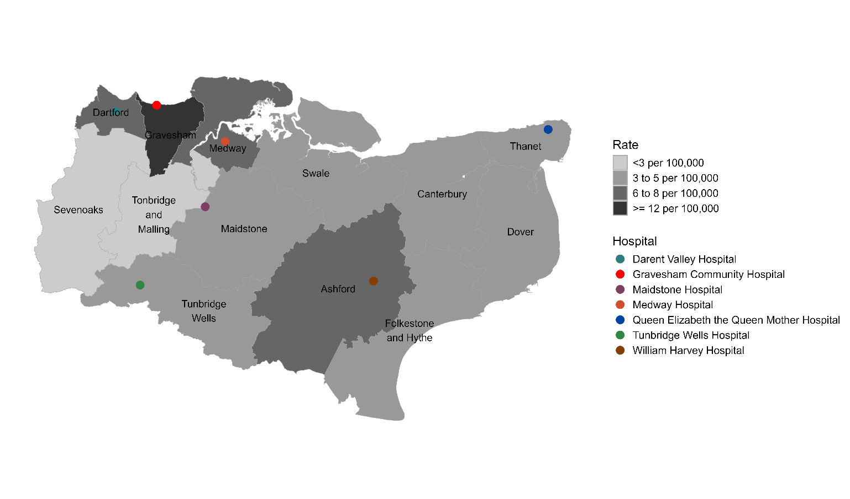

Both consultants and TB nurse specialists work within the same acute trust in Medway and MTW. The TB service is nurse-led at both, with support from consultants. In North and East Kent, TB cases will see physicians at DGS or EKHUFT for diagnosis and treatment. The KCHFT community service is nurse-led, and TB nurse specialists are involved in case management of active cases to ensure compliance with treatment and contact screening. All services have multi-disciplinary team (MDT) meetings to discuss cases.

Hospital TB clinics are summarised in Table 20. Information was not available for every clinic site. Clinic sites were felt to have generally good transport links in Medway and MTW, although car park congestion was raised in Medway. All services see inpatients.

**Table 20: Summary of clinics at each hospital**

|  |  |  |  |  |  |
| --- | --- | --- | --- | --- | --- |
|  | **Darent Valley** | **William Harvey** | **Queen Elizabeth the Queen Mother** | **Medway Maritime** | **Maidstone** |
| **Nurse-led or Consultant-led** | Consultant-led. KCHFT TB nurses may attend to support a patient. | Consultant-led. KCHFT TB nurses may attend to support a patient. | Consultant-led. KCHFT TB nurses may attend to support a patient. | Nurse-led, with respiratory consultant support. | Mostly nurse-led, but consultants lead some clinics. 2 clinic slots for consultant per week but no cover if on annual leave. |
| **Clinic Summary** |  | 1 adult clinic / week  1 paediatric clinic / month |  | Dedicated TB clinic for nurses, general respiratory clinic for consultants. | All are dedicated TB clinics. |
| **Clinic Days/Times** |  |  |  | 1 clinic/week:  Wednesdays PM Patients are seen on ad hoc arrangements – open door policy. | 3 clinics/week* + 1 clinic/week for HMP (prison population):  Mondays 8am - 12pm (HMP)  Tuesdays 1 - 4pm  Wednesdays 8 – 11am  Fridays 8am – 12pm (often overbooked) |

*currently reduced from 4 clinics/week due to a new member of staff

Every case with active TB is given a named case manager across all services. KCHFT have recently started a new TB clinic run by nurses at Gravesham Community Hospital. All services provide home visits – KCHFT routinely sees active TB cases starting treatment at home, MTW and Medway see cases at home, according to need.

Paediatric cases are managed by general paediatrics in conjunction with adult TB nurses. Although paediatric case numbers are low in K&M, NICE guidelines advise that paediatric trained nursing staff should manage cases where possible. General paediatricians should have advice from specialised clinicians which is available via the London hospitals[85].

**Recommendation**: To review paediatric case management to ensure that paediatric trained nursing staff are available for cases, in line with NICE guidance and the national service specification.

### **4.2.2 Referrals**

Across the TB services, formal referral pathways and methods varied (Table 21). Not all services have direct referrals in place to the TB service. The national service specification requires direct referral to TB services to be available through primary care, A&E, self-referral and direct access TB clinics. Pathways should be in place for referrals from other non-TB services.

**Recommendation**: Review referral pathways for TB services to ensure clear and easy access pathways are in place for referrals from primary care, A&E, histopathology and radiology in particular.

In MTW referrals are triaged by the TB nurses. In Medway referrals are filtered out from the secretaries to either consultants or nurses. Some referrals also come from self-referral or within the team as a result of contact screening.

**Table 21: Formal pathway for referrals, by TB service**

|  |  |  |  |  |
| --- | --- | --- | --- | --- |
|  | **KCHFT North Kent + DGS** | **KCHFT East Kent + EKHUFT** | **Medway** | **MTW** |
| **Primary Care** | No urgent access pathway | Urgent access via email | Yes | No pathway – tend to refer via general respiratory, TB generic email or GP phone call |
| **A&E** | No | No | Yes | Yes – phone call |
| **Radiology** | No | No | Yes | Yes – phone call |
| **Microbiology** | Yes | Yes | Yes | Yes – email or phone call |
| **Histopathology** | No | No | Yes | No |
| **Other acute** | No | No | Yes | Formal pathway for ophthalmology |
| **Paediatrics** | Email to paediatrics consultants | Email to paediatrics consultants and referral form | Directly discussed with paediatric consultants | No |

### **4.2.3 Delays**

Delays can occur at several points in the patient pathway from onset of symptoms to completion of treatment. Listed in Table 22 are TB service insights into why delays may occur, along with recurring themes from the TB network’s cohort review logs.

**Table 22 – TB service insights into reasons for delays**

|  |  |
| --- | --- |
| **Point in the patient pathway** | **Possible reasons for delays** |
| Symptom onset to healthcare presentation | * Poor access to GPs – difficulty getting appointments or being able to take time off work. * Lack of awareness of TB symptoms. * Poor prioritisation of own health. |
| Healthcare presentation to referral to TB service | * Lack of awareness of TB symptoms and signs in primary care – mistaken for chest infection, asthma or COVID-19. * Lack of awareness of TB symptoms and signs in secondary care – patients are seen by other specialties first introducing a delay in diagnosis. * TB not being picked up or reported clearly on radiology reports. * Lack of a formal referral pathway. * Poor knowledge of how to refer. |
| Referral to TB service and treatment | * Acute trust errors – lost referrals or incorrect triaging. * Patients do not attend (DNA) – around 28% DNA rate in KCHFT for example. All are rebooked but the majority continue to DNA. * Wait times for cases to be seen in clinic. * Interrupted care due to cases going abroad. |

All TB services have access to awareness raising materials and resources, including TB alert[86] and national TB team webinars. All TB services provide teaching or training to other health and social care professionals; however, this was generally done on an ad hoc basis. Health professionals receiving training included hospital clinicians, primary care, health visitors, midwives, social care and voluntary organisations and these were delivered via presentations given face-to-face or virtually. Only KCHFT has a website which provides information on how to refer to the service[87].

**Recommendation**: To consider introducing a centralised website for K&M TB services to increase awareness and easy access to referral pathways for healthcare professionals and professionals working with high-risk populations. If no centralised system, ensure information on access to TB services is available on all TB services websites.

**Recommendation**: To increase education and training about TB symptoms and signs to healthcare professionals to improve early diagnosis. Ideally a regular programme of education activities, including induction training for primary care, A&E and secondary care departments who may be involved in TB recognition and diagnosis. This may require increased resources and staffing for the TB services to deliver this routinely.

Diagnostic TB cultures take place at DVH (for North Kent and Medway) and MTW (for East Kent and MTW). Whilst smears and polymerase chain reaction (PCR) tests are available when required, there can be delays in diagnosis due to samples being couriered and tested in neighbouring trusts for Medway and East Kent. As tests cannot be done rapidly in-house in Medway and East Kent, smears can take up to 5 days and PCR tests up to 7 days to receive results in these trusts. A microbiology audit for TB by UKHSA is underway which may provide further understanding of resources, staffing and areas for improvement in the South East.

**Recommendation**: To explore the ability to do local TB diagnostic testing in Medway and EKHUFT to reduce delays in diagnosis and risk of infection control issues within acute trusts. If this is not possible, to understand how the process of transporting and testing samples in neighbouring trusts, along with communicating results can be improved.

**Recommendation**: To review the findings of the UKHSA TB microbiology to highlight areas for improvement.

The TB service specification sets an expectation that suspected pulmonary TB patients are assessed within two working days of referral and all patients with suspected TB seen within two weeks. Reducing waiting times for active TB cases has been prioritised by all services and is often achieved by providing ad-hoc appointments outside of regular clinic times. MTW promptly discusses all cases at a MDT meeting allowing investigations to be actioned and an initial appointment with a TB nurse to be booked. Consultant appointment delays have reduced by initiating formal consultant appointments for TB cases each week. EKHUFT have managed timely appointments for active TB cases, but this has been achieved by consultants often working during their annual leave to ensure cases are seen. There are long delays for LTBI appointments in North and East Kent, with patients being see in general respiratory clinics instead.

**Recommendation**: To review consultant capacity for managing acute TB cases. To increase capacity for LTBI appointments for treatment in acute trusts, or commission community services to deliver LTBI treatment, to reduce delays, particularly in North and East Kent.

Whilst there was good awareness of possible reasons for delays, capacity within the workforce and lack of resources to address the delays were mentioned as significant barriers.

### **4.2.4 Contact screening**

In all services, contact screening and treatment takes place for pulmonary or laryngeal TB cases, according to NICE guidelines and this includes household and non-household contacts, depending on the case. For extra-pulmonary cases, contact screening takes place for household contacts in Medway, and for children of the index case in KCHFT.

Screening is done according to NICE guidelines, using IGRA or Mantoux tests (with a chest X-ray if indicated) and can be done either in clinic or during a home visit. Mantoux negative contacts of patients with pulmonary or laryngeal TB, who are under 35 years, are offered BCG vaccination in all TB services, although in KCHFT this is only given to children up to the age of 16 years. There is a lack of data on the proportion of contacts eligible for screening who attend for testing. Reasons for contacts not being tested included lack of perceived contact with the active case, work commitments, transport issues getting to diagnostic tests or due to a lack of support for new entrant migrants.

No standard operating procedure (SOP) is in place for managing incidents or outbreaks. Stand-alone funding has been provided in the past, via the ICB or the local authority but there is no formal pathway for this.

**Recommendation**: To establish a SOP and formal pathway for funding for TB incidents requiring mass contact screening, to ensure staff and other resources are available when required, as per the national service specification. Alternatively, to use the existing general MOU in place for incidents requiring a public health response.

### **4.2.5 High risk populations**

A lack of formal pathways are in place for referrals, testing and treatment of high-risk populations as summarised in Table 23. TB services do receive referrals from other organisations despite there being no formal pathway in place, facilitated by outreach work and in KCHFT through connections with other community-based services. However, it is unclear if all outreach services in K&M are aware of how to access support for TB testing and referrals. TB in high risk populations is discussed further in Section 5.0.

**Recommendation:** To ensure all outreach organisations in K&M receive training or communications on symptoms of TB and referral pathways to services, with an aim of embedding learning into organisations to ensure TB is an ongoing priority.

**Recommendation**: To raise awareness of the signs and symptoms of TB and referral pathways amongst staff working in important local authority teams for TB such as housing, social care and children’s services. This could be in the form of email reminders or during existing meetings or training sessions.

**Table 23 – Formal pathways in place for high-risk populations, by TB service**

|  |  |  |  |
| --- | --- | --- | --- |
|  | **KCHFT** | **Medway** | **MTW** |
| **Asylum-seekers and refugees** – via reception centres or accommodation settings | Screening for UASC done during the initial health assessment and some testing by primary care. Refer to TB service if positive. | No – except for UASC | No – except for UASC |
| **Prison population** | n/a – none in the area | Yes | Yes |
| **Homeless population** – via organisations providing support for homeless people | No | No | No |
| People with **no recourse to public funds** | No | No | No |

*Note – UASC = unaccompanied asylum seeking children*

Some TB services do outreach work, by working with the local voluntary sector and sometimes meeting patients in public locations or in voluntary organisation buildings. However, there is no regularly commissioned service in place across the whole of K&M for active case finding and supporting IHGs, such as the UCLH Find & Treat service[88]. Use of this service in the past has helped identify cases part of a cluster and as part of specialist screening events in Canterbury, Thanet and Margate. A commissioned active case finding service is likely to be of benefit given the high numbers of socially complex TB cases identified in K&M.

**Recommendation:** To consider introducing active case finding outreach services in K&M, such as the UCLH Find & Treat service (and other examples can be found in the [TB IHG toolkit](https://www.gov.uk/government/publications/tackling-tb-in-inclusion-health-groups-toolkit-for-a-multi-agency-approach/tackling-tb-in-inclusion-health-groups-a-toolkit-for-a-multi-agency-approach)), to identify more undiagnosed TB cases, particularly in inclusion health groups. This is likely to be of benefit, given the high proportion of socially complex cases identified in K&M.

KCHFT have good links with housing services, social care, substance misuse services, probation services, food banks, rough sleeper services, migrant help, social prescribing and mental health support given they are a community-based trust. Complex care nurses have also supported with case management for high-risk TB cases. This is less accessible at the acute trusts, although Medway mentioned a direct link to some services and the ability to offer food parcels via local charities. Lack of sufficient support for new entrant migrants, UASC and the homeless population is a particular issue. Routine access to translation services and written information in other languages would also be of benefit.

**Recommendation**: To ensure links with local outreach services are in place in MTW and Medway to support management of high-risk cases.

**Recommendation**: To explore Medway’s access to on-site interpreters to support with management of cases and ensure the service’s access to interpreters is in line with the other services in K&M.

None of the TB services have funding for incentives to support enhanced case management and help cases complete their treatment. TB nurses will sometimes self-fund small support items such as food, coffee and toiletries.

Case management RCN toolkits are used by MTW. It was unclear if this toolkit is currently in use in the other TB services.

**Recommendation**: To ensure access to RCN case management toolkits and other training resources in all TB services.

### **4.2.6 Latent TB infection (LTBI)**

Undiagnosed and untreated LTBI cases in K&M are at risk of progression to active TB, which contributes to community transmission and is a public health concern. Reactivation of LTBI to active TB is approximately 5 to 15% within the first 2 to 5 years following infection, but this is higher with comorbidities such as HIV infection[89]. Successful treatment of LTBI involves three to six months of daily medication making compliance with treatment in people who are not well supported an issue.

LTBI cases may be picked up through contact screening, occupational health screening or via testing for people starting biologic treatments. LTBI screening for new-entrant migrants takes place in some areas of the country but is not currently available in K&M, this is discussed further in Section 5.1.3. Treatment and follow-up for LTBI varies across the TB services. There is a lack of data on the number of LTBI cases managed and treatment completion rates across K&M.

**Recommendation**: To ensure regular data collection for the number of cases with LTBI and treatment completion rates in K&M.

In MTW and Medway, LTBI cases are managed by the TB nurses. In MTW most cases are seen in clinic, in Medway by phone call. Between 10-30% of cases require enhanced case management. In Medway, treatment completion rates were reported as 90-100%, however those having LTBI treatment are not formally reviewed at the end of treatment.

In North and East Kent, KCHFT are not commissioned to manage LTBI cases and do not have capacity to do so. Acute trusts start the treatment, but most cases are not supported during treatment or followed up, and there is no nursing capacity within the acute trusts to do so. Sometimes KCHFT TB nurses will support UASC or children in the household of an active case, however they are not commissioned to do this work. The only support provided is minimal, usually via leaflets or telephone advice.

**Recommendation**: To ensure commissioning is in place for LTBI case management by TB specialist nurses, to improve LTBI treatment completion rates.

Reasons for LTBI cases not starting treatment included pregnancy, breastfeeding, social and work commitments limiting ability to attend appointments. Reasons for LTBI cases not completing treatment included side effects, drug interactions, length of treatment courses, forgetting to take medications and stigma.

In all services, screening for LTBI in people starting biologics is done by the service providing the biologics, with onward to referral to TB services in the case of a positive result. Occupational health screens new patient-facing staff using IGRA tests.

MTW also provide a screen and treat service at HMP Maidstone, which is a separately commissioned service.

### **4.2.7 Staffing**

Staffing is summarised in Table 24. There are no current vacancies in any of the TB services, but gaps in the paediatric service were highlighted in MTW. All four services did not think clinical staffing was sufficient. Reasons for this included lack of staffing during times of short-term sickness or annual leave, increasing complexity of patients, large numbers of cases requiring incident management or big screening events and an increase in occupational health and migrant referrals.

A suggestion for improvement was employing a Band 4 staff member who could assist in community activities or handle the phone referrals to free up nursing time. In East and North Kent, KCHFT felt it would be preferable to have dedicated TB/ infectious disease consultants working within the service.

**Recommendation**: To consider expanding the TB specialist nursing service to include staff that can support with outreach activities and DOT, considering the number of cases requiring enhanced case management in K&M.

**Recommendation**: In KCHFT, consider recruitment of a dedicated TB or infectious disease consultant to work within the service.

There are no cross-cover arrangements between the services, and this was suggested to support with staffing sickness or annual leave, or for incident screening.

**Recommendation**: To consider how the K&M TB services can work together to provide cross-cover arrangements in times of reduced capacity of the workforce. Alternatively to consider a single commissioned TB service across K&M to ensure consistency and an equitable service across the area.

Admin staff often support both BCG vaccination work and general respiratory pathways. A lack of dedicated admin staff for TB work was raised.

**Recommendation**: To review commissioning and service specifications for respiratory services in acute trusts to include dedicated time for TB work for consultants and administrative staff.

**Table 24 – summary of consultant, nursing and administrative staffing, by TB service**

|  |  |  |  |  |
| --- | --- | --- | --- | --- |
|  | **KCHFT North Kent + DGS** | **KCHFT East Kent + EKHUFT** | **Medway** | **MTW** |
| **Consultants** | 2 consultants | 2 consultants | 1 consultant | 1 lead consultant (0.5PA per week for TB/lung cancer) |
| **TB nurses** | 2x Band 7 – 1x clinical lead (0.8 WTE), 1x operational lead (0.85 WTE)  N Kent – 3x band 6 (2.2 WTE)*  E Kent – 3x band 6 (2.36 WTE) and 1x band 5 (0.88 WTE)* | | 2x Band 7 | 1x Band 7  1x Band 6 development post (new staff member) |
| **Admin staff** | 1x Band 4 (1.0 WTE)*  Band 3 (2.8 WTE)* | | 1x Band 4 pathway administrator for the respiratory consultant* | 1x Band 4 |

*includes time spent doing BCG vaccination work

All TB services have an induction programme for new starters. Student nursing placements are available at Medway and KCHFT. Regional TB nurse peer support meetings are attended by all TB services.

**Recommendation**: Continue participation by TB services at regional meetings to encourage peer support.

Access to a training budget was available at KCHFT and Medway. At MTW, there is a lack of study time available due to lack of staff, and support for funding training is not available. At KCHFT, a lack of opportunity and progression within the service was acknowledged, along with concerns about the future sustainability of the specialist nursing team.

**Recommendation**: To provide opportunities and resources for training for TB specialist nurses, to support career progression and future-proof the service.

### **4.2.8 Resources**

Most hospitals have sufficient single/side rooms to isolate infectious patients. Negative-pressure rooms are available in MTW (1 in Tunbridge Wells hospital A&E, and 1 in Maidstone hospital on ward 21). Insufficient clinic room space in MTW and EKHUFT, along with inappropriate ventilation in EKHUFT clinics were reported. Availability of X-ray and blood test facilities in the community varies, with no availability reported in MTW. All TB services have access to laptops and mobile phones to join meetings and conduct virtual clinics.

**Recommendation**: To ensure there is sufficient clinic space for TB clinics, particularly in East Kent and MTW to facilitate face-to-face appointments where required and minimise risk of transmission.

**Recommendation**: Continue to ensure good access to technology required by clinical teams for remote working, as developed during the COVID-19 pandemic.

Shortages in TB drugs have meant shorter supplies given to patients and an increased pill burden for patients. In KCHFT there have been issues with prescribing due to patients being managed by different NHS trusts. Lack of access to community dietitians and physiotherapists in Medway was also raised.

**Recommendation**: Monitor for ongoing shortages in TB drugs that affect pill supplies for patients and feed this back to the TB network.

Use of directly observed therapy (DOT) and video observed therapy (VOT) varies between TB services (Table 25).

**Table 25 - Summary of DOT and VOT delivery, by TB service**

|  |  |  |  |
| --- | --- | --- | --- |
|  | **KCHFT** | **Medway** | **MTW** |
| **DOT used?** | No | Yes | Yes |
| **DOT delivery** | n/a | Delivered by TB nurses at  home or at the hospital. Patients prefer use of VOT. | Delivered by TB nurses or the patient’s significant other (if deemed competent) at  home or in the workplace. VOT now used more frequently. |
| **DOT availability** | n/a | Not always available due to staffing. | All cases requiring DOT are offered it, but this may not be in place at weekends and BHs due to staffing. |
| **VOT used?** | Yes | No | Yes |
| **VOT delivery** | Delivered by UCLH Find and Treat | n/a | Delivered by TB nurses and UCLH Find and Treat |
| **VOT availability** | All cases requiring VOT are offered it. | n/a | All cases requiring VOT are offered it. |
| **Commissioning** | Funded by the ICB. | DOT is included within the TB service work. VOT is currently not commissioned but the service is in the process or acquiring it. | DOT is included within the block contract for the respiratory service. |

**Recommendation**: To ensure VOT is commissioned for Medway TB services.

**Recommendation**: To ensure there is enough funding for DOT/VOT in existing contracts to support the high number of complex TB cases in K&M.

### **4.2.9 Multi-drug resistant TB**

MDR-TB cases are managed using British Thoracic Society (BTS) guidelines[90], and via shared care with tertiary referral centres, such as Imperial College Healthcare NHS Trust. There is a regional MDR-TB meeting, providing advice for the management of these cases.

### **4.2.10 BCG provision**

The BCG vaccination programme in the UK aims to immunise those at increased risk of exposure to TB infection[91]. Vaccinations are given to infants living in areas of the UK where the incidence is high (>40/100,000) or with parents or grandparents born in countries of high incidence. Individuals under 16 years of age may also be vaccinated if they meet eligibility criteria and were not vaccinated as an infant, or if they are close contacts of pulmonary or laryngeal TB cases. Healthcare workers with direct contact with TB patients should also be vaccinated, along with consideration for vaccination for other occupational groups at high risk (e.g. staff working with homeless people). New entrants to the UK who are 16 to 35 years old and Mantoux negative and from high-incidence counties (>500 per 100,000) should also be vaccinated[92].

In 2022/23, both Kent and Medway local authority areas achieved a slightly higher coverage (%) than for the South East overall (Table 26). Medway had a higher coverage than for England overall. The TB action plan currently sets a target of 80% uptake at 4 weeks for those eligible[93].

**Recommendation**: To explore with providers the reasons why BCG vaccination may not be given, in order to develop a strategy to increase uptake in K&M.

**Table 26: BCG vaccine coverage (%) at 3 months of age for eligible children in K&M, South East and England, 2022/23[94].**

|  |  |  |
| --- | --- | --- |
| **Area** | **Number vaccinated** | **Coverage (%)** |
| Medway | 565 | 71.5 |
| Kent | 2,003 | 67.3 |
| South East | 13,399 | 64.8 |
| England | 109,029 | 68.8 |

K&M is not a high incidence area, and therefore vaccination is only routinely given to children who meet the eligibility criteria. In Medway, East Kent and North Kent, TB services deliver the infant BCG vaccination programme, whereas in MTW this is delivered by paediatrics (Table 27). There are clear pathways in place for infants, but less so for children older than 1 year.

**Table 27 – summary of BCG vaccination by TB services in K&M**

|  |  |  |  |
| --- | --- | --- | --- |
|  | **KCHFT** | **Medway** | **MTW** |
| **Infants** | TB service – subcontracted by maternity services. Different service specification and established SOP available. | TB service. Established SOP available. | Paediatrics. |
| **Under 16-year-olds** | Not commissioned to provide BCG in over 1 year-olds, unless contacts of respiratory TB. However, can usually see those eligible and have support from health visitors and school age immunisation team. | TB service. Established SOP available. | No formal pathway, TB nurses will do opportunistic vaccinations. |

### **4.2.11 Perspectives – consultants and specialist nurses**

TB services were asked what is working well within their service, and what are the significant issues.

KCHFT reported good working relationships between TB nurses, respiratory and microbiology consultants and treatment outcomes for active TB amongst the best in England. Medway reported good clinical management within the service.

The significant issues reported often overlapped between trusts:

* Lack of formal commissioning for TB or dedicated time for respiratory physicians to attend TB specific events
* Lack of capacity for prompt appointments in the acute trusts in North and East Kent
* Heavy caseloads due to socially complex patients, with a lack of social worker support, high use of interpreters required, and often patients that are not registered with a GP with no support to do so
* Lack of capacity to respond to large mass screening events
* Lack of TB dedicated funds to help support patients
* Lack of VOT funding in Medway

Several changes have been made to help improve services. This included training of a Band 6 nurse to become Band 7 in Medway, support from other services (e.g. sexual health) within the Public Health directorate in KCHFT and having a weekly MDT in MTW to allow initiation of investigations and consultations with nurses whilst waiting for a consultant appointment.

Several changes are planned, including setting up a VOT service in Medway, and employing consultants within KCHFT to streamline the patient experience. TB services in K&M have also been working with the ICB and Local Authorities to review TB provision across K&M, as discussed in Section 4.1.

### **4.2.12 Perspectives – service users**

TB services were asked if they collect any insights of feedback from service users. All TB services have done so, via electronic surveys.

Generally, feedback has been positive, but it has been difficult to get enough replies.

Some examples of responses from North and East Kent are:

“Everything has been excellent from the 1st appointment to ongoing”

“The specialist nurse was very professional, very knowledgeable and explained the treatment procedures and side effects efficiently. She was also very empathetic.” “My experience has been very satisfactory.”

“Helpful, friendly and professional”

“There isn't anything to make it better the lady was really kind and caring”

“Helpful and the advice very good”

“The [specialist nurse] was a god send we couldn't of gone through this without her. She went above and beyond to help not only me but my whole family threw this hard time”

Issues were raised with the accessibility of survey methods, given they were sometimes only available in English and required IT skills meaning some patients could not access them. Feedback has also been asked for in person in MTW, and this was generally positive, although TB services felt this was likely to be biased.

**Recommendation**: To consider K&M wide patient satisfaction surveys, using an appropriate methodology that accounts for language and technology barriers and reduces biased feedback, to support improvements in the quality of TB service patient-centred care.

### **4.2.13 Summary of acute and community TB services**

Hospitals are broadly located in geographical areas of high TB incidence, but the two hospital sites in East Kent cover a large area which may introduce accessibility issues for TB cases. There are high DNA rates (28% in KCHFT) for cases attending clinics.

Referral pathways to TB services vary between areas. Formal pathways directly to TB services from primary care, A&E, radiology and histopathology are not in place in several areas. This can contribute to delays in diagnosis and treatment, along with delays caused by cases being referred initially to other specialties. KCHFT has a website which provides information on how to refer to the service.

There was a recognition amongst all TB services of a lack of awareness of TB signs and symptoms in both the population of K&M and healthcare professionals. All services provide teaching or training to healthcare professionals in K&M; however, this is often ad-hoc and not as part of a regular programme.

Diagnostic delays are introduced, particularly in Medway and East Kent, due to tests being couriered and processed in neighbouring trusts, which has implications on infection prevention control in hospitals.

Timely appointments in acute trusts are generally achieved for active TB cases, often by providing ad-hoc appointments outside of clinic times. However, this can be affected by a lack of cover during times of annual leave, and result in consultants attending TB clinics during their leave. MTW have a weekly MDT allowing cases to be discussed and investigations actioned whilst waiting for an initial consultant appointment. There are long delays for LTBI cases, particularly in North and East Kent. Capacity within the workforce and lack of resources to address delays were acknowledged as barriers.

Whilst the cohort review data shows that TB services in K&M are achieving better identification of contacts than the South East, there is a lack of data on the proportion of contacts eligible for screening who attend for testing. Lack of support (particularly for new-entrant migrants) and transport issues were identified as barriers. All services conduct home visits for active TB cases (KCHFT routinely, and Medway and MTW when required) which does allow contact screening at home to take place. There is no SOP or formal pathway for funding available for incidents requiring mass contact screening.

Some outreach work is done by TB services, however there is no service in place for finding and treating inclusion health group patients who may be at a higher risk of TB and less likely to present to services. Referral and treatment pathways are in place for prisons in K&M, but not for other high-risk populations. KCHFT have good links with services to support high-risk populations, given they are a community-based trust. A lack of social care support for K&M’s high number of complex cases was identified by all services. None of the services have funding for incentives to support enhanced case management and help cases complete their treatment. Sometimes nurses will self-fund small support items, such as food, coffee and toiletries.

LTBI cases are managed by the TB service in MTW and Maidstone. In North and East Kent, the TB specialist nurses work in a separate NHS trust to the consultants. Here, cases are started on treatment by consultants in the acute trust, but KCHFT TB specialist nurses are not commissioned to manage LTBI cases and do not have the capacity currently to do so. This means cases are not supported to complete their treatment. There is a lack of data around completion rates, and it is unclear if cases are formally reviewed at the end of their treatment across all services in K&M.

Good clinical management and working relationships between TB nurses and consultants are in place and contribute to the excellent treatment outcomes for active TB in K&M. A lack of capacity in the workforce was identified, along with no cross-cover arrangements between services to cover both incidents and staff sickness or annual leave. All services did not think clinical staffing was sufficient, especially considering the increasing complexity of cases in K&M, and the lack of LTBI case management. Issues with funding and time available for training, along with a lack of opportunity and progression for TB specialist nurses was raised. Consultants and administrative staff in the acute trusts often support general respiratory work and the BCG vaccination, meaning there can be issues finding dedicated time for TB work.

In terms of resources, there is insufficient clinic room space for TB clinics in MTW and EKHUFT. DOT is used by Medway and MTW, but cases eligible cannot always access it due to staffing issues. VOT allows all cases who require enhanced case management to receive it in KCHFT and MTW. VOT is not currently commissioned in Medway, although this is planned.

BCG vaccination for infants is delivered by the TB service in KCHFT and Medway with established SOPs available. In MTW the service is delivered by paediatrics. Vaccinations for over 1 year-olds tend to be opportunistic and KCHFT are not commissioned to provide this, although they can usually support with vaccinations. In 2022/23, both Kent and Medway local authority areas achieved a slightly higher coverage than for the South East overall and Medway had a higher coverage than for England overall.

## **4.3 Getting It Right First Time (GIRFT)**

GIRFT[95] is a national programme in England designed to improve patient care by reducing unwarranted variations in clinical practice. TB services completed questionnaires in 2023 and were subsequently provided with a data pack showing how their questionnaire answers compare with the overall national response.

The next steps suggested by GIRFT are to identify good practice and areas for improvement for each service, conduct ‘deep dives’ within TB networks and develop action plans for improving TB services. A ‘deep dive’ meeting in East Kent took place with attendees from the TB teams, EKHUFT clinicians, microbiology and service managers, the ICB, UKHSA, NHSE and LAs. This was facilitated by GIRFT and resulted in a number of recommendations for improvement that are included below.

To support interpretation of these data packs and development of recommendations for the HNA that can feed into a K&M action plan, key areas from the GIRFT data packs have been summarised below. It should be noted that some of the data was based on 2022 cases only, and given the relative low number of TB cases in K&M compared to some areas of England there may be a large fluctuation each year which will affect the rankings. These findings should therefore be interpreted alongside the data presented in section 3.2 and 3.4.

### **4.3.1 Epidemiology**

K&M was the 14th highest ICB (of 42 ICBs) for number of notified TB cases in 2022. Cases had a similar age/sex profile to England overall, but were more likely to be of white ethnicity (39% vs. 21% in England) and UK-born (32% vs. 21% in England). Whilst all four TB services had a higher proportion of cases born in the UK, ethnicity varied. Proportion of cases of white ethnicity varied, with 67% in MTW, 45% in KCHFT East Kent, 29% in Medway and 18% in KCHFT North Kent.

A higher proportion of non-pulmonary cases in people under 20 years was seen in 2022 in K&M (60% vs. 37% in England), with the highest proportions in Medway. However this may be due to low overall numbers in this age group and trends over a longer period of time should be checked.

K&M was the 2nd highest ICB for percentage of cases offered ECM (75%). Of those with ECM, 42% received the highest level (level 3), compared to 16% in England overall. K&M was also the 2nd highest ICB for proportion of cases offered and receiving DOT. Medway had the highest proportion, compared to other TB services in England. VOT wasn’t included in the GIRFT questionnaire.

For social risk factors, K&M ranked highly for proportions of cases with a history of alcohol misuse (2nd highest ICB), drug misuse (6th highest) and imprisonment (6th highest). KCHFT East Kent ranked highest of the K&M TB services for drug misuse (13% of cases), MTW and Maidstone for alcohol misuse (28% and 24%) and KCHFT North Kent for imprisonment (14%). The K&M rank was low for cases with a history of mental health problems (24th highest) and for asylum seekers or immigration detainees (30th highest).

There were a high proportion of cases with immunosuppression due to other reasons (mostly HIV) in K&M (80% vs. 42% in England). K&M had a low number of MDR cases in 2022 compared to other ICBs.

### **4.3.2 Diagnosis**

**Good practice:**All notified TB cases had a test performed (includes culture, PCR, microscopy, histology or chest X-ray) in every TB service.

**Areas for improvement:**There were fewer PCR results available for K&M cases compared to England (67% vs. 84%). Improvements could be made for HIV tests, where K&M had 85% of cases with HIV tests done, in particular for Medway (52%). It should be noted however that there were gaps in the data for HIV tests offered so it’s unclear if this is a data error.

Smears are available 24/7 in Medway and KCHFT North Kent. Compared to other TB services in England, 40% had 24/7 availability.

**Recommendation**: Explore the reasons for low PCR rates for K&M cases, compared to England, as highlighted in the GIRFT datapacks, with a view to increasing rates where possible.

### **4.3.3 Management of TB**

**Good practice:**There are high treatment completion rates for K&M, with 88% completion at 12 months compared to 68% in England. Each TB service was above the England average with 97% in KCHFT East Kent, 91% in KCHFT North Kent, 86% in Medway and 72% in MTW.

Services generally had good access to information in other languages. There are good links in place for connecting socially complex cases to other services supporting with issues such as housing and access to benefits in KCHFT North and East Kent.

**Areas for improvement:**K&M had long delays in treatment compared to other ICBs. For days between symptom onset and treatment, K&M was 6th highest for pulmonary cases (86 days) and 4th highest for non-pulmonary cases (98 days) between 2019 and 2022. KCHFT East Kent had the highest duration of the K&M services with an average of 126 days for pulmonary cases, and 180 days for non-pulmonary cases. Looking at just 2022 data, K&M was 2nd highest for days between symptom onset and treatment (184 days).

K&M was 13th highest for proportion of cases with over 2 weeks from diagnosis to treatment (9%), with MTW and Medway having the highest proportions in K&M (17% and 14%). This data indicates the need for improvements in recognition of TB symptoms in both the population and healthcare professionals to promote earlier diagnosis.

Medway had a lack of routine access to on-site interpreters. Nationally, 71% of services had access to this. There is also a lack of access to services supporting with issues such as housing and access to benefits in MTW and Medway.

**Recommendation**: Improve public awareness of TB symptoms, to encourage engagement with healthcare professionals and early diagnosis. This could take place as part of World TB Day communications.

**Recommendation:** To explore Medway’s access to on-site interpreters to support with management of cases and ensure the service’s access to interpreters is in line with the other services in K&M.

**Recommendation:** To ensure links with local outreach services are in place in MTW and Medway to support management of high-risk cases.

### **4.3.4 Contact tracing**

**Good practice:**K&M were amongst the best ICBs for the number of contacts identified per case, being the 4th highest for proportions of cases with more than 5 contacts identified (26.09% of cases) and 4th highest for more than 10 contacts (9%).

For contacts with LTBI who were children, 100% of cases started treatment and 94% completed treatment.

**Areas for improvement:**There were variations in which groups have contact tracing for extra-pulmonary cases. Medway and MTW screen household contacts, in line with 78.8% of services in England. KCHFT North and East Kent don’t screen any contacts of extra-pulmonary cases, however NICE guidelines[96] only advise screening for contacts of pulmonary (or laryngeal) cases.

Of the ICBs where information was available (38/42), K&M was 4th lowest for the proportion of contacts starting treatment for LTBI (42%). To put this into perspective, 16% of adult contacts screened had LTBI in 2022.

**Recommendation:** To increase capacity for LTBI appointments for treatment in acute trusts, or commission community services to deliver LTBI treatment, to reduce delays, particularly in North and East Kent.

**4.3.5 Prevention of TB (LTBI diagnosis and management)**

**Areas for improvement:**K&M has no LTBI screening programme in place, in line with 35.4% of ICBs. Of the rest, 11.1% had national commissioning, 22.2% local commissioning and 33.3% had both national and local commissioning of these programmes.

Of the ICBs where information was available (38/42), K&M was the lowest for the proportion of adults with LTBI completing treatment (42%). There were variations across TB services. For the proportion of people with LTBI starting treatment this was 100% in Medway, 55% in KCHFT East Kent, 33% in KCHFT North Kent and 17% in MTW. For completion of treatment this was 100% in MTW, 36% in KCHFT East Kent, 25% in Medway, and data was not available for KCHFT North Kent. Each service offers different follow up for those on LTBI treatment, with a face to face visit in MTW, a phone call in Medway, and follow up only for children in KCHFT North and East Kent.

**Recommendation:** To ensure commissioning is in place for LTBI case management by TB specialist nurses, to improve LTBI treatment completion rates.

### **4.3.6 Staffing**

**Good practice:**Respiratory medicine consultants had 0.6 to 1 sessions available for TB in MTW, KCHFT North and East Kent, with sessions available on demand in Medway. Compared to other services, 37% had fewer than 0.6 sessions available and 32% had more than 1 session available, meaning the services were roughly in the middle in terms of respiratory consultant availability.

**Areas for improvement:**There were no sessions for the medical clinical lead to manage the TB service at MTW, KCHFT North and East Kent. Compared to other services, 61.1% had at least 0.1 sessions available for this. There are also no paediatric consultant sessions available at MTW, KCHFT North and East Kent. Medway has this available on demand.

**Recommendation:** To review commissioning and service specifications for respiratory services in acute trusts to include dedicated time for TB work for consultants and administrative staff.

### **4.3.7 Organisational support and infrastructure**

**Good practice:**All services had SOPs in place for neonatal BCG vaccinations (compared to 85% of services in England) and a regular MDT (compared to 82% of services).

Service specifications were in place for Medway and KCHFT North and East Kent. Regular meetings with management to discuss service delivery and funding take place in KCHFT North and East Kent.

**Areas for improvement:**A lack of service specification in MTW and no regular meetings with management in Medway and MTW were identified. Three of the four TB services did not agree there was sufficient funding in place to deliver NICE guidance, the TB action plan or the local service specification. Compared to other services in England, 43.7% agreed or strongly agreed that sufficient funding was in place for NICE guidance, 26% for the TB action plan and 33.3% for the local service specification.

There were mixed views on whether support was provided to manage outbreaks and if external funding was provided, highlighting inconsistencies and unclear pathways. SOPs that are compliant with national guidelines were not in place for LTBI or for screening healthcare workers (except in Medway). Compared to other services in England, 59% of services had SOPs compliant with national guidelines for LTBI and 55.6% for screening healthcare workers.

**Recommendation:** Development of detailed service specifications for each TB service to improve clarity for providers on what TB service provision is under their remit. Alternatively to consider a single commissioned TB service across K&M to ensure consistency and an equitable service across the area.

**Recommendation:** To establish a SOP and formal pathway for funding for TB incidents requiring mass contact screening, to ensure staff and other resources are available when required, as per the national service specification. Alternatively, to use the existing general MOU in place for incidents requiring a public health response.

# **5.0 Inclusion health groups (IHG)**

People in inclusion health groups (IHGs) have disproportionately poorer health outcomes, including a higher risk of TB infection. IHG populations include people experiencing homelessness, vulnerable migrants (asylum seekers, refugees and undocumented migrants), people in contact with the criminal justice system, sex workers, GRT groups, victims of modern slavery and people with drug and alcohol dependence. NHSE, ICBs, local government and UKHSA all have statutory obligations to address health inequalities[97].

People in IHGs can experience multiple intersecting social risk factors for TB. As shown in the epidemiology data in Sections 3.2.5 and 3.4.10, the number of TB cases with social risk factors is increasing in K&M and those with social risk factors are less likely to complete treatment, both locally and nationally[98]. Incomplete treatment is a risk for both the individual, and the population, through development of drug resistance and increased transmission in the community. Tackling TB in IHGs is therefore essential for reducing the incidence of TB in K&M.

The COVID-19 pandemic’s impact on TB service delivery particularly negatively impacted people experiencing homelessness and vulnerable migrants, according to a national stakeholder consultation exercise[99]. Ensuring the aims of the national TB action plan[100], whose first priority is recovery from COVID-19, are addressed locally will need a focus on improvements in TB prevention, detection and control in IHGs.

Estimated TB rates in England in 2021 were highest for asylum seekers entering the UK (50.4 per 100,000), people experiencing homelessness (30.2 per 100,000) and prisoners (28.1 per 100,000)[101]. These groups have been discussed further in the following sections.

## **5.1 Migrant Population**

### **5.1.1 Epidemiology and risk factors**

People born in a country with a high incidence of TB represent one of the groups at highest risk of developing active TB in the UK. In 2021, the top 5 countries of birth for people with TB in the non-UK born population were India, Pakistan, Romania, Somalia and Eritrea[102]. Extra-pulmonary TB is more common in non-UK born people, and there is a continued risk of developing TB many years after arrival to the UK. As shown in Section 3.2.3, the largest proportion of cases in non-UK born people in K&M were in those who have been in the UK for >10 years. UK-born people with links to high incidence countries through social networks and travel are also at an increased risk of TB[103].

**Recommendation**: Increase awareness in migrants from high-incidence countries of the symptoms of active TB and what to do if they develop them. This is of particular importance given the high net international migration seen in K&M in recent years. This could take place as part of World TB Day communications.

**Recommendation:** Increase awareness for primary care health professionals of the continued risk of active TB, including extra-pulmonary TB in migrants from high-incidence countries many years after arrival to the UK. This is of particular importance given the high net international migration seen in K&M in recent years. This could take place as part of World TB Day communications or by encouraging completion of the [RCGP learning module by TB alert](https://elearning.rcgp.org.uk/course/info.php?id=107).

Vulnerable migrant groups including asylum seekers, refugees and undocumented migrants are at a particular risk of poor health outcomes. Along with place of birth, the journey to enter the UK, including countries of transit, is an important risk factor for TB. On arrival to the UK, poor living conditions, barriers in accessing healthcare, malnutrition, stigma and marginalisation are all factors that can contribute to the increased incidence of TB in this population[104]. Challenges include barriers to registering with primary care, language and cultural barriers, lack of support for those with NRPF, concerns around the impact of a TB diagnosis on immigration status, interrupted care due to short-notice relocation around the country and mental health needs linked to their migration experiences[105].

### **5.1.2 Active TB screening**

Migrants residing in a high incidence country, arriving to the UK via formal visa routes are required to have pre-entry screening for active pulmonary TB, but are not screened for extra-pulmonary TB or LTBI.

Migrants arriving by unofficial routes will not have access to pre-entry screening. They should be screened for symptoms of active TB as soon as possible after arrival, by the first point of contact with healthcare services or on registration with primary care. For adults and children over 11 years, this includes a symptom check, a chest X-ray and a sputum assessment if coughing. For children aged 11 and under a symptom check should be done[106].

For those arriving by a government supported humanitarian pathway or resettlement scheme, pre-entry screening is unlikely to have been completed. People from Afghanistan and Ukraine who have come to the UK on government schemes should be screened for TB in primary care[107][108]. This relies on all new entrants registering with a GP, which is a known barrier for IHGs. More information is needed on how often active TB screening is completed for new entrants in K&M, and what local barriers or issues may exist for both the migrant population and primary care.

**Recommendation**: Through engagement with primary care, improve understanding of how often migrants from high incidence countries are screened for active TB and LTBI in primary care and what barriers or issues may exist.

### **5.1.3 Latent TB screening**

NICE guidance[109] is to offer LTBI screening to people who have recently arrived from a high-incidence country who present to healthcare services. A high-incidence country is defined here as >40 cases per 100,000 people.

NHSE fund a LTBI testing and treatment programme[110] in some areas of the country. Where it is available, the programme is implemented by ICBs and delivered through various models including primary-care, secondary-care and community-care based services. A [toolkit](https://www.thetruthabouttb.org/resource/latent-tb-toolkit/) developed by TB Alert[111] is available to provide guidance and support for providers of LTBI testing and treatment programmes. The programme has stricter eligibility criteria, with testing for new entrants to the UK (within the last 5 years) who are between 16-35 years old and who were born or have spent >6 months in a high-incidence country, defined here as ≥150 cases per 100,000 people or Sub-Saharan Africa.

K&M does not currently have a LTBI screening programme. In areas where a formal programme is not established, screening for LTBI is still recommended.

**Recommendation**: Through engagement with primary care, improve understanding of how often migrants from high incidence countries are screened for active TB and LTBI in primary care and what barriers or issues may exist.

**Recommendation:** Consider implementation of a LTBI testing programme for migrants from high incidence countries in K&M, to increase detection and treatment of LTBI and reduce the risk of reactivation to active TB.

Based on the most recent data available (2021) from the NHSE LTBI programme[112], the KPHO team modelled the number of migrants who would be eligible for LTBI testing in K&M, under the conditions of the programme. This modelling used the Chartered Institute of Public Finance & Accounting (CIPFA)’s nearest neighbours model to identify the five CCGs that have the LTBI programme, who are most similar to K&M. These were NHS Bristol, North Somerset and South Gloucestershire, NHS Coventry and Warwickshire, NHS Hampshire, Southampton and Isle of Wight, NHS Herts Valley and NHS Nottingham and Nottinghamshire. The number of migrants eligible through the NHSE programme is estimated using Flag 4 GP Registration Data.

The average proportion of migrants (0.35% of the total population) identified in these CCGs was applied to the K&M population to give a modelled number of 6,414 for K&M (Table 28). The uptake of LTBI testing for migrants identified ranged from 3.27% to 12.53% in the five CCGs. Applying the average uptake to the modelled K&M number of migrants identified results in 404 migrants screened. The positivity rates ranged from 11.3% to 33.1% in the five CCGs. Applying the average positivity rates to the modelled K&M number screened results in 83 positive results per year.

**Table 28 – LTBI testing in five CCGs and modelled in K&M**

|  |  |  |
| --- | --- | --- |
| **Metric** | **Mean of the five CCGs (range)** | **Modelled K&M (range)** |
| Proportion of migrants identified (%) | 0.35% (0.16% - 0.66%) | n/a |
| Total number of migrants identified (n) | 3,574.4 (1,660 – 6,250) | 6,414 (2,932 – 12,094) |
| Proportion of migrants screened (%) | 6.29% (3.27% - 12.53%) | n/a |
| Total number of migrants screened (n) | 225 (119 – 331) | 404 (212 – 802) |
| Proportion screened who were LTBI positive (%) | 20.68% (11.3% - 33.1%) | n/a |
| Total number LTBI positive (n) | 44 (22 – 83) | 83 (46 – 134) |

There are many limitations of the modelled numbers outlined above in Table 28. Applying the proportion of migrants identified in the five CCGs to the K&M population results in a large range, meaning there is a lot of uncertainty in the denominator used for the calculations.

The latest data available was 2021 data, which may not be reflective of the LTBI programme in 2024. The national report[113] highlighted a 17.2% decrease in the numbers tested in 2021, when compared to 2019, which was attributed to a partial recovery from the pandemic. Therefore the modelled uptake numbers may be an underestimation. Uptake of screening also varies widely between CCGs in the 2021 data.

The NHSE LTBI programme aims to test 25% of eligible migrants, but in 2021, 9.4% were screened. Applying the target of 25% to the modelled K&M number of migrants identified would result in 1,603 migrants screened. If considering the best performing CCG for uptake in 2021 (NHS Kirklees), 69.4% of migrants identified were screened. Applying this to the modelled K&M number of migrants identified would result in 4,451 migrants being screened.

Positivity also varies widely between areas. The five CCGs used in the modelling above had a higher average positivity rate than the overall England rate in 2021. The positivity rate has also declined from 21.7% in 2016 to 14.4% in 2021. If considering the England positivity rate of 14.4% and applying this to the modelled K&M number of migrants screened (404), 58 migrants would be positive for LTBI.

When considering implementation of a LTBI screening programme there are a number of factors to consider. Ensuring that the target population is registered with a GP in order to identify and invite them for screening is key, along with testing available in accessible community locations, availability of culturally sensitive and translated information about latent TB and training of staff to improve understanding of its difference from active TB. LTBI tests are usually sent to external laboratories so this will require a formal pathway in place and sufficient in-house laboratory capacity to process these samples. For those testing positive, timely appointments and commencement of treatment with social support and sufficient funding for case management from TB services will be vital for treatment completion, given the long course of treatment required.

### **5.1.4 Asylum seekers - adults**

For asylum seekers arriving in K&M via small boats, they are reviewed at Western Jet Foil in Dover, before moving to the processing centre in Manston in Ramsgate and then on to temporary accommodation. Whilst asylum seekers will be offered a health check on initial arrival at Western Jet Foil or Manston, this tends to be for urgent medical issues and therefore screening for active TB does not necessarily occur.

Depending on the type of accommodation they move to, most people in K&M will need to register with a general practice to have a general health assessment, supported by the resettlement teams. There is currently no commissioned outreach service working across K&M that undertakes health assessments that include screening for active or latent TB.

At Napier barracks in Folkestone, which is used as a temporary accommodation site, there is a GP outreach clinic, run by a nurse practitioner, with administrative support to register everyone who arrives. A screening questionnaire is offered, which includes screening for active TB symptoms. A chest X-ray and referral to TB services is arranged if required, and this process works well. Napier also has isolation facilities for anyone with suspected active TB, whilst investigations are pending. However, on positive diagnosis, individuals have to be relocated to more appropriate accommodation for infection control. LTBI testing was previously offered at this initial assessment, with accompanying translated information, and taken up by around 50% of individuals, of which around 20% would test positive. However, given the wait to be seen and treated for latent TB in K&M, individuals had usually moved out of the area by the time of their appointment and therefore this is no longer offered.

Stakeholder engagement highlighted a number of areas where improvements could be made:

* On diagnosis of active TB, individuals will often be required to move accommodation to a site with appropriate infection control measures. Whilst important for limiting spread of infection this causes continuity of care issues for the TB team, and can make it more difficult for cases to remain engaged and supported with their treatment.
* In large shared accommodation settings such as Napier Barracks, often individuals have not been screened for active TB prior to arrival. A subsequent diagnosis has significant public health implications with potentially a large number of contacts at risk who require screening.
* It’s unclear how often TB is assessed for as a priority in initial health assessments in primary care. There are multiple challenges including lack of support for asylum seekers registering with the GP, lack of familiarity with the healthcare system meaning appointments are often missed, time constraints of appointments in primary care which are even more pressured when a translator is required and many competing priorities for individuals meaning TB (especially latent TB) may not be the first concern.
* Given the frequency with which asylum seekers are required to move locations, they may register with a GP multiple times. Each registration may not have been done with the exact same name, making it difficult to merge health records and understand what care has already taken place. This is a particular concern for those who have been diagnosed with latent TB and are awaiting treatment.

In November/December 2023, the NHS England South East regional public health team undertook a survey of ICBs and TB service providers to understand TB screening arrangements in asylum contingency accommodation. This identified several challenges, and the NHSE regional team are working with ICBs to understand these in more detail and support delivery against best practice guidance as documented within the migrant health guide[114]. Separately national work is underway led by the NHS England Latent TB screening programme, and UKHSA national TB teams, with further guidance expected to be published later in the year.

Challenges identified in K&M were:

* No clear arrangement for who should screen new entrant adult migrants for active TB.
* Lack of commissioning in North and East Kent for LTBI management by the TB nursing team.
* Issues for patients attending appointments including language barriers, the distance from accommodation sites and clinic sites and a requirement for escorts from accommodation centres.
* Lack of TB awareness in some accommodation staff.
* Poor engagement with social workers and difficulty finding out the named social workers for each patient.
* Patients often move out of area in the time between a referral being received and their first appointment, meaning appointments aren’t attended and follow up is difficult when there is no onward address available.
* Stigma about TB infection amongst asylum seekers, worsening engagement and adherence to treatment.
* Lack of linkage and sharing of information between agencies within the system meaning care is disjointed.

**Recommendation:** Increase awareness in asylum seekers of the importance of registering with a GP practice, and support them in accommodation settings to do so.

**Recommendation:** Improve awareness in primary care of the right of asylum seekers, people who are homeless and other IHGs to register with GP services, support staff to develop registration processes that are inclusive and reinforce the importance of screening for TB during health assessments, as set out in the [Migrant health guide](https://www.gov.uk/government/collections/migrant-health-guide).

**Recommendation:** Increase awareness in staff working in asylum accommodation settings of the symptoms of active TB, how to access referral pathways and infection prevention and control measures. This is of particular importance in new reception centres being set up for children in K&M.

**Recommendation:** Establish a clear pathway in K&M for initial health assessments for adult asylum seekers, including responsibility for screening for active TB, to reduce the likelihood of individuals with active TB being placed in accommodation settings without appropriate isolation.

**Recommendation:** Explore the option for commissioning an outreach service or specialist general practice service for asylum seekers that can provide initial health assessments, including TB screening. This can also offer an opportunity to carry out health checks for other diseases and provide vaccinations and other prevention interventions. Good practice exemplars and recommendations for implementation can be found in the UKHSA IHG [toolkit](https://www.gov.uk/government/publications/tackling-tb-in-inclusion-health-groups-toolkit-for-a-multi-agency-approach/tackling-tb-in-inclusion-health-groups-a-toolkit-for-a-multi-agency-approach) and Doctors of the World’s [toolkit](https://www.doctorsoftheworld.org.uk/wp-content/uploads/2023/07/Toolkit-for-ICBs-and-PC-commissioners-access-to-healthcare-for-asylum-accommodation-DOTW-2023.pdf).

**Recommendation:** Work with asylum accommodation settings and the Home Office to improve communication with TB services in K&M to improve information sharing when cases move out of area before or during TB investigation and treatment. An exemplar of good practice for this recommendation is found in the UKHSA IHG [toolkit](https://www.gov.uk/government/publications/tackling-tb-in-inclusion-health-groups-toolkit-for-a-multi-agency-approach/tackling-tb-in-inclusion-health-groups-a-toolkit-for-a-multi-agency-approach).

### **5.1.5 Asylum seekers - children**

Unaccompanied Asylum Seeking Children (UASC) are those under the age of 18 at the point of submission of an asylum application. Local authorities are responsible for unaccompanied children[115] and new reception centres are due to open in Kent in order to increase the accommodation capacity in the area[116]. There is a statutory requirement for an initial health assessment (IHA), carried out within 20 working days of a child being registered with a local authority. This includes both children with citizenship and those awaiting a decision on their asylum application.

The UASC Health Project Team was created in 2015 in response to rising numbers of unaccompanied children entering K&M. The UASC Health website shares learning with other local authority areas and current work by the team includes updating of the UASC health website and reviewing the translated TB information leaflets available. A health needs assessment[117] in 2016 found that most unaccompanied children were male, aged 15-17 years, with the largest proportion coming from Eritrea and Afghanistan, two countries with a high TB incidence. At that time recommendations were made to increase the capacity for the IHA and to allow for direct referral to TB services. An audit of health records[118] from the IHA and a follow up assessment one year later was undertaken and reflected the HNA findings whereby less than a third of the cohort studied had LTBI test results available at one year.

In K&M, the ICB’s Looked after Children’s Team work with providers to deliver the IHAs. Clear pathways are currently in place for identification and referral for TB. Children are assessed by a community paediatrician who completes a proforma which includes a section for TB screening. Children are assessed for symptoms of active TB, history of TB and vaccination status. A report with actions is sent to the child’s GP and social worker. Those with symptoms of active TB are referred directly to the TB service in the area they are currently living. LTBI testing is also arranged for all children regardless of their country of origin, given the elevated risk during their journey to the UK. Children who are due to leave K&M on the national transfer scheme are not tested for LTBI given the difficulty with follow-up of results. For those testing positive, they are referred directly to TB services. Although there is a lack of commissioning for TB services to support with LTBI treatment, in practice, the TB nurses tend to support children, given this is a high risk group requiring more support.

Stakeholder engagement highlighted a number of areas where improvements could be made:

* Due to high numbers of children requiring a IHA (which includes both children with citizenship and those awaiting asylum decisions), the 20 working day requirement is not always met.
* Some children are moved out of area prior to their IHA being completed.
* There have been reports of positive LTBI results not being shared with the requesting teams meaning results are not actioned appropriately. Looked after children’s nurses routinely follow up test results at 3 months as a safety net, however it can be difficult to access results, depending on the child’s area of residence and the IT system in place.
* It can take up to a year for LTBI testing to take place, with specific funding available for LTBI testing this may expedite this, lowering the risk of transmission during this period. There have been cases of missed LTBI which have developed into active TB in children in K&M, resulting in a prolonged period of illness and hospital admission.
* Compliance with testing and treatment for unaccompanied children is very difficult due to a number of reasons including language barriers and movement between accommodation settings. Social support for this is not in place.
* Fragmentation of the system is a barrier to achieving good TB testing and treatment processes.
* Services working with unaccompanied asylum seeking children are not represented in the TB network.
* New reception centres in K&M may pose a concern regarding isolation areas for communicable diseases and staff education around the management of TB and other infections.

**Recommendation:** Improve capacity for undertaking the IHA for unaccompanied asylum seeking children, to ensure all children have an IHA within the 20 working day requirement.

**Recommendation:** Increase awareness in staff working in asylum accommodation settings of the symptoms of active TB, how to access referral pathways and infection prevention and control measures. This is of particular importance in new reception centres being set up for children in K&M.

**Recommendation:** When developing and implementing local actions targeted at inclusion health groups, ensure stakeholders working with these groups are invited to relevant meetings and workshops.

## **5.2 Prison population**

Prison incarceration is a known social risk factor for TB. People in contact with the criminal justice system face a number of health challenges including a high prevalence of co-morbidities, shared and often overcrowded facilities, issues with transfer of health information between services, difficulty maintaining continuity of care due to transfers between settings, high levels of homelessness and financial hardship on release from prison, high levels of stigma and a lack of trust in institutions and officials[119]. In K&M between 2014 and 2023, of the 179 cases of TB with a social risk factor recorded, 60 (33.52%) of those were in people with a history of prison incarceration.

All new prisoners should be screened for symptoms of active TB and if available have a chest X-ray, with anyone with suspected TB isolated in a single cell and referred urgently to the TB service[120]. The HPT should also be notified as public health actions, including contact tracing may be required. All prisoners with TB should receive DOT.

Whilst screening for LTBI is not in place for all areas, the MTW TB service took part in a national pilot in 2020 whereby LTBI screening took place in HMP Maidstone. Screening was carried out by UCLH’s Find and Treat service in collaboration with Oxford Immunotec. The TB service then attended the prison to provide treatment[121]. Following this, a separately commissioned screen and treat service is now in place at HMP Maidstone, with good TB pathways and links to the TB service.

**Recommendation:** Work with NHS England Health and Justice to ensure any national recommendations for screening in prisons are implemented locally.

## **5.3 People experiencing homelessness**

Homelessness is a broad term, encompassing people who are sleeping rough, squatting, sofa surfing and living in hostels or other temporary accommodation[122]. For people experiencing homelessness, poor living conditions, an increased risk of co-morbidities and malnutrition and other social risk factors such as alcohol and drug dependence are more likely, increasing the risk of TB infection. They may face multiple barriers accessing healthcare due to a lack of a fixed address and problems attending appointments and adhering to TB treatment, including inability to store medications. In K&M between 2014 and 2023, of the 179 cases of TB with a social risk factor recorded, 63 (35.20%) of those were in people with a history of homelessness.

**Recommendation**: Through engagement with outreach services working with the homeless population, improve understanding of TB awareness in both the population and staff, and ensure staff are aware of how to refer suspected cases to TB services.

People experiencing homelessness with active pulmonary TB should receive state-funded accommodation during their treatment[123]. Having a clear pathway in place for this is important, with fast-tracked referrals and reduced numbers of meetings required to ensure accommodation is provided as early as possible[124].

**Recommendation**: Ensure pathways for arranging accommodation for people who are homeless with active pulmonary TB are in place, including ensuring referrals for accommodation are fast-tracked to reduce delay.

No recourse to public funds (NRPF) is a condition applied to people under immigration control and means they cannot claim most benefits, tax credits or housing assistance[125]. This can include both migrants with and without permission to enter and stay in the UK. For those with active pulmonary TB who are homeless with NRPF, this is a significant challenge for TB control. NICE guidance states that MDT TB teams working with commissioners and the local authority should work together to agree a process for providing accommodation for those with pulmonary TB who are homeless with NRPF[126].

**Recommendation**: Continue to work on a risk sharing agreement between the local authority and ICB for those requiring support who are homeless, with NRPF.

## **5.4 Summary of IHG populations**

People in IHG populations have disproportionately poorer health outcomes with the highest TB rates in England in 2021 for asylum seekers, people experiencing homelessness and prisoners.

People born in a high TB incidence country are at highest risk of developing active TB in the UK and this risk continues many years after arrival to the UK. Migrants arriving by unofficial routes and by government supported humanitarian pathways and resettlement schemes do not have access to pre-entry screening for active pulmonary TB. This should be done on registration with primary care services during an initial health check, however it is unclear how often this happens and if TB is prioritised during these health checks. There is no commissioned outreach service working across K&M with asylum seekers to screen for active TB in adults, aside from at Napier Barracks where there is an outreach clinic run by a nurse practitioner. Unaccompanied asylum seeking children have an initial health assessment by a community paediatrician and are referred to TB services for active TB screening, however this is not formally commissioned in North and East Kent.

There is no LTBI testing programme available for migrants from high incidence countries in K&M. Modelling based on the NHSE LTBI testing and treatment programme (available in some areas of the country) gave estimated figures of 6,414 migrants per year who would be identified for LTBI testing, an uptake of 404 migrants, resulting in 83 positive LTBI cases per year. However, there was considerable uncertainty in the modelling, especially for the number of migrants who would be identified each year, and the uptake, given it was based on very low rates seen in 2021 (6.29% in five nearest neighbour CCGs vs. the target of 25%). For asylum seekers who do test positive for LTBI, they often move out of the area before treatment can commence. Completion of treatment is likely to be an issue given the lack of commissioning for TB services to support cases and long waits to start treatment for LTBI in North and East Kent.

Asylum seekers face additional barriers and issues relating to TB identification and treatment including barriers registering with a GP and keeping an appointment, language barriers, frequent relocation, difficulty travelling to hospital appointments, lack of TB awareness in asylum accommodation staff, a lack of social support required for compliance with testing and treatment, stigma amongst the cohort and a lack of sharing of information between agencies within the system.

People in contact with the criminal justice system face a number of health challenges including issues with transfer of health information between services, difficulty maintaining continuity of care due to transfers between settings, high levels of homelessness and financial hardship on release from prison, high levels of stigma and a lack of trust in institutions and officials. All new prisoners should be screened for symptoms of active TB, with cases referred to the health protection team and managed with directly observed therapy. In K&M, HMP Maidstone has a commissioned screen and treat service in place for LTBI.

For people experiencing homelessness, poor living conditions, an increased risk of co-morbidities and malnutrition and other social risk factors such as alcohol and drug dependence are more likely, increasing the risk of TB infection. They may face multiple barriers accessing healthcare due to a lack of a fixed address and problems attending appointments and adhering to TB treatment, including inability to store medications. Clear pathways should be in place for people experiencing homelessness with active TB to receive state-funded accommodation during their treatment. For those with NRPF, lack of housing presents a significant challenge, which should be addressed between TB teams, commissioners and the local authority.

# **6.0 Evidence**

The HNA has used a wide range of sources of UK and international policy, strategy and toolkits/guidance relating to TB, to help identify unmet needs and to inform the recommendations made. This includes the following publications:

[Tuberculosis (TB): action plan for England, 2021 to 2026, UKHSA and NHSE](https://www.gov.uk/government/publications/tuberculosis-tb-action-plan-for-england/tuberculosis-tb-action-plan-for-england-2021-to-2026)

[Tuberculosis (TB): collaborative strategy for England, 2015 to 2020, Public Health England](https://www.gov.uk/government/publications/collaborative-tuberculosis-strategy-for-england)

[The end TB strategy, 2015, World Health Organization](https://www.who.int/publications/i/item/WHO-HTM-TB-2015.19)

[Tackling TB in inclusion health groups: a toolkit for a multi-agency approach, 2024, UKHSA](https://www.gov.uk/government/publications/tackling-tb-in-inclusion-health-groups-toolkit-for-a-multi-agency-approach/tackling-tb-in-inclusion-health-groups-a-toolkit-for-a-multi-agency-approach)

[Vulnerable migrants: migrant health guide, 2017, OHID](https://www.gov.uk/guidance/vulnerable-migrants-migrant-health-guide)

[Tuberculosis, NICE guideline 33, 2016, NICE](https://www.nice.org.uk/guidance/ng33)

[A Case Management Tool for TB Prevention, Care and Control in the UK, 2023, RCN](https://www.rcn.org.uk/Professional-Development/publications/case-management-tool-tb-uk-pub-010-230)

[Mycobacterium tuberculosis whole-genome sequencing and cluster investigation handbook, 2022, UKHSA](https://www.gov.uk/government/publications/tb-strain-typing-and-cluster-investigation-handbook/mycobacterium-tuberculosis-whole-genome-sequencing-and-cluster-investigation-handbook)

[The Green Book, Chapter 32: Tuberculosis, 2013, UKHSA](https://assets.publishing.service.gov.uk/media/5b645a2140f0b66875559e93/_Greenbook_chapter_32_Tuberculosis_.pdf)

[National latent tuberculosis infection testing and treatment programme, NHS England](https://www.england.nhs.uk/ourwork/prevention/tuberculosis-programme/national-latent-tuberculosis-infection-testing-and-treatment-programme/)

[Management of tuberculosis in prisons: guidance for prison healthcare teams, 2013, Public Health England](https://assets.publishing.service.gov.uk/media/5a748ee4ed915d0e8e399281/TB_guidance_for_prison_healthcare.pdf)

[People with tuberculosis, no money, no recourse to public funds and no accommodation, 2019, Public Health England](https://www.yhphnetwork.co.uk/media/47068/yhne-tbcb-tb-nrpf-directory-june-2019-v3.pdf)

[Access to healthcare for people seeking asylum in initial and contingency accommodation, 2023, Doctors of the World](https://www.doctorsoftheworld.org.uk/wp-content/uploads/2023/07/Toolkit-for-ICBs-and-PC-commissioners-access-to-healthcare-for-asylum-accommodation-DOTW-2023.pdf)

[Latent TB toolkit, 2016, TB Alert](https://www.tbalert.org/ltbi-toolkit/#:~:text=The%20toolkit%20has%20been%20developed%20by%20TB%20Alert%2C,latent%20TB%20programme%20%E2%80%93%20access%2C%20testing%20and%20treatment.)

# **7.0 Summary and conclusions**

England is a low incidence country for TB, although there has been a rise in cases following the COVID-19 pandemic. In Kent and Medway, incidence is low, however there is variation between districts with a higher number of cases in deprived areas. K&M has a high proportion of cases with social risk factors compared to other areas in the South East and England, and this proportion has continued to increase over the past decade. There have also been a number of TB clusters in K&M, linked to inclusion health groups including vulnerable migrants, the homeless population and those using drugs.

TB services are achieving high culture confirmation rates for pulmonary cases and excellent treatment completion rates for active TB. There are however long delays between symptom onset and treatment compared to other areas in England, with a number of reasons for this identified, especially lack of TB awareness in the population and amongst healthcare professionals leading to delayed diagnoses. Certain groups of the population tend to have both longer delays, and worse treatment outcomes, including over 65-year olds, UK-born cases, those of white ethnicity and those with social risk factors. Given the high number of complex cases in K&M, further funding for social support, incentive payments, DOT/VOT required for enhanced case management and commissioned outreach services are essential to improve early diagnosis and treatment completion.

There is no programme for LTBI screening for migrants from high-incidence countries and significant challenges for TB services to support with screening and LTBI treatment completion which is essential to preventing active TB and further community transmission. Some inclusion health groups experience the highest TB rates, including asylum seekers, people experiencing homelessness and the prison population. These groups have specific needs that require system-wide collaboration and tackling TB in IHGs is essential for reducing the incidence in K&M.

This HNA makes a set of recommendations to support with a local strategic action plan, aligned to the TB action plan for England to improve the detection, prevention and control of TB in K&M.

# **Table of Recommendations**

The [Tuberculosis (TB): action plan for England, 2021 to 2026](https://www.gov.uk/government/publications/tuberculosis-tb-action-plan-for-england/tuberculosis-tb-action-plan-for-england-2021-to-2026#priority-1-recovery-from-covid-19) sets out priorities and actions to improve the prevention, detection and control of TB in England. The strategic action plan set out below is intended to make recommendations for local action based on needs identified through this HNA, aligned to the key areas in the national action plan. Recommendations should be reviewed and actions and timelines agreed by the Kent and Medway TB Network. The recommendations can also be found throughout the main body of this HNA, to give further context and evidence for the recommendations made.

|  |  |  |  |  |
| --- | --- | --- | --- | --- |
| **National Action Plan** | **Key Area** | **Local Recommendation / Actions** | **Suggested Lead/s** | **Timeline** |
| ***Priority 1: Recovery from COVID-19*** | | | | |
| 1.1.1 | Monitoring TB notifications, rates and trends. | Monitor annually the incidence in K&M following a rise in cases since 2020 to understand if this rise shows a return to pre-pandemic baseline or the start of an upward trend as seen nationally. | UKHSA Field Services |  |
| 1.1.2 | Increasing LTBI testing as part of the national new entrant LTBI testing and treatment programme. | *See 2.2.* | *See 2.2* |  |
| 1.2.1 | Access to laptops, mobile phone, virtual clinics and MS Teams. | Continue to ensure good access to technology required by clinical teams for remote working, as developed during the COVID-19 pandemic. | TB providers |  |
| 1.2.2 | Adequate outpatient clinic space. | To ensure there is sufficient clinic space for TB clinics, particularly in East Kent and MTW to facilitate face-to-face appointments where required and minimise risk of transmission. | Acute trusts |  |
| 1.3.1 | Clear messaging on how to access TB services. | To consider introducing a centralised website for K&M TB services to increase awareness and easy access to referral pathways for healthcare professionals and professionals working with high-risk populations. If no centralised system, ensure information on access to TB services is available on all TB services websites. | ICB, TB providers |  |
| 1.3.2 | Use of learning regarding drivers of behaviours that influence access to healthcare. | To ensure access to RCN case management toolkits and other training resources in all TB services. | TB providers |  |
| 1.3.3 | Use of technology for appointments and DOT/VOT. | To ensure there is enough funding for DOT/VOT in existing contracts to support the high number of complex TB cases in K&M. | ICB |  |
| To ensure VOT is commissioned for Medway TB services. | ICB |  |
| 1.4 | Continuation of the regional TB nurse peer support meetings. | Continue participation by TB services at regional meetings to encourage peer support. | TB providers |  |
| 1.5 | Support for health protection teams | Monitor and report at network meetings the number of yearly TB incidents managed by the HPT and TB services. Given the impact of incidents on TB services workloads, a sustained increase in incidents will require enhanced resources. | HPT, TB providers, ICB |  |
| 1.6 | Maintenance of TB control boards, including new links to ICSs. | Continue regular network meetings and cohort review, to discuss common themes arising from cases and ensure timely regular review of action logs. Where required, escalate issues to the TBCB for further support. | TB network, TBCB |  |
| ***Priority 2: Prevent TB*** | | | | |
| 2.1 | Reducing active TB in people entering the UK after having negative tests overseas for a visa application. | The highest proportion of cases in those who have entered the UK recently (<2 years) was seen in 2023 in K&M. Monitor this proportion to understand if cases are rising in this cohort as this may represent active TB in migrants who did not have pre-entry screening. | UKHSA Field Services |  |
| 2.2 | Detection and treatment of LTBI in new migrants. | Consider implementation of a LTBI testing programme for migrants from high incidence countries in K&M, to increase detection and treatment of LTBI and reduce the risk of reactivation to active TB. | ICB |  |
| 2.3 | Update the published LTBI guidance and advice. | *No local recommendation – national action.* | *n/a* |  |
| 2.4 | Strengthen prevention, detection and treatment of active and/or LTBI in higher risk groups. Active engagement with local authorities and the third sector. Higher risk groups include:   1. Asylum seekers 2. Healthcare workers 3. The immunocompromised 4. The homeless 5. Those in contact with the criminal justice system 6. People starting biological therapies | **System:** To champion TB via leadership within the local authority, through the health protection board, health and wellbeing board, and inclusion of TB in the Joint Strategic Needs Assessment (JSNA). | Local authorities |  |
| **System**: To raise awareness of the signs and symptoms of TB and referral pathways amongst staff working in important local authority teams for TB such as housing, social care and children’s services. This could be in the form of email reminders or during existing meetings or training sessions. | Local authorities with TB providers |  |
| **System:** To ensure all outreach organisations in K&M receive training or communications on symptoms of TB and referral pathways to services, with an aim of embedding learning into organisations to ensure TB is an ongoing priority. | Local authorities, ICB |  |
| **System:** To consider introducing active case finding outreach services in K&M, such as the UCLH Find & Treat service (and other examples can be found in the [TB IHG toolkit](https://www.gov.uk/government/publications/tackling-tb-in-inclusion-health-groups-toolkit-for-a-multi-agency-approach/tackling-tb-in-inclusion-health-groups-a-toolkit-for-a-multi-agency-approach)), to identify more undiagnosed TB cases, particularly in inclusion health groups. This is likely to be of benefit, given the high proportion of socially complex cases identified in K&M. | ICB |  |
| **Asylum seekers:** Increase awareness in asylum seekers of the importance of registering with a GP practice, and support them in accommodation settings to do so. | ICB, local authorities |  |
| **Asylum seekers:** Improve awareness in primary care of the right of asylum seekers, people who are homeless and other IHGs to register with GP services, support staff to develop registration processes that are inclusive and reinforce the importance of screening for TB during health assessments, as set out in the [Migrant health guide](https://www.gov.uk/government/collections/migrant-health-guide). | ICB with primary care |  |
| **Asylum seekers:** Increase awareness in staff working in asylum accommodation settings of the symptoms of active TB, how to access referral pathways and infection prevention and control measures. This is of particular importance in new reception centres being set up for children in K&M. | Local authorities |  |
| **Asylum seekers:** Establish a clear pathway in K&M for initial health assessments for adult asylum seekers, including responsibility for screening for active TB, to reduce the likelihood of individuals with active TB being placed in accommodation settings without appropriate isolation. | ICB, with Home Office |  |
| **Asylum seekers:** Explore the option for commissioning an outreach service or specialist general practice service for asylum seekers that can provide initial health assessments, including TB screening. This can also offer an opportunity to carry out health checks for other diseases and provide vaccinations and other prevention interventions. Good practice exemplars and recommendations for implementation can be found in the UKHSA IHG [toolkit](https://www.gov.uk/government/publications/tackling-tb-in-inclusion-health-groups-toolkit-for-a-multi-agency-approach/tackling-tb-in-inclusion-health-groups-a-toolkit-for-a-multi-agency-approach) and Doctors of the World’s [toolkit](https://www.doctorsoftheworld.org.uk/wp-content/uploads/2023/07/Toolkit-for-ICBs-and-PC-commissioners-access-to-healthcare-for-asylum-accommodation-DOTW-2023.pdf). | ICB |  |
| **Asylum seekers:** Improve capacity for undertaking the initial health assessment for unaccompanied asylum seeking children, to ensure all children have an assessment within the 20 working day requirement. | Local authorities, ICB |  |
| **Asylum seekers:** Work with asylum accommodation settings and the Home Office to improve communication with TB services in K&M to improve information sharing when cases move out of area before or during TB investigation and treatment. An exemplar of good practice for this recommendation is found in the UKHSA IHG [toolkit](https://www.gov.uk/government/publications/tackling-tb-in-inclusion-health-groups-toolkit-for-a-multi-agency-approach/tackling-tb-in-inclusion-health-groups-a-toolkit-for-a-multi-agency-approach). | TB services, local authorities, Home Office |  |
| **Homeless population**: Through engagement with outreach services working with the homeless population, improve understanding of TB awareness in both the population and staff, and ensure staff are aware of how to refer suspected cases to TB services. | Local authorities, TB providers |  |
| **Prison population:** Work with NHS England Health and Justice to ensure any national recommendations for screening in prisons are implemented locally. | ICB, NHSE Health & Justice |  |
| **Healthcare and social care workers:** Focus awareness raising of symptoms and early diagnosis interventions in healthcare, social care and education settings. This could take place as part of World TB Day communications. | ICB, UKHSA, TB providers |  |
| **Healthcare and social care workers:** Engage with occupational health departments to understand where issues may arise in pre-employment screening for active and latent TB. Explore the options for ensuring screening takes place, including reviewing existing service specifications. | ICB, local authorities |  |
| 2.5 | Optimise contact tracing. | TB services in K&M are identifying a high proportion of close contacts (40%) compared to other ICB areas and should continue aiming to identify 5 or more contacts in pulmonary TB cases, where possible. | TB providers |  |
| 2.6 | National contact tracing evidence-based guidance and/or toolkits. | *No local recommendation – national action.* | *n/a* |  |
| 2.7 | Review communications used to increase awareness of TB in at-risk populations. | *No local recommendation – national action.* | *n/a* |  |
| 2.8 | BCG vaccine provision. | To explore with providers the reasons why BCG vaccination may not be given, in order to develop a strategy to increase uptake in K&M. | ICB, TB providers (paeds in MTW) |  |
| ***Priority 3: Detect TB*** | | | | |
| 3.1 | Improve early detection by identifying and acting on components contributing to patient delay. | Ongoing review of cases with delays in cohort review meetings, to discuss and implement local actions to reduce delays. Annual monitoring of delay data to understand where delays occur and to review if local actions are effective. | TB network, UKHSA field services |  |
| Increase awareness for primary care health professionals of the continued risk of active TB, including extra-pulmonary TB in migrants from high-incidence countries many years after arrival to the UK. This is of particular importance given the high net international migration seen in K&M in recent years. This could take place as part of World TB Day communications or by encouraging completion of the [RCGP learning module by TB alert](https://elearning.rcgp.org.uk/course/info.php?id=107). | ICB with primary care, UKHSA |  |
| Through engagement with primary care, improve understanding of how often migrants from high incidence countries are screened for active TB and LTBI in primary care and what barriers or issues may exist. | ICB with primary care |  |
| Improve public awareness of TB symptoms, to encourage engagement with healthcare professionals and early diagnosis. This could take place as part of World TB Day communications. | ICB, local authorities |  |
| Increase awareness in migrants from high-incidence countries of the symptoms of active TB and what to do if they develop them. This is of particular importance given the high net international migration seen in K&M in recent years. This could take place as part of World TB Day communications. | ICB, local authorities, UKHSA |  |
| 3.2 | Reduce healthcare system delay by improving access to diagnostics and treatment. | To explore the ability to do local TB diagnostic testing in Medway and EKHUFT to reduce delays in diagnosis and risk of infection control issues within acute trusts. If this is not possible, to understand how the process of transporting and testing samples in neighbouring trusts, along with communicating results can be improved. | ICB with microbiology |  |
| To review consultant capacity for managing acute TB cases. To increase capacity for LTBI appointments for treatment in acute trusts, or commission community services to deliver LTBI treatment, to reduce delays, particularly in North and East Kent. | ICB with TB providers |  |
| Review referral pathways for TB services to ensure clear and easy access pathways are in place for referrals from primary care and A&E in particular. | ICB, TB providers |  |
| 3.3.1  3.3.2 | Improve diagnostics by increasing culture confirmation rates and PCR use. | Explore the reasons for decreasing rates of culture confirmation in non-pulmonary TB cases, with a view to increasing rates where possible. There are good culture confirmation rates for pulmonary TB cases in K&M, with over 80% confirmed in K&M in 2023. | TB providers with microbiology |  |
| Explore the reasons for low PCR rates for K&M cases, compared to England, as highlighted in the GIRFT datapacks, with a view to increasing rates where possible. | TB providers with microbiology |  |
| 3.3.2 | Annual monitoring of diagnostics including microbiology and radiology for diagnostic delay. | Review referral pathways for TB services to ensure clear and easy access pathways are in place for referrals from histopathology and radiology in particular. | ICB with acute trusts, TB providers |  |
| 3.3.3 | Three-yearly audit of TB provision in microbiology laboratories. | To review the findings of the UKHSA TB microbiology audit and to highlight areas for improvement. | TB network, microbiology |  |
| 3.4 | Use of surveillance and WGS to provide cluster data and support contact tracing or public health interventions. | *No local recommendation – national action.* | *n/a* |  |
| 3.5 | Improving detection and management of TB in people with social risk factors. | To increase the number of cases with a social risk factor who complete treatment. A target of 5% a year is recommended by the national action plan, although K&M’s treatment completion rates (81% for those with a SRF vs. 84% for those without) are higher than the England average so this is unlikely to be appropriate. The completion rates should be monitored annually. | TB providers |  |
| TB prevention and early diagnosis should be focussed in areas and population groups where social risk factors for TB infection are highest, including drug and alcohol misuse, homelessness, prisoners and deprived areas. | TB network |  |
| Explore the commissioning arrangements to support treatment completion for socially complex cases, including support for travel costs, accommodation and food and provision of incentives or conditional cash transfers. Funding for incentives to support enhanced case management is supported by NICE guidance and the national service specification. | ICB |  |
| Explore the possibility of funding for a dedicated TB service social worker to support K&M’s high number of complex TB cases to facilitate registration with GP practices, attendance at appointments for testing and completion of treatment. Funding for social workers to support enhanced case management is supported by NICE guidance and the national service specification. | ICB |  |
| Continue to work on a risk sharing agreement between the local authority and ICB for those requiring support who are homeless, with NRPF. | ICB, local authorities |  |
| Ensure pathways for arranging accommodation for people who are homeless with active pulmonary TB are in place, including ensuring referrals for accommodation are fast-tracked to reduce delay. | ICB, local authorities |  |
| 3.6 | Support the new NTBS development and roll-out. | *No local recommendation – national action.* |  |  |
| 3.7 | Support the development of direct WGS from TB specimens and maintain the reference service. | *No local recommendation – national action.* |  |  |
| ***Priority 4: Control TB Disease*** | | | | |
| 4.1.1 | Provide patient-centred care, working to the national TB service specification including:   1. Completion rates 2. Provision of both doctor and nurse led clinics 3. Consistent approach to ECM 4. integrated approach for those with social risk factors and blood borne viruses | TB services are achieving high treatment completion rates for active TB cases. The national action plan sets a target of 90% treatment completion for drug sensitive cases by 2026, K&M met this target in 2021 and 2022. Improvements should be targeted toward groups with lower treatment completion rates, including men, over 65-year-olds, UK-born cases, cases with white ethnicity and cases with at least 1 social risk factor. | TB providers |  |
| Whilst the proportion lost to follow-up is low for K&M, this should remain a focus, given the risk of community transmission of TB in those who do not complete treatment. | TB providers |  |
| To ensure regular data collection for the number of cases with LTBI and treatment completion rates in K&M. | TB providers |  |
| Ensure all TB services have the resources required, including sufficient TB case managers, and DOT/VOT availability to support the high proportion of cases requiring enhanced case management. | ICB |  |
| To explore Medway’s access to on-site interpreters to support with management of cases and ensure the service’s access to interpreters is in line with the other services in K&M. | ICB |  |
| To consider K&M wide patient satisfaction surveys, using an appropriate methodology that accounts for language and technology barriers and reduces biased feedback, to support improvements in the quality of TB service patient-centred care. | TB providers |  |
| To ensure all people with TB are offered a HIV test. | TB providers |  |
| 4.1.2 | Partner low incidence TB services and commissioners with high incidence areas. | Consider partnering with a ICB or TB service in a high incidence area outside of K&M to encourage shared learning. This could be done at regional level via the TBCB. | TBCB |  |
| 4.1.3 | Ensure access to TB advice and support from a specialist TB service. | To review paediatric case management to ensure that paediatric trained nursing staff are available for cases, in line with NICE guidance and the national service specification. | ICB, TB providers |  |
| In KCHFT, consider recruitment of a dedicated TB or infectious disease consultant to work within the service. | ICB, TB providers |  |
| 4.1.4 | All health services involved in caring for people with TB are members of the local TB clinical network. | When developing and implementing local actions targeted at inclusion health groups, ensure stakeholders working with these groups are invited to relevant meetings and workshops. | TB network |  |
| 4.1.5 | Access to anti-TB medications. | Monitor for ongoing shortages in TB drugs that affect pill supplies for patients and feed this back to the TB network. | TB providers |  |
| 4.1.6 | Review of national specification and update NICE guidance. | *No local recommendation – national action.* |  |  |
| 4.2 | Ensure timely and complete reporting in NTBS. | *No local recommendation – national action.* |  |  |
| 4.3 | Ensure analysis and dissemination of national TB surveillance data. | *No local recommendation – national action.* |  |  |
| 4.4  4.5 | Improve operation of the WGS system and contribute to global sharing of genomic data. | *No local recommendation – national action.* |  |  |
| 4.6 | Ensure effective management of MDR-TB. | *No local recommendation – national action.* |  |  |
| 4.7 | Share evidence to improve the detection and response to TB. | *No local recommendation – national action.* |  |  |
| ***Priority 5: Workforce*** | | | | |
| 5.1.1 | Review TB services against the national TB service specification. | *No local recommendation – national action.* |  |  |
| 5.1.2 | Ensure every trust has a designated lead TB clinician and/or nurse lead. | This is already in place in K&M TB services and should be continued. | TB providers |  |
| 5.1.3 | Workload of the nurses and medical workforce. | To review commissioning and service specifications for respiratory services in acute trusts to include dedicated time for TB work for consultants and administrative staff. | ICB with acute trusts |  |
| To consider expanding the TB specialist nursing service to include staff that can support with outreach activities and DOT, considering the number of cases requiring enhanced case management in K&M. | ICB |  |
| 5.1.4 | Determining the minimum number of people affected by TB required to provide a safe TB service and maintain expertise. | *No local recommendation – national action.* |  |  |
| 5.1.5 | Publish guidance on staff competencies and provide training in signposting patients to benefits and housing support. | To ensure links with local outreach services are in place in MTW and Medway to support management of high-risk cases. | ICB, local authorities |  |
| 5.1.6 | Report on TB nurse competency and qualifications. | *No local recommendation – national action.* |  |  |
| 5.2.1 – 5.2.5 | Improve education, training and peer support for the TB workforce | To provide opportunities and resources for training for TB specialist nurses, to support career progression and future-proof the service. | ICB, TB providers |  |
| 5.2.6  5.2.7 | Education and training for hospital doctors, nurses and GPs. Induction training for staff in primary care and emergency departments. | To increase education and training about TB symptoms and signs to healthcare professionals to improve early diagnosis. Ideally a regular programme of education activities, including induction training for primary care, A&E and secondary care departments who may be involved in TB recognition and diagnosis. This may require increased resources and staffing for the TB services to deliver this routinely. | TB providers |  |
| 5.3.1 | TB workforce aligns with the workforce section of the NHSE long-term plan. | *No local recommendation – national action.* |  |  |
| 5.3.2 | Service transformation to provide people centred TB services and sustain management of active TB, LTBI and incidents, outbreaks and surge capacity. | Development of detailed service specifications for each TB service to improve clarity for providers on what TB service provision is under their remit. Alternatively to consider a single commissioned TB service across K&M to ensure consistency and an equitable service across the area. | ICB |  |
| Explore the commissioning arrangements for TB services within acute trusts to ensure funding streams specifically for TB are in place. | ICB |  |
| To ensure commissioning is in place for LTBI case management by TB specialist nurses, to improve LTBI treatment completion rates. | ICB |  |
| To establish a SOP and formal pathway for funding for TB incidents requiring mass contact screening, to ensure staff and other resources are available when required, as per the national service specification. Alternatively, to use the existing general MOU in place for incidents requiring a public health response. | ICB with UKHSA |  |
| To consider how the K&M TB services can work together to provide cross-cover arrangements in times of reduced capacity of the workforce. Alternatively to consider a single commissioned TB service across K&M to ensure consistency and an equitable service across the area. | ICB, TB providers |  |
| 5.3.3 | The workforce reflects the requirements of local people with TB and the community to meet changing local populations. | In East Kent in particular, access to hospitals may be difficult due to the large geographical area covered by its two hospitals. Financial and social support should be in place for cases who may find it difficult to travel to hospital sites in order to reduce DNA rates. | ICB with TB providers |  |
| To explore the feasibility and need for community TB clinics in East Kent. | ICB with TB providers |  |
| 5.3.4 | Encourage the use of digital and social media to raise awareness of TB. | To increase communications about TB symptoms and signs to the K&M population, with targeting to the groups at increased risk identified in the epidemiology and cohort data. Targeting could be achieved by directing communications to organisations and those working with high risk groups, using World TB Day as an annual reminder. | UKHSA, local authorities, ICB |  |

# **Appendices**

## **Appendix A – Service mapping questionnaire**



1. [Tuberculosis incidence and epidemiology, England, 2023 - GOV.UK](https://www.gov.uk/government/publications/tuberculosis-in-england-2024-report/tuberculosis-incidence-and-epidemiology-england-2023)
2. [1.1 TB incidence 2020-2022, World Health Organization](https://www.who.int/teams/global-tuberculosis-programme/tb-reports/global-tuberculosis-report-2023/tb-disease-burden/1-1-tb-incidence#:~:text=Countries%20with%20the%20highest%20rates,Mediterranean%20and%20Western%20Pacific%20regions) .
3. [Tuberculosis (TB): action plan for England, 2021 to 2026 - GOV.UK](https://www.gov.uk/government/publications/tuberculosis-tb-action-plan-for-england/tuberculosis-tb-action-plan-for-england-2021-to-2026)
4. [1.1 TB incidence 2020-2022, World Health Organization](https://www.who.int/teams/global-tuberculosis-programme/tb-reports/global-tuberculosis-report-2023/tb-disease-burden/1-1-tb-incidence#:~:text=Countries%20with%20the%20highest%20rates,Mediterranean%20and%20Western%20Pacific%20regions) .
5. [Tuberculosis incidence and epidemiology, England, 2023 - GOV.UK](https://www.gov.uk/government/publications/tuberculosis-in-england-2024-report/tuberculosis-incidence-and-epidemiology-england-2023)
6. [The End TB Strategy, 2015, WHO](https://iris.who.int/bitstream/handle/10665/331326/WHO-HTM-TB-2015.19-eng.pdf?sequence=1)
7. [TB incidence and epidemiology, England, 2022 - GOV.UK](https://www.gov.uk/government/publications/tuberculosis-in-england-2023-report-data-up-to-end-of-2022/tb-incidence-and-epidemiology-england-2022)
8. [Tuberculosis (TB): action plan for England, 2021 to 2026 - GOV.UK](https://www.gov.uk/government/publications/tuberculosis-tb-action-plan-for-england/tuberculosis-tb-action-plan-for-england-2021-to-2026)
9. [Tuberculosis (TB): collaborative strategy for England - GOV.UK](https://www.gov.uk/government/publications/collaborative-tuberculosis-strategy-for-england)
10. [Overview | Tuberculosis | Guidance | NICE](https://www.nice.org.uk/guidance/ng33)
11. [What we do - Getting It Right First Time - GIRFT](https://gettingitrightfirsttime.co.uk/what-we-do/)
12. [Tuberculosis (TB): collaborative strategy for England - GOV.UK](https://www.gov.uk/government/publications/collaborative-tuberculosis-strategy-for-england)
13. [Directors of public health in local government: roles, responsibilities and context - GOV.UK](https://www.gov.uk/government/publications/role-of-the-director-of-public-health-in-local-authorities/directors-of-public-health-in-local-government-roles-responsibilities-and-context)
14. [Who we are :: NHS Kent and Medway](https://www.kentandmedway.icb.nhs.uk/about-us/who-we-are)
15. [Kent and Medway Integrated Care Strategy :: Kent & Medway ICS](https://www.kmhealthandcare.uk/about-us/vision-and-priorities/kent-and-medway-integrated-care-strategy)
16. [Tuberculosis (TB): action plan for England, 2021 to 2026 - GOV.UK](https://www.gov.uk/government/publications/tuberculosis-tb-action-plan-for-england/tuberculosis-tb-action-plan-for-england-2021-to-2026)
17. [National Tuberculosis Surveillance System data set, 2024, UKHSA](https://www.gov.uk/government/publications/tuberculosis-in-england-2023-report-data-up-to-end-of-2022/methodology-and-definitions--2)
18. [Tuberculosis in England, 2023 report (data up to end of 2022) - GOV.UK](https://www.gov.uk/government/publications/tuberculosis-in-england-2023-report-data-up-to-end-of-2022)
19. [TB Strategy Monitoring Indicators | Fingertips | Department of Health and Social Care](https://fingertips.phe.org.uk/profile/tb-monitoring)
20. [Childhood Vaccination Coverage Statistics, England, 2022-23 - NHS England Digital](https://digital.nhs.uk/data-and-information/publications/statistical/nhs-immunisation-statistics/england-2022-23)
21. [Census - Office for National Statistics](https://www.ons.gov.uk/census)
22. [Population estimates for England and Wales: mid-2023 - Office for National Statistics](https://www.ons.gov.uk/peoplepopulationandcommunity/populationandmigration/populationestimates/bulletins/populationestimatesforenglandandwales/mid2023/relateddata)
23. [Offender management statistics quarterly - GOV.UK](https://www.gov.uk/government/collections/offender-management-statistics-quarterly)
24. [Homelessness statistics - GOV.UK](https://www.gov.uk/government/collections/homelessness-statistics)
25. [NHS England » National latent tuberculosis infection testing and treatment programme](https://www.england.nhs.uk/ourwork/prevention/tuberculosis-programme/national-latent-tuberculosis-infection-testing-and-treatment-programme/)
26. [Overview | Tuberculosis | Guidance | NICE](https://www.nice.org.uk/guidance/ng33)
27. [Tuberculosis (TB): action plan for England, 2021 to 2026 - GOV.UK](https://www.gov.uk/government/publications/tuberculosis-tb-action-plan-for-england/tuberculosis-tb-action-plan-for-england-2021-to-2026)
28. [Where you live :: Kent & Medway ICS](https://www.kmhealthandcare.uk/where-you-live)
29. [2023 Mid-year population estimates: Age and sex profile, Kent Analytics](https://www.kent.gov.uk/__data/assets/pdf_file/0019/14725/Mid-year-population-estimates-age-and-gender.pdf)
30. [Health and care partnerships :: NHS Kent and Medway](https://www.kentandmedway.icb.nhs.uk/about-us/who-we-are/integrated-care-partnerships)
31. [2023 Mid-year population estimates: Age and sex profile, Kent Analytics](https://www.kent.gov.uk/__data/assets/pdf_file/0019/14725/Mid-year-population-estimates-age-and-gender.pdf)
32. [English indices of deprivation 2019 - GOV.UK](https://www.gov.uk/government/statistics/english-indices-of-deprivation-2019)
33. [East Kent :: Kent & Medway ICS](https://www.kmhealthandcare.uk/where-you-live/east-kent)
34. [A picture of growth in Kent and Medway, Kent County Council](https://www.kent.gov.uk/__data/assets/pdf_file/0004/79906/GIF-A-Picture-of-Growth-in-Kent-and-Medway.pdf)
35. [Vulnerable migrants: migrant health guide - GOV.UK](https://www.gov.uk/guidance/vulnerable-migrants-migrant-health-guide)
36. [Inclusion Health Groups SE datapack, 2023, South East Clinical Networks](https://www.southeastclinicalnetworks.nhs.uk/wp-content/uploads/2023/12/Inclusion-Health-Groups-SE-datapack_KM.pdf)
37. [Inclusion Health Groups SE datapack, 2023, South East Clinical Networks](https://www.southeastclinicalnetworks.nhs.uk/wp-content/uploads/2023/12/Inclusion-Health-Groups-SE-datapack_KM.pdf)
38. [Safe and Legal (Humanitarian) routes to the UK - GOV.UK](https://www.gov.uk/government/statistics/immigration-system-statistics-year-ending-march-2024/safe-and-legal-humanitarian-routes-to-the-uk)
39. [Offender management statistics quarterly - GOV.UK](https://www.gov.uk/government/collections/offender-management-statistics-quarterly)
40. [Statutory homelessness in England: January to March 2024 - GOV.UK](https://www.gov.uk/government/statistics/statutory-homelessness-in-england-january-to-march-2024/statutory-homelessness-in-england-january-to-march-2024)
41. [Inclusion Health Groups SE datapack, 2023, South East Clinical Networks](https://www.southeastclinicalnetworks.nhs.uk/wp-content/uploads/2023/12/Inclusion-Health-Groups-SE-datapack_KM.pdf)
42. [Gypsy Roma Traveller HNA, 2023, KPHO](https://www.kpho.org.uk/__data/assets/word_doc/0003/154803/Gypsy-Roma-Traveller-HNA-2023.docx)
43. [Gypsy Roma Traveller HNA, 2023, KPHO](https://www.kpho.org.uk/__data/assets/word_doc/0003/154803/Gypsy-Roma-Traveller-HNA-2023.docx)
44. [Methodology and definitions - GOV.UK](https://www.gov.uk/government/publications/tuberculosis-in-england-2023-report-data-up-to-end-of-2022/methodology-and-definitions--2)
45. [The end TB strategy](https://www.who.int/publications/i/item/WHO-HTM-TB-2015.19)
46. [National quarterly report of tuberculosis in England: quarter 2, 2024, provisional data - GOV.UK](https://www.gov.uk/government/statistics/tuberculosis-in-england-national-quarterly-reports/national-quarterly-report-of-tuberculosis-in-england-quarter-2-2024-provisional-data)
47. [TB Strategy Monitoring Indicators | Fingertips | Department of Health and Social Care](https://fingertips.phe.org.uk/profile/tb-monitoring)
48. [TB incidence and epidemiology, England, 2022 - GOV.UK](https://www.gov.uk/government/publications/tuberculosis-in-england-2023-report-data-up-to-end-of-2022/tb-incidence-and-epidemiology-england-2022)
49. [Tuberculosis incidence and epidemiology, England, 2023 - GOV.UK](https://www.gov.uk/government/publications/tuberculosis-in-england-2024-report/tuberculosis-incidence-and-epidemiology-england-2023)
50. [TB incidence and epidemiology, England, 2022 - GOV.UK](https://www.gov.uk/government/publications/tuberculosis-in-england-2023-report-data-up-to-end-of-2022/tb-incidence-and-epidemiology-england-2022)
51. [TB incidence and epidemiology, England, 2022 - GOV.UK](https://www.gov.uk/government/publications/tuberculosis-in-england-2023-report-data-up-to-end-of-2022/tb-incidence-and-epidemiology-england-2022)
52. [Tuberculosis in England, 2023 report (data up to end of 2022) - GOV.UK](https://www.gov.uk/government/publications/tuberculosis-in-england-2023-report-data-up-to-end-of-2022)
53. [Global Tuberculosis Programme](https://www.who.int/teams/global-tuberculosis-programme/populations-comorbidities/social-determinants#:~:text=Poverty%20is%20a%20powerful%20determinant,factor%20for%20developing%20active%20disease.)
54. [English indices of deprivation 2019 - GOV.UK](https://www.gov.uk/government/statistics/english-indices-of-deprivation-2019)
55. [TB in children, England, 2022 - GOV.UK](https://www.gov.uk/government/publications/tuberculosis-in-england-2023-report-data-up-to-end-of-2022/tb-in-children-england-2022)
56. [UKHSA issues reminder of symptoms on ‘World TB Day’](https://ukhsa-newsroom.prgloo.com/news/ukhsa-issues-reminder-of-symptoms-on-world-tb-day-4)
57. [Mycobacterium tuberculosis whole-genome sequencing and cluster investigation handbook - GOV.UK](https://www.gov.uk/government/publications/tb-strain-typing-and-cluster-investigation-handbook/mycobacterium-tuberculosis-whole-genome-sequencing-and-cluster-investigation-handbook)
58. [Tuberculosis](https://www.nice.org.uk/guidance/ng33/resources/tuberculosis-pdf-1837390683589)
59. [TB incidence and epidemiology, England, 2022 - GOV.UK](https://www.gov.uk/government/publications/tuberculosis-in-england-2023-report-data-up-to-end-of-2022/tb-incidence-and-epidemiology-england-2022#clinical-characteristics-of-disease)
60. [TB incidence and epidemiology, England, 2022 - GOV.UK](https://www.gov.uk/government/publications/tuberculosis-in-england-2023-report-data-up-to-end-of-2022/tb-incidence-and-epidemiology-england-2022#clinical-characteristics-of-disease)
61. [Tuberculosis](https://www.nice.org.uk/guidance/ng33/resources/tuberculosis-pdf-1837390683589)
62. [TB diagnosis and microbiology, England, 2022 - GOV.UK](https://www.gov.uk/government/publications/tuberculosis-in-england-2023-report-data-up-to-end-of-2022/tb-diagnosis-and-microbiology-england-2022#diagnostic-confirmation)
63. [TB diagnosis and microbiology, England, 2022 - GOV.UK](https://www.gov.uk/government/publications/tuberculosis-in-england-2023-report-data-up-to-end-of-2022/tb-diagnosis-and-microbiology-england-2022#diagnostic-confirmation)
64. [NTBS, Methodology and definitions - GOV.UK](https://www.gov.uk/government/publications/tuberculosis-in-england-2023-report-data-up-to-end-of-2022/methodology-and-definitions--2)
65. [TB diagnosis and microbiology, England, 2022 - GOV.UK](https://www.gov.uk/government/publications/tuberculosis-in-england-2023-report-data-up-to-end-of-2022/tb-diagnosis-and-microbiology-england-2022#diagnostic-confirmation)
66. [TB prevention in England, 2021 - GOV.UK](https://www.gov.uk/government/publications/tuberculosis-in-england-2022-report-data-up-to-end-of-2021/tb-prevention-in-england-2021#contact-tracing)
67. [Tuberculosis (TB): action plan for England, 2021 to 2026 - GOV.UK](https://www.gov.uk/government/publications/tuberculosis-tb-action-plan-for-england/tuberculosis-tb-action-plan-for-england-2021-to-2026)
68. [Case Management TB | Publications | Royal College of Nursing](https://www.rcn.org.uk/Professional-Development/publications/case-management-tool-tb-uk-pub-010-230)
69. [TB treatment and outcomes, England, 2022 - GOV.UK](https://www.gov.uk/government/publications/tuberculosis-in-england-2023-report-data-up-to-end-of-2022/tb-treatment-and-outcomes-england-2022)
70. [Tuberculosis](https://www.nice.org.uk/guidance/ng33/resources/tuberculosis-pdf-1837390683589)
71. [TB treatment and outcomes, England, 2022 - GOV.UK](https://www.gov.uk/government/publications/tuberculosis-in-england-2023-report-data-up-to-end-of-2022/tb-treatment-and-outcomes-england-2022)
72. [TB treatment and outcomes, England, 2022 - GOV.UK](https://www.gov.uk/government/publications/tuberculosis-in-england-2023-report-data-up-to-end-of-2022/tb-treatment-and-outcomes-england-2022)
73. [Video observed therapy for TB | UCL Institute of Health Informatics - UCL – University College London](https://www.ucl.ac.uk/health-informatics/research/impact-research/video-observed-therapy-tb)
74. [TB treatment and outcomes, England, 2022 - GOV.UK](https://www.gov.uk/government/publications/tuberculosis-in-england-2023-report-data-up-to-end-of-2022/tb-treatment-and-outcomes-england-2022)
75. [TB treatment and outcomes, England, 2022 - GOV.UK](https://www.gov.uk/government/publications/tuberculosis-in-england-2023-report-data-up-to-end-of-2022/tb-treatment-and-outcomes-england-2022)
76. [Tuberculosis (TB): action plan for England, 2021 to 2026 - GOV.UK](https://www.gov.uk/government/publications/tuberculosis-tb-action-plan-for-england/tuberculosis-tb-action-plan-for-england-2021-to-2026)
77. [Tuberculosis (TB): action plan for England, 2021 to 2026 - GOV.UK](https://www.gov.uk/government/publications/tuberculosis-tb-action-plan-for-england/tuberculosis-tb-action-plan-for-england-2021-to-2026)
78. [TB treatment and outcomes, England, 2022 - GOV.UK](https://www.gov.uk/government/publications/tuberculosis-in-england-2023-report-data-up-to-end-of-2022/tb-treatment-and-outcomes-england-2022)
79. [TB treatment and outcomes, England, 2022 - GOV.UK](https://www.gov.uk/government/publications/tuberculosis-in-england-2023-report-data-up-to-end-of-2022/tb-treatment-and-outcomes-england-2022)
80. [TB treatment and outcomes, England, 2022 - GOV.UK](https://www.gov.uk/government/publications/tuberculosis-in-england-2023-report-data-up-to-end-of-2022/tb-treatment-and-outcomes-england-2022)
81. [Tuberculosis (TB): action plan for England, 2021 to 2026 - GOV.UK](https://www.gov.uk/government/publications/tuberculosis-tb-action-plan-for-england/tuberculosis-tb-action-plan-for-england-2021-to-2026)
82. [Tuberculosis (TB): action plan for England, 2021 to 2026 - GOV.UK](https://www.gov.uk/government/publications/tuberculosis-tb-action-plan-for-england/tuberculosis-tb-action-plan-for-england-2021-to-2026)
83. [TB diagnosis and microbiology, England, 2022 - GOV.UK](https://www.gov.uk/government/publications/tuberculosis-in-england-2023-report-data-up-to-end-of-2022/tb-diagnosis-and-microbiology-england-2022#diagnostic-confirmation)
84. [Tuberculosis (TB): action plan for England, 2021 to 2026 - GOV.UK](https://www.gov.uk/government/publications/tuberculosis-tb-action-plan-for-england/tuberculosis-tb-action-plan-for-england-2021-to-2026)
85. [Tuberculosis](https://www.nice.org.uk/guidance/ng33/resources/tuberculosis-pdf-1837390683589)
86. [TB Alert - for a future without tuberculosisTB Alert](https://www.tbalert.org/?gad_source=1&gclid=Cj0KCQjwiuC2BhDSARIsALOVfBJHuULLQ5JKw-3PDPphS2LFIrp8vZuB9DRqj5KGzwPovA8FGHg2fIUaAoyOEALw_wcB)
87. [Tuberculosis (TB) Nursing Service | Kent Community Health NHS Foundation Trust](https://www.kentcht.nhs.uk/service/tuberculosis-tb-nursing-service/)
88. [Find & Treat Service | Infectious Diseases & Mobile Health Screening](https://www.uclh.nhs.uk/our-services/find-service/tropical-and-infectious-diseases/find-treat-service)
89. [Latent tuberculosis infection: An overview - PMC](https://pmc.ncbi.nlm.nih.gov/articles/PMC5764738/)
90. [BTS MDR-TB Clinical Advice Service | British Thoracic Society | Better lung health for all](https://www.brit-thoracic.org.uk/quality-improvement/bts-mdr-tb-clinical-advice-service/)
91. [Greenbook chapter 32 - tuberculosis](https://assets.publishing.service.gov.uk/media/5b645a2140f0b66875559e93/_Greenbook_chapter_32_Tuberculosis_.pdf)
92. [Tuberculosis](https://www.nice.org.uk/guidance/ng33/resources/tuberculosis-pdf-1837390683589)
93. [Tuberculosis (TB): action plan for England, 2021 to 2026 - GOV.UK](https://www.gov.uk/government/publications/tuberculosis-tb-action-plan-for-england/tuberculosis-tb-action-plan-for-england-2021-to-2026#priority-2-prevent-tb)
94. [Childhood Vaccination Coverage Statistics, England, 2022-23 - NHS England Digital](https://digital.nhs.uk/data-and-information/publications/statistical/nhs-immunisation-statistics/england-2022-23)
95. [Home - Getting It Right First Time - GIRFT](https://gettingitrightfirsttime.co.uk/)
96. [Tuberculosis](https://www.nice.org.uk/guidance/ng33/resources/tuberculosis-pdf-1837390683589)
97. [Tackling TB in inclusion health groups: a toolkit for a multi-agency approach - GOV.UK](https://www.gov.uk/government/publications/tackling-tb-in-inclusion-health-groups-toolkit-for-a-multi-agency-approach/tackling-tb-in-inclusion-health-groups-a-toolkit-for-a-multi-agency-approach#introduction)
98. [TB treatment and outcomes, England, 2022 - GOV.UK](https://www.gov.uk/government/publications/tuberculosis-in-england-2023-report-data-up-to-end-of-2022/tb-treatment-and-outcomes-england-2022)
99. [Tackling TB in inclusion health groups: a toolkit for a multi-agency approach - GOV.UK](https://www.gov.uk/government/publications/tackling-tb-in-inclusion-health-groups-toolkit-for-a-multi-agency-approach/tackling-tb-in-inclusion-health-groups-a-toolkit-for-a-multi-agency-approach#introduction)
100. [Tuberculosis (TB): action plan for England, 2021 to 2026 - GOV.UK](https://www.gov.uk/government/publications/tuberculosis-tb-action-plan-for-england/tuberculosis-tb-action-plan-for-england-2021-to-2026#priority-2-prevent-tb)
101. [Tackling TB in inclusion health groups: a toolkit for a multi-agency approach - GOV.UK](https://www.gov.uk/government/publications/tackling-tb-in-inclusion-health-groups-toolkit-for-a-multi-agency-approach/tackling-tb-in-inclusion-health-groups-a-toolkit-for-a-multi-agency-approach#introduction)
102. [Tuberculosis (TB): migrant health guide - GOV.UK](https://www.gov.uk/guidance/tuberculosis-tb-migrant-health-guide)
103. [Tuberculosis (TB): migrant health guide - GOV.UK](https://www.gov.uk/guidance/tuberculosis-tb-migrant-health-guide)
104. [Tuberculosis (TB): migrant health guide - GOV.UK](https://www.gov.uk/guidance/tuberculosis-tb-migrant-health-guide)
105. [Tackling TB in inclusion health groups: a toolkit for a multi-agency approach - GOV.UK](https://www.gov.uk/government/publications/tackling-tb-in-inclusion-health-groups-toolkit-for-a-multi-agency-approach/tackling-tb-in-inclusion-health-groups-a-toolkit-for-a-multi-agency-approach#introduction)
106. [Tuberculosis (TB): migrant health guide - GOV.UK](https://www.gov.uk/guidance/tuberculosis-tb-migrant-health-guide)
107. [Afghanistan: migrant health guide - GOV.UK](https://www.gov.uk/guidance/afghanistan-migrant-health-guide#afghan-relocation-and-resettlement-schemes-advice-for-primary-care)
108. [Ukraine: migrant health guide - GOV.UK](https://www.gov.uk/guidance/ukraine-migrant-health-guide#arrivals-from-ukraine-advice-for-primary-care)
109. [Tuberculosis](https://www.nice.org.uk/guidance/ng33/resources/tuberculosis-pdf-1837390683589)
110. [NHS England » National latent tuberculosis infection testing and treatment programme](https://www.england.nhs.uk/ourwork/prevention/tuberculosis-programme/national-latent-tuberculosis-infection-testing-and-treatment-programme/)
111. [Latent TB toolkit - TB AlertTB Alert](https://www.tbalert.org/ltbi-toolkit/#:~:text=The%20toolkit%20has%20been%20developed%20by%20TB%20Alert%2C,latent%20TB%20programme%20%E2%80%93%20access%2C%20testing%20and%20treatment.)
112. [TB prevention in England, 2021 - GOV.UK](https://www.gov.uk/government/publications/tuberculosis-in-england-2022-report-data-up-to-end-of-2021/tb-prevention-in-england-2021)
113. [TB prevention in England, 2021 - GOV.UK](https://www.gov.uk/government/publications/tuberculosis-in-england-2022-report-data-up-to-end-of-2021/tb-prevention-in-england-2021)
114. [Tuberculosis (TB): migrant health guide - GOV.UK](https://www.gov.uk/guidance/tuberculosis-tb-migrant-health-guide)
115. [Care of unaccompanied migrant children and child victims of modern slavery: Statutory guidance for local authorities](https://assets.publishing.service.gov.uk/government/uploads/system/uploads/attachment_data/file/656429/UASC_Statutory_Guidance_2017.pdf)
116. [Reception centres for unaccompanied asylum-seeking children - Kent County Council](https://www.kent.gov.uk/education-and-children/protecting-children/reception-centres-for-unaccompanied-asylum-seeking-children)
117. [Unaccompanied-children-HNA.pdf](https://www.kpho.org.uk/__data/assets/pdf_file/0011/58088/Unaccompanied-children-HNA.pdf)
118. [Early-health-outcomes-of-unaccompanied-children-in-the-care-of-KCC-UASC-Data-Collection-Project-v1.5.pdf](https://www.uaschealth.org/wp-content/uploads/2023/06/Early-health-outcomes-of-unaccompanied-children-in-the-care-of-KCC-UASC-Data-Collection-Project-v1.5.pdf)
119. [Tackling TB in inclusion health groups: a toolkit for a multi-agency approach - GOV.UK](https://www.gov.uk/government/publications/tackling-tb-in-inclusion-health-groups-toolkit-for-a-multi-agency-approach/tackling-tb-in-inclusion-health-groups-a-toolkit-for-a-multi-agency-approach#introduction)
120. [Management of TB in Prisons - Guidance for prison healthcare teams](https://assets.publishing.service.gov.uk/media/5a748ee4ed915d0e8e399281/TB_guidance_for_prison_healthcare.pdf)
121. [TB Nurses play important role in national study involving prisoners - Maidstone and Tunbridge Wells NHS Trust](https://www.mtw.nhs.uk/2020/02/tb-nurses-play-important-role-in-national-study-involving-prisoners/)
122. [Tackling TB in inclusion health groups: a toolkit for a multi-agency approach - GOV.UK](https://www.gov.uk/government/publications/tackling-tb-in-inclusion-health-groups-toolkit-for-a-multi-agency-approach/tackling-tb-in-inclusion-health-groups-a-toolkit-for-a-multi-agency-approach#introduction)
123. [Tuberculosis](https://www.nice.org.uk/guidance/ng33/resources/tuberculosis-pdf-1837390683589)
124. [People with tuberculosis, no money, no recourse to public funds and no accommodation, 2019, PHE](https://www.yhphnetwork.co.uk/media/47068/yhne-tbcb-tb-nrpf-directory-june-2019-v3.pdf)
125. [Public funds - GOV.UK](https://www.gov.uk/government/publications/public-funds--2/public-funds)
126. [Tuberculosis](https://www.nice.org.uk/guidance/ng33/resources/tuberculosis-pdf-1837390683589)