[](http://www.kpho.org.uk)``

**Primary School Aged Health Needs Assessment**

December 2023



**|**

# Content Page

Figures………………………………………………………………………………………………………………………………….5

Maps…………………………………………………………………………………………………………………………………….8

# 1. Executive summary……………………………………………………………………9

1.1 Introduction…….…………………………………………………………………………………………………….10

# 2. National context and overview………………………………………………..11

2.1 Social environment and wellbeing 11

2.2 Healthier growth….………………………….…………………………………………………………………..13

2.3 Healthy child programme……………………….………………………………………………………….…13

2.4 The impact of covid 19 on learning in primary aged children…………….………….………14

# 3. Methods………………………………………………………………………………….17

3.1 Literature review…………………………………………………………………………………….……………17

3.2 Sources of data……………………………………………………………………………………….…………..17

3.3 Data limitations…………………………………………………………………………………………………….17

3.4 Stakeholder engagement………………………………………………………………………………………18

# 4. Our primary aged school population in Kent……………………………19

4.1 Ethnicity …………………………………………………………………………….……………20

4.2 Children in care……………….…………………………………………………………….……..…………….24

4.3 Young carers……….………………………………………………………………………………………………..27

4.4 Special educational needs…………………….………………………………………………………………27

4.5 Elected educated at home……………………………………………………………………………………29

# 5. Primary children in families……………………………………………………..31

5.1 Healthy child programme 31

5.2 Parenting primary aged children 32

5.3 Early Help & preventative services…………………….………………………………………………….32

5.4 Children social work team…………………………………………………………………………………….34

# 6. The impact of the wider determinants of health on primary school aged chidren…..…………………………………………………..........36

6.1 Poverty and deprivation……………………………………….………………………………………………37

6.2 Housing 41

6.3 Free school meals………………………………………………………………………………………………...42

6.4 Disability living allowance …………………………………………………………………………………….44

6.5 Digital inclusion…………………………………………………………………………………………………….48

6.6 Education attainment…………………………………………………………………………………………...48

6.6.1 Kent Test………………………………………………………………………………………………………..50

# 7. Access to health care services by primary school aged children 52

7.1 A & E attendances…………………………………………………………………………………………………53

7.2 Hospital episodes for long term conditions; diabetes, epilepsy & asthma….………..55

7.2.1 Diabetes ………………………………………………………………………………………………………..55

7.2.2 Epilepsy…………………….……………………………………………………………………………………57

7.2.3 Asthma…………………………………………………………………………………………………………..58

7.3 Hospital care for dental caries………………………………………………………………………………59

7.4 Injury; deliberate & unintentional………………………………………………………………………..61

# 8. Health and wellbeing impacting on health outcomes………………64

8.1 Sleep and emotional wellbeing…………………………………………………………………………….64

8.2 Mental health……………………………………………………………………………………………………….64

8.3 Child weight………………………………………………………………………………………………………….67

8.3.1 Changes in the weight status of children between the first and final years of primary school………………………………………………………………………………………………………..70

8.4 Oral health……………………………………………………………………………………………………………70

8.5 Neurodevelopmental needs…………………………………………………………………………………72

8.6 Immunisation & vaccination……………………….……………………………………………………….75

# 9 Key findings………………………………………………………………………………77

# 10 Recommendations from findings......................………………………79

Appendix A 81

Appendix B 82

Appendix C …………………………………………………………………………………83

Appendix D ………………………………………………………………………………….89

Appendix E………………………………………………………………………………….91

Appendix F……………………………………………………………..…………………..92

Appendix G..…………………………………………………………..…………………..93

Appendix H..…………………………………………………………..…………………..94

# References…………………………………………………………………………………..95

# Figures

Figure 1: Percentage of teacher’s priority level of welfare needs for families in more disadvantaged schools

Figure 2: Population age profile of resident population in Kent by five-year age bands, 2021

Figure 3: Number and crude rate of the population of 5- 11-year-olds by district, Kent, 2022

Figure 4: Ethnicity groups of all pupils in years R-6 attending a KCC school, including special.

Figure 5: GRT pupil and absence data 2017-2021

Figure 6: White: ‘other white’ pupil and absence data 2020- 2022

Figure 7: Number of Children in Care aged 5-11 years old originating in Kent by district of placement April 2022

Figure 8: Count of children in care originating in Kent by district of placement and origin April 2022

Figure 9: Crude rate of Kent Children in Care 2020-2022 by district and Kent

Figure 10: Number of children aged 5- 11 years in care, by gender Kent 2020-2022

Figure 11: Count of Children in Care aged 5-11 years old originating in Kent by district. April 2022

Figure 12: Percentage of 5–11-year-olds with SEN or EHCP support who have Speech, Language and Communications needs in Kent. 2021

Figure 13: Percentage of EHCP support from Kent schools (including Special schools) for children aged 5-11 years old by category from 2016-2021.

Figure 14: Elective home educated starters by Key stage and gender, Kent 2018/19 – 2021/22

Figure 15: Front door contacts which met threshold for the Early Help service where domestic abuse was the primary reason for support and one or more 5–11-year-old was in the household 2019/21

Figure 16: Front door contact which met the threshold for Kent children's social work services where one or more 5–11-year-old was in the household

Figure 17: Number, crude rate and percentage of children under 16 years of age living in absolute low-income families in Kent 2020/21

Figure 18: Proportion of 0-4, 5-10 and 11-15-year-olds in absolute low-income families in Kent by age group, 2020/21.

Figure 19: Proportion of households in Kent on Universal Credit with a child aged 5-10 years old by district as of Feb 2023

Figure 20: FSM eligibility for all state funded primary schools in England, South East and Kent from 2018-2023

Figure 21: Percentage of eligibility and uptake of Free School Meals amongst primary aged children, by district, Kent, March 2022

Figure 22: Percentage of the population aged 5-11 years who are entitled to Disability Living Allowance by district August 2021.

Figure 23: Children aged 5-11 years old entitled to disability living allowance by broad health condition per district, Kent 2021

Figure 24: Percentage of children aged 5-11 years old entitled to Disability Living Allowance by district in Kent, August 2018- 2021

Figure 25: Education attainment data for KS1 2017-2022

Figure 26: Education attainment data for KS2 2017-2022

Figure 27: NHS England Core20Plus5 reducing health inequalities for children and young people.

Figure 28: Crude rate of A & E attendances of children per 1,000 5–11-year-olds residing by district, Kent 2016/17-2020/21.

Figure 29: Crude rate of emergency admissions per 1,000 5–11-year-olds residing by district, Kent 2021-22

Figure 30: Crude rate of diabetes admission of children aged 5-11 years old in Kent for 2016/17-2020/21

Figure 31: Crude rate of epilepsy admissions for 5-11 years old by district, Kent for 2016/17-2020/21

Figure 32: Crude rate of asthma admissions for 5-11 years old by district, Kent 2016/17-2020/21

Figure 33: Crude rate of admissions for dental caries per 10,000 5–11-year-olds by district, Kent aggregated 2016/17 -2020/21

Figure 34: Crude rate of admission for dental caries in children aged 6- 10 years, Kent 2022

Figure 35: Crude rates of unintentional and deliberate injury admissions of children for 5–11-year-olds in Kent 2018/19-2020/21

Figure 36: Prevalence of probable mental health disorder amongst 6–10-year-olds

Figure 37: Prevalence of weight categories in Year R children 2016/17-2020/21

Figure 38: Proportion of year R by category of weight, Kent 2019/20 – 2021/22

Figure 39: Proportion of year 6 by category of weight, Kent 2019/20 and 2021/22

Figure 40: The number of children aged 5-11 years old who have received NHS dental care in Kent in the 12 months preceding the quarter end date of June 2022

Figure 41: Primary identified need in primary school 2021/22

Figure 42: Mean conduct and hyperactivity problem scores in 6–10-year-olds 2017 and 2021

Figure 43: Population vaccination coverage for Flu of Primary School aged children 2019-2021

Figure 44: Universal health and wellbeing review

Figure 45: School academic sessions recorded as not attending due to COVID 19 circumstances in 2020/2021 academic year by term.

Figure 46: Full academic year absence rates for all schools in England from 2015-2021

Figure 47: Percentage of primary school aged children in England meeting the expected standards at the end of Key stage 2

Figure 48: Kent Test pass rate by year includes Kent mainstream, out of county and independent schools 2017-2021

Figure 49: Kent Test pass rate by gender from 2017-2021

Figure 50: Numbers of year 6 children completing the Kent test 2017-2021

Figure 51: Percentage of children under 16 years of age, per district in Kent living in low-income families 2022

# Maps

# Map 1: Percentage of children under the age of 16 years old living in absolute low-income families in Kent 2020/21

# 1. Executive summary

Conducting this health needs assessment post pandemic has emphasised the differences in outcomes experienced by those children living in deprivation, in terms of health and education. This is particularly notable in terms of emotional and mental health.

This health needs assessment has drawn on data specific to Kent or for England where local data is not available.

**Amplification of emotional and mental health needs in this age cohort:**

* **emotional and mental health needs** are seen to be more prevalent, and this theme runs throughout this health needs assessment.
* Increased exposures to trauma experienced.
* Detrimental impact of the COVID-19 pandemic on primary school aged children’s learning, mental health and wellbeing, socialisation, routine, and sleep being apparent.
* Schools’ integral part of identification and support for primary aged children who have faced adversity.
* Understanding the mental health needs of children with epilepsy.

**Expected learning and education outcomes:**

* Developmental milestones in terms of learning are not being met.
* Lower uptake of free school meals where entitlement is highest.
* Decreased school attendance.

**Healthcare needs:**

* Emergency admission to hospital is highest in districts with greatest proportions of the population from different ethnic groups.
* Increasing health and health care needs as seen in the prevalence of obesity and dental decay.

**Determinants impacting health outcomes:**

* Widening inequalities with increased entitlement to child disability living allowance.

## Introduction

This health needs assessment (HNA) reviews the health and wellbeing of primary school children aged 5 to 11 years in Kent, a foundation period in which children grow and develop.

Recent published reports and policies have highlighted the importance of this age group and the challenges they face, particularly from the COVID-19 pandemic. All school communities have been impacted by the pandemic and national lockdowns and these in turn have affected children in different ways. There is evidence that shows that disadvantaged children and those who live in areas that were particularly hard hit by higher rates of COVID-19 are amongst those whose learning is most likely to have been affected. [1][2]

C**ore20PLUS5** is a national NHS England approach to support the reduction of health inequalities at both national and system level. [3] The approach defines a target population cohort and identifies ‘5’ focus clinical areas requiring accelerated improvement.

The context of Core20plus5 is a running theme which focuses on the breadth of health inequalities drawing out the 20% most vulnerable children in the county.[4]

This health needs assessment provides updated demographic information for 5–11-year-olds living in Kent. The population in Kent is increasing and so is the variation of ethnicity, for example approximately one third of Gravesham’s population is now non-white. The highest proportions of children living in absolute low-income families are seen in the east of the county and some areas of Dartford and Gravesham districts.

In undertaking this health needs assessment national and local policies relating to 5–11-year-olds health and wellbeing, as well as relevant published literature, has been reviewed.

**|**

# 2. National context and overview

Ensuring every child has the best start in life is one the key priorities of the Office for Health Improvement and Disparities (OHID). Investing in children and families and enabling children to thrive is a crucial part of achieving the Governments ‘Levelling Up’ agenda to reduce inequalities seen across the country. Delays in identifying and meeting the health and wellbeing needs of children can have far reaching effects, impacting their chance of reaching their full potential and having the healthiest fulfilling lives.

## 2.1 Social environment and wellbeing

Adverse childhood experiences can be highly stressful, and potentially traumatic events or situations. They can be a single event, or prolonged threats to, and breaches of, the child’s safety, security, trust, or bodily integrity[5]

Children who face the most adversity are least likely to have the resources needed to help them build resilience, but school can help to support and build their resilience.

In September 2020, Public Health England published ‘No child left behind: a public health informed approach to improving outcomes for vulnerable children.’[6] This report aimed to support directors of public health, working with their local partners, to inform a coordinated approach to reduce the number of children who are vulnerable to poor health and wellbeing and to take action to mitigate risks of poor outcomes. There is evidence that childhood poverty leads to premature mortality and poor health outcomes for adults.[7]

The report sets out a public health informed approach which encompasses preventing occurrence of adverse childhood experiences (primary prevention), intervening early when problems arise (early intervention) and creating an environment throughout the life course where negative impact is mitigated (mitigation). The social determinants of health into which children are born, live and grow significantly shapes their physical, emotional, and mental wellbeing.[8] An essential part of reducing the number of children who are vulnerable to poorer outcomes is investing in early years and early intervention support. The early development of social and emotional skills in primary school has shown to make a positive difference to children’s long-term outcomes.[9]

NICE guidance (July 2022) on social, emotional and mental wellbeing in primary and secondary education reports that evidence has shown that  [adverse childhood experiences](https://www.nice.org.uk/guidance/ng223/chapter/recommendations#adverse-childhood-experiences) are a key factor associated with increased prevalence of poor social, emotional and mental wellbeing. The guideline committee agreed that although the presence of one or two adverse childhood events should not be seen as a pre-determined risk for poor social, emotional, and mental wellbeing, it was a sign that assessment was needed to decide whether to intervene or to monitor the child’s wellbeing. The committee recognised that children with neurodiverse conditions (such as autism or attention deficit hyperactivity disorder) and those with special educational needs or disabilities were key populations. Therefore, it was important to take their individual needs into account and to engage with relevant agencies.[10]

From their expertise and experience, the committee stated that **lack of awareness and training for staff members was a key barrier to identifying children at risk**. They agreed that staff needed to be aware of how poor social, emotional, and mental wellbeing may present so that they are able to identify issues. They also need to be aware that sometimes these issues can mask unrecognised special educational needs, and it is important to understand how to respond to this. The committee noted that much of this is set out in statutory guidance.

They recognised that further research is needed into **how poor social, emotional, and mental wellbeing can be identified in children, especially those who internalise their distress, and what the barriers are to school staff recognising it**. They discussed the impact of the COVID-19 pandemic on children’s social, emotional, and mental wellbeing and agreed that the medium- to long-term effects of this are not yet clear but need to be investigated. [11]

Action for Children protects and supports children, proving practical emotional care and support, ensuring their voices are heard and campaigning to bring lasting improvements to their lives. They have reported that most lifelong mental health issues begin in childhood, but that by talking about wellbeing early on can help children cope better with life's challenges.[12] Furthermore they report that we should all be talking more about how we are feeling - not waiting until there’s a serious problem. Most public funding focuses on dealing with crisis, but early intervention gives more families the confidence to care for their wellbeing and get help when they need it.

Our stakeholder interviews highlighted that anxiety, low mood and mental health and emotional wellbeing were a common feature of their concerns in primary school aged children. Whilst school offer a nurturing safe environment some were concerned that they were not best placed to deal with mental health issues of children or were too concerned to re-traumatise a child by asking for their lived experience of their worries so would refer to other services.

There is a growing body of research on the impact that childhood adversity has on long-term mental and physical health. Trauma-informed approaches have become increasingly cited in policy and adopted in practice as a means for reducing the negative impact of trauma experiences and supporting mental and physical health outcomes. Implementing a trauma-informed approach in schools ensures the whole school is aware of adversity, trauma, and resilience. It ensures there is a commitment to creating a safe, welcoming, and nurturing environment through policies, procedures, and practice.[13]

Trauma Informed Schools UK are committed to improving the health, wellbeing and ability to learn of the most vulnerable schoolchildren in the UK, namely those who have suffered trauma, abuse, neglect and/or have mental health problems or attachment issues. They aim to provide appropriate training for schools, communities, and organisations so that they become trauma informed and mentally healthy places for all. They strongly endorsed the statement in the Government Green Paper December (2017) Transforming Children’s Mental Health Provision, ‘There is evidence that appropriately trained and supported staff such as teachers, school nurses, counsellors, and teaching assistants can achieve results comparable to those achieved by trained therapists in delivering a number of interventions addressing mild to moderate mental health problems.[14] Kent County Council Public Health are leading on the implementation of training in trauma informed approaches across Kent including a trauma informed healing centred programme.[15]

## 2.2 Healthier growth

The Governments food strategy which was published before the cost-of-living crisis escalated in late 2022, includes commitment to support children and families on low incomes through a focus on longer-term measures to support a resilient, healthier, and more sustainable food system that is affordable to all. It was complementary to the wider government work on the cost of living, which set out measures to ease supply chain bottlenecks and improve efficiency, which were expected to reduce pressures on the cost of food. The strategy included its intention to sustain support for children and families in need with breakfast clubs free school meals, and the Holiday Activities and Food Programme (HAF).

One of the government objectives of this strategy is to halve childhood obesity by 2030, reducing the healthy life expectancy (HLE) gap between local areas where it is highest and lowest by 2030, adding 5 years to HLE by 2035 and reducing the proportion of the population living with diet-related illnesses; and to support this, increasing the proportion of healthier food sold. The independent review highlighted the growing problem of obesity in the UK.

## 2.3 Healthy child programme

Ensuring every child has the best start in life is one the key priorities of the OHID. The Healthy Child Programme is a universal programme of prevention and support for children which includes primary aged children. It is delivered as part of the local authority’s statutory responsibility to commission public health services for children. It aims to bring together health, education, and other main partners to deliver an effective programme for prevention and support for children. Investing in children and families and enabling children to thrive is a crucial part of achieving the Governments ‘Levelling Up’ agenda to reduce inequalities seen across the country.

School nursing lead the healthy child programme across the school years. This includes four aims for primary school aged children to:

* reduce inequalities and risk
* ensure readiness for school at 5
* support autonomy and independence
* increase life chances and opportunity

The programme suggests universal health reviews for primary aged children at key development stages:

* **Four to five-year-old health needs review-** this could include assessing immunisation status, speech and language skills and healthy weight.
* **Seven- to eight-year-old needs contact-**this could include brief interventions around supporting emotional and mental resilience.
* **10 to 11-year-old health needs assessment-**this could include supporting the transition to secondary school and providing information around healthy weight.

As with other stages of the healthy child programme the school nursing service also has high impact areas for consideration. In primary school aged children these will be reflective of work with the family, school or other agency support and are shown in appendix B.

The Health and Social Care Act 2012 sets out the local authority’s statutory responsibility for commissioning public health services for children. Local authorities play a key role in ensuring integrated commissioning and delivery with a wide range of stakeholders, including the NHS, voluntary sector, and schools.[16]

## 2.4 The impact of COVID-19 on learning in primary aged children

The mental wellbeing of children is of significant importance, with evidence to support the correlation between good mental health, educational engagement, and academic achievement. Half of all mental health problems present before the age of 14.[17]

In the first year of the COVID-19 pandemic the modelled number of children aged 6 to 10 years old with a probable mental health disorder increased from 1 in 10 in 2017 to 1 in 6 in 2020.[18] This has disproportionately affected children from economically disadvantaged backgrounds, and those with pre-existing mental health needs.[19] Delays in identifying and meeting emotional wellbeing and mental health needs can have far reaching effects on all aspects of children’s lives.

The pandemic caused unprecedented disruptions to both schooling and home life for many children and families by compounded and widened inequalities because of the blended model of learning that took place. The outbreak and subsequent school closures shone a spotlight on the importance of digital access for children across the UK but what was not considered was the digital poverty, so many families faced additional inequalities. With libraries and other sources of free Wi-Fi closed during lockdown, some people without a device or access to the internet (usually those from poorer backgrounds) lost their online access.[20] Digital inclusion is no longer a nice-to-have, but a need-to-have resource which does not just mean having access to Wi-Fi, but the ability to be able to pay for it. COVID-19 took us into different ways of living and working with many social, business and service interactions replaced with digital substitutes rather than face to face contacts.

Existing research by Andrew et al, 2020; Cullinane & Montacute, 2020; Hupkau & Petrongolo, 2020 has shown how the COVID-19 pandemic disruptions exacerbated inequalities in access to education. During the first period of school closures (March to May 2020) data from England suggested that compared to their more affluent peers, children in low-income households spent less time on education, had less parental support in terms of time and expertise, received fewer paid-for educational services, and had more problems with access to devices and the internet.[21]

In the U.K., Rising Stars (2021) found that those schools with a higher percentage of children eligible for free school meals (FSM) experienced higher than average levels of ‘learning loss’ during the pandemic. Rising Stars are an assessment provider for primary schools and have created an award-winning range of books, teaching resources and software that support primary teachers and learners in the UK in all areas of the primary curriculum, from maths, English, computing, and physical education. [22] All their products are created in collaboration with teachers and learners.

At the pupil level, direct estimates generally show that gaps have widened for primary school students—*although the magnitude of gap widening has been somewhat less than our median expectation at the onset of the pandemic.* [23] The most relevant evidence for this study suggests that gaps have grown by around a half to one month’s progress.[24]

The Institute of Education [25] report in May 2020 of Primary school teachers’ experience of the COVID-19 lockdown found that almost all reported they were worried about the well-being of some of the children they taught, regardless of social circumstances of the school. However, those in disadvantaged schools were far more worried about the well-being of parents and the impact of this on what they could do. Primary age children’s well-being cannot be fully separated from their parents’ well-being. Although schools have a duty of care towards children, primary schools operating home learning programmes are reliant on having parents who are willing and able to interpret learning instructions and support children in completing their work. This was reflected across all primary schools in the actions staff to took once lockdown started. Teachers’ primary concern at the start of lockdown was with pupil welfare and priorities in communicating with families with families during the lockdown period.

The Teacher Tapp survey[26] is a daily survey app which thousands of primary school teachers respond to daily, enabling their collective opinions to be heard and used to inform school leaders, media, policy makers and organisations creating products for schools. During the COVID-19 pandemic the survey showed that Headteachers were taking a disproportionate amount of the responsibility for safeguarding and welfare during lockdown, as well as carrying out practical jobs of delivering hard copy resources, checking student welfare on the doorstep, and running food banks and administration of the free school meals voucher scheme – a task that proved particularly troublesome.

Every school has ‘caring’ duties to fulfil for families, but for the schools in the most disadvantaged areas, monitoring and responding to the effects of poverty and hardship was more of a priority. Indeed, teachers in these schools were more likely to be spending time on activities not traditionally thought of as ‘teaching’. Figure 1 shows that 51% of teachers in the most deprived primary schools in England found they needed to prioritise the practicalities of free school meal voucher distribution in conversations with parents, versus just 18% of teachers in the least deprived schools.

Figure 1: Percentage of teacher’s priority level of welfare needs for families in more disadvantaged schools, England 2020.

Bar graph showing the percentage of teachers' priority level of welfare needs for families in more disadvantaged schools. 51% of teachers in the most deprived primary schools in England found they needed to prioritise the practicalities of free school meal voucher distribution in conversations with parents, versus just 18% of teachers in the least deprived schools.





Source: Teacher Tapp

Summary: This chapter reflects the impacts on primary school children’s emotional wellbeing during the COVID-19 pandemic from family experiences, parental anxieties, increased parental mental health needs. There needs to be acknowledgement of the concern’s schools had during this time about the wellbeing of not only their pupils but these children’s parents, particularly those from disadvantaged areas. Whilst it is not yet fully known about the impact of the pandemic on primary school aged children’s social emotional wellbeing, we are aware from stakeholders that it has left these children confused, angry and anxious about being in school and away from home.This summary highlights the importance of early intervention, resilience building, and coordinated efforts to improve children’s health and wellbeing.

# 3. Methods

## 3.1 Literature Review

A literature review of national and local evidence was undertaken to inform this HNA. This was carried out by a public health specialist librarian and a public health specialist. The following databases were included in the search: NICE Evidence, Social Care Online, LAPH, Cochrane database, Trip database, Embase, Medline and the British Nursing Index. The search words used were primary school aged children and health. National policies, guidance, and strategies on the health and wellbeing of 5–11-year-old children were reviewed as well as evidence of effectiveness of different public health interventions. Findings of the literature review are summarised and referenced through the document.

## 3.2 Sources of data

A wide variety of data sources have been utilised to inform this HNA. To understand population data, screening, and health indicators, the Office for National Statistics (ONS) and Public Health England (PHE) Fingertips data were used for comparisons with national and regional figures. To understand service use such as A&E attendances and hospital admissions, Hospital Episode Statistics (HES) and meditool were used.

Modelled estimated data has been used to present the ethnicity profiling from the 2011 national census and some of the now published 2021 census data.

The data utilised from the public domain has enabled analysis and exploration of trends over a five-year period and comparison with the England average. Where there was available data, presentation at district or ward level has been presented. Where numbers were too small to present at district level, data has been combined over a three-to-five-year period. The data presented is the most up to date available at the time of analysis.

## 3.3 Data limitations

In the absence of local data for some aspects of this HNA, national data was used. Some of the published data presented was collected before the COVID-19 pandemic, yet as COVID-19 has impacted most areas of health and wellbeing, including services, it is difficult to discern the truest picture of primary age school children’s health and wellbeing. Lastly, different time frames may have been used for different datasets due to data availability at the time of analysis. There may not be the same volume of service data but there have been surveys and research which have contributed to the picture of primary school aged children’s health.

## 3.4 Stakeholder engagement

A range of professionals were interviewed to help inform the HNA. Of the 15 identified individuals who were contacted, semi structured interviews were conducted with 14 respondents. Subsequent thematic analysis was undertaken. See appendix A for a list of stakeholders by role.

## 4. Our primary aged school population

The health and wellbeing needs of 5- to 11-year-olds in Kent are varied. Differences are driven by population, ethnicity, sex, health condition, nurturing, education, and living environment amongst other factors. Facts and figures presented below are comparing Kent or Kent districts to national data where possible. It is important to understand the demography of Kent and its districts to help with planning of appropriate and differing levels of services which is presented in the following two figures starting with the population.

Figure 2: Population age profile of resident population in Kent by five-year age bands, 2021.

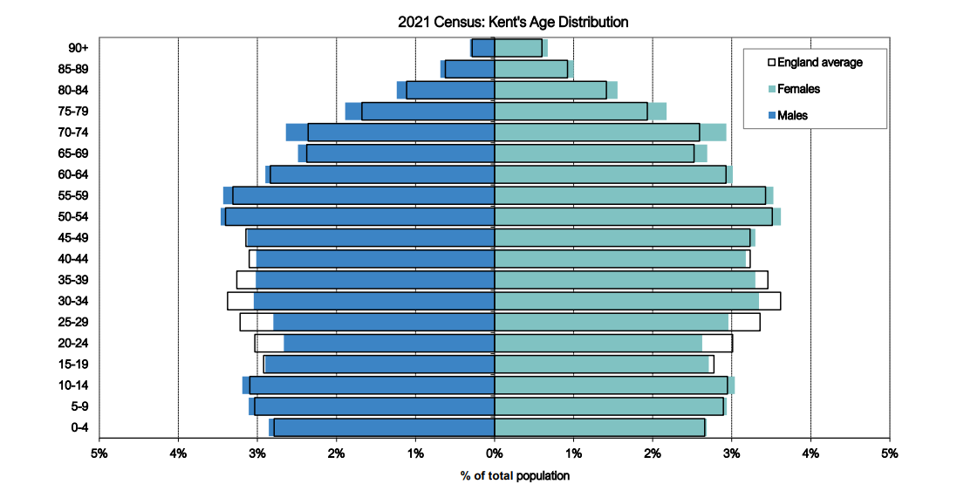 source: ONS, 2021 census, presented by Kent analytics, KCC.

This figure illustrates that children aged 5-11 years in Kent constitute a similar proportion of the population when compared to the national proportion. The following figure uses modelled population estimates from 2020 and provides overview by districts in Kent.

Figure 3: Numbers of and crude rate per 1,000 population aged 5- 11-year-olds by district, Kent, 2022

|  |  |  |
| --- | --- | --- |
| District | Number of 5–11-year-olds | Crude rate per 1,000 5–11-year-olds |
| Ashford | 12370 | 94.4 |
| Canterbury | 12135 | 72.7 |
| Dartford | 11662 | 102.2 |
| Dover | 9385 | 79.1 |
| Folkestone & Hythe | 8800 | 77.6 |
| Gravesham | 10373 | 97.0 |
| Maidstone | 15808 | 91.3 |
| Sevenoaks | 11435 | 94.1 |
| Swale | 14076 | 93.2 |
| Thanet | 12183 | 86.0 |
| Tonbridge and Malling | 12218 | 89.5 |
| Tunbridge Wells | 10882 | 91.5 |
| Kent | **141327** | 88.7 |

Source: Kent Analytics Power BI district report. KCC accessed March 2022

## 4.1 Ethnicity

Ethnicity varies across the districts in Kent. The ethnic and cultural profile is becoming more diverse due to migration. There is a risk that inequalities will keep widening as cultural needs, language differences, interpretation, social norms are misunderstood or not heard.

Ethnicity is not well recorded and reported through the NHS. The 2001 Census saw the introduction of the question on religion and country of birth; this was further expanded on in the 2011 Census with the introduction of questions about national identity. Changes in ethnicity profiles of primary aged children in Kent are shown in the figure below.

Figure 4: Ethnicity groups of all pupils in years R-6 attending a KCC school, including special.

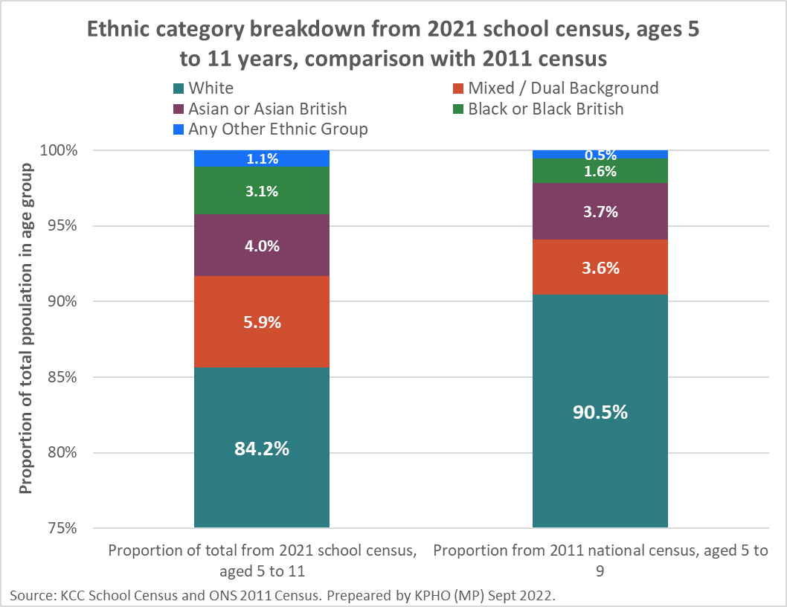

Source: KCC school census and ONS

Gypsy, Roma, and those from a Traveller of Irish heritage background (GRT) children continue to be most at risk in the education system. The latest government statistics of 2021/2022 show that overall absentee rates in England for primary school children were 6.0%, whereas the average absentee for GRT child in school was 16.5%[27] The socio-economic status of GRT children is seen as one of the causes of school absenteeism as well as 50% of families not having a static base, parents/carers being protective and defensive of their children in terms of acceptance and views of the education system, digital exclusion – unlikely to have access to Wi-Fi, access to internet and many enrolments to school are now only accessible digitally.

Kent has 5–11-year-old GRT children attending primary schools across all the districts as shown in the next figure with Maidstone having the highest number and Folkstone and Hythe having the lowest. Thanet has seen the numbers of GRT children registered with primary schools nearly halve since 2017, however it does not have any designated Gypsy and Traveller sites and neither does Folkstone and Hythe district. The other 10 districts in Kent all have one or more designated Gypsy and Traveller sites. Whilst some GRT do live in a fixed dwelling we do not have this data.

Figure 5: Numbers of GRT pupils and percentage of school absence by districts and Kent 2017/18-2020/21

|  |  |  |  |  |  |  |  |  |  |
| --- | --- | --- | --- | --- | --- | --- | --- | --- | --- |
| **District** | **Number of 5–11-year-old GRT pupils in school** | | | **Percentage of Unauthorised absence** | | | **Number of pupils with persistent absence.** | | |
|  | 2017/18 | 2018/19 | 2020/21 | 2017/18 | 2018/19 | 2020/21 | 2017/18 | 2018/19 | 2020/21 |
| Ashford | 119 | 127 | 116 | 12.1% | 8.7% | 13.6% | 53 | 54 | 42 |
| Canterbury | 48 | 66 | 58 | 14.4% | 12.7% | 13.3% | 32 | 26 | 26 |
| Dartford | 108 | 105 | 91 | 16.6% | 22.7% | 13.3% | 66 | 63 | 51 |
| Dover | 131 | 138 | 115 | 4.4% | 12.1% | 18.4% | 47 | 43 | 45 |
| Folkestone & Hythe | 62 | 54 | 46 | 9.1% | 12.3% | 19.6% | 25 | 25 | 27 |
| Gravesham | 122 | 111 | 101 | 14% | 14.1% | 14.2% | 60 | 59 | 52 |
| Maidstone | 254 | 252 | 269 | 29.1% | 26.8% | 16.9% | 146 | 121 | 136 |
| Sevenoaks | 152 | 134 | 146 | 17.9% | 23% | 23.8% | 97 | 86 | 64 |
| Swale | 151 | 165 | 182 | 13.6% | 10.9% | 23.1% | 51 | 70 | 76 |
| Thanet | 157 | 122 | 88 | 4.7% | 27.6% | 41.7% | 27 | 24 | 47 |
| Tonbridge & Malling | 70 | 74 | 73 | 10.8% | 14.7% | 16.8% | 36 | 46 | 28 |
| Tunbridge Wells | 70 | 71 | 64 | 23.1% | 7.7% | 9% | 28 | 25 | 34 |
| **Kent** | **1454** | **1411** | **1359** | **17.8%** | **15.9%** | **18.2%** | **668** | **642** | **628** |

Source: KCC MIU

**Please note a pupil is classed as persistently absent if they miss 10% or more of the sessions it was possible for them to attend. The data presented above is for the whole academic year. There is no data for 2019-2020 due to the Covid Pandemic**

Persistent absence in GRT primary school aged children in Kent remains high across the county and this highlights the concern that whilst not in school they are missing learning opportunities. This contributes to the lowest achievement and attendance of any ethnic group in Kent. Attainment is the measurable progress which children make as they advance through and beyond school, and the development of the range of skills, knowledge and attributes needed to succeed in learning, life, and work. Pupils from Gypsy, Roma and those from a Traveller of Irish heritage background had the lowest attainment of all ethnic groups in Kent.

Nationally across the 19 ethnic groups, the largest percentage point increase was seen in the number of people identifying through the "White: Other White" category; 6.2%, 3.7 million in 2021, up from 4.4%, 2.5 million in 2011. This response option allows people to specify their ethnic group through writing it in; the increase may be partly explained by the new search-as-you-type functionality introduced for Census 2021, making it easier for people to self-define when completing the census online.[28]

Kent has a diverse population, with the ‘White: Other White’ category having some of the largest numbers of minority groups. This group is chiefly European and includes Polish, Romanian, Slovakian, Latvian, Ukrainian and others but are not of the English, Welsh, Scottish or Irish ethnic groupings. In 2021/22 there were 7463 children of primary school age in Kent whose ethnicity was identified as ‘white: other white’.

This is a transient community whose numbers have been exacerbated by an increase in the migrant seeking asylum or refugee settlement.

Unauthorised and persistent absences for these categories are presented below by district across two academic years.

Figure 6: Unauthorised and persistent absences among primary aged pupils of White: ‘other white’ ethnic group by district in Kent 2020/21 & 2021/22

|  |  |  |  |  |  |  |
| --- | --- | --- | --- | --- | --- | --- |
| **District** | **Number of 5–11-year-old pupils in school** | | **Percentage of Unauthorised absence** | | **Number of pupils with persistent absence** | |
|  | 2020/21 | 2021/22 | 2020/21 | 2021/22 | 2020/21 | 2021/22 |
| Ashford | 514 | 526 | 0.9% | 1.4% | 36 | 89 |
| Canterbury | 553 | 572 | 0.9% | 1.5% | 27 | 94 |
| Dartford | 743 | 778 | 0.7% | 1.3% | 53 | 131 |
| Dover | 342 | 359 | 1.1% | 2.0% | 38 | 93 |
| Folkestone & Hythe | 351 | 354 | 1.5% | 2.4% | 56 | 99 |
| Gravesham | 963 | 906 | 1.6% | 2.1% | 107 | 200 |
| Maidstone | 1044 | 1072 | 0.6% | 1.3% | 55 | 164 |
| Sevenoaks | 564 | 563 | 0.5% | 1.0% | 35 | 68 |
| Swale | 597 | 622 | 0.8% | 1.4% | 34 | 95 |
| Thanet | 737 | 699 | 3.7% | 4.6% | 148 | 230 |
| Tonbridge & Malling | 428 | 490 | 0.4% | 0.8% | 15 | 61 |
| Tunbridge wells | 510 | 522 | 0.4% | 0.&% | 17 | 69 |
| **Kent** | 7346 | 7463 | 1.1% | 1.7% | 621 | 1393 |

Source: KCC MIU

## 4.2 Children in care

Vulnerable Children are defined **as ‘any children at greater risk of experiencing physical or emotional harm and/or experiencing poor outcomes because of one or more factors in their lives**’[29].

Children come into care when it is the most appropriate arrangement for them and for most children, this happens in a planned and timely way. Some children are taken into care because of a legal order made by a court (such as a care order or emergency protection order) or are taken into care because someone with parental responsibility has made this request. The next three figures provide different of 5- 11 years old in care by district.

Figure 7: Numbers of Children in Care aged 5-11 years old originating in Kent by district of placement April 2022

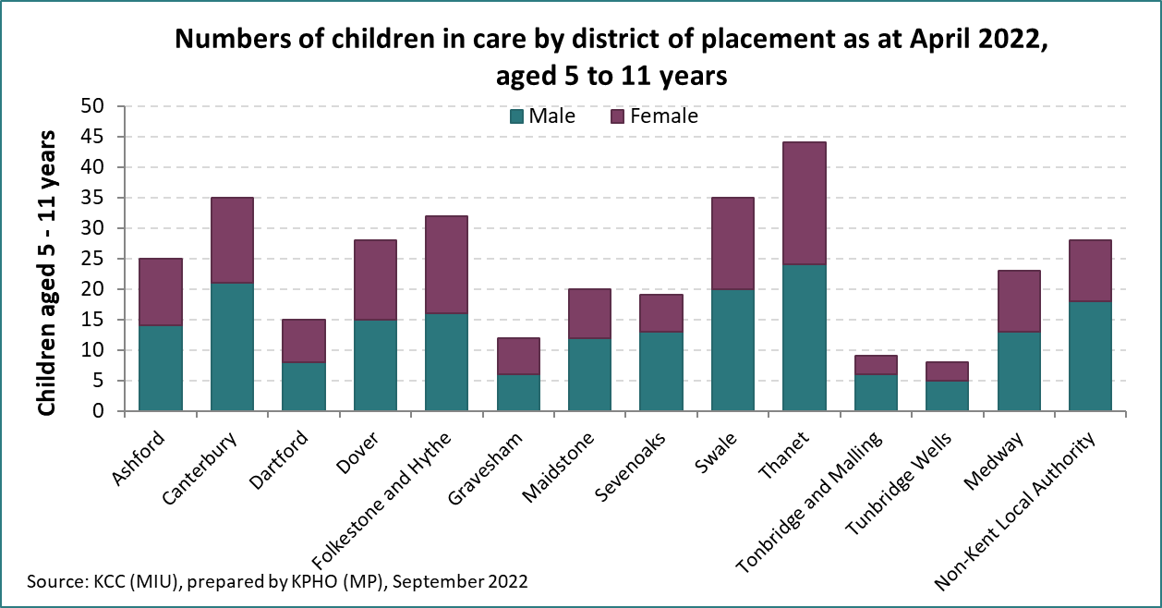

Source MIU KCC

Figure 8: Count of children in care originating in Kent by district of placement and origin April 2022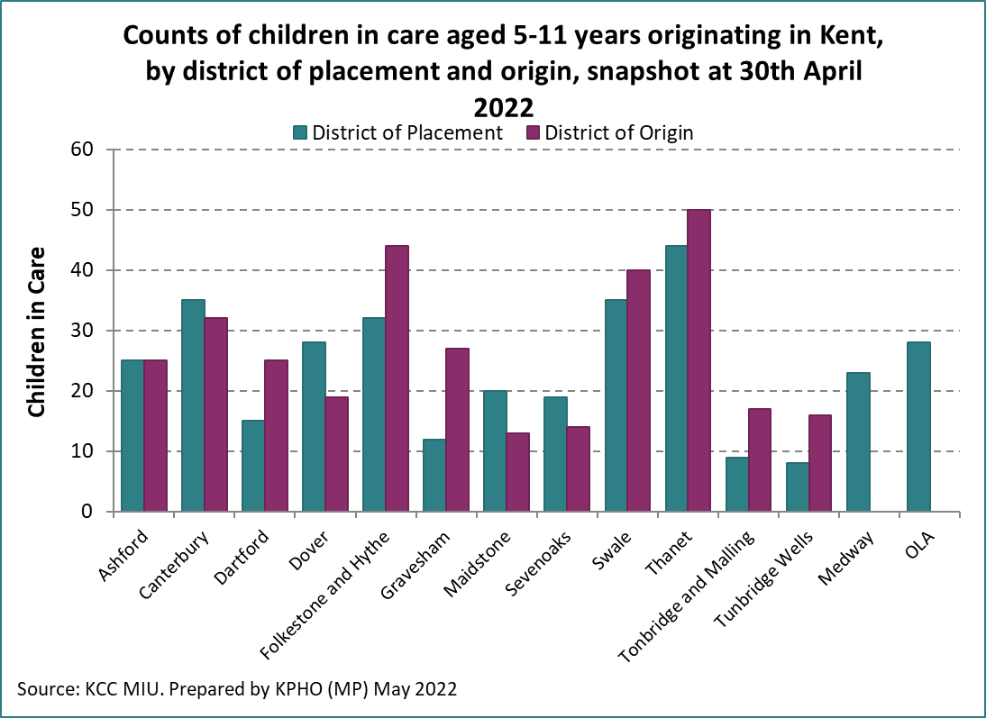

Source KCC MIU

Figure 9: Crude rate per 1,000 children aged 5- 11 years in care, 30th April 2022 by district and Kent.

Source: KCC MIU

The number of children aged 5-11 years old in care over the last 3 years has remained similar as shown in the next figure with a consistent larger number of boys. We do not have access to the reasons for the children going into care but are aware that this age cohort tend to go into foster care, kinship care, with a family member and smaller numbers to residential care settings.[30]

Figure 10: Number of children aged 5- 11 years in care, by gender. Kent 2020-2022

|  |  |  |  |
| --- | --- | --- | --- |
| Year | Number of males aged 5-11 years old in care | Number of females aged 5-11 in care | Total number of 5–11-year-olds in care |
| 2020 | 211 | 148 | 359 |
| 2021 | 188 | 137 | 325 |
| 2022 | 191 | 142 | 333 |

Source: KCC MIU

Looking at the age at which primary aged children enter care is varied and shown at one time point in the following figure.

Please note that the next figure presents the numbers of primary aged children by age taken into care at one timepoint only.

Figure 11: Count of children in care aged 5-11 years old originating in Kent, 30th April 2022.

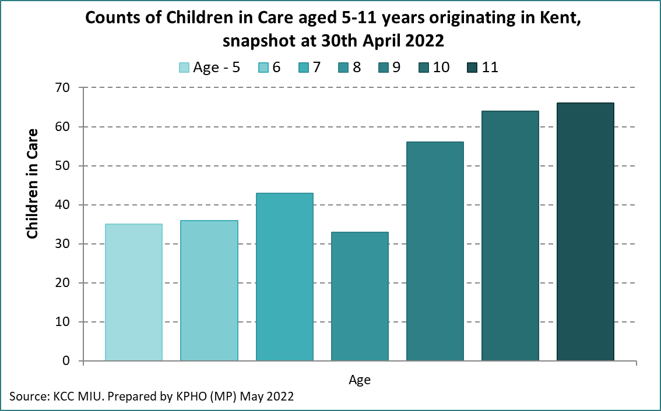Source: KCC MIU

Children in care are supported to live in homes, including adoptive homes, with their brothers and sisters when this meets their wishes and is in their best interests. When a child is taken into care, there is a named social worker who works with the family and the child to make sure that the child is suitably cared for both now and in future.

## 4.3 Young carers

Section 96 of the Children and Families Act 2014 defines a young carer as: “A person under 18 who provides or intends to provide care for another person (of any age, except where that care is provided for payment, pursuant to a contract or as voluntary work). This relates to care to any family member who is physically or mentally ill, frail, elderly, disabled or misuses alcohol, or substances.”

Currently the number of registered young carers in Kent aged 5–11-year-olds is **1,949** [crude rate of 14.5 per 1000 population aged 5-11 years]. The Kent Young Carers (KYC) service is outsourced to Imago who run the service, register, and provide support to KYC.

Kent Young Carers often take on practical and/or emotional caring responsibilities that would normally be expected of an adult. The tasks undertaken can vary according to the nature of the illness or disability, the level and frequency of need for care and the structure of the family as a whole.

Kent Young Carers (KYC) is the countywide service for school aged Young Carers across Kent.  Young Carers are taking on caring responsibilities for a family member with a long-term illness, disability, mental health, or substance misuse issue.

KYC works with schools, communities, and statutory and voluntary agencies to identify hidden young carers. Following assessment, KYC offer a range of short-term interventions including signposting, one-to-one support, in school support and workshops. KYC also offer training and information to professionals.

## 4.4 Special Educational Needs and disability (SEND) and Education Health Care Plans (EHCP)

Good provision for children with SEND requires co-operation between services and joint commissioning arrangements between local authorities and the health systems that are informed by assessment of local need.

The next figure provides an overview of primary aged children with SEN or EHCP with a focus on speech language and communication needs in 2021.

Figure 12: Percentage of 5–11-year-olds with SEN or EHCP support who have Speech, Language and Communications needs in Kent, 2021

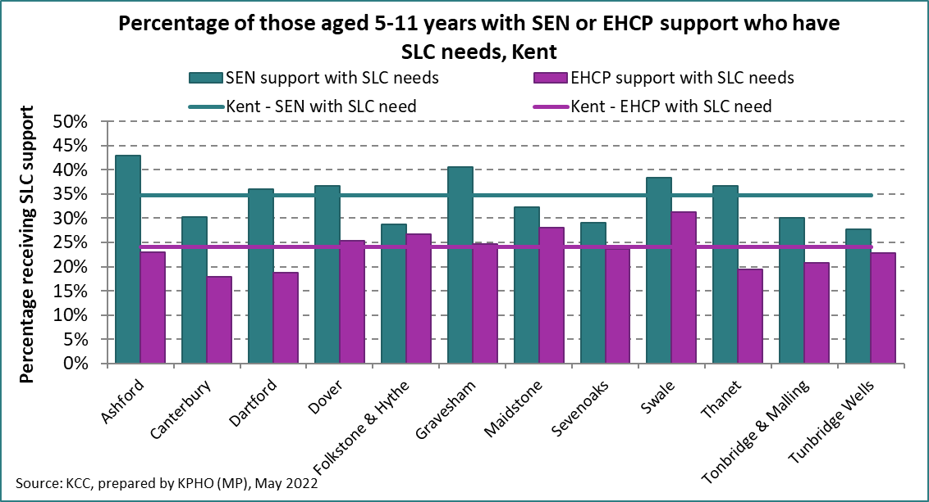

Source KCC KPHO

The following figure provides a different perspective illustrating changes year by year over a five-year period of the various categories of need identified as requiring EHCP support. To note: the high spike in 2018/19 relates to specific LD and is the percentage change on the previous year.

Figure 13: Percentage of EHCP support from Kent schools (including Special schools) for children aged 5-11 years old by category 2016-2021.

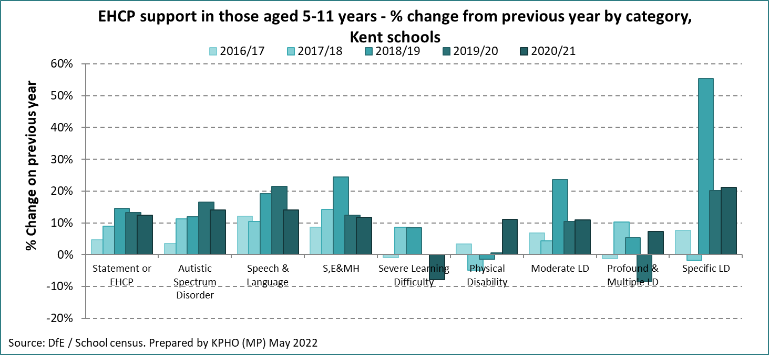

Source: DfE/ school census prepared by KPHO

## 4.5 School: Elective Home Educated

The total number of Children and Young People (CYP) recorded with the Elective Home Education (EHE) team in Kent fluctuates. This is shown in the figure below which presents four academic years. At the end of Term 4 (2021-2022), 469 primary school aged children were recorded as home educated.

In primary schools the highest number of children recorded with EHE were made in year 6 which is at end of key stage 2 when the children complete standardised assessment tests [SATs] examinations.

Figure 14: Elective home educated starters by Key stage and gender, Kent 2018/19 – 2021/22

|  |  |  |  |  |
| --- | --- | --- | --- | --- |
| **Year** | **Key stage 1** | | **Key stage 2** | |
|  | **Boys** | **Girls** | **Boys** | **Girls** |
| **2018/19** | 89 | 66 | 206 | 156 |
| **2019/20** | 86 | 55 | 163 | 141 |
| **2020/21** | 147 | 133 | 286 | 268 |
| **2021/22** | 93 | 76 | 137 | 163 |

Source: Elective Home Education Report KCC

Stakeholders stated during interviews that schools had reported seeing an increase in home education with anxiety and health issues as the main cause. Other reasons have included dissatisfaction with school due to SEND, dissatisfaction with school due to bullying, difficulties accessing school place and a means to avoid legal prosecution.

During stakeholder interview there was a reoccurring theme around children’s anxiety and concerns over returning to school following the pandemic, lockdown, and sporadic school attendance. Many reported that changes in routines for children and their families was a common theme and trying to get back into a routine for some had proved challenging. Whilst home schooling during lock down period, many children’s routines were reported as having been ‘relaxed’ in that they were not up and ready to learn for 9am. Parents had challenges of working from home themselves as well as having to care for other children in the household at the same time. This along with missing education time, lack of socialisation with peers, has caused anxiety levels in some to have increased.

Summary: This chapter looks at the 5–11-year-olds population. Ethnicity varies across the districts in Kent with the 2021 census highlighting the changes in ethnic diversity across the county since the 2011 census. Gypsy Roma Traveller primary school age children are highlighted as a concern with their education attendance and attainment. The highest number of children recorded as Elective Home Educated were made in year 6. There is focus on looked after children, attention on young carers and an overview of primary aged children with SEN or EHCP. These findings highlight the importance of understanding demographic variations and addressing the specific needs of diverse groups to improve health and wellbeing outcomes for children in Kent.

# 5. Primary children in families

## 5.1 Healthy Child Programme (HCP)

The social determinants of health into which children are born, live and grow significantly shapes their physical, emotional, and mental wellbeing.[31] School Nurses and their colleagues, deliver the school aged elements of the Healthy Child Programme, have a key role in providing a needs-led, personalised service that aims to deliver support and intervention early. The Healthy Child Programme is available to every child and aims to identify families that may need additional support and children who are at risk of poor outcomes, providing a personalised response. There are no mandated reviews for school aged children but recommendations for best delivery of the service and opportunities to develop a framework of reviews based on evidence and local need.[32]

Evidence-based interventions provided by school health workforce should be tailored to meet individual and family needs. There is a connectivity and fluidity between the level of support as these needs may change over time and circumstances. The support required by most families and children will predominantly be met through the universal offer. In Kent universal health reviews are offered to all four- to five-year-olds and 10 – 11-year-old children, which is year R school entrants and year 6. These reviews use the Lancaster model [TLM]. The school health service can review the responses to the reviews and offer the most appropriate support.

School nurses use a needs assessment to determine targeted interventions which can be met within the services or the need for more specialist interventions that require referrals or clear signposting. Whilst receiving specialist support school nurses will still provide the universal offer and work in partnership with other agencies. Health needs will be identified in partnership with parents, children using an approach that builds on their strengths as well as identifying any difficulties. Clinical judgement will be used alongside formal screening and assessment tools. Engagement with the whole family is an important component of the Healthy Child Programme. Public health improvement and prevention should be integral to making every contact count and promoting healthy conversations.

Outcomes are measured and reported in line with national outcome frameworks and commissioning reporting requirements.

Safeguarding children is embedded through the model because school nurses have a vital role in keeping children safe and supporting local safeguarding arrangements. It is essential to define local roles and responsibilities including school nurses, as identified within commissioning guidance. [Working Together to Safeguard Children](https://www.gov.uk/government/publications/working-together-to-safeguard-children--2)[33] provides the statutory guidance on inter-agency working to safeguard and promote the welfare of children.

## 5.2 Parenting primary aged children

Kent families have access to free parenting programmes across the County. These can support families to understand their child and help them to build loving and close relationships between children and their carers.

Kent adult education offer online parenting programmes which are designed for parents and carers of children to help tackle everyday family issues and understanding of their child.

Kent Community Healthcare Foundation Trust [KCHFT] offer free online parenting courses to support anyone caring for a child aged 6 months to 19 years.[34] For primary school aged children these courses include:

* Understanding your child
* Understanding your child with additional needs
* Understanding your child’s feelings
* Understanding your child’s mental health and wellbeing

## 5.3 Early Help and Preventative Services

Early Help and Preventative Services [EHPS] is not a statutory service but a key service delivery in Kent which aims to target early help services for the most vulnerable children, and families with a focus on delivering better outcomes.

Children and families should be able to access the right services at the right time in the right place. The aim of the service is to work in an integrated way and avoiding, where possible, lack of coordination or duplication.

The EHPS offer a wide range of support services to children and families across different levels of need. Most children may have a few basic needs that are well supported through a range of universal services. However, some children have more additional or complex needs and may require access to additional, intensive or specialist services to support them. These levels of need are defined by the Kent support level guidance sheet[35]

Request for support from the EHPS can be submitted by partners and by individuals/families themselves. The support is offered at different levels. (See appendix E for further detail) The Early Help Units work in partnership with other professionals and agencies and the family to build resilience and develop solutions to problems the family may be experiencing. Where intensive support is agreed, the information will be shared with the relevant Early Help District team and allocated to an Early Help Unit. An Early Help Worker will contact the referrer and work with them and the family to complete an assessment and plan to achieve the best outcomes.

The figure below presents the picture for support following domestic abuse, before and during the pandemic and as such reduced numbers in front door contacts over the three-year time period 2019-2021. This may not reflect an accurate picture as suggested from stakeholder experience.

Figure 15: Front door contact which met threshold for early help service where domestic abuse was primary reason for support and one or more 5–11-year-old were in the household, Kent 2019-2021

Source: KCC MIU

The figure shows a higher number of contacts in Swale and Thanet, the most deprived districts in 2019, to the highest number of contacts in 2021 in the least deprived districts Sevenoaks and Tunbridge Wells. The differences in Tunbridge Wells and Sevenoaks may reflect service development in those districts.

*We have seen an increase in children’s mental health because of domestic abuse within the home that is then translating into schools and socially.*

Source: stakeholder interview

## 5.4 Children’s social work team

Local authorities, working with partner organisations and agencies, have specific duties to safeguard and promote the welfare of all children in their area. Working together to safeguard children 2018[36] The Children Acts of 1989[37] and 2004[38] set out specific duties; Section 17 of the Children Act 1989 puts a duty on the local authority to provide services to children in need in their area, working closely within a multi-agency team.

This is seen through front door contacts. The next figure provides presentation of front door contacts who met the threshold for Kent children social work service. These are consistently higher in Thanet, Swale and Maidstone over the 3-year period 2019, -2021 in comparison to the Kent average. To note the population of 5- 11-year-olds in Maidstone and Swale districts are higher than other districts in Kent.

Figure 16: Front door contacts which met threshold for Kent Children’s Social Work Service where one or more 5–11-year-old was in the household, Kent 2019-2021

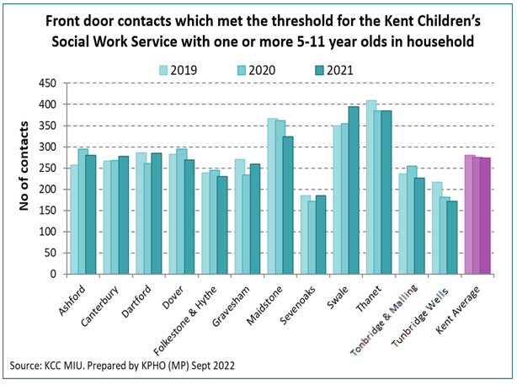

Source KCC MIU

Summary: This chapter looks at the Healthy Child Programme for primary school age children and its aims to deliver support and early intervention for families that may need additional support and children who are at risk of poor outcomes, with a personalised response. Early Help and Preventative Services (EHPS) in Kent aims to target early help services for the most vulnerable children, young people and families with a focus on delivering better outcomes. EHPS offer a wide range of support services to children, young people and families across different levels of need. The Kent support level guidance shows the different support levels that are available to support children and their familes including those who have more additional or complex needs and may require access to additional, intensive or specialist services to support them.

**|**

# 6. The Impact of The Wider Determinants of Health on Primary School Aged Children

Since the 2010 Marmot Review there have been important developments in the evidence about the social determinants of health and implementation of interventions and policies to address them. There have also been fundamental political, cultural, social, economic and policy changes that have profoundly affected all aspects of the social determinants in England.[39]

Local government has a crucial role in addressing the social determinants of health such as housing, income, community resilience, jobs, education, and wider built and environmental conditions. Local government is also best placed to influence the adoption of a locally led, shared vision across organisational boundaries such as voluntary sector services, and early help services which prioritise and address the underlying causes, as well as the outcomes, of vulnerability.

Health inequalities are differences in health across the population, and between different groups in society, which are systematic, unfair, and avoidable. They are caused by the conditions in which we are born, live, work and grow. These conditions influence opportunities for good mental and physical health.

Health inequalities can be experienced by people grouped by a range of different factors including:

* socioeconomic status and deprivation
* sharing certain protected characteristics
* belonging to vulnerable or excluded groups of society
* geography

These factors often overlap, meaning people can fall into combinations of these categories. Health inequalities are not caused by one single issue, but a complex mix of environmental and social factors which play out in a local area, or place - this means that local areas have an important role to play in reducing health inequalities. Addressing the wider determinants of health through a life course approach is important for achieving impact at the level of population health - rather than at the individual level.

Action on the social determinants of health requires action across multiple arenas and domains and that requires commitment and know-how from a range of workforces outside health.[40]

## 6.1 Poverty and deprivation

Kent has varying levels of deprivation and child poverty. There are 901 LSOAs in Kent, of these 51 are within the 10% most deprived LSOAs in England. This number has remained unchanged since the previous IMD2015. In Dartford and Gravesham district, the IMD2019 showed there had been a reduction in the number of their LSOAs within the 10% most deprived. The level of deprivation in the 9 out of 12 Kent local authority districts has increased since IMD2015 relative to other areas in England. Thanet continues to rank as the most deprived local authority in Kent. Tunbridge Wells continues to rank as the least deprived local authority in Kent. The largest increase in deprivation relative to other areas has been experienced in Tonbridge & Malling.

Within Kent the impact of deprivation and health inequalities can be seen across the life course with a significant difference in life expectancy at birth, and 5 years of healthy life expectancy, between the most and least deprived wards in the county.

The next figure provides illustration of the impact of deprivation through the percentage of children living in absolute low-income families.

Map 1: Percentage of children under the age of 16 years living in absolute low-income families in Kent 2020/21.

Map showing the percentage of children aged under 16 years living in absolute low income families in Kent 2020/21 by middle layer super output area (MSOAs) and district boundary. 


Source: DWP Stat Xplore produced by Kent Analytics

In 2020/21 13.8% of children under 16 in Kent were living in absolute low-income families. This is presented in more detail by district in the following figure.

Figure 17: Number, crude rate and percentage of children under 16 living in absolute low-income families by district, Kent 2020/21 with percentage change since 2019/20.

|  |  |  |  |  |
| --- | --- | --- | --- | --- |
| **District** | **Total number of children aged under 16** | **Number and % of children under 16 living in absolute low-income families 2020/21** | **Crude rate per 1,000 population 0-15 years 2020/21** | **% change since 2019/20** |
| Ashford  Canterbury  Dartford  Dover  Folkestone & Hythe  Gravesham  Maidstone  Sevenoaks  Swale  Thanet  Tonbridge & Malling  Tunbridge Wells | 26931  26463  26062  20800  19037  22999  34690  24615  30908  26691  27015  23917 | 3767 14.0%  3561 13.5%  3437 13.2%  3384 16.3%  3212 16.9%  3935 17.1%  4364 12.6%  2583 10.5%  4661 15.1%  4815 18.0%  2757 10.2%  2214 9.3% | 139.8  134.5  131.8  162.6  168.7  171.0  125.7  104.9  150.8  180.3  102.0  92.5 | -0.5%  0.1%  6.6%  -6.6%  2.8%  2.2%  3.3%  10.3%  -0.2%  -9.8%  1.3%  4.3% |
| **Kent**  **England** | 310,128  10,852,250 | 42,686 13.8%  1,641,170 15.1% | 137.6 | 0.3%  -3.7% |

Source: DWP Stat Xplore; ONS MYPE Presented by: Kent Analytics, Kent County Council

There have been significant changes to the financial landscape since the time of writing in 2022, but this has not been shown in the 2022/23 presentation of the percentage of children under 16 living in absolute low-income families.

Figure 18: Proportion of 0-4 years, 5-10 years and 11-15-year-olds in absolute low-income families in Kent by age group, 2020/21.

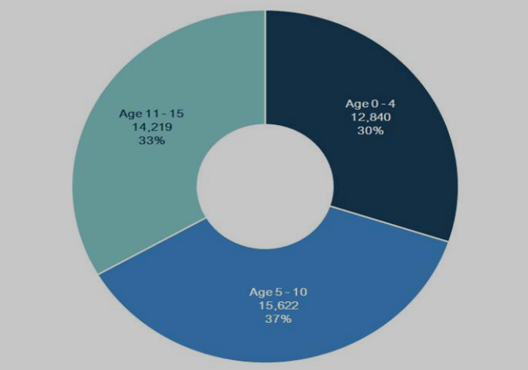

Source: DWP Stat Xplore

According to the Income Deprivation Affecting Children Index, all the top 20 most deprived areas in Kent are in coastal areas. Cliftonville West in Thanet is the 5th most deprived in the country for the IMD 2019 indicator, measuring children and young people’s education, skills, and training. [41]

Children **born into poverty** are more likely to suffer from greater health and social inequalities and experience a wide range of health problems including poor nutrition, chronic disease, and mental health issues. Poverty has a significant impact on children's life chances.

Children **living in poverty** are more likely to: die in the first year of life, breathe secondhand smoke, be bottle fed, become overweight, suffer from asthma, have tooth decay, perform poorly at school, and die in an accident.

Whilst there is no single definitive measure of child poverty, The Child in Poverty Bulletin (April 2022) looks at several measures. The children in low-income families [CiLIF] statistics provide information on the number and proportion of children living in Relative and Absolute low income before Housing Costs by local area across Great Britain.

The Children in Low-income Families measure (CiLIF) looks at the number of children in families, where the income is less than 60% of median income before housing costs, in both absolute and relative terms. For both measures a family must have claimed one or more of Universal Credit, Tax Credits or Housing Benefit at any point in the year to be classed as low income in these statistics.

Children in Low Income Families, (DWP 2020/21 released 31 March 2022) stated that 37% of children in Kent living in absolute low-income families were aged 5-10 years. The number of children in absolute low-income families where at least one adult was in work has increased over the year 2020/21 while those in out of work families have decreased. 16.9% of children under 16 in Kent were in relative low-income families and this had increased by 2.3% since the previous year.

The number of children aged 5-10 years in relative low-income families has increased. **In 2020 an estimated 5.7% of households in Kent with dependent children had no adult in work, up from 4.6% the previous year**.[42]

At least a third of vulnerable children are ‘invisible’ (in the sense of not being known to services) and are therefore not getting any support. In a typical class of 30, 6 children are growing up at risk due to family circumstances, 4 have an identified special education need (SEN) and 4 will have a mental health issue but only 1 of them will be accessing mental health services. The report highlights that 25% of the amount councils spend on children goes on the 1.1% of children who need acute and specialist services. [43]

*Social determinants of health and poverty are the main issues with mental health we see in parents that then play out in their children.*

Source: stakeholder interview

Financial insecurity has extended with the ‘cost of living crisis’ which refers to the fall in ‘real’ disposable incomes (that is, adjusted for inflation and after taxes and benefits) that the UK has experienced since late 2021.

It is reported by Save The Children that families who are already experiencing poverty are finding that their soaring bills are simply unaffordable. When before the crisis many families had to choose between heating or eating, they now find themselves unable to afford to do either.  The concern is that many families will not be able to provide for their children.

Food insecurity (sometimes referred to as food poverty) is the state of being without reliable access to a sufficient quantity of affordable, nutritious food. Many stakeholders reported that they have seen an increase in parents accessing food banks due to the rise in the cost of living. The Food Foundation 2022 report that in England fuel poverty is not experienced in isolation but with multiple inequalities that impact on an ability to function in the world and engage with society.[44]

## 6.2 Housing

Housing Benefit assists those who are unemployed, on a low income or claiming benefits. This has been replaced by Universal Credit,[45] and in part explains the reduction in claimants.

As of February 2023, 4.2% of households in Kent were claiming Universal Credit, and had a child aged 5-10 living in the household. The next figure provides overview of this presenting the proportion of households in Kent by district on Universal Credit with a child aged 5-10 years.

It illustrates that Thanet district had the highest proportion with 5.7% of households in this category, and Tunbridge Wells district had the lowest proportion at 2.8% of households.

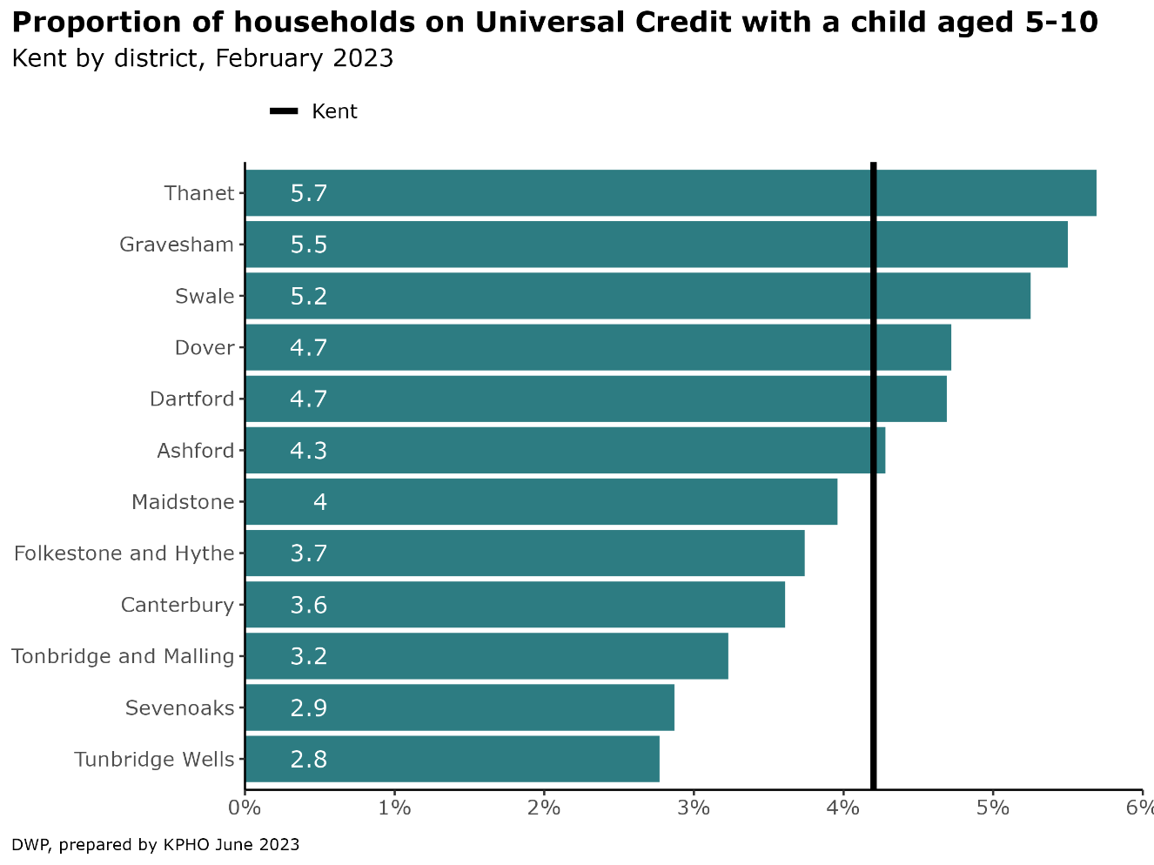Figure 19: Proportion of households in Kent on Universal Credit with a child aged 5-10 years in Kent by district as of February 2023

Source: DWP

## 6.3 Free School Meals (FSM)

FSM is used as an indicator of inequality. If a child is under 19 and in full-time education, and their parent(s) receive certain benefits, they may be able to get free school meals. If eligible and registered a child will get:

* a choice of a healthy hot meal every school day at no cost – (worth £470 a year per child)
* meals to cater for cultural, dietary, and religious requirements
* the chance to develop social skills by sitting with friends for a school meal
* a £10 food voucher per eligible child each week during the school holidays

The school will also receive additional funding to cover the catering cost and school funding grants, such as the Pupil Premium, based on their take up of free school meals.

Some schools and academies also offer reduced rates for school trips, clubs, after school care, and uniform to children registered for free school meals.[46]

The following figure shows free school meal eligibility between 2018/19 to 2022/23 for state funded primary schools. Kent had 14.3% eligible in 2018/19, below the England figure of 15.8% but higher than the South-east region at 11.8%. By 2022/23 this had increased to 24% eligible, similar to England, while the South-east was lower at 19.5%.

Figure 20: FSM eligibility for all state funded primary schools in England, South East and Kent from 2018-2023

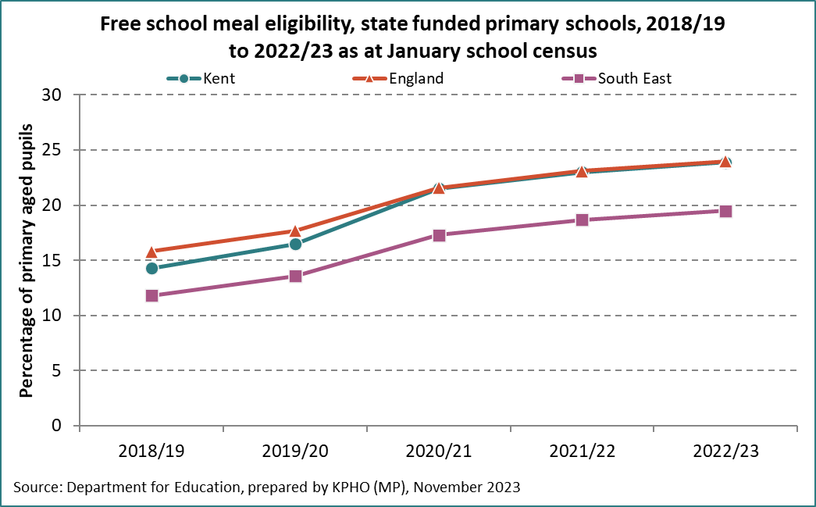

Source: DfE

The data in the following figure is for all pupils within the reported schools (Key stage 1 [KS1] and Key stage 2 [KS2] for primary schools) and includes those pupils who are eligible based on financial criteria. This is however not a true representation of primary schools in Kent as the data does not include academies. These figures reflect records for 306 out of 548 primary schools across the county of Kent at one time point, March 2022. The figure reflects a total number of pupils on roll of 95,173 across the 306 schools. The average FSM eligibility in Kent is at 20.7% with the highest at 32.7% (Thanet) and the lowest 13.3% (Tunbridge Wells). This figure shows higher uptake where there is lower eligibility. The average take-up of FSM in Kent is 72.1%.

Some stakeholders have suggested there may be embarrassment at taking up FSM, schools not promoting and encouraging but moreover that children have become fussy eaters, and many will not eat what is on the daily menu at school so choose to have a packed lunch with the things they ‘will’ eat.

Figure 21: Percentage of eligibility and uptake of Free School Meals amongst primary aged children, by district, Kent, March 2022

Source KCC MIU

Across the county there is a combination of schools having their own kitchens, catering teams, external caterers or where no kitchen, food is delivered. All schools in Kent must provide food in line the schools food standards[47] (updated May 2022). School’s standards are designed to help children develop healthy eating habits and ensure they have energy and nutrition they need to get the most from their school day.

The uptake of FSM is not an issue in Kent only as it has been reported in other parts of England. The headteachers update which is a magazine for all UK primary school head teachers[48] reported that the number of children eligible for FSM continues to increase with many not knowing that they are eligible, and others afraid of the stigma from claiming FSM.

## 6.4 Disability Living Allowance (DLA)

Disability and poverty are closely tied, with disability often increasing health care and related costs while simultaneously limiting entry or stay in the labour market. Tinson et al. (2016) stated that disabled people are at a higher risk of poverty than many in the UK, for two main reasons:

* Impairments, health conditions and social responses to these conditions often prevent disabled people from working and thus deprive them of income
* Disability often brings with it a series of higher and additional costs that further reduce income

The Joseph Rowntree Foundation reported in 2018 that there were approximately 6.6 million people in families in poverty that include a disabled adult or child in the UK and that disability has also been linked with an increased risk of destitution, such as going without essentials such as a home, food, heating, lighting, clothing, shoes, and basic toiletries".[49]

Maclnnes et al (2014), suggests that there is evidence that disabled children are significantly more likely to grow up in poverty than those who are non-disabled. Furthermore, the presence of a child with a disability may increase the chances of a family descending into poverty and reduce the chances of them escaping from poverty. The association between poverty and childhood disability are not yet fully understood, however growing up in poverty is said to be associated with increased exposure to range of factors, such as poorer nutrition and housing, that may increase the risk for health conditions or impairments.[50]

Disability Living Allowance (DLA) is granted following an assessment qualification process and allocated to those who have extra care needs or mobility needs (difficulty getting around) because of a disability.

To qualify for DLA, the child’s disability or health condition must mean at least one of the following apply:

* They need much more looking after than a child of the same age who does not have a disability
* They have difficulty getting about
* They must have had these difficulties for at least 3 months and expect them to last for at least 6 months.

DLA for children may help with the extra costs of looking after a child who:

* is under 16
* has difficulties walking or needs much more looking after than a child of the same age who does not have a disability

The conditions claimed for require interpretation as the most claimed for are ‘learning difficulties.’ There are differences in the definition of learning difficulties with the **DWP definition of ‘learning difficulties’ including:**

* ‘Learning difficulties’’ (an old generic code still used for pre-2008 cases before more detailed sub-categories were introduced)
* ‘Down’s syndrome’
* ‘Fragile X syndrome’
* ‘Learning disability - other/type not known’
* ‘Autism’
* ‘Asperger syndrome’
* ‘Retts disorder’

The following figures provide overview of the uptake or distribution of the DLA and importantly the needs identified giving entitlement to this allowance. There are distinctions between entitled and receiving [claimed]. Entitled is only for people in hospital that are not counted, **receiving** [claimed] is essentially those NOT in hospital.

The next figure gives presentation at a district level of the percentage of the population aged 5- 11 years entitled to the disability living allowance.

Figure 22: Percentage of the population aged 5-11 years who are entitled to Disability Living Allowance by district August 2021.

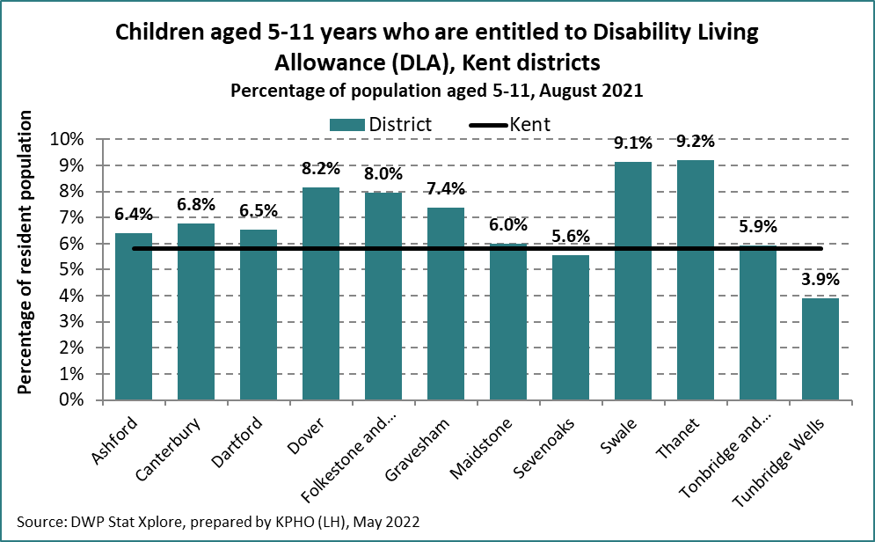

The timepoint August 2021 in this figure suggests that there were higher percentages of the population aged 5-11 years entitled to DLA in Swale and Thanet districts.

Those who can receive the allowance because of extra care needs or mobility needs is presented by overall need and by district in the next figure as of August 2021. It is unclear from the analysis whether mental health disorders are identified in parallel with other conditions or documented separately. [51]

Figure 23: Children aged 5-11 years old entitled to Disability Living Allowance by broad health condition per district in Kent, August 2021

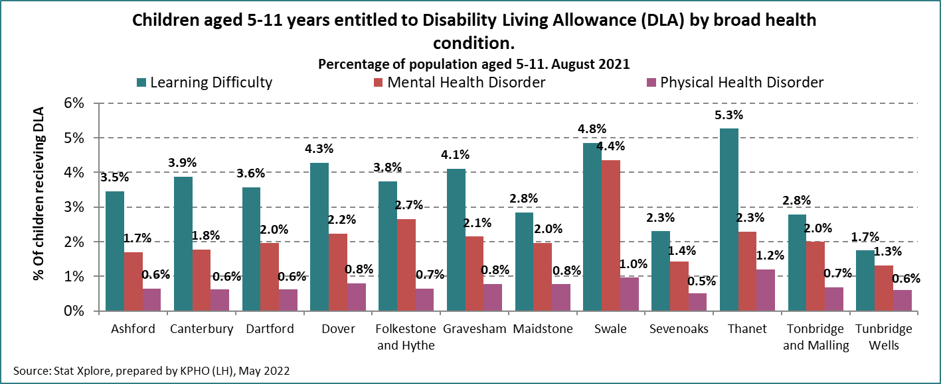

Source Stat Xplore

The following figure shows an increase in the proportion of children entitled to DLA throughout the county over the four timepoints August 2018 – August 2021 and most districts suggest an increase of 1% in those entitled to DLA.

Figure 24: Percentage of children aged 5-11 years old entitled to Disability Living Allowance by district in Kent, August 2018- 2021

|  |  |  |  |  |
| --- | --- | --- | --- | --- |
| **% of children aged 5 - 11 entitled to Disability Living Allowance** | **Aug-18** | **Aug-19** | **Aug-20** | **Aug-21** |
| Ashford | 5.2% | 5.5% | 6.0% | 6.4% |
| Canterbury | 5.6% | 6.1% | 6.7% | 6.8% |
| Dartford | 5.6% | 6.2% | 6.4% | 6.5% |
| Dover | 6.9% | 6.9% | 7.6% | 8.2% |
| Folkestone and Hythe | 7.0% | 7.0% | 7.6% | 8.0% |
| Gravesham | 6.4% | 7.0% | 7.2% | 7.4% |
| Maidstone | 4.3% | 5.1% | 5.8% | 6.0% |
| Sevenoaks | 4.4% | 4.7% | 5.2% | 5.6% |
| Swale | 8.2% | 8.3% | 8.8% | 9.1% |
| Thanet | 7.2% | 7.7% | 8.4% | 9.2% |
| Tonbridge and Malling | 5.0% | 5.2% | 5.5% | 5.9% |
| Tunbridge Wells | 3.2% | 3.5% | 3.6% | 3.9% |
| **Kent** | **4.8%** | **5.1%** | **5.5%** | **5.8%** |

Source: stat Xplore

## 6.5 Digital inclusion

Digital inclusion is about ensuring everyone has access and the skills to use the Internet and digital technologies. Digitally excluded people can lack skills, confidence, and motivation, along with having limited or no access to equipment and connectivity. There is a close relationship between digital exclusion and social inequalities. There are significant disparities in digital inclusion across and within districts in Kent. Thanet is consistently highlighted as the most digitally excluded district in Kent across multiple measures of digital exclusion. Dartford, Dover, Folkestone and Hythe and Swale also have many digitally excluded neighbourhoods. Sevenoaks, Tonbridge and Malling and Tunbridge Wells are the districts with the least digitally excluded neighbourhoods. However, rurality in Tunbridge Wells district means that it ranks as the top district for households with poor broadband. Even within a district, there can be marked disparities between neighbourhoods. For example, over three-quarters of households in an LSOA in Folkestone and Hythe are likely to not use the Internet every day as compared to 0.1% of households in another LSOA in the same district. [52]

Digital and virtual services allow school nurses and other professionals to work with children both in and out of school settings and can help to widen the reach. The need for good digital provision has been highlighted particularly by the emergence of the COVID-19 pandemic, and the impact it had on face to face services.

Digital exclusion can perpetuate social inequalities. Digital exclusion reinforces other existing forms of social and economic deprivation. For example, those digitally excluded may be disadvantaged through not being able to search or apply for jobs online, be excluded from training and upskilling or be excluded from more flexible working practices such as working from home. The segments of the population in significant need of and likely to engage with public services are more likely to be digitally excluded, which potentially limits the reach of online services and restricts the potential for long-term financial saving. [53]

The way we live, work, communicate and access services is increasingly digital with digital access, often via a smartphone app, becoming the default. Non-digital channels for services are becoming harder to use or being withdrawn by service providers. However, according to Ofcom, 1.7 million households do not have decent internet access at home and many more struggle to access services and opportunities online due to the quality of their connection or devices.[54]

## 6.6 Educational attainment

The level of education attainment is a known wider determinant of health and often measured at the age of 16 years, but the foundation is laid much earlier which includes enjoyment of education through primary school and the family to support with the understanding of how valuable it is for child development.

The following two figures present the Kent attainment data for key stage one [KS1] and key stage two [KS2]. Please note that no data was collected in 2020 and 2021 due to the education disruption caused by the Covid 19 pandemic.

Figure 25: Education attainment data Key stage one [KS1] by district and Kent 2017-2022

Cluster bar chart showing for Key Stage 1, the percentage achieving expected standards on reading, writing and maths in Kent schools by district in 2017 to 2022. All 12 districts in Kent have seen a decline from 2019-2022 in the expected achievement standards in reading, writing and maths for KS1. Thanet district had less than 50% of its KS1 pupils meeting the expected standards, whilst Sevenoaks district remained the highest.



Source KCC prepared by KPHO.

All 12 districts in Kent have seen a decline from 2019-2022 in the expected achievement standards in reading, writing and maths for KS1. Thanet district had less than 50% of its KS1 pupils meeting the expected standards, whilst Sevenoaks district remained the highest.

KS2 figures show a decline in the expected standards from 2019 to 2022 however to a lesser percentile than KS1 figures across all districts. Dover district had the lowest expected standards in reading, writing and maths when looking at 2019 to 2022.

Figure 26: Education attainment data key stage two [KS2] by district and Kent 2017-2022

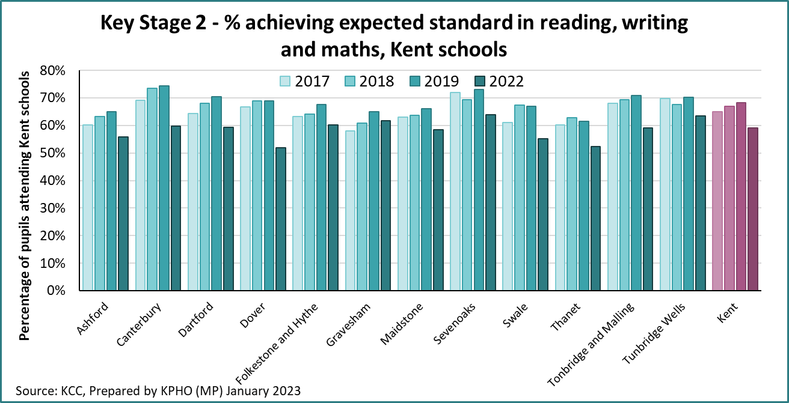Source KCC prepared by KPHO.

The correlation between achievement at KS1 and KS2 by districts is connected to deprivation. The primary years show a lasting importance of the early home learning environment and the emergence of new important behavioural, attitudinal and belief variations by family background. Children from poor backgrounds are much less likely to experience a rich home learning environment than children from better-off backgrounds, and while poverty is linked to, but not causal to, poor educational attainment, being born into a deprived area does not have to automatically mean that a person will not achieve academically. However, deprivation can lead to children gaining fewer qualifications and skills as living in poverty can create a number of barriers to attainment in school that are not faced by children from more affluent backgrounds. These can be categorised as material, social, and personal barriers. Material barriers include a lack of educational resources at home, such as books, internet access, and a lack of money to pay for school trips and experiences. Social barriers can include a poor home learning environment, and low levels of parental education and support for education. Personal barriers can include low self-esteem, lack of confidence, and a lack of social and emotional maturity.

## 6.6.1 Kent test

There are different education opportunities for primary aged children. One of these is the transition from year 6 and the end of primary school to year 7, the start of secondary education. This is illustrated in the take up of the Kent test to enter a grammar school education as opposed to the comprehensive education system.

Details on education attainment and Kent test data is presented in appendix C.

Summary: This chapter illustrates the importance of accesss to financial support for families with primary school aged children. The stark difference to eligibility and take up of free school meals across the districts is noteworthy. The increase in the proportion of children eligible for disability living allowance across all districts is observed. There is a close relationship observed with digital exclusion and social inequalities with Thanet being highlighted as the most digitally excluded districts in Kent. The reduction in education attainment across key stage one is evident from 2019 to 2022 with Dover seeing the greater reduction for key stage two over the same time period.

# 7. Access to health care services by Primary School Aged Children

Many primary aged children will access health services as part of a universal offer such as vision screening in reception year in mainstream schools. In addition, children will be receiving care for health conditions or requiring urgent care. This chapter examines health services use by primary aged children but begins by looking at the focus announced in November 2022 to reduce healthcare inequalities. Publication of the NHSE Core20plus5 approaches for children and young people provides a response to drive improvement in healthcare inequalities across five key clinical areas, four of which were identified in the 2019 NHS forward plan. This programme to reduce healthcare inequalities among CYP is presented below.

Figure 27: NHS England: Core20plus5 Reducing health care inequalities for children and young people.

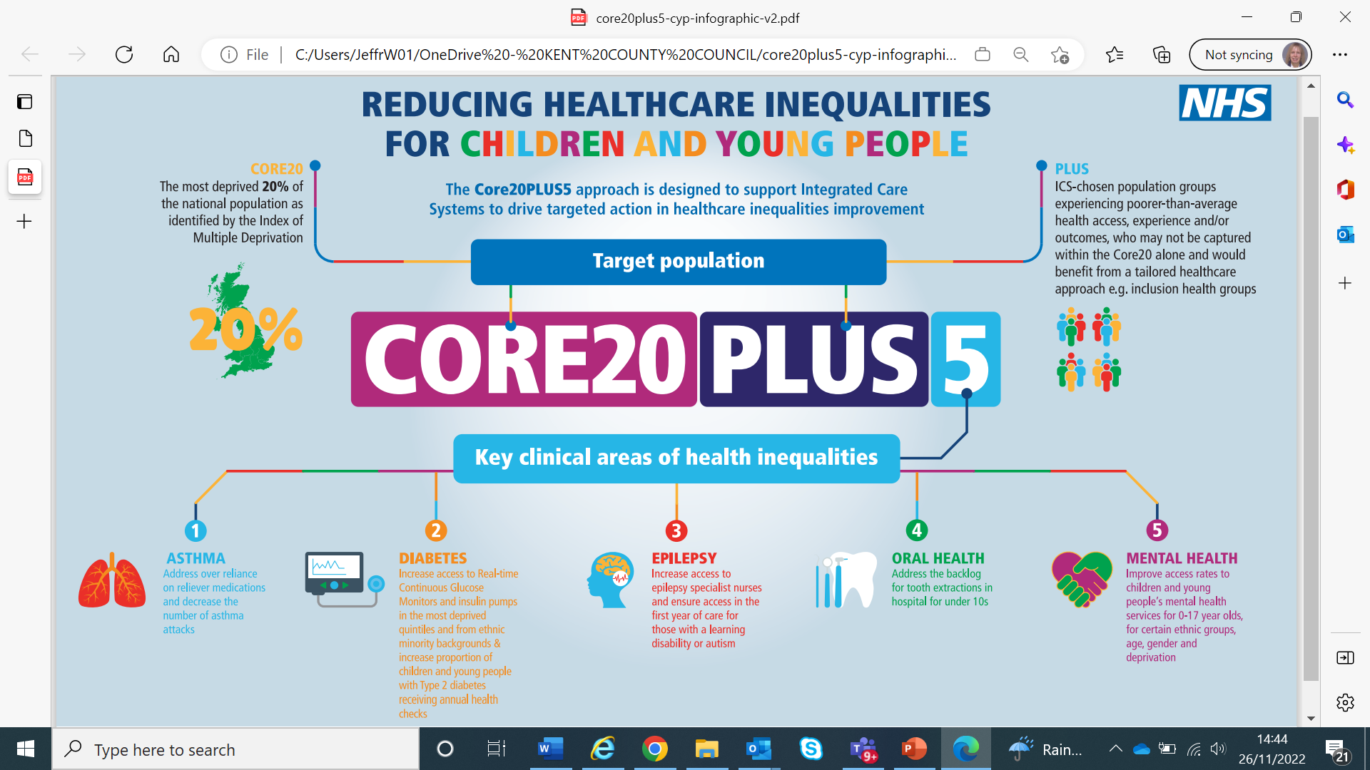

Source: NHSE

**Core20PLUS5** is an NHS England approach to support the reduction of health inequalities at both national and system level. The approach defines a target population cohort and identifies ‘5’ focus clinical areas requiring accelerated improvement. The approach, which initially focussed on healthcare inequalities experienced by adults, has now been adapted to apply to children and young people. The information below outlines the Core20PLUS5 approach for children and young people.

**Core20** represents the most deprived 20% of the national population as identified by the national [Index of multiple deprivation (IMD)](https://www.gov.uk/government/statistics/english-indices-of-deprivation-2019). The IMD has seven domains with indicators accounting for a wide range of social determinants of health.

**PLUS** identifies the population groups and include: ethnic minority communities; inclusion health groups; people with a learning disability and autistic people; coastal communities with pockets of deprivation hidden amongst relative affluence; people with multi-morbidities; and protected characteristic groups.

Specific consideration for the primary school age group should be taken to include young carers and looked after children. [Inclusion health](https://www.gov.uk/government/publications/inclusion-health-applying-all-our-health/inclusion-health-applying-all-our-health) groups for primary aged children may consider: people experiencing homelessness, vulnerable migrants, Gypsy, Roma and Traveller communities, victims of modern slavery or other socially excluded groups.

**Five** areas of focus are part of wider actions for Integrated Care Board and Integrated Care Partnerships to achieve system change and improve care for children. These relate to asthma, epilepsy, diabetes, oral health and mental health and the intention of focus is presented at the beginning of the relevant section in this chapter. Governance for these five focus areas sits with national programmes; national and regional teams coordinate local systems to achieve.

## 7.1 Accident & Emergency [A & E] attendance

A and E attendance can provide an overview of health care needs. Access to urgent treatment centres or accident and emergency departments are included in the same hospital coding. Minor injury units can treat injuries that are not critical or life threatening. There are 10 minor injuries units throughout Kent. Please see appendix H for details There are observed differences in the rates of attendances over the five-year period across the districts. This may in part be explained by the minor injury units in Sevenoaks, Folkestone & Hythe, Gravesham, and Dover districts.

The next figure provides the rates from five-year combined data 2016/17 -2020/21 of hospital attendances among 5- 11-year-olds by district in Kent.

Figure 28: The crude rate of A & E attendances per 1,000 5-11 years olds residing in Kent by district 2016/17-2020/21.

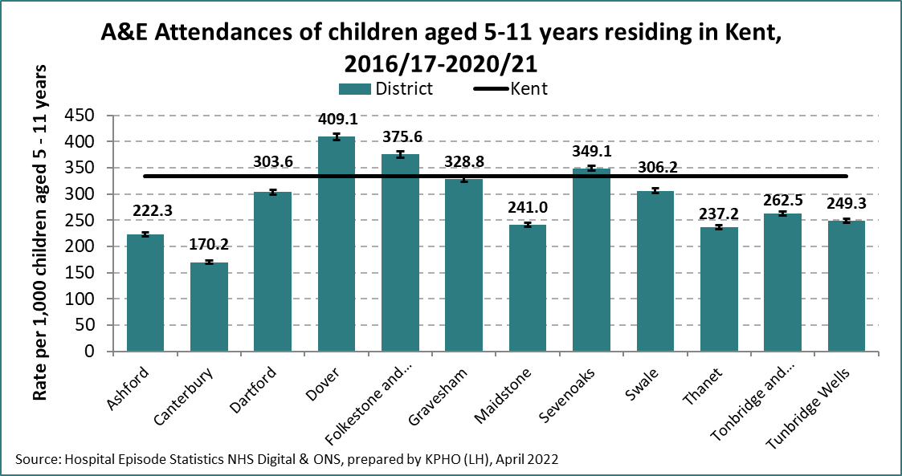

Source: Hospital episode statistics NHS digital, prepared by KPHO

Attendance at A & E departments can lead to hospital admission. Looking at one year of data which is not a year which was presented on attendance in the previous figure, provides overview of emergency admissions among 5–11-year-olds by district. This illustrates that the highest rates of emergency admissions amongst 5- 11-year-olds in 2021/22 were in Dartford and Gravesham districts which was also observed amongst 0–4-year-olds health needs assessment. [55]

Figure 29: Crude rate of emergency admissions per 1,000 5–11-year-olds residing in Kent by district 2021/22.

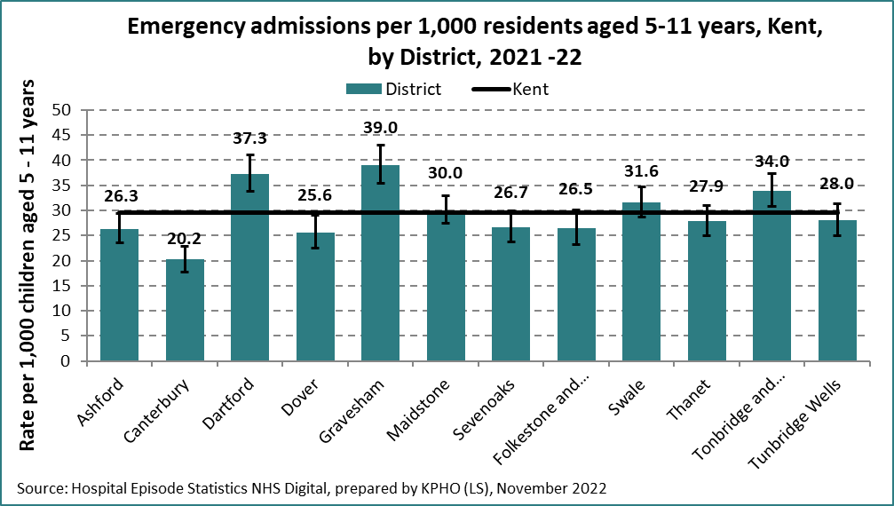

Source: Hospital episode statistics NHS digital prepared by KPHO

## 7.2 Hospital episodes for long-term conditions: Diabetes, Epilepsy & Asthma

These three long term conditions are identified within the NHS long term plan. At a local level, observation of obesity amongst those children admitted to hospital with a long-term condition has received specific attention in Kent over the last 12 months.

## 7.2.1 Diabetes

Type 1 diabetes is caused because the body is unable to produce enough insulin, which is needed to control levels of blood glucose. Type 1 is more prevalent than type 2 diabetes in children, diagnosis being seen mostly amongst under 5-year-olds and pubescent ages of 10-14 years and accounts for approximately 90% of diabetes cases in children. The risk of developing type 1 diabetes is greater for children with a sibling or parent with the condition. Type 2 diabetes is seen more in children who are obese or overweight, South Asian, and Afro-Caribbean ethnicity and prevalence is strongly associated with deprivation.[56]

Key actions to reducing diabetes healthcare inequalities by:

* increasing access to real-time continuous glucose monitors and insulin pumps across the most deprived quintiles and from ethnic minority backgrounds.
* increasing the proportion of those with Type 2 diabetes receiving recommended NICE care processes is presented in the Core20plus5 approaches for children.

There are about 35,000 children and young people under the age of 19 with diabetes in the UK. [57] Of these 96% have Type 1 diabetes. All children and young people with Type 1 diabetes and their families should have access to the best possible care and be involved in decisions that affect them. However, despite the UK having the fourth highest population of children and young people with diabetes in Europe, there is no standardised approach to care and the UK is one of the worst performing countries in terms of blood glucose control.

The following figure of the rate of diabetes admissions over a five-year period amongst primary school aged children in Kent indicates a need to better understand the difference in the rate in Gravesham district compared to other districts.

Figure 30: Crude rate of diabetes admissions per 100,000 5-11 years old by district, Kent, 2016/17-2020/21.

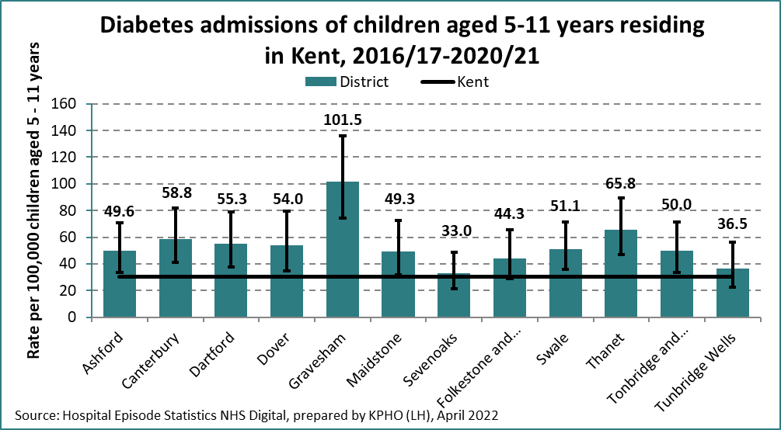

Source Hospital episodes statistics NHS digital, prepared by KPHO.

A national paediatric diabetes audit (NPDA) has been undertaken through the royal college of paediatrics and child health annually since 2010/11 which hospitals in England and Wales are encouraged to participate in. The NPDA published report for 2020/21 highlights that the incidence of type 1 diabetes amongst 0–15-year-olds in England has increased significantly. This showed a rate of 25.6 new cases per 100,000 0–15-year-old population in 2018/19 compared to a rate of 30.9 new cases per 100,000 0-15 years old population in 2020/21. The increase was higher in males compared to females. [58]

## 7.2.2 Epilepsy

**Epilepsy is the most prevalent and significant long-term neurological condition in childhood.** These may be children born with specific conditions such as Dravet syndrome who have seizures, children with brain tumours or those who receive trauma to the brain.

The prevalence of epilepsy in primary aged children is unclear but there is reference to most diagnoses being identified in the first year of life and up to the age of 10 years.

A population-based study[59] found reporting of mental health problems in children with epilepsy to be higher than parental reporting. Earlier research identified mental health problems to be highest in children with epilepsy compared to those without epilepsy. This study found that **by looking at seizure type the children who reported more symptoms of anxiety and depression experienced generalised seizures**.

Reducing epilepsy healthcare inequalities by increasing access to epilepsy specialist nurses and ensure access in the first year of care for those with a learning disability or autism is presented in the Core20plus5 approaches for children.

The following figure presents the crude rate of epilepsy admissions per 100,000 5- 11 years population over a five-year period by district 2016/17 – 2020/21. These rates range from 19.8 per 100,000 in Sevenoaks district to 129.6 per 100,000 in Dover district. These may relate to new diagnosis, difficulties in compliance or access to medication and primary care.

Figure 31: Crude rate of epilepsy admissions per 100,000 5–11-year-old population in Kent by district 2016/17-2020/21.

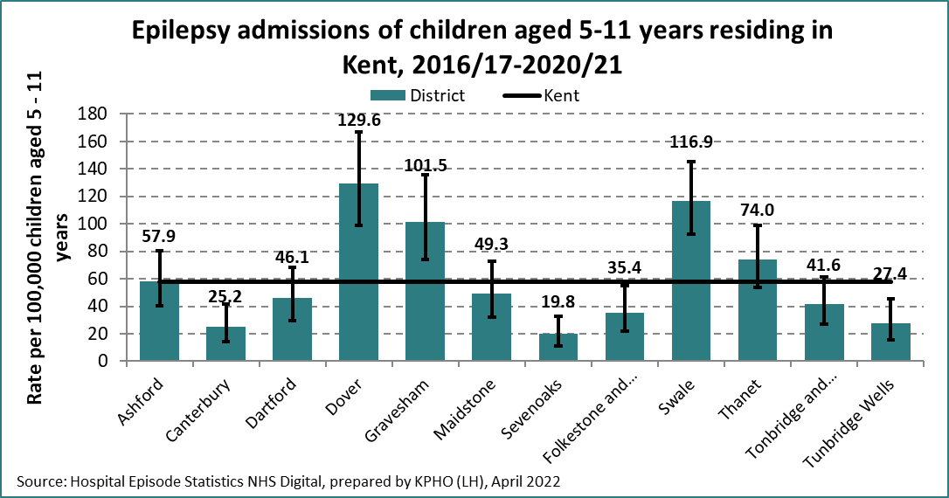

Source Hospital episodes statistics NHS digital, prepared by KPHO.

## 7.2.3 Asthma

**Currently one in 11 children in the UK are receiving treatment for asthma**.[60] The condition can be well managed but allergies, the environment, emotional changes, and hormonal changes such as puberty can affect the control of asthma.

NICE 2017[61] recommended observation and advice given on an individual’s inhaler technique: in all care settings and at every consultation relating to an asthma attack; when there is deterioration in asthma control; when the inhaler device is changed; at every annual review and if the person asks for it to be checked.

The national asthma and COPD programme organisational audit of children and young people with asthma was published in July 2022.[62] This found differences against key indicators including no dedicated respiratory nurse specialist trained in the care of children and young people with asthma in the two hospital trusts in Kent who responded. Previous national surveys in primary care have found variance in the basic care of individuals with asthma.

**Emergency admissions for asthma are strongly associated with deprivation**despite the prevalence of asthma being evenly distributed. Children and young people living in deprived areas are more likely to be exposed to higher levels of tobacco smoke and environmental pollution internal and external. Families with lower health literacy use fewer preventative services and have less effective communication with healthcare professionals and less recall and adherence to medical instruction and healthcare regimes. [63] This is illustrated in the following figure which provides the admissions for asthma among children aged 5-11 years and combines five years of data from 2016/17 – 2020/21.

Figure 32: Crude rate of asthma admissions per 100,000 population aged 5-11 years by district, Kent 2016/17 -2020/2021.

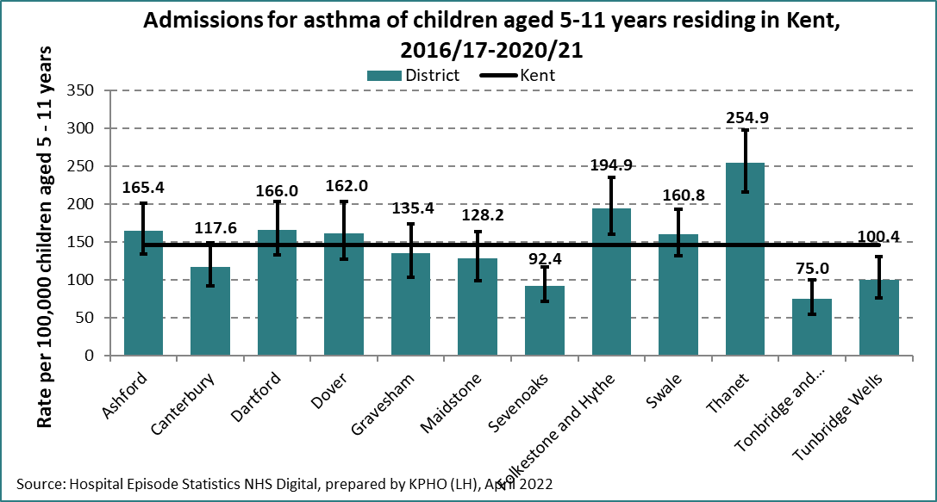

The national audit of children and young people with asthma in 2021 found that more boys [60%] than girls [40%] were admitted to hospital **and that the average age of admissions among children were 6 years old**. Most diagnosis of asthma occurs in children aged 6-8 years but similar clinical appearances to other respiratory infections may make this difficult. The arrival at hospital by children with asthma was found to be highest in the afternoon and early evening.

Reducing asthma healthcare inequalities by decreasing the number of asthma attacks and addressing over reliance on reliever medications is presented in the Core20plus5 approaches for children. Increasing knowledge and understanding will improve outcomes through:

* Improving parent/ carer understanding of asthma care and the importance of continuing management
* Improving school awareness and understanding of asthma
* Increasing awareness of the external and internal environments which may be triggers for asthma attacks amongst families, schools, and wider workforces working with children.

## 7.3 Hospital care for dental caries

In the academic year 2018/19 nationally 23.4% of 5-year-olds in England had visible tooth decay. White children were least likely to have visible tooth decay (20.6%) out of all ethnic groups whereas children from “Other” (which is classed as Other ethnic group; “Arab” and any other ethnic group) (44.3%) and “Asian” (36.9%) ethnic groups were most likely to have visible tooth decay. This data is taken from a survey in 2018/19 academic year by trained dental examiners in mainstream state funded primary schools.[64] Previous evidence looking at the survey of five-year-olds findings included strong significant statistical association that children were more likely to experience tooth decay if they were from Asian/Asian British, Mixed and Other ethnic groups when compared to White British. The most recent survey of 5-year-olds oral health in England found that ‘within ethnic groups, in the white ethnic group, children from the Gypsy and Irish traveller ethnic group (66.4%) and any other white background (37.8%) had a greater prevalence of experience of dentinal decay than children from the white British ethnic group (18.5%) [65]

Tooth decay may lead to dental extraction. Looking at the crude rates of admissions for dental caries per 10,000 5 – 11-year-old population across the districts in Kent over a five-year period in the next figure shows Gravesham district were statistically significantly higher than other districts in Kent between 2016/17 - 2020/21.

Figure 33: Crude rate of admissions for dental caries per 10,000 5–11-year-olds by district, Kent aggregated 2016/17 -2020/21

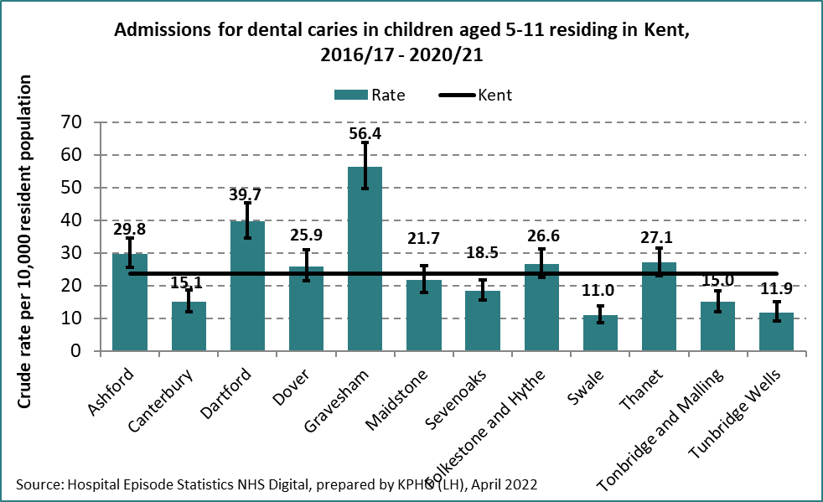

Nationally tooth extractions are still the most common reason for hospital admissions in children aged 6- 10 years.[66] Episodes of tooth extraction from children living in the most deprived communities were nearly 3 and a half times more than that of those living in affluent communities with the majority of teeth removed because of dental caries. [67]

A subsequent single year of data in the next figure shows that Gravesham district had the highest rate of admission for dental caries among children aged 6-10 years. The data for Dover district was too low and has therefore been suppressed. It is worth noting that this is not a complete picture of dental extractions undertaken under general anaesthesia among children, as this data set does not include community dental services.

Figure 34: Crude rate of admission for dental caries in children aged 6- 10 years, Kent 2022

Source : https://www.gov.uk/government/statistics/hospital-tooth-extractions-in-0-to-19-year-olds-2022

## 7.4 Injury: deliberate and unintentional

The term ‘unintentional and deliberate injuries’ is used rather than ‘accidents’ since most injuries and their precipitating events are predictable and preventable. Unintentional injuries are identified as external causes of harm, such as road traffic collisions, sports injury, falls, accidental contact with machinery, burns, poisoning and drowning. Deliberate injuries include different types of assaults and deliberate self-harm.

Nationally the five most common causes of emergency hospital admission for injury in children are falls, injuries caused by humans (not including assaults or self-harm) or animals, injuries from being hit, crushed, or cut by physical objects, burns and scalds, and poisoning. These causes account for over 90% of all emergency hospital admissions for unintentional injuries. [68]

A PHE report in 2018 [69] identified unintentional injuries as a major health inequality. The risk of unintentional injury is greatest for those living in the most deprived circumstances, for example children of parents who have never worked or are long-term unemployed are 13 times more likely to die from unintentional injury than those whose parents are in managerial or professional occupations. The risks are not solely linked to income but complex and interrelated factors, such as gender, age, culture, ethnicity, and control over the home environment.[70]

Reducing injuries has clear benefits for children and their families. Childhood injuries, especially severe injuries, can have long-term health, educational, social, and occupational consequences. These include physical disability, long-lasting psychological impact, cognitive or social impairment, lower educational achievement, and poorer employment prospects. In addition, injuries also have a negative effect on the psychological health and wellbeing of those caring for children.[71]

In conducting stakeholder interviews for this health needs assessment, interviewees reported that they had seen deliberate self-injury being displayed by children in this age group. Head banging, hair pulling, scratching self, removing eyelashes were described as related to children who presented with low mood, anxiety, and sadness.

Reducing mental healthcare inequalities by improving access rates to children’s mental health services for certain ethnic groups, age, gender, and deprivation is presented in the Core20plus5 approaches for children.

The higher rates of hospital admissions over the three-year period 2018/19 – 2020/21 for children aged 5- 11 years for unintentional injuries are seen in Gravesham and Maidstone districts in the following figure. These are not the districts with the most deprivation so further understanding as to why these rates are higher is recommended.

Figure 35: Crude rate of unintentional and deliberate injury admissions per 10,000 5-11 years old residing in Kent by district 2018-19- 2020/21



A bar chart of injury admission
Crude rate of unintentional and deliberate injury admissions of children per 10,000 5-11 years old residing in Kent 2018-19- 2020/21. The highest rate is in Gravesham at 76.5.

Summary: This section discusses access to health care services by primary school aged children which includes both services such as part of a universal offer such as vision screening and children who may be receiving care for health conditions or requiring urgent care. Presentation of three or five years of data provides information which can be compared using rates at district level. Differences are seen in the use of health care services by district. Demographics including ethnicity are not identified. These findings highlight the importance of addressing healthcare inequalities and improving access to specialised care for children with long-term conditions in Kent.

# 8. Health and wellbeing impacting on health outcomes

Supporting children to avoid poorer health outcomes by utilising measures to prevent these are important whilst recognising that many factors can determine outcomes.

## 8.1 Sleep and emotional wellbeing

The Anna Freud foundation state that good sleep is fundamental to good mental health, just as good mental health is vital to good sleep. The pattern and quality of our sleep is not only closely linked with our mental health and wellbeing, but also with our immune system, our alertness/cognitive functioning, our mood, our physical wellbeing, blood pressure and general health. Having enough good-quality sleep is key, and often underestimated, protective factor for children. Sleep helps to regenerate brains and bodies, process information and memories, boost immunity, guard against obesity and stress, and help concentration, learning and behaviour. **Primary school-aged children**[**generally need**](https://www.nhs.uk/live-well/sleep-and-tiredness/how-much-sleep-do-kids-need/)**around 10 to 11 hours of sleep a night.**[72]

In 2021, over a quarter (29%) of six- to 10-year-olds, were affected by problems with sleep on three or more nights of the previous seven. Across all age groups, levels of sleep problems were much higher in those with a probable mental disorder.[73]

Insufficient sleep means not getting enough sleep at night, which can cause several problems including **decreased brain development, learning problems and more frequent negative emotions**. It can also contribute to weight management problems, growth issues and increased frequency of illnesses.

Sleep plays a crucial role in the development of young minds. In addition to having a [direct effect on happiness](https://pubmed.ncbi.nlm.nih.gov/21651607/), research shows that sleep impacts [alertness and attention](https://pubmed.ncbi.nlm.nih.gov/25762537/), [cognitive performance](https://pubmed.ncbi.nlm.nih.gov/20202902/). Sleep also has important effects on growth, especially in [early infancy](https://pubmed.ncbi.nlm.nih.gov/26429758/). In toddlers, napping appears to be necessary for [memory consolidation](https://pubmed.ncbi.nlm.nih.gov/24062429/), [executive attention](https://pubmed.ncbi.nlm.nih.gov/28340050/), and [motor skill development](https://pubmed.ncbi.nlm.nih.gov/26645305/).[74]

## 8.2 Mental health

Mental health is as important to a child's safety and wellbeing as their physical health. It can impact on all aspects of their life, including their educational attainment, relationships, and physical wellbeing. Preventing poor mental health in primary aged children and supporting them when they have difficulties is important for future health outcomes. It can be very difficult for children to speak out about the challenges they are experiencing. Trauma informed practice asks what has happened to you. It focuses on developing trusting relationships, considers developmental need and assists practitioners to deliver the right intervention at the right time, based on the child's cognitive, social, and emotional ability. Brain changes following childhood trauma mean that children may perceive the social world differently from those who have not experienced trauma, especially at times of stress. This can make it more difficult for them to regulate their emotions and behaviour.

Prioritising the social experience of children, systems around the child should develop policies and approaches that foster supportive relationships, from the earliest years. This means being mindful of how decisions might impact a child’s ability to cultivate and maintain relationships. Activities that promote rewarding and stable relationships can have a positive social and educational impact on the child.[75]

Overall, primary school children have had greater changes in levels of mental health difficulties throughout the covid 19 pandemic compared to secondary school aged children.[76]

***We told children COVID-19 was very serious, and we all had to be very careful and stay 2 metres apart from every person. Then we told them it was all fine to go back to school and expect them not to be worried anymore***

Source: stakeholder interviews

A national longitudinal survey on children’s mental health through NHS Digital has been conducted in 2017, 2020, 2021 and 2023. One in ten 5- to 10-year-olds were estimated to have at least one mental health disorder when assessed in 2017.[77] The latest NHS digital longitudinal prevalence survey for England highlights the number of children with a diagnosable mental health condition.

The prevalence of probable mental disorder in 6- to 10-year-olds increased between 2017 and 2021; from one in ten (9.9%) to approximately one in six (17.1%). In 2021, a further one in ten (9.0%) of 6 to 10 years have a possible mental disorder.[78] The next figure provides illustration of probable mental disorders in 6- 10-year-olds.

Figure 36: Prevalence of probable mental disorder among 6- to 10-year-olds, 2017 and 2021

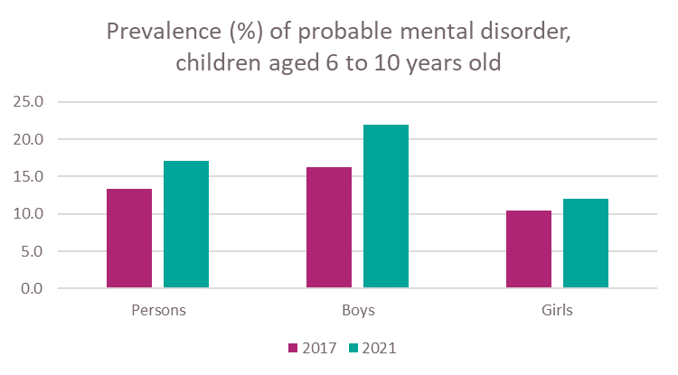

Source: NHS Digital

Applying the prevalence of a having a probable mental disorder (17.4%) to the Kent registered population aged 6 to 10 years would suggest that approximately 20,600 children may have a probable mental disorder and 10,900 may have a possible mental disorder.[79]

The findings through this longitudinal study suggest **that probable mental disorders were nearly twice as likely amongst boys compared to girls aged 6 – 10 years in 2021** and that this affects 1 in 5 boys aged 6- 10 years.

Wave 4 of this longitudinal study in 2023 suggested that probable mental disorders of children in England were more likely amongst boys compared to girls aged 8-10 years old [80]:

*We have seen an increase in the complexity of 5–11-year-olds mental needs with an increased number being seen by NELFT.*

Source: Stakeholder comment

The Strengths and Difficulties Questionnaire (SDQ) is a brief behavioural and emotional screening questionnaire and was used to indicate whether each child was unlikely, possibly, or probably demonstrating a mental health condition in the following domains: emotional challenges, behaviour challenges and hyperactivity disorders.[81]

To ensure every child develops positive mental health and resilience, it is important that schools:

* support children to make sense of their experience(s)
* find ways to manage their emotions and feelings
* create an environment of safety, connection, and compassion at all times
* build a school/Trust network of strong, positive, supportive relationships through training
* ensure children maintain the capacity to learn, despite difficult events that may occur

As part of a national programme to transform children mental health, the government is implementing Mental Health Support Teams (MHSTs) in schools and supporting a comprehensive training programme for senior mental health leads in schools, which is being taken up by schools in Kent. This approach involves promoting the mental wellbeing of all children encouraging self-care and resilience as well as more targeted work to prevent mental health problems arising in populations more vulnerable to poorer outcomes.

## 8.3 Child weight

A Kent child weight health needs assessment was published in October 2020. This section provides update on subsequent policy, strategy, and surveillance.

The national child measuring programme [NCMP] is overseen by the Office for Health Improvement and Disparities, analysed, and reported by NHS Digital. This programme measures the height and weight of children in England annually. The NCMP is a longitudinal surveillance programme which provides information on the proportion of children in reception and year 6 who are identified as underweight, healthy weight, overweight, obese, or severely obese.

In the academic year 2020/21 there was delay to the commencement of the national child measuring programme as a consequence of the Covid-19 pandemic with measuring being undertaken during the summer term only. The national requirement was to measure 10% of the total cohort for the two age groups. The intention was to measure as many as possible in year R in Kent resulting in 89.4% being measured and nearly 9% from year 6 in 2020/21. Insufficient numbers of children aged 10-11 were measured to produce robust prevalence estimates. The NCMP found that over a quarter of children aged 4-5 years in Kent were overweight or obese with the prevalence of excess weight having increased from 25.2% in the academic year 2019/20 to 26.6% in 2020/21 with higher proportion identified as obese or severely obese as shown in the following figure.

Figure 37: Prevalence of weight categories in Year R children, Kent 2016/17-2020/21

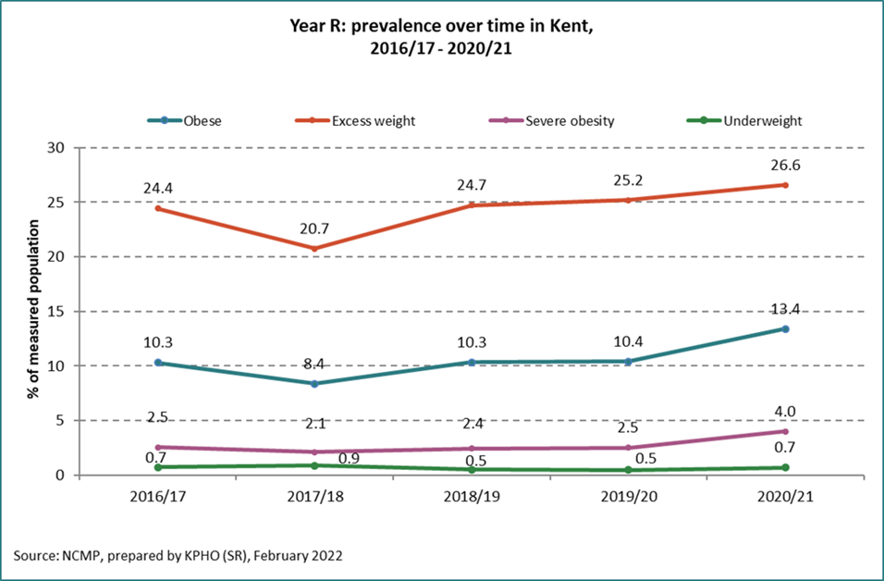

Source: NCMP

**A strong correlation between deprivation and obesity was further observed in 2020/21** with theobesity prevalence nationally for reception aged children found to be over twice as high for children living in the most deprived areas (20.3%) than for children living in the least deprived areas (7.8%). For year 6 children nationally, it was also twice as high for children living in the most deprived areas (33.8%) than for children living in the least deprived areas (14.3%). [82] In Kent year R children living in the most deprived areas in 2020/21 were nearly three times as likely to be obese than those in the least deprived areas (20.1% and 7.2% respectively).

The unintended and unexpected impacts on child weight during the covid 19 pandemic readjusted for the subsequent year R. The NCMP figures for year 6 in 2021/22 indicated a further increase in the proportion identified as overweight and identified as obese as shown in the next two figures below.

Figure 38: Proportion of year R by category of weight as measured through the NCMP, in Kent 2019/20 – 2021/22

|  |  |  |  |
| --- | --- | --- | --- |
| **Category** | **2019/20** | **2020/21** | **2021/22** |
| Healthy weight | 74.3% | 72.8% | 77.8% |
| Overweight including obese | 25.2% | 26.6% | 21.3% |
| Overweight | 14.8% | 13.2% | 11.9% |
| Obese including severely obese | 10.4% | 13.4% | 9.4% |
| Severely obese | 2.5% | 4% | 2.6% |

Source: PHE fingertips

Figure 39: Proportion of year 6 by category of weight as measured through the NCMP, in Kent 2019/20 and 2021/22

|  |  |  |
| --- | --- | --- |
| **Category** | **2019/20** | **2021/22** |
| Healthy weight | 64.3% | 62.8% |
| Overweight including obese | 34.5% | 35.8% |
| Overweight | 14.6% | 13.7% |
| Obese including severely obese | 19.9% | 22.1% |
| Severely obese | 4.2% | 5.1% |

Source: PHE fingertips

The proportion participating in the NCMP needs to be sufficiently high to ensure robustness of the data. Participation by school year dropped from 95% pre COVID to 88% in Kent compared to the national figure of 93%. Wider promotion of engagement in this programme with schools is recommended.

## 8.3.1 Changes in the weight status of children between the first and final years of primary school.

TheNational Child Measurement Programme (NCMP) National Tracking report is a longitudinal cohort analysis of programme data between 2013 to 2014 and 2019 to 2020. [83] This was the first national analysis of the NCMP data which assesses how weight status changes in individual children during primary school from reception year (aged 4 to 5 years) in 2013 to 2014 to year 6 (aged 10 to 11 years) in 2019 to 2020. It examined how individual children’s body mass index (BMI) has changed between their measurements in reception at age 4 to 5 years and their measurements in year 6 at age 10 to 11 years. How children move between BMI weight categories in reception to year 6 is examined by sex, ethnic group, deprivation, and geographic region to see if the patterns differ within these groupings. The findings therefore provide a new insight into how weight status tracks during primary school and is an important benchmark for future analyses.

Only children whose measurements could be matched between those years are included (395,623 records) and clinical thresholds for child body mass index (BMI) are used for weight status.[84]

The majority of children were a healthy weight in reception (84.7%), of these:

* 78.8% remained a healthy weight in year 6; this proportion was higher among girls (81.2%) than boys (76.6%) and among children living in the least deprived areas (84.7%) than the most deprived (74.3%)
* smaller proportions of Bangladeshi (70.2%), black African (74.0%), black Caribbean (72.9%), Indian (73.1%) and Pakistani (71.1%) children remained a healthy weight in year 6, whereas higher proportions of white British children (80.4%) remained a healthy weight in year 6
* higher proportions of children from the East of England, Southeast and Southwest remained a healthy weight (80.2%, 81.6% and 81.8% respectively) in year 6
* 19.7% moved to a higher weight category (overweight, living with obesity or severe obesity); this proportion was lower among girls (17.2%) than boys (22.3%) and higher among children living in the most deprived areas (24.3%) than the least deprived (13.9%)[85]

**This report has shown that clear demographic and geographic disparities are evident in the change of weight status of children during the primary school years**.[86]

## 8.4 Oral health

Oral health forms ‘an important aspect of a child’s overall health status and of their school readiness.’[87]

Oral health is multi-faceted and includes the ability to speak, smile, smell, taste, touch, chew, swallow and convey a range of emotions through facial expressions with confidence and without pain, discomfort, and disease of the craniofacial complex.

There are differences in primary and permanent teeth, including the composition of the enamel in primary teeth, which is less resilient and not able to provide the same level of protection from bacteria. Decay of primary teeth in the upper front teeth is associated with the recurrent consumption of sugary drinks through bottles or supping cups. This decay can easily spread to other teeth.

Tooth decay is the most common oral disease affecting children in England, yet it is largely preventable. The experience of oral health care can be seen through the extraction of teeth with general anaesthetic which is often a child’s first introduction to dental care and can lead to fear and anxiety with lifetime consequences.

There are opportunities to access to NHS dental care which is shown over a 12-month period by children aged 5- 11 years in Kent below.

Figure 40: The number of children aged 5- 11 years old who have received NHS dental care in Kent in the 12 months preceding the quarter end date of June 2022

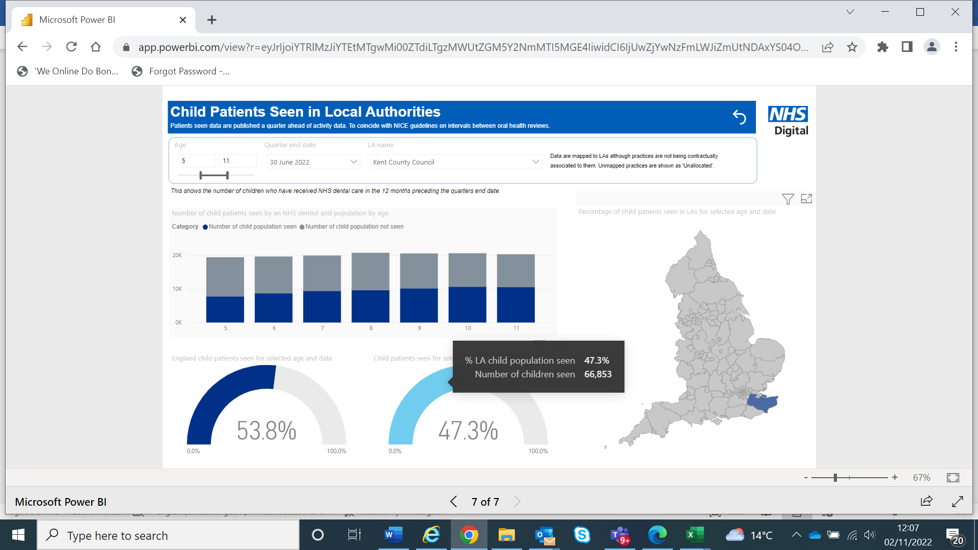

Source: NHS digital

Tooth decay can cause problems with eating, sleeping, communication and socialising, and results in at least 60,000 days being missed from school during the year for hospital extractions alone. Regularly consuming food and drinks containing sugar increases the risk of tooth decay and can lead to an increased risk of obesity and type 2 diabetes. Children are still consuming more than the recommended daily limit. [88]

The impact pathway for everyday interactions on child oral health, is a useful tool for measuring the demonstrating the impact of actions, for example from school health nurses, on oral health[89]

Areas with higher levels of deprivation experience poorer dental health, with most recent national data showing that 45% of variation can be explained by deprivation (aged 5, 35% vs 14%, from most vs least deprived quartile).

Universal evidence-based recommendations to reduce dental decay include tooth brushing twice a day, fluoride varnishing, and minimising the amount and frequency of consumption of sugar containing food and drinks.[90]

Findings from the Office for Health Improvement and Disparities (OHID) report showed that adding fluoride to drinking water can significantly reduce tooth extractions and cavities among children in England. It found that children in areas in England with higher fluoride concentrations in water were up to 63% less likely to be admitted to hospital for tooth extractions due to decay than those in areas with low fluoride concentration. The benefits seen were greater for those in more deprived areas, reducing inequalities and helping level up oral health.[91] Recent publication of a cohort study[92] in Cumbria found only a modest reduction in dental caries amongst children from the addition of fluoride in drinking water.

## 8.5 Neurodevelopmental needs

**Autism**

There is no robust prevalence of autism data of children in Kent. NHS Digital 2017 survey of children’s mental health estimated the prevalence of autism to be 1.5% (2.5% in boys and 0.4% in girls)[93]. Research published in 2021 that analysed the School Census data from the National Pupil Database, collected by the Department for Education from individuals aged 2-21 years old in state-funded schools in England further supported the NHS digital estimated and showed that of more than 7 million pupils studied, 1.76% were diagnosed with Autism. Boys showed a prevalence of autism of 2.8% and girls showed a prevalence of 0.65%. [94]

Applying the prevalence estimates of 1.76% from this recent study to the Kent population aged 6 to 10 years gives an estimated number of children with Autism of 2,100[95].

Local intelligence might suggest this proportion is an underestimate as the numbers of children on the waiting list for assessment increases and the number already diagnosed exceeds the modelled estimates. However, it is well recorded that there are significant delays in children accessing diagnostic assessments, both within Kent[96] and nationally[97] As the children included in the research conducted using the school census had a diagnosis of autism, it is possible that the prevalence is higher due to the large number of children waiting a diagnostic assessment.

A retrospective, longitudinal, school registry study in England looking at autism incidence and included areas of Kent has highlighted the incidence of autism diagnosis differs across ethnic groups. ‘The adjusted incidence of autism was slightly higher in 2014–15 than in 2015–16 or 2016–17, and, of the age groups, pupils aged 1–3 years, 4–6 years, and 10–12 years had the highest incidence of autism. Adjusted autism incidence in boys was 3·9-times the incidence in girls.’[98]

The most recent analysis from 2021/22 of SEND needs for primary aged children in Kent is presented in the next figure. Whilst this shows the primary identified need for 1 in 3 with special educational needs as speech, language and communication needs **this analysis also highlighted that 13.1% of primary aged children in Kent with SEN have a primary need identified as autistic spectrum disorder which is a medical term for autism higher than other England local authorities and that nearly 1 in 5 with SEN have social and emotional mental health as a primary need.**

Figure 41: Primary identified need in primary school 2021/22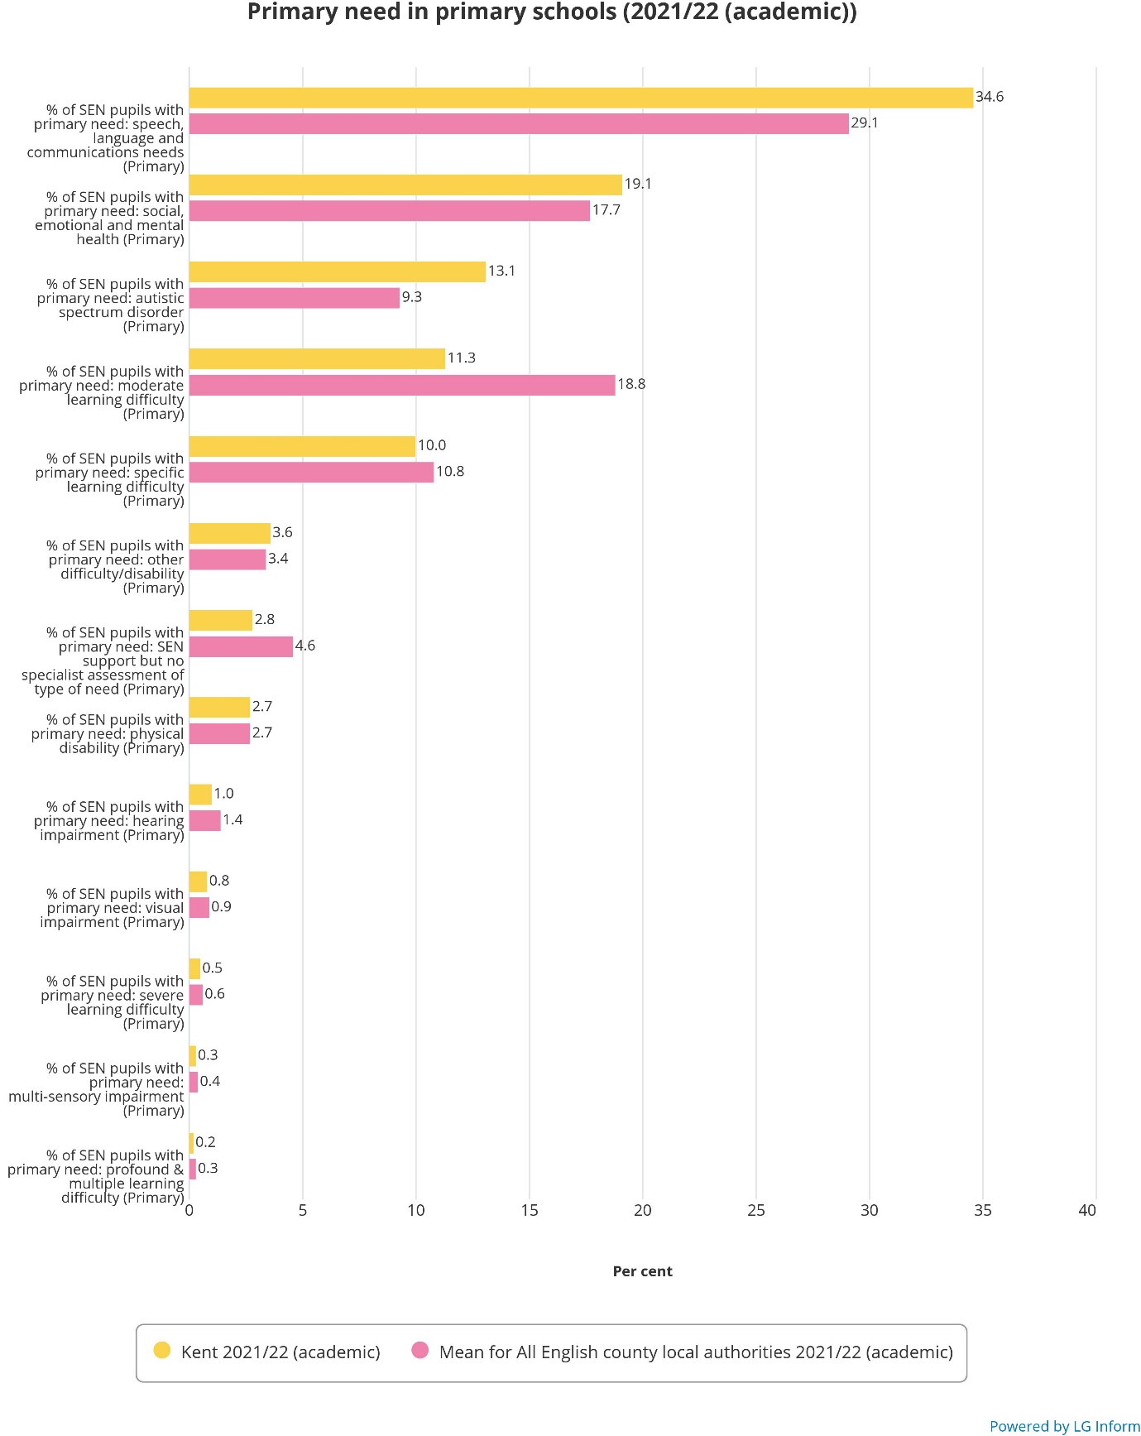Source: LGinform[99]

Communication can be difficult for those children who are autistic as social environments are difficult, they have experienced overload or have had to shut down. Assessment and diagnosis may not be made at the time the additional provision is being identified and instead place some children who are autistic with a different primary need.

**Attention deficit hyperactivity disorder [ADHD]**

ADHD is a condition which is usually identified before a child is 12 years of age and affects individuals’ behaviour. Those with ADHD may appear restless, have difficulty in concentrating or act on impulse which can make them very vulnerable. The prevalence of ADHD is globally estimated to be approximately 5% and is more commonly diagnosed in boys than girls.[100]

NHS Digital’s 2021 survey looked at the change in mean conduct problem and hyperactivity problem scores between 2017 and 2021 which is presented in the next figure. For 6- to 10-year-olds, the mean score had increased for both conduct and hyperactivity problems for both boys and girls over this time period.

Figure 42:Mean conduct and hyperactivity problem scores in 6–10-year-olds 2017 and 2021

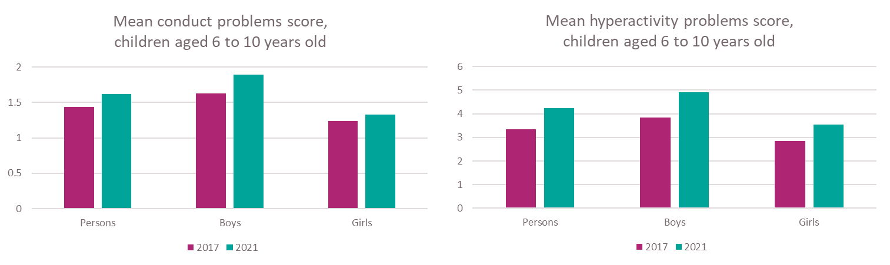

Source NHS Digital survey

## 8.6 Immunisation and vaccination

Vaccination of children is based on the recommendation of the Joint Committee on Vaccination and Immunisation (JCVI), the independent expert advisory group that advises government on vaccination. In primary aged children the main vaccination offered is the annual flu vaccine. The benefits include protection against flu for the children who receive the vaccine and reduced transmission of flu in the community. This is because children play a key role in the prevention of transmission of flu, including to those who may be at higher risk from the complications from flu such as the elderly.

Since the start of the programme, research in 2022 has shown that vaccinating large numbers of children has reduced the circulation of flu in the community. This has reduced the number of GP consultations for flu-like illness for both the vaccinated children and the wider community and has also reduced hospital admissions from flu. For schools, the benefits include reduced absenteeism and the reduced likelihood of teachers catching flu from their pupils. [101]

All primary school-aged children in England (from Reception class to Year 6) are offered a flu vaccination which is delivered by the local school-aged immunisation service. Delivery of the programme through schools increases consent as it makes it more accessible to pupils which results in higher uptake levels. The following figure provides data across three years 2019- 2021 of the proportion of primary aged children in Kent receiving the flu vaccination.

Figure 43: The proportion of Primary School aged children receiving the flu vaccination 2019-2021in Kent and England

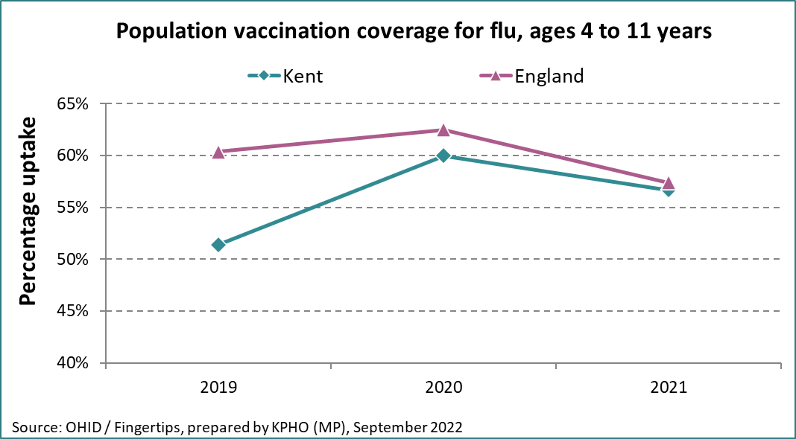

Source OHID. Fingertips

The World Health Organisation [WHO] stated vaccine hesitancy as one of the greatest threats to global health[102] however, the COVID-19 pandemic has led to a reduction in early vaccination coverage for children which means that many children starting reception unvaccinated are at risk[103].

In summary: The demographic variations are observed in the outcomes presented in this chapter. Demand for mental health support for this age group has increased with more complex and varied presenting needs being seen for primary school aged children in Kent. Self-reported injuries, sleep problems, and their impact on emotional well-being, learning, and development are major concerns. Trauma informed knowledge and practice is vital to support and response to the many concerns highlighted for primary school aged children and remains important for all professionals working with this age group to be trained in.

# 9. Key findings

Increased exposure to trauma experienced by the 5-11 age cohort which can impact their wellbeing. Sleep problems in primary school aged children affected 29% of 6–10-year-olds in 2021.

Children who face the most adversity are least likely to have resources to help them build resilience, but schools are an integral part to identify and support these children. This may be linked to the observed changes in the emotional, mental health and wellbeing needs of children aged 5-11 years as seen through increased demand for support particularly around anxiety, low mood, emotional wellbeing concerns and intentional injury. The impact on the emotional health and wellbeing of primary school age children following the Covid pandemic and lock down experiences are not yet fully understood but have been observed by schools and stakeholders.

There are also concerns over the number of home educated children, particularly those at year 6 who appear to then miss out on services as they are not in school but could have access to school public health workforce support if they wanted.

Developmental milestones in terms of learning are not being met. GRT primary school aged children have the poorest attainment and attendance of all ethnicity categories in Kent with socio-economic status and digital exclusion contributing to these issues.

Opportunities have been missed where offered and seen in the lower uptake of free school meals where entitlement is highest.

The impact of social determinants and poverty on health inequalities and the significant challenges faced by low-income and vulnerable families is seen with primary school aged children

The proportion of children eligible for disability living allowance has increased across all districts in Kent

Increasing inequalities have been illustrated as exampled in the reduced access to dentistry due to the Covid-19 pandemic, and changes to familial daily routines including toothbrushing, or in eating behaviours, have exacerbated oral health inequalities.

Differences in health care use is seen in hospital episode data. This has indicated that Gravesham district has had the higher rates of hospital admissions in four aspects of health care among primary aged children. These are: emergency admissions, admission for diabetes, unintentional /deliberate self -injury and dental extractions. Dover district has higher rates of admission for epilepsy and Thanet for admission of asthma.

Asthma in children remains both treatable and preventable, but closely linked with environmental factors such as, air pollution both outside and inside the home including poor damp housing conditions and second-hand smoking

Good sleep is fundamental to primary school aged children’s mental health and overall wellbeing, affecting cognitive function, mood, physical health, and immune system.

Differences have been seen in childhood weight as measured through the national child measuring programme showing 1 in 3 year 6 children were not a healthy weight and 3 in 4 year R children were a healthy weight.

# 10. Recommendations from findings

Trauma informed knowledge and practice is vital to support and respond to the many concerns highlighted for primary school aged children and remains highly important for all professionals working with this age group to be trained in. Trauma informed approaches are fundamental in particular for primary school children who have experienced a traumatic event and key to managing wellbeing and preventing re traumatisation.

The COVID-19 impact has had medium and long term effects on children’s emotional wellbeing. Many children have experienced increased levels of anxiety, stress, and depression due to disruptions in their daily routines, social isolation, and the uncertainty surrounding the pandemic. Further studies are needed to fully understand the extent of these effects and to develop effective interventions.

Improvement of family’s importance and understanding of personal, social and emotion skills is needed to help their children build “emotion” language skills. Earlier intervention for children in learning and understanding about talking about how they are feeling, not just at crisis point is encouraged. Promotion of online parenting courses on ‘Understanding your child’

Wider promotion of engagement in the NCMP programme with schools is recommended as this provides the data for the child excess weight indicators in the Public Health Outcomes Framework and is part of the government’s approach to tackling child obesity. The need to prevent childhood obesity remains a key focus with obesity prevalence as measured through the national child measuring programme, showing more emergence as a public health concern. There needs to be consistent monitoring of child weight in secondary care to help identify and prevent increases in a child’s weight.

Parents of primary school aged children have every right to choose to elective home educated them, however more communication is needed to ensure that these parents/carers recognise that they are still able to access support from services for their child should they need to.

Concerted system wide effort to work in the areas of greatest deprivation to support families to improved health and wellbeing and have access to services where they are needed.

Embedding activity which address wider determinants of health that impact and may increase the risk of asthma in children such as mouldy or damp housing, both of which are preventable. More investment in research and support is required to highlight the risks associated with these factors to parents, landlords and professionals.

Greater insight is needed into understanding Kent’s diverse population and the link with diabetes in 5–11-year-old children. Parents of primary school age pupils need to be supported to help their children who are insulin dependent which may impact on their child’s health and wellbeing.

More recognition is needed of differences in the population which means the way we present information is designed to accept them.

Wider promotion of eligibility for Free School Meals in primary schools, acknowledging that all children is KS1 are entitled. KCC to highlight in school entrance letter to family’s eligibility of criteria for FSM.

Reviewed investment of Digital Inclusion to reduce Digital Poverty. Greater accessible is needed for children and their families learning, online services and for greater freedom to access information.

# Appendix A

A sincere thank you to all those who have supported the authors and given their time to talk to us or provide support and access to relevant data sets. Our understanding is so much richer from our engagement with you.

We spoke to a range of stakeholders across Kent working in various sectors who are listed by general role.

* Clinical Commissioning Group [CCG] commissioners particularly those working in children’s commissioning
* ACEs programme manager
* GP
* School nursing
* Primary school DSL leads
* Attendance and inclusion manager
* Safeguarding lead
* Professional working in Domestic abuse services
* SEND partnership manager
* Professionals from Virtual school Kent

**|**

# Appendix B

Ensuring every child has the best start in life is one the key priorities of the OHID. The Healthy Child Programme is a universal programme of prevention and support for children that includes primary aged children. It is delivered as part of the local authority’s statutory responsibility to commission public health services for children. It aims to bring together health, education, and other main partners to deliver an effective programme for prevention and support for children investing in children and families and enabling children to thrive is a crucial part of achieving the Governments ‘Levelling Up’ agenda to reduce inequalities seen across the country.

Figure 44: Universal health and wellbeing review

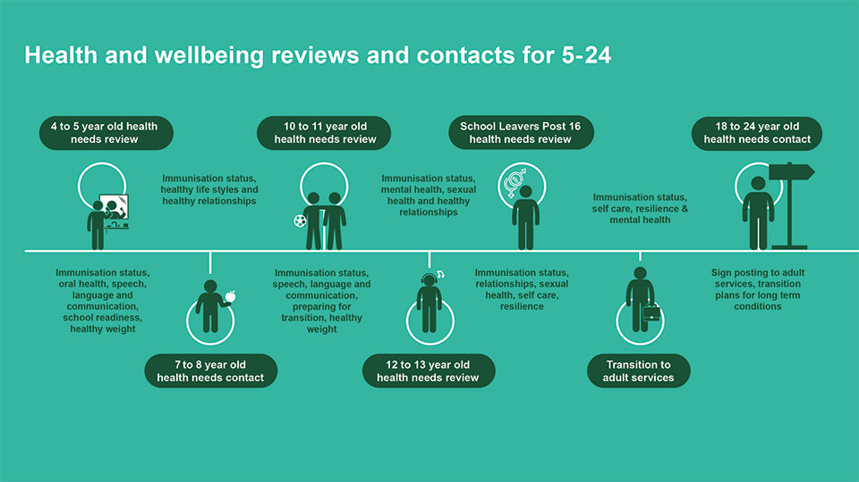

Source: school nursing and school delivery model PHE May 2021

**|**

# Appendix C

**Pupil absence and attainment England**

21.3% of possible sessions in the 2020/21 academic year were recorded as not attending in circumstances related to coronavirus. This includes pupils self-isolating and shielding, including when a class or bubble has been required to stay at home, and includes the period of national restrictions in Spring term 2021 when 57.5% of sessions were recorded as not attending. Schools were expected to provide immediate access to remote education. A further 4.6% of sessions were recorded as absence in 2020/21. This equates to over 58 million days. 2.1% of enrolments missed 10% or more possible sessions in the 2020/21 academic year.[104]

During the national lockdown period, schools were prioritised to continue providing face to face education for pupils deemed to be in the vulnerable group (those with a social worker, an education, health, and care plan, and those deemed vulnerable by the school or local authority). The department strongly encouraged vulnerable pupils to continue attending school for their education and well-being during this period.

The department also advised, however, that attendance for these children, although strongly encouraged, was not mandatory. And, where parents of a vulnerable pupil wanted their child to be absent, schools were advised to grant a leave of absence for the pupil given the exceptional circumstances. All legal penalties associated with absence over this period were disapplied to guarantee that parents were not penalised.

Other pupils who were not eligible to attend school, during restrictions, were recorded as ‘not attending in circumstances relating to coronavirus’. This is because their attendance at school was contrary to public health guidance.

This means that the absence rates for pupils who were prioritised to continue attending school this term will be higher than for those who were not eligible to attend.

Figure 45: School academic sessions recorded as not attending due to COVID 19 circumstances in 2020/2021 academic year by term.

|  |  |  |  |
| --- | --- | --- | --- |
| Sessions recorded as not attending due to COVID circumstances in 2020/21 academic year by term | | | |
|  | 2020/21  Autumn Term | 2020/21  Spring Term | 2020/21  Summer Term |
| Number of sessions recorded as not attending due to COVID circumstances | 66,831,468 | 438,795,923 | 35,526,993 |
| Rate of sessions recorded as not attending due to COVID circumstances | 7% | 57.5% | 4.3% |
| Overall absence rate | 4.7% | 3.3% | 5.8% |

Source: School census

Sessions recorded as not attending due to COVID-19 are included as possible sessions in 2020/21 only but not as an absence within absence rates. The total includes state funded primary, secondary, and special schools in England.

Figure 46: Full academic year absence rates for all schools in England from 2015 to 2021.

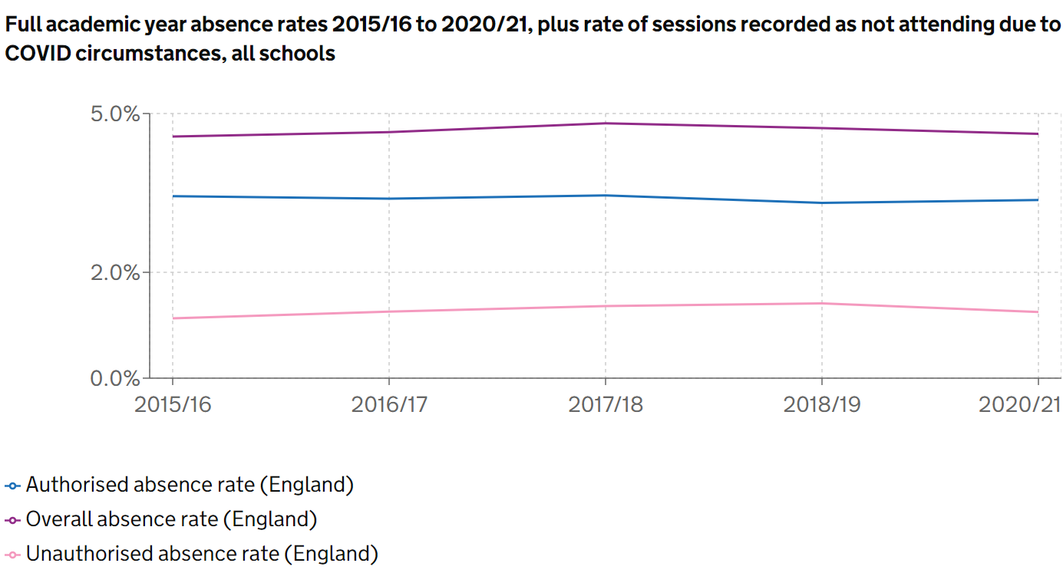

Source: School census

**National Standard Assessment Test results**

The National Curriculum Standard Assessment Tests (SATS) were cancelled in 2020 and 2021 due to the COVID-19 pandemic but reintroduced in 2022 with mixed reviews from school, parents, and carers over the readiness of children to take these.

National Curriculum Sats cover attainment in the following assessments taken by pupils at the end of year 6, when most are age 11:

* Reading test
* Maths test
* Grammar, punctuation, and spelling test
* Writing teacher assessment
* Science teacher assessment

Figure 47: Percentage of Primary pupils in England meeting the expected standards at the end of Key Stage 2.

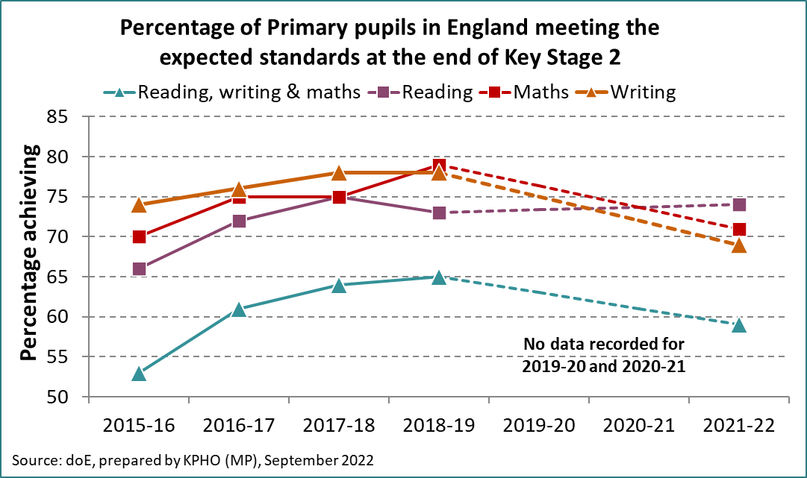

Source: Gov.UK

**The above figure includes:**

1. All schools with pupils eligible for assessment at key stage 2. Participation by independent schools is voluntary, therefore figures include results from independent schools that chose to submit data and met the requirements for assessment and moderation.
2. Pupils who reached the expected standard in all of reading, writing and maths. The expected standard in reading and maths is a scaled score of 100 or above. The expected standard in writing is a teacher assessment of 'working at the expected standard' or 'working at greater depth'.
3. The expected standard in the reading, maths and grammar, punctuation and spelling tests is a scaled score of 100 or above. The expected standard in writing is a teacher assessment of 'working at the expected standard' or 'working at greater depth'. The expected standard in science is a teacher assessment of 'working at the expected standard'.
4. Data is not available for 2020 and 2021 as assessments were cancelled in these years due to the COVID-19 pandemic.
5. Attainment in writing is not directly comparable to 2016 and 2017 because of changes to writing teacher assessment frameworks in 2018.
6. Attainment in all of reading, writing and maths is not directly comparable to 2016 and 2017 because of changes to writing teacher assessment frameworks in 2018.

The 2022 Sats show that overall, the standards in reading, writing and maths have slipped among year 6 pupils in England since the pandemic. They show 59% of pupils met the expected level in these combined areas this year, down from 64% in 2019. In individual subjects, attainment increased slightly in reading and fell in all other subjects compared to 2019.[105]

* 74% of pupils met the expected standard in reading, up from 73% in 2019.
* 71% of pupils met the expected standard in maths, down from 79% in 2019.
* 69% of pupils met the expected standard in writing, down from 78% in 2019.
* 72% of pupils met the expected standard in grammar, punctuation, and spelling, down from 78% in 2019.
* 79% of pupils met the expected standard in science, down from 83% in 2019.

The government say the Sats results were expected due to the impact of the pandemic and that there is more work to do to help pupils catch up. The Government has set out a levelling up missions, wanting 90% of children leaving Key stage 2 primary school to be reaching the expected standards in reading, writing and maths by 2030.[106]

The pupils who took their key stage 2 sats in 2022 were mostly 10- and 11-year-olds who were part way through year 4 when schools first closed to most children in 2020 due to the COVID-19 pandemic. Further school closures followed while they were in year 5 and many pupils also experienced disruption again due to the COVID-19 pandemic at the beginning of year.

**Kent Test**

Figure 48: Kent Test pass rate by year includes Kent mainstream, out of county and independent schools 2017-2021.

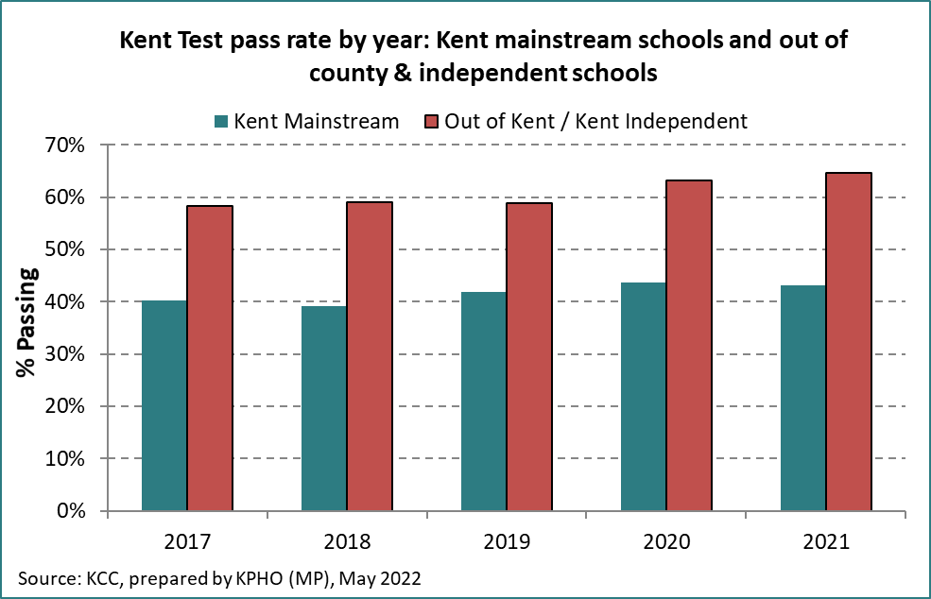

Source KCC prepared by KPHO.

Figure 49: Kent Test pass rate by gender from 2017-2021

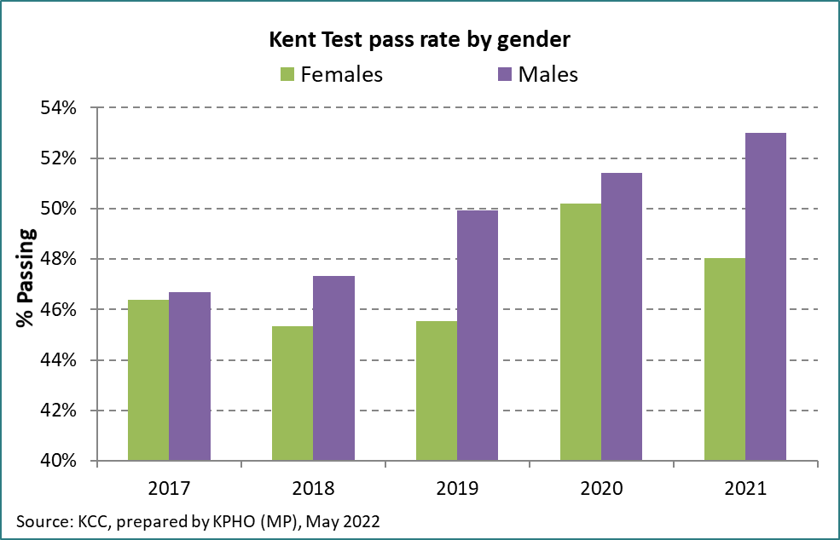Source KCC prepared by KPHO.

Figure 50: Numbers of year 6 children completing the Kent test 2017-2021

|  |  |  |  |  |  |  |
| --- | --- | --- | --- | --- | --- | --- |
| **Kent Test Pass rates - 2017 to 2021** | **Passed** | **Failed** | **Total** | **Pass rate** | **LCI** | **UCI** |
| Kent Mainstream Schools - Female | 10,849 | 15,896 | 26,745 | 40.6% | 0.398 | 0.413 |
| Kent Mainstream Schools - Male | 10,853 | 14,552 | 25,405 | 42.7% | 0.419 | 0.435 |
| Kent Mainstream Schools - Total | 21,702 | 30,448 | 52,150 | 41.6% | 0.411 | 0.422 |
| OOC/Kent Independent/Miscellaneous - Female | 8,220 | 5,562 | 13,782 | 59.6% | 0.584 | 0.609 |
| OOC/Kent Independent/Miscellaneous - Male | 8,962 | 5,526 | 14,488 | 61.9% | 0.606 | 0.632 |
| OOC/Kent Independent/Miscellaneous - total | 17,182 | 11,088 | 28,270 | 60.8% | 0.599 | 0.617 |
| **Total** | **38,884** | **41,536** | **80,420** | **48.4%** | 0.479 | 0.488 |

Source: KCC

# Appendix D

**Early help and preventative services**

Universal services - level 1. Universal services are provided to or are routinely available to all children and families. These services are accessed in the local community and delivered by partners including schools, early years education and childcare, health, GPs, hospitals, community health services, children's centres, youth hubs, police, fire service, voluntary and community groups.

Additional Support - Level 2. Children, young people, and families with additional needs who require extra help to improve education, parenting, behaviours, or to meet specific health needs. These needs can be met by universal services working together or with the addition of some targeted services such as Open access Early Help support.

Intensive Support - Level 3. Intensive support can be offered to children, young people, and families where they have complex or multiple needs requiring local authority services to work together to assess, plan and work with the family to bring about positive change. This would be worked by intensive early help and child in need services.

Specialist Support - Level 4. Children who are considered to have been harmed or are likely to suffer significant harm as a result of abuse, neglect, removal from home, or will suffer serious lasting impairment without the intervention of local authority statutory services, under high level concern Child in Need (CIN) or high-risk Child Protection (CP) services and specialist justice youth work. Children whose disability affects all aspects of development. Level 4 support would be provided by the Children social work team (CSWT)

The Front Door service is available to give access to support for children, young people and families requiring intensive or specialist support at levels 3 and 4. Any referrals that do not meet the criteria should be referred to the appropriate service for additional or universal services or consideration given as to whether the identified needs can be met within the referrer’s own service.

The Support Levels Guidance has been developed in a way which will better assist partner agencies when considering where children, young people and families sit within the continuum of need.

Partners should have a discussion with the parents or carers; and with the children and young people where appropriate, before making any request for support. If there are concerns that a child may be suffering significant harm, the Request for Support Form should be completed and immediately submitted to the Front Door.

The Request for Support Form will be used to determine the most appropriate advice and support for the family. The quality of the information received will enable the Front Door team to direct the request to the most appropriate service where the criteria is met - an Early Help Unit or Children’s Social Work Team. If the request for support does not meet level 3 or 4, the referrer or parent (if self-referred), will be contacted and advised to have a district conversation with open access. Alternatively request just for open access support can be submitted directly to open access.

Following a District Conversation, the support that can be offered is low level bespoke 1:1 single piece of support of up to 4 sessions, or signposting to local services, referrals to parenting programmes, engaging in groups and services, where additional support can be accessed. The aim is that the family will have the bespoke short piece of work and when these ends, they continue to access support universally via the children’s centres.

[SLG-Sheet-_-Nov-23_compliant_PDF.pdf (kscmp.org.uk)](https://www.kscmp.org.uk/__data/assets/pdf_file/0008/158660/SLG-Sheet-_-Nov-23_compliant_PDF.pdf)

# Appendix E

**Child disability allowance**

The DLA rate is between £24.45 and £156.90 a week and depends on the level of help the child needs. You can claim DLA for children if you’re in or out of work.[107]

The child’s disability or health condition must mean at least one of the following apply:

* they need much more looking after than a child of the same age who does not have a disability
* they have difficulty getting about

They must have had these difficulties for at least 3 months and expect them to last for at least 6 months.

DLA for children is a tax-free benefit made up of 2 components (parts). The child might qualify for one or both components.

**Care component**

|  |  |
| --- | --- |
| Care Component | Weekly Rate |
| Lowest | £24.45 |
| Middle | £61.85 |
| Highest | £92.40 |

**Mobility component**

|  |  |
| --- | --- |
| Mobility Component | Weekly Rate |
| Lowest | £24.45 |
| Highest | £64.50 |

It is also possible to qualify for carers allowance if you spend at least 35 hours a week caring for a child who gets the middle or highest care rate of DLA. [108]

**|**

# Appendix F

**Children’s mental health service use**

Across Kent and Medway, there are many emotional wellbeing and mental health services for young people aged between 5 and 11 years; however, many of these services cater for a wider age range and a breakdown of the data by age is not always available. Data have been provided below for those services where an age breakdown is possible.

[Fantastic FRED](https://www.thefantasticfredexperience.com/#:~:text=The%20Fantastic%20FRED%20Experience%20is,hall%20or%20a%20large%20classroom.) is a live performance-led mental health resource for primary aged children delivered by a team of trained actors. The letters in FRED’s name represent the areas of educational focus: F is for food, R is for rest, E is for exercise and D is for devices. Through this interactive production, children learn how to keep themselves mentally and physically healthy. As of June 2022, over 100,000 children within Kent’s primary schools had participated in the Fantastic FRED experience.

[Mental Health Support Teams](https://www.nelft.nhs.uk/kent-and-medway-mental-health-support-teams/) are a new government initiative to help increase children and young people’s access to support for emotional wellbeing and mental health. Our Kent and Medway MHSTs are provided by NELFT. MHSTs work in collaboration with education staff to develop and implement a Whole School Approach (WSA) to emotional wellbeing and mental health; offer support and guidance to schools and offer evidence-based, time-limited targeted support for difficulties. As of March 2022, there were 8 MHSTs rolled out across Kent and Medway and an additional 13 teams will mobilise over the next 2 years. The current 8 MHSTs provide support in 127 schools across Kent and Medway, of which 80 of these are primary schools.

Xenzone provide [KOOTH](https://www.kooth.com/), an online counselling service which support children and young people aged 10 to 25 years. KOOTH also hosts an online community where CYP can access articles, create journals, or participate in facilitated discussion areas. In quarter 4 of 2021/22, service users aged 10 or 11 years old represented 12.51% of KOOTH’s new registrations.

[CHUMS](https://chums.uk.com/kent-bereavement-service/) mobilised across Kent and Medway offering specialist bereavement support to children and young people from 3½ up until their 26th birthday. In the first six months of the service, 42.8% of CYP on the CHUMS caseload were aged between 5 and 11 years old.

More detail regarding emotional wellbeing and mental health services available to children and young people across Kent and Medway can be found in the Local transformation plan [Local Transformation Plan](https://www.kentandmedwayccg.nhs.uk/about-us/ccg-archive/Local-transformation-plan-for-CYP-emotional-wellbeing-and-mental-health).

# Appendix G

**Minor injuries units**

Estuary View, Whitstable

Victoria Hospital, Deal

Sevenoaks hospital, Sevenoaks

Queen Victoria memorial Hospital, Herne Bay

Faversham Health centre, Faversham

Sittingbourne Memorial hospital, Sittingbourne

Royal Victoria hospital, Folkestone

Gravesham community hospital, Gravesham

Buckland hospital, Dover

Edenbridge hospital, Tonbridge Wells

Sheppey Community Hospital, Sheppey

# Appendix H

Figure 51: Percentage of children under 16 years of age, per district in Kent living in low-income families 2022.

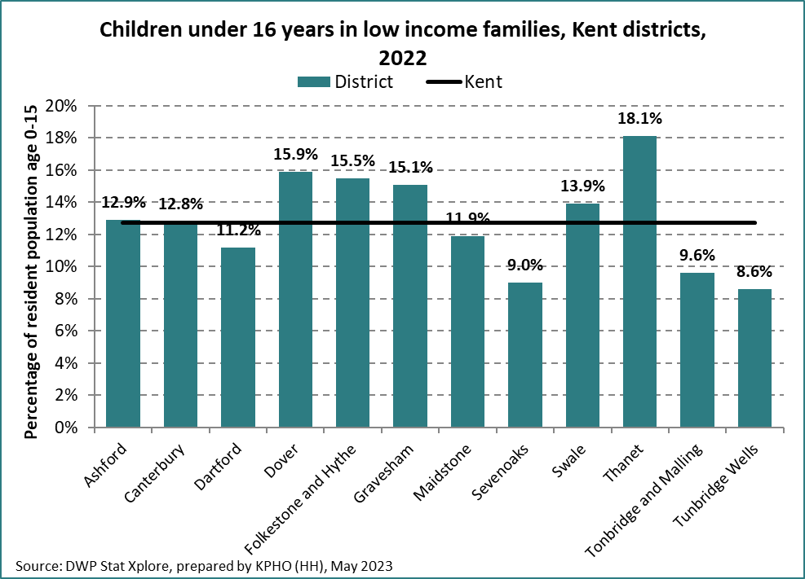

Source: DWP Sta Xplore

The percentage of children in low-income families varied across Kent districts in 2022, from 8.6% in Tunbridge Wells to 18.1% in Thanet. The Kent average was 12.8%, equating to approximately 38,000 children**.** Please note these figures were not validated at the time presented.

## References

1. [Covid-19: impact on child poverty and on young people’s education, health and wellbeing - House of Lords Library (parliament.uk)](https://lordslibrary.parliament.uk/covid-19-impact-on-child-poverty-and-on-young-peoples-education-health-and-wellbeing/#:~:text=The%20huge%20disruption%20to%20schooling,seen%20prior%20to%20the%20pandemic.)
2. [Mental Health of Children and Young People in England, 2020: Wave 1 follow up to the 2017 survey - NHS England Digital](https://digital.nhs.uk/data-and-information/publications/statistical/mental-health-of-children-and-young-people-in-england/2020-wave-1-follow-up)
3. Core20PLUS5 - An approach to reducing health inequalities for children and young people [NHS England » Core20PLUS5 infographic – Children and young people](https://www.england.nhs.uk/publication/core20plus5-infographic-children-and-young-people/)
4. Core20Plus5 – An approach to reducing health inequalities for children and young people NHS England [NHS England » Core20PLUS5 – An approach to reducing health inequalities for children and young people](https://www.england.nhs.uk/about/equality/equality-hub/national-healthcare-inequalities-improvement-programme/core20plus5/core20plus5-cyp/)
5. . [Overview | Social, emotional and mental wellbeing in primary and secondary education | Guidance | NICE](https://www.nice.org.uk/guidance/ng223)
6. [Addressing vulnerability in childhood - a public health informed approach (publishing.service.gov.uk)](https://assets.publishing.service.gov.uk/media/5f4e8896d3bf7f0a2d41c511/Public_health_approach_to_vulnerability_in_childhood.pdf)
7. [Fair Society Healthy Lives (The Marmot Review) - IHE (instituteofhealthequity.org)](https://www.instituteofhealthequity.org/resources-reports/fair-society-healthy-lives-the-marmot-review)
8. [Strategic Review of Health Inequalities in England - post 2010 - Presentation of findings - IHE (instituteofhealthequity.org)](https://www.instituteofhealthequity.org/resources-reports/strategic-review-of-health-inequalities-in-england-post-2010-presentation-of-findings)
9. [What works in enhancing social and emotional skills development during childhood and adolescence? | Early Intervention Foundation (eif.org.uk)](https://www.eif.org.uk/report/what-works-in-enhancing-social-and-emotional-skills-development-during-childhood-and-adolescence)
10. [Overview | Social, emotional and mental wellbeing in primary and secondary education | Guidance | NICE](https://www.nice.org.uk/guidance/ng223)
11. [Overview | Social, emotional and mental wellbeing in primary and secondary education | Guidance | NICE](https://www.nice.org.uk/guidance/ng223)
12. [Mental health support | Action For Children](https://www.actionforchildren.org.uk/our-work-and-impact/children-and-families/good-mental-health/)
13. Working definition of trauma-informed practice - GOV.UK (www.gov.uk)
14. [Trauma Informed Schools UK](https://www.traumainformedschools.co.uk/)
15. [Trauma informed resources - Kent County Council](https://www.kent.gov.uk/social-care-and-health/information-for-social-care-professionals/space-matters/trauma-informed-resources)
16. [Health and Social Care Act 2012: fact sheets - GOV.UK (www.gov.uk)](https://www.gov.uk/government/publications/health-and-social-care-act-2012-fact-sheets)
17. [School aged years high impact area 6: Supporting self-care and improving health literacy - GOV.UK (www.gov.uk)](https://www.gov.uk/government/publications/commissioning-of-public-health-services-for-children/school-aged-years-high-impact-area-6-supporting-self-care-and-improving-health-literacy)
18. [Mental Health of Children and Young People in England, 2020: Wave 1 follow up to the 2017 survey - NHS England Digital](https://digital.nhs.uk/data-and-information/publications/statistical/mental-health-of-children-and-young-people-in-england/2020-wave-1-follow-up)
19. [Coronavirus (COVID-19) and the different effects on men and women in the UK, March 2020 to February 2021 - Office for National Statistics (ons.gov.uk)](https://www.ons.gov.uk/peoplepopulationandcommunity/healthandsocialcare/conditionsanddiseases/articles/coronaviruscovid19andthedifferenteffectsonmenandwomenintheukmarch2020tofebruary2021/2021-03-10)
20. [COVID-19 and the digital divide in the UK - The Lancet Digital Health](https://www.thelancet.com/journals/landig/article/PIIS2589-7500(20)30169-2/fulltext)
21. Education Endowment Foundation: COVID-19 disruption – attainment gaps and primary school responses Feb 2022 [Impact of COVID-19 disruptions in primary schools: attainment… | EEF (educationendowmentfoundation.org.uk)](https://educationendowmentfoundation.org.uk/projects-and-evaluation/projects/covid-19-disruptions-in-primary-schools-attainment-gaps-and-school-responses#:~:text=Key%20findings,to%20about%20one%20month%27s%20progress.)
22. [Books, Resources & Software for Teachers - Rising Stars (risingstars-uk.com)](https://www.risingstars-uk.com/)
23. Education Endowment Foundation COVID-19 disruption – attainment gaps and primary school responses Feb 2022, page 10 [Impact of COVID-19 disruptions in primary schools: attainment… | EEF (educationendowmentfoundation.org.uk)](https://educationendowmentfoundation.org.uk/projects-and-evaluation/projects/covid-19-disruptions-in-primary-schools-attainment-gaps-and-school-responses#:~:text=Key%20findings,to%20about%20one%20month%27s%20progress.)  
    
24. [DfE Outcome Delivery Plan: 2021 to 2022 - GOV.UK (www.gov.uk)](https://www.gov.uk/government/publications/department-for-education-outcome-delivery-plan/dfe-outcome-delivery-plan-2021-to-2022)
25. [Primary teachers' experience of the COVID-19 lockdown – Eight key messages for policymakers going forward - UCL Discovery](https://discovery.ucl.ac.uk/id/eprint/10103669/)
26. Teacher Tapp Survey [Homepage - Teacher Tapp](https://teachertapp.co.uk/)
27. Explore-education-statstics.service.gov.uk [Explore our statistics and data - Explore education statistics - GOV.UK (explore-education-statistics.service.gov.uk)](https://explore-education-statistics.service.gov.uk/)
28. [Ethnic group, England and Wales - Office for National Statistics (ons.gov.uk)](https://www.ons.gov.uk/peoplepopulationandcommunity/culturalidentity/ethnicity/bulletins/ethnicgroupenglandandwales/census2021#ethnic-group-data)
29. [No child left behind: understanding and quantifying vulnerability (publishing.service.gov.uk)](https://assets.publishing.service.gov.uk/government/uploads/system/uploads/attachment_data/file/913974/Understanding_and_quantifying_vulnerability_in_childhood.pdf)
30. Why do children go into children’s homes April 2022 GOV.UK [Why do children go into children’s homes? - GOV.UK (www.gov.uk)](https://www.gov.uk/government/publications/why-do-children-go-into-childrens-homes/why-do-children-go-into-childrens-homes)
31. [Fair society, healthy lives : the Marmot Review : strategic review of health inequalities in England post-2010. - GOV.UK (www.gov.uk)](https://www.gov.uk/research-for-development-outputs/fair-society-healthy-lives-the-marmot-review-strategic-review-of-health-inequalities-in-england-post-2010)
32. Healthy child programme: 5-19 years old. GOV.UK [Healthy child programme - GOV.UK (www.gov.uk)](https://www.gov.uk/government/collections/healthy-child-programme)
33. [Working together to safeguard children 2023: statutory guidance (publishing.service.gov.uk)](https://assets.publishing.service.gov.uk/media/669e7501ab418ab055592a7b/Working_together_to_safeguard_children_2023.pdf)
34. KentCHT free online parenting courses [Parenting courses to support you and your child - Kent family (kentcht.nhs.uk)](https://family.kentcht.nhs.uk/support/your-family/health-visiting-services-for-you/parenting-courses-to-support-you-and-your-child/)
35. Kent Support Level Guidance [Support-Levels-Guidance-Sheet.pdf (kelsi.org.uk)](https://www.kelsi.org.uk/__data/assets/pdf_file/0010/86464/Support-Levels-Guidance-Sheet.pdf)
36. [Working together to safeguard children 2023: statutory guidance (publishing.service.gov.uk)](https://assets.publishing.service.gov.uk/media/669e7501ab418ab055592a7b/Working_together_to_safeguard_children_2023.pdf)
37. Children’s Act 1989 [The Children Act 1989 guidance and regulations (publishing.service.gov.uk)](https://assets.publishing.service.gov.uk/government/uploads/system/uploads/attachment_data/file/1000549/The_Children_Act_1989_guidance_and_regulations_Volume_2_care_planning__placement_and_case_review.pdf)
38. Children’s Act 2004 [Children Act 2004 (legislation.gov.uk)](https://www.legislation.gov.uk/ukpga/2004/31/contents)
39. Health Equity in England: The Marmot review 10 years on. Institute of Health Equity [Marmot Review 10 Years On - IHE (instituteofhealthequity.org)](https://www.instituteofhealthequity.org/resources-reports/marmot-review-10-years-on)
40. Marmot et al, Health Equity in England: The Marmot Review 10 Years On (2020) [the-marmot-review-10-years-on - IHE (instituteofhealthequity.org)](https://www.instituteofhealthequity.org/the-marmot-review-10-years-on)
41. Index of multiple deprivation 2019 Headline findings for Kent [The Index of Multiple deprivation (IMD2019): Headline findings for Kent](https://www.kent.gov.uk/__data/assets/pdf_file/0006/7953/Indices-of-Deprivation-headline-findings.pdf)
42. Children in Poverty, Kent Analytics statistical bulletin April 2022 [Children in Poverty (kent.gov.uk)](https://www.kent.gov.uk/__data/assets/pdf_file/0009/7956/Children-in-poverty.pdf)
43. No child left behind: understanding and quantifying vulnerabilities. [No child left behind: understanding and quantifying vulnerability - GOV.UK (publishing.service.gov.uk)](https://assets.publishing.service.gov.uk/media/5f4f72c68fa8f523f4c3c0ed/Understanding_and_quantifying_vulnerability_in_childhood.pdf/preview)
44. Food Insecurity. The Food Foundation September 2022 [New data show 4 million children in households affected by food insecurity | Food Foundation](https://foodfoundation.org.uk/publication/new-data-show-4-million-children-households-affected-food-insecurity)
45. Usually, you will not get Housing Benefit if:

    your savings are over £16,000 - unless you get Guarantee Credit of Pension Credit

    you’re paying a mortgage on your own home - you may be able to get [Support for Mortgage Interest (SMI)](https://www.gov.uk/support-for-mortgage-interest)

    you live in the home of a close relative.

    you’re already claiming [Universal Credit](https://www.gov.uk/housing-and-universal-credit) (unless you’re in temporary or supported housing)

    you live with your partner, and they are already claiming Housing Benefit

    you’re a full-time student.

    you’re residing in the UK as a [European Economic Area (EEA)](https://www.gov.uk/eu-eea) jobseeker.

    you’re an asylum seeker or sponsored to be in the UK.

    you’re subject to immigration control and your granted leave states that you cannot claim public funds.

    you’re a Crown Tenant

    you’ve reached State Pension age, but your live-in partner has not - unless you had an existing claim as a couple before 15 May 2019
46. [Free school meals - Kent County Council](https://www.kent.gov.uk/education-and-children/schools/free-school-meals)
47. [School food standards: resources for schools - GOV.UK (www.gov.uk)](https://www.gov.uk/government/publications/school-food-standards-resources-for-schools#full-publication-update-history)
48. Headteachers update 2020 [Free school meals uptake: Removing the barriers (headteacher-update.com)](https://www.headteacher-update.com/best-practice-article/free-school-meals-uptake-removing-the-barriers-poverty-pupil-premium-funding-disadvantage-fsm-stigma-1/237883/)
49. [Disability, poverty and transitional support | Iriss](https://www.iriss.org.uk/resources/esss-outlines/disability-poverty-transitions)
50. [Disability_long_term_conditions_and_poverty.pdf (npi.org.uk)](https://www.npi.org.uk/files/7814/0490/1005/Disability_long_term_conditions_and_poverty.pdf)
51. <https://www.gov.uk/disability-living-allowance-children/eligibility>
52. [Resource - Kent Digital Exclusion Reports - June 2021 (digitalkent.uk)](https://www.digitalkent.uk/resources/detail/kent-digital-exclusion-reports-june-2021-537)
53. [Resource - Kent Digital Exclusion Reports - June 2021 (digitalkent.uk)](https://www.digitalkent.uk/resources/detail/kent-digital-exclusion-reports-june-2021-537)
54. [Digital Poverty in the UK - Evidence Review 2022 - LGiU](https://lgiu.org/briefing/digital-poverty-in-the-uk-evidence-review-2022/)
55. Health needs assessment 0–4-year-olds in Kent 2022 [0-4-HNA-10.11.22.pdf (kpho.org.uk)](https://www.kpho.org.uk/__data/assets/pdf_file/0016/141433/0-4-HNA-10.11.22.pdf)
56. Royal College of Paediatrics and Child Health (2020) State of Child Health. London: RCPCH. [RCPCH – State of Child Health – Insight into the state of child health in the UK](https://stateofchildhealth.rcpch.ac.uk/)
57. [High Quality Care for Children and Young People with Type 1 Diabetes | Diabetes UK](https://www.diabetes.org.uk/about-us/about-the-charity/our-strategy/position-statements/high-quality-care-for-children-and-young-people-with-type-1-diabetes-in-the-uk)
58. National Paediatric Diabetes Audit (NPNA) annual national report 2020/21: care and processes [National NPDA report 2020-21 Summary Report.pdf (rcpch.ac.uk)](https://www.rcpch.ac.uk/sites/default/files/2022-04/National%20NPDA%20report%202020-21%20Summary%20Report.pdf)

   
59. [Symptoms of anxiety and depression in school-aged children with active epilepsy: A population-based study - PubMed (nih.gov)](https://pubmed.ncbi.nlm.nih.gov/26432983/)
60. <https://stateofchildhealth.rcpch.ac.uk/evidence/long-term-conditions/asthma/#page-section-5>
61. NICE 2017 ‘Asthma: diagnosis, monitoring and chronic asthma management’ <https://www.nice.org.uk/guidance/ng80/chapter/Recommendations#monitoring-asthma-control>
62. [National Asthma and COPD Audit Programme (NACAP) - Child and young person asthma 2021 organisational audit - data.gov.uk](https://www.data.gov.uk/dataset/931b2727-30c2-4933-8c6d-ee40adb15398/national-asthma-and-copd-audit-programme-nacap-child-and-young-person-asthma-2021-organisational-audit)
63. <https://www.asthmaandlung.org.uk/sites/default/files/2023-03/auk-health-inequalities-final.pdf>
64. [Tooth decay in 5 year olds - GOV.UK Ethnicity facts and figures (ethnicity-facts-figures.service.gov.uk)](https://www.ethnicity-facts-figures.service.gov.uk/health/physical-health/absence-of-tooth-decay-in-5-year-olds/latest/#:~:text=Main%20facts%20and%20figures%20in%20the%202021%20to,ethnic%20groups%20%E2%80%93%20lower%20than%20the%20national%20average)
65. [National Dental Epidemiology Programme (NDEP) for England: oral health survey of 5 year old children 2022 - GOV.UK (www.gov.uk)](https://www.gov.uk/government/statistics/oral-health-survey-of-5-year-old-children-2022/national-dental-epidemiology-programme-ndep-for-england-oral-health-survey-of-5-year-old-children-2022)
66. [Tooth decay key cause for hospital visits among children - Dentistry](https://dentistry.co.uk/2023/02/24/unfair-and-unjust-tooth-extractions-key-reason-for-hospital-admissions-among-young-children/#:~:text=%27Unfair%20and%20unjust%27%20%E2%80%93%20tooth,hospital%20admissions%20among%20young%20children&text=New%20data%20shows%20that%20tooth,between%20six%20and%2010%20years.)
67. Hospital tooth extractions in 0 to 19 year olds 2022 - GOV.UK (www.gov.uk)
68. [Reducing unintentional injuries in and around the home among children under five (publishing.service.gov.uk)](https://assets.publishing.service.gov.uk/media/5ac3515be5274a0b107eac59/Unintentional_injuries_under_fives_in_home.pdf)
69. [Reducing unintentional injuries on the roads among children and young people (publishing.service.gov.uk)](https://assets.publishing.service.gov.uk/media/5abb9f9e40f0b67d67479cb2/Reducing_unintentional_injuries_on_the_roads_among_children_and_young_people_.pdf)
70. [Overview | Unintentional injuries in the home: interventions for under 15s | Guidance | NICE](https://www.nice.org.uk/Guidance/PH30)
71. [Reducing unintentional injuries in and around the home among children under five (publishing.service.gov.uk)](https://assets.publishing.service.gov.uk/media/5ac3515be5274a0b107eac59/Unintentional_injuries_under_fives_in_home.pdf)
72. Sleep. Anna Freud centre for children and families [Sleep : Mentally Healthy Schools](https://www.mentallyhealthyschools.org.uk/factors-that-impact-mental-health/lifestyle-factors/sleep/)
73. [Mental Health of Children and Young People in England 2021 - wave 2 follow up to the 2017 survey - NHS England Digital](https://digital.nhs.uk/data-and-information/publications/statistical/mental-health-of-children-and-young-people-in-england/2021-follow-up-to-the-2017-survey)
74. [Children and Sleep | Sleep Foundation](https://www.sleepfoundation.org/children-and-sleep)
75. [Childhood trauma, the brain and the social world - UK Trauma Council](https://uktraumacouncil.org/resource/childhood-trauma-and-the-social-world)
76. [Co-Space Study (cospaceoxford.org)](https://cospaceoxford.org/)
77. [Mental Health of Children and Young People in England, 2017 [PAS] - NHS England Digital](https://digital.nhs.uk/data-and-information/publications/statistical/mental-health-of-children-and-young-people-in-england/2017/2017)
78. NHS Digital [mhcyp_2020_meth.pdf (digital.nhs.uk)](https://files.digital.nhs.uk/D1/D411D3/mhcyp_2020_meth.pdf)
79. NHS Digital [mhcyp_2020_meth.pdf (digital.nhs.uk)](https://files.digital.nhs.uk/D1/D411D3/mhcyp_2020_meth.pdf)
80. Mental health of CYP in England 2023 wave 4 follow up to 2017 survey. [Mental Health of Children and Young People in England, 2023 - wave 4 follow up to the 2017 survey - NHS England Digital](https://digital.nhs.uk/data-and-information/publications/statistical/mental-health-of-children-and-young-people-in-england/2023-wave-4-follow-up)
81. NHS Digital, <https://files.digital.nhs.uk/D1/D411D3/mhcyp_2020_meth.pdf> [accessed June 2022]
82. [National Child Measurement Programme, England 2020/21 School Year - NHS England Digital](https://digital.nhs.uk/data-and-information/publications/statistical/national-child-measurement-programme/2020-21-school-year)
83. [Changes in the weight status of children between the first and final years of primary school: A longitudinal cohort analysis of data from the National Child Measurement Programme in England between 2013 to 2014 and 2019 to 2020 - Official statistics announcement - GOV.UK (www.gov.uk)](https://www.gov.uk/government/statistics/announcements/changes-in-the-weight-status-of-children-between-the-first-and-final-years-of-primary-school-a-longitudinal-cohort-analysis-of-data-from-the-national)
84. [Changes in the weight status of children between the first and final years of primary school (phe.org.uk)](https://fingertips.phe.org.uk/static-reports/national-child-measurement-programme/Changes-in-the-weight-status-of-children-between-the-first-and-final-years-of-primary-school.html)
85. [Changes in the weight status of children between the first and final years of primary school - GOV.UK (www.gov.uk)](https://www.gov.uk/government/statistics/changes-in-the-weight-status-of-children-between-the-first-and-final-years-of-primary-school)
86. [Changes in the weight status of children between the first and final years of primary school: A longitudinal cohort analysis of data from the National Child Measurement Programme in England between 2013 to 2014 and 2019 to 2020 - Official statistics announcement - GOV.UK (www.gov.uk)](https://www.gov.uk/government/statistics/announcements/changes-in-the-weight-status-of-children-between-the-first-and-final-years-of-primary-school-a-longitudinal-cohort-analysis-of-data-from-the-national)
87. [School-aged years high impact area 3: Supporting healthy lifestyles - GOV.UK (www.gov.uk)](https://www.gov.uk/government/publications/commissioning-of-public-health-services-for-children/school-aged-years-high-impact-area-3-supporting-healthy-lifestyles)
88. [Child oral health: applying All Our Health - GOV.UK (www.gov.uk)](https://www.gov.uk/government/publications/child-oral-health-applying-all-our-health/child-oral-health-applying-all-our-health)

   
89. [Delivering better oral health: an evidence-based toolkit for prevention - GOV.UK (www.gov.uk)](https://www.gov.uk/government/publications/delivering-better-oral-health-an-evidence-based-toolkit-for-prevention)
90. [The Eatwell Guide - GOV.UK (www.gov.uk)](https://www.gov.uk/government/publications/the-eatwell-guide)
91. [New report confirms fluoridation can reduce tooth decay among children - GOV.UK (www.gov.uk)](https://www.gov.uk/government/news/new-report-confirms-fluoridation-can-reduce-tooth-decay-among-children)
92. # [Evaluation of water fluoridation scheme in Cumbria: the CATFISH prospective longitudinal cohort study (nihr.ac.uk)](https://www.journalslibrary.nihr.ac.uk/phr/SHMX1584/#/full-report)

   
93. [Mental Health of Children and Young People in England, 2017 [PAS] - NHS England Digital](https://digital.nhs.uk/data-and-information/publications/statistical/mental-health-of-children-and-young-people-in-england/2017/2017)
94. [Association of Race/Ethnicity and Social Disadvantage With Autism Prevalence in 7 Million School Children in England - PubMed (nih.gov)](https://pubmed.ncbi.nlm.nih.gov/33779707/)
95.
96. [SEND Written Statement of Action (kent.gov.uk)](https://www.kent.gov.uk/__data/assets/pdf_file/0008/99719/SEND-Written-Statement-of-Action.pdf)
97. [Autism spectrum disorder (bma.org.uk)](https://www.bma.org.uk/what-we-do/population-health/improving-the-health-of-specific-groups/autism-spectrum-disorder)
98. [Autism incidence and spatial analysis in more than 7 million pupils in English schools: a retrospective, longitudinal, school registry study (thelancet.com)](https://www.thelancet.com/action/showPdf?pii=S2352-4642%2822%2900247-4)
99. [Local area Special Educational Needs and Disabilities report for Kent County Council | LG Inform](https://lginform.local.gov.uk/reports/view/send-research/local-area-send-report?mod-area=E10000016&mod-group=AllCountiesInCountry_England&mod-type=namedComparisonGroup)
100. [Prevalence | Background information | Attention deficit hyperactivity disorder | CKS | NICE](https://cks.nice.org.uk/topics/attention-deficit-hyperactivity-disorder/background-information/prevalence/)
101. [Flu vaccination in schools - GOV.UK (www.gov.uk)](https://www.gov.uk/government/publications/flu-vaccination-in-schools)
102. WHO [Ten threats to global health in 2019 (who.int)](https://www.who.int/news-room/spotlight/ten-threats-to-global-health-in-2019#:~:text=These%20range%20from%20outbreaks%20of,change%20and%20multiple%20humanitarian%20crises.)
103. [COVID-19: impact on childhood vaccinations: data to August 2021 - GOV.UK (www.gov.uk)](https://www.gov.uk/government/publications/covid-19-impact-on-childhood-vaccinations-data-to-august-2021)
104. [Attendance in education and early years settings during the coronavirus (COVID-19) pandemic, Week 30 2022 - Explore education statistics - GOV.UK (explore-education-statistics.service.gov.uk)](https://explore-education-statistics.service.gov.uk/find-statistics/attendance-in-education-and-early-years-settings-during-the-coronavirus-covid-19-outbreak)
105. [Key stage 2 attainment, Academic year 2021/22 - Explore education statistics - GOV.UK (explore-education-statistics.service.gov.uk)](https://explore-education-statistics.service.gov.uk/find-statistics/key-stage-2-attainment/2021-22)

    
106. [Levelling Up the United Kingdom - GOV.UK (www.gov.uk)](https://www.gov.uk/government/publications/levelling-up-the-united-kingdom)
107. [Disability Living Allowance (DLA) for children: Overview - GOV.UK (www.gov.uk)](https://www.gov.uk/disability-living-allowance-children)
108. [Disability Living Allowance (DLA) for children: Overview - GOV.UK (www.gov.uk)](https://www.gov.uk/disability-living-allowance-children)