[](http://www.kpho.org.uk)

**Kent Sexual Health Needs Assessment**

**November 2024**



**|**

Version Control

|  |  |  |  |
| --- | --- | --- | --- |
| **Version Number** | **Date** | **Reviewer** | **Change reference and summary** |
| 1 | 19/08/2024 |  | Initial draft submitted |
| 2 | 17/09/2024 |  | Final Draft complete for SMT input |
| 3 | 04/11/2024 |  | Final Draft with SMT Input Included |
| 4 | 11/11/2024 |  | External Version Created |
| 5 | 18/11/2024 |  | External Version Edited and Finalised |

**|**

Contents

1.Purpose of this Document 2

2.Introduction 2

2.1 National Context 2

2.1.2 Social trends and changes in sexual health attitudes and behaviours 2

2.1.3 The HIV Action Plan 2

2.1.4 The Women’s Health Strategy 2

2.1.5 Relationships and Sex Education (RSE) in Schools 2

2.1.6 Changes to termination of pregnancy services 2

2.1.7 Expansion of the Pharmacy Contraception Service (PCS) 2

2.1.8 Extension of the licence for the Mirena intra-uterine device (IUD) 2

2.1.9 Mpox outbreak 2

2.1.10 Funding for Sexual Health Services 2

2.2 Local Context 2

3. Kent Population Profile 2

3.1 Kent Population and Geography 2

3.2 Groups at higher risk of poor sexual health 2

3.2.1 Young people 2

3.2.2 People living in deprived areas 2

3.2.3 Black and ethnic minority populations 2

3.2.4 Migrant population 2

3.2.5 LGBTQ+ people 2

3.2.6 People experiencing sexual abuse or violence 2

3.2.7 Gypsy, Roma and Traveller (GRT) people 2

3.2.8 Alcohol and drug misuse 2

3.2.9 People in Contact with the Justice System 2

3.2.10 Homeless Population 2

3.2.11 Women’s Health 2

3.2.12 Intersectionality 2

3.2.13 Conclusion 2

4.Kent’s Sexual Health Needs 2

4.1 Sexually Transmitted Infections 2

4.1.1 Chlamydia 2

4.1.2 Gonorrhoea 2

4.1.3 Genital Herpes and warts 2

4.1.4 Syphilis 2

4.2 HIV 2

4.3 Use of Long-Acting Reversible Contraception (LARC) 3

4.4 Under 18 Conceptions 3

4.5 Abortions 3

4.6 Ectopic Pregnancy and Pelvic Inflammatory Disease 3

5.Sexual Health Services in Kent 3

5.1 Specialist Integrated Sexual Health Services 3

5.1.1 East Kent ISH Services provided by KCHFT 5

5.1.2 North and West Kent ISH Services provided by MTW 5

5.1.3 Strengths of the Integrated Sexual Health Service 5

5.1.4 Recommendations for the Integrated Sexual health service 5

5.2 Psychosexual Therapy 5

5.2.1 Strengths of the Psychosexual Therapy Service 6

5.2.2 Possible Transformation Recommendations 6

5.3 HIV Services 6

5.3.1 Strengths of the HIV Services 8

5.3.2 Possible Transformation Recommendations 8

5.4 Online STI Testing 8

5.4.1 Strengths of the Online STI Testing Service 13

5.4.2 Possible Transformation Recommendations 13

5.5 Pharmacy Sexual Health Services 13

5.5.2 Strengths of the Pharmacy Sexual Health Service 14

5.5.3 Possible Transformation Recommendations 14

5.6 Get It Condom Programme 14

5.6.1 Strengths of the Condom Programme 14

5.6.2 Possible Transformation Recommendations 14

5.7 Long-Acting Reversible Contraception (LARC) Services 14

5.7.1 Strengths of the LARC Services 16

5.7.2 Possible Transformation Recommendations 16

5.8 Out of Area 16

5.8.1 Possible Transformation Recommendations 16

5.9 General Transformation Recommendations Applying to All Sexual Health Services 16

6.NICE Quality Standards for Sexual Health 16

7. STI Prioritisation Framework 16

8. Insights from local communities, service users and residents 16

8.1 31ten 16

8.2 NATSAL 16

8.3 Metro Charity Young People’s survey 16

9. Future Research Needs 16

10.Exploring other models in the UK 16

10.1 Women’s Health Hubs in Liverpool 16

10.2 Postnatal Contraception in North-West London 16

10.3 Integrated approach to commissioning in Sussex 16

10.4 Psychosexual models 16

11. Recommendations 16

11.1 Key overarching recommendations: 16

11.2 Key recommendations for the sexual health commissioning 16

11.3 Table of recommendations for existing services 16

Appendix A 17

**| Glossary**

DHSC Department of Health and Social Care

DNA Did Not Attend

EoC Emergency Oral Contraception

FRSH Faculty of Sexual & Reproductive Health

GBMSM Gay and Bisexual men who have sex with men

GRT Gypsy Roma and Traveller Communities

GUM Genito-urinary medicine

HIV Human Immunodeficiency Virus

ICB Integrated Care Board

ISHS Integrated Sexual Health Services

IUD Intra Uterine Device

IUS Intra Uterine System

KCC Kent County Council

LARC Long-Acting Reversible Contraception

LGBTQ+ Lesbian, Gay, Bisexual, Transexual, Queer +

MSM Men who have sex with men

NATSAL National Survey of Sexual Attitudes and Lifestyle

PID Pelvic Inflammatory Disease

PreP Pre-Exposure Prophylaxis

RSE Relationship and Sex Education

SARC Sexual assault referral centres

SDI Subdermal Implant

SRH Sexual and Reproductive Health

STI Sexually Transmitted Infection

TV Trichomonas vaginalis

UKHSA United Kingdom Health Security Agency

VAWG Violence Against Women and Girls

WHO World Health Organisation

# 1. Purpose of this Document

This health needs assessment was undertaken in order to understand the sexual health needs of the Kent population in 2024. It was felt particularly important given that since the publication of the last Sexual Health Needs Assessment in 2019 there has been the COVID-19 pandemic, major policy changes, changes to our local population and their needs as well as a growing body of evidence about how best to improve sexual health outcomes despite the major pressures faced in the health and social care system at present. The aim of this work was to ensure local sexual health services, one focus of our transformation work underway, are optimally designed to meet the needs of local people and fit not only for now but for the future also. This document outlines key areas studied through this needs assessment and includes recommendations for going further for improving sexual health outcomes across Kent and sets out a call to action for everyone to be able to play their part in this.

# 2. Introduction

*Key Messages*

* *The COVID-19 pandemic has resulted in a changed landscape in sexual health. Kent services have adapted by introducing more availability of online services, for example asymptomatic testing via the online testing route.*
* *Since 2020, there have been several national policy changes and strategies that influence sexual health including the Women’s Health Strategy, the addition of oral contraception availability in pharmacies, introduction of statutory relationship and sex education in schools and changes in the way people can access termination of pregnancy services.*
* *Sexual health attitudes and behaviours have changed, for example with the growth of digital and social media apps and engagement in risky sexual behaviours.*
* *Reductions in spending for sexual health services has been affected by cuts to the public health grant.*

Sexual health is a long accepted public health issue. The World Health Organisation expanded the definition in 2006 to reflect that sexual health encompasses many aspects of a person's wellbeing and safety, as well as the absence of disease[1]. Further narrative explains that societies, economies, and interpersonal development of communities are all influenced through improving sexual health and wellbeing in the population[2]. To demonstrate the breadth of sexual health and wellbeing the below proposed model by Mitchell et al[3] visualises the different remits that when put together, encompass holistic sexual health needs. (**Figure 1**).

Many aspects of this model will be reflected throughout this report, including contraception, STI transmission, violence against women and girls, reducing stigma, and psychosexual aspects of sexual health. It is hoped that by outlining the full reach of sexual health needs we can identify areas for improvement to support and enable the Kent population to reach positive sexual health and wellbeing.

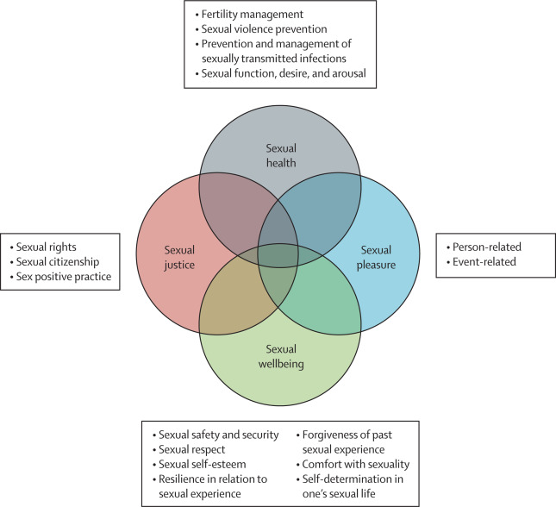Figure 1: Model of Holistic Sexual Health

To fully assess the current sexual health needs in Kent, it is important to first reflect. Since the last sexual health needs assessment (SHNA) in 2018, the sexual health landscape has changed considerably, with the impact of the COVID-19 pandemic, growing funding gaps for sexual health services and changing social trends. Data has also changed to suggest that a re-focus of efforts on sexual health is needed. There have also been several national policies introduced and changes in guidance that affect sexual health. This has been summarised below.

## 2.1 National Context

**2.1.1 The impact of the COVID-19 pandemic on the sexual health landscape**

The COVID-19 pandemic had a significant impact on both the delivery of sexual health services, and the sexual health attitudes and behaviours of the UK population.

The Faculty of Sexual & Reproductive Health (FSRH) surveyed its members in May 2020 to understand service issues during the pandemic. They found that 77% of GPs and 64% of specialists had ended or limited the provision of essential sexual health services since the pandemic began[4].

There were changes to service delivery with a shift to remote consultations and the use of home self-sampling kits for STI testing. Whilst this allowed some ongoing provision of services during lockdowns, there were concerns that changes to service delivery could worsen health inequalities for groups who would have difficulty accessing the service in this way[5]. Inequalities in access to STI testing was observed for people living with HIV and minority ethnic participants in a cross-sectional survey completed in July 2020[6]. Unmet need for condoms was also reported in 2021, with higher unmet need for young men aged 18 to 24 years, and men who have sex with men (MSM). Those who reported unmet need were also more likely to report sexual behaviours associated with STI and HIV risk[7], highlighting the impact of the pandemic on availability of primary prevention methods.

The National Surveys of Sexual Attitudes and Lifestyles (NATSAL) team conducted a study in 2020/21 to understand how the national lockdowns impacted sexual health and to understand the longer-term impacts of the pandemic[8].

The impact on contraceptive services was reflected in the findings that one in six participants reported an unmet need when attempting to access services. Younger participants in particular were affected, with them more likely to report barriers to access and to have switched method of contraception during the pandemic[9]. The study found mixed views on use of telemedicine within sexual healthcare, where some participants found it acceptable, but others reported difficulty navigating the changing services with concerns around privacy within their household or community[10]. Further insights about the impact of COVID-19 on sexual health attitudes and behaviours are discussed in Section 5.2.

Incidence of sexually transmitted infections have risen alongside other indicators of changing sexual health provision such as termination of pregnancy rates increasing[11]. This has resulted in calls for the new Government to prioritise and focus on sexual health and sexual health inequalities through a national sexual health strategy[12].

## 2.1.2 Social trends and changes in sexual health attitudes and behaviours

The sexual practice of ‘chemsex’ (referring to the use of drugs in sexualised settings or during sex, most often in but not limited to gay and bisexual men) 35, with use particularly by men who have sex with men (MSM). Whilst evidence[13] suggests a decline in use between 2015 and 2018, chemsex remains an issue for sexual health, given the increased risk of STIs in this context, and the resulting increased attendance at sexual health clinics. Further understanding of chemsex locally is important to understand where sexual health services may be increasingly required.

Rising numbers of over-65s with STIs have been reported[14], and this will be of increasing importance to public health, given the UK’s ageing population[15].

In the last decade, dating apps have become more popular, with some research showing a link between the use of these and risky sexual behaviours and STIs[16],[17]. This is especially important, given that most 15- to 24-year-olds own a smartphone and therefore can easily access these apps[18].

There has been increasing popularity of digital technologies used by women, termed as ‘FemTech’, for example period-tracking apps and fertility solutions[19]. This may provide an opportunity for innovative public health interventions and to help reach a wider audience. However, concerns have also been documented about the regulation of these apps and the risk of increasing unplanned pregnancies[20],[21].

## 2.1.3 The HIV Action Plan

In 2021, the government released a HIV Action Plan[22], setting out a plan for 2022 to 2025, with the aim of achieving zero new transmissions of HIV by 2030. New HIV diagnoses amongst men who have sex with men has declined, narrowing the gap between gay and bisexual men and the heterosexual population. The action plan highlights however that progress is still needed for priority groups including black African heterosexuals and gay and bisexual men.

The action plan has four key objectives, that will be achieved with partnership working across the health system. The first objective is centred around prevention, with an annual national HIV Testing Week, a range of prevention campaigns and new funding to provide HIV pre-exposure prophylaxis (PrEP) in sexual health services. A plan will also be developed to provide PrEP in settings outside of sexual health services, such as pharmacies and drug and alcohol services. There have however been concerns around the impact of offering PrEP within sexual health services on other sexual health appointments[23].

The second objective is to scale up HIV testing, increasing the number of people offered a test in sexual health services and improving the coverage of opt-out testing in healthcare settings in geographic areas of high HIV prevalence.

The third objective is to optimise rapid access to treatment and provide additional support for those with complex needs to address inequalities in access to and retention in treatment. This will be done by identifying the key barriers to retention in care and providing information for local commissioners and service providers to use innovative HIV care delivery such as outreach work and remote consultations.

And finally, the fourth objective aims to improve quality of life for people living with HIV and address stigma. This will be done by improving knowledge about transmission of HIV and the importance of treatment as prevention and investing in peer support pathways.

The newly elected Labour Government have committed to issuing a new HIV Action Plan in 2025 to support and grow the work set out above. It will cover a 10-year period and aim to bring transmissions down to 0[24].

## 2.1.4 The Women’s Health Strategy

The Women’s Health Strategy for England[25] was released by the government in August 2022. It provides a 6-point plan to improve health outcomes for women and girls and improve the way in which the health and care systems engages with them, within the next 10 years. The strategy will also support several priority areas where issues were highlighted, including the menopause, the health impacts of violence against women and girls, and gynaecological conditions. The strategy adopts a life course approach, with the need for good sexual health and wellbeing being prioritised across the life course from adolescence to later years.

Sexual and reproductive health is included within the strategy in several areas. Ensuring women’s voices are heard, in particular for gynaecological procedures is a key area, with the strategy outlining implementation of best practice that encourages shared decision making between professionals and women. To improve access to services, the strategy encourages local commissioners to consider one-stop clinics and women’s health hubs with co-commissioning of reproductive health and sexual health services between local authorities and the NHS.

The strategy recognises that women in inclusion health populations may not have engaged in the call for evidence that supported development of the strategy. To tackle disparities, the government pledges to work with the Women’s Health Ambassador to address these gaps in insight when implementing the strategy. The call for evidence also recognised that there was very low awareness of services for victims of violence, such as sexual assault referral centres (SARCs). Actions to address this are underway, for example the NHS launched a campaign in February 2022 to increase awareness of SARCs.

Further strategic guidance relating to sexual health will be included in the sexual and reproductive health strategy which is due to be released by the government.

## 2.1.5 Relationships and Sex Education (RSE) in Schools

In September 2020, Relationship and Sex Education become a mandatory subject on the curriculum for schools in England[26]. This supports young people’s development of healthy relationships, safe sex lives, and other contributors to good sexual health outcomes such as understanding the impacts of drug and alcohol use on sexual behaviours.

Pupils should be taught a range of topics relevant to sexual health including information about fertility and reproductive health, contraceptive choices, consent and the law and STIs (including prevention, testing and treatment).

RSE also supports the Women’s Health Strategy[27] by teaching about women’s health topics such as contraception and the menopause. Both boys and girls are taught, ideally together, to reduce stigma around these issues.

In Kent, RSE is delivered by a mixture of teaching staff, non-teaching staff, and external agencies. There is no mandatory training for RSE, but there are training materials available.

## 2.1.6 Changes to termination of pregnancy services

During the COVID-19 pandemic, access to in-person termination of pregnancy services was affected[28], leading to the introduction of at-home early medical abortions. This was initially a temporary change to legislation[29], which was made permanent from August 2022[30]. The legislation allows for women and girls to access pills for early (up to a gestation of 9 weeks and 6 days) abortion via a teleconsultation, and for these to be taken at home. The Royal College of Paediatrics and Child Health (RCPCH) was also commissioned to develop safeguarding guidance for children and young people under 18 accessing the services[31].

Information on place of termination will be collected via abortion notification forms so that data can be collected on the impact of this change in services.

In March 2024, NHS England released a call to action for integrated care boards (ICBs) to improve abortion care, following rising demands for termination of pregnancy services resulting in increased wait times for surgical abortions[32]. They also shared an example of good practice in Sussex where increasing access to contraception has been promoted as a preventative measure, using a whole-system approach to assessing population needs. This is discussed in greater detail at the end of the needs assessment.

## 2.1.7 Expansion of the Pharmacy Contraception Service (PCS)

In November 2023, it was announced by the Department of Health & Social Care, that from December 2023, the PCS would expand to include initiation of oral contraception[33], which could previously only be started within primary care or sexual health clinics. Individuals can self-refer, or be referred to the pharmacy from primary care, sexual health or another NHS service such as 111. If the pharmacy cannot meet the person’s contraception need, they should be signposted to another pharmacy or service[34].

The aim of this expansion was to enable greater choice and access to help address health inequalities, and to create additional capacity in primary care and sexual health clinics for those requiring more complex care[35].

## 2.1.8 Extension of the licence for the Mirena intra-uterine device (IUD)

In January 2024, the UK Medicines Health Regulatory Authority (MHRA) approved an extension to the Mirena licence from 5 years to 8 years for contraception[36]. The licensed duration of use for management of heavy menstrual bleeding and for endometrial protection with hormone replacement therapy (HRT) has stayed the same.

## 2.1.9 Mpox outbreak

In May 2022, rising cases of Mpox (formerly called monkeypox) were seen in the UK, the majority of which occurred in gay, bisexual, and other men who have sex with men (GBMSM) who had not travelled to endemic countries[37]. Prior to this, most cases in the UK were associated with travel. Although most cases were in London residents, cases were found throughout the UK as a result of direct person-to-person transmission42 . In June 2022, the Joint Committee on Vaccination and Immunisation (JCVI) advised that the smallpox vaccine (which provides cross-protection against mpox) should be given to GBMSM at highest risk, identified by clinicians at sexual health services[38].

The management of symptoms of Mpox, and later vaccination largely took place within sexual health services. As a result, services had to quickly adapt, redesign services and clinical pathways and ensure staff had appropriate infection prevention and control measures in place[39]. They had to work at speed to enable swift rollout of the vaccination for this. This placed additional demand and pressure on sexual health services that were already at maximum capacity and demonstrated the need for longer term preparation for future infectious disease outbreaks[40]. Local teams have been working together to gather lessons from this experience, and build in proactive plans for solidifying our approach, as well as ensuring preparedness for future recurrence.

These efforts and learning has been helpful, because on the 15th of August 2024, the World Health Organisation (WHO) declared a public health emergency of international concern[41] relating to Mpox and on 6th October 2024 the UK Health Security Agency (UKHSA) reported the detection of a fourth confirmed human case of Clade Ib Mpox in London, England. The risk to the UK population remains low but the situation will be monitored and calls to action for Kent integrated sexual health services (ISHS) held in readiness using lessons learned from 2022 to monitor potential impacts.

KCC and sexual health providers continue to work with UKHSA, who lead on health protection in the UK, alongside KCC’s consultant lead for health protection. Proactive communications led from the UKHSA are supported by KCC, and targeted vaccination programmes are being rolled out to the following groups; Gay, bisexual and MSM, certain healthcare workers, specialist healthcare workers and humanitarian workers, close contacts of a confirmed case.

## 2.1.10 Funding for Sexual Health Services

Since 2015/16 the public health grant paid to local authorities from the Department for Health and Social Care (DHSC) has faced a cut of 28% (on a real terms per person basis)[42]. This had led to national reductions in spending linked to policy changes, with sexual health services one of the largest areas affected. There are national concerns about the impact of spending cuts given the long-term health consequences for those with poor sexual health[43]. In the light of this, considerable efforts and underway across Kent County Council to undertake a major programme of transformation to review existing contracts and optimise value for money and optimal performance. There are steps to mitigate against this through our advocacy and partnership efforts across Kent, South East region and nationally to support ensuring optimal funding and focus for sexual health.

## 2.2 Local Context

Kent’s population has changed since the last sexual health needs assessment with a population increase of 14,600 from mid-2021 to mid-2022, of which, 95.7% has been because of migration[44]. This is likely to have an impact on health services in the county, including for sexual health.

The total fertility rate and general fertility rate in Kent are both declining over time[45]. The total fertility rate is the “average number of live children that a group of women would bear if they experienced the age-specific fertility rates of the calendar year throughout their childbearing lifespan”. General fertility rate is the “number of live births in a year per 1,000 women aged 15 to 44 years”. It is a measure of current fertility levels[46]. The birth rate, which is the total number of live births each year, is currently at its lowest level for over 10 years.

Declining fertility and birth rates have been attributed to better access to contraception for women, as well in delays in the age at which a woman has her first child, amongst other social determinants[47].

In terms of other factors in Kent impacting on sexual health, there has been challenges with Kent’s sexual health estates and often there are difficulties with finding and retaining appropriate sexual health property.

This sexual health needs assessment aims to give a pragmatic look at Kent’s sexual health needs and services to help inform Kent County Council (KCC)’s service transformation work. This will help to ensure any changes to services are based on the best available public health information. This document summarises the sexual health headline areas.

# 3. Kent Population Profile

## 3.1 Kent Population and Geography

Kent’s population is growing, over the last 20 years it has risen by 19.4%[48]. Since the last needs assessment in 2018 it is estimated that the population has increased by approximately 65,400 people.

**Figure 2: Population Pyramid for Kent Population in 2022**

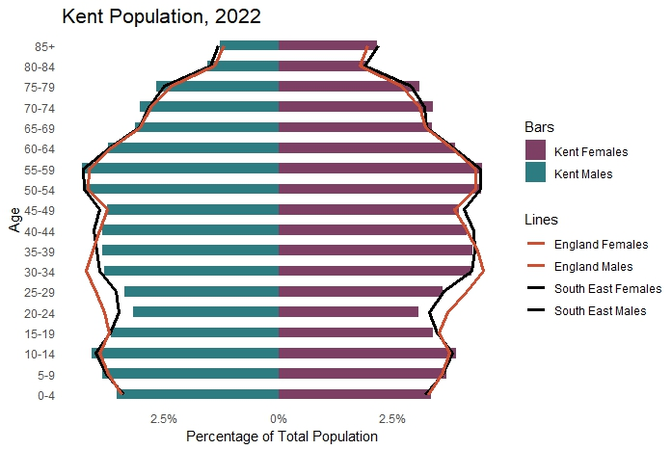

Within the Kent population, there are more females than males and the population pyramid (**Figure 2**) shows a high proportion of individuals in the younger age group (5 to 14), with the number being slightly higher than the regional and national figures. There is also a large proportion of people within the middle-aged group (50 to 59). The pyramid narrows towards the top, indicating a smaller elderly population within Kent. Additionally, there are fewer young adults compared to regional and national figures, specifically between the ages of 20 to 29.

## 3.2 Groups at higher risk of poor sexual health

Different groups in society experience health inequalities, including sexual health inequalities[49]. Health inequalities can be described as avoidable, unfair and systematic differences in health between groups[50]. This needs assessment demonstrates how different groups in Kent are impacted in terms of sexual health with the use of data and analysis in latter sections. This section aims to explore the inequalities experienced by certain groups who are at a higher risk of poor sexual health.

*Young people are at a higher risk of STIs and unplanned pregnancy, making this group a key focus for sexual health services. Young people have raised a lack of awareness of services and a need to improve education around healthy relationships.*

## 

## 3.2.1 Young people

Young people (aged 15 to 24 years) are more likely to be diagnosed with an STI[51]. Nationally, they report larger numbers of sexual partners, with the age of sexual debut becoming younger over time. Certain groups of young people are at an increased risk of poor sexual health including those from ethnic minority groups, incarcerated youths, teenage parents, those who use drugs and those living in more deprived areas[52]. Under-18 conceptions are of a public health concern, given that teenagers have the highest rates of unplanned pregnancy and have disproportionately poor outcomes46.

Within Kent, Canterbury is the district with the highest number of young people aged 16 to 25 years, corresponding with being the second highest district for STI diagnoses rates in Kent. Whilst under-18 conception rates have declined both in Kent and nationally, there is significant variation within the county with higher rates in Thanet, Swale, Dover and Ashford.   
  
In 2024, Kent County Council commissioned 31ten consultancy to obtain insights about KCC’s public health services, including sexual health. As part of this work, a small sample of local 16- to 20-year-olds were consulted, with a key finding being that the top reason about why condoms might not be used during sex was due to pressure (including peer pressure and pressure from partners). A lack of awareness of services was also apparent with 4 out of the 12 respondents to the survey not being aware of services available at their local sexual health clinics and 3 not being aware that free condoms were available for anyone aged 24 and under. Whilst this being a small sample means that it is hard to draw strong conclusions from this, it does provide some useful findings that will be important to follow up further and seek to test with more young people in the next steps of our work. Additionally, this work has highlighted the need for greater engagement with local people, particularly from groups that are under-represented or at higher risk of poorer sexual health outcomes. This will be incorporated into the next steps of this work also going forwards. For the purposes of this needs assessment, we attempted therefore to supplement this work with additional insights from providers and others to be able to draw further conclusions.

A survey by Metro Charity found that 59% of sexually active young people surveyed had never had an STI test. Almost half of the girls surveyed who engaged in condomless sex, reported the reason for this was that they were using alternative contraception and therefore didn’t think they needed a condom. This could demonstrate a need for better education around testing and risk, but further insights would be able to decipher if this is generalisable to the whole Kent population of young people.

Access to quality relationship and sex education, digital solutions[53], informed parents, targeted campaigns and cross-system plans and approaches[54] are evidenced prevention strategies to ensure good sexual health in young people.

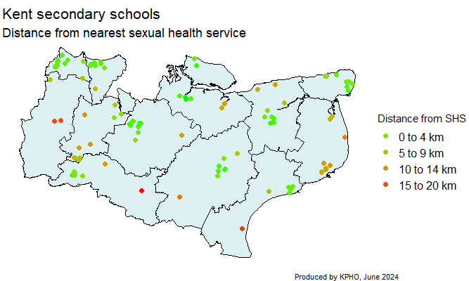

**Figure 3: Map of Secondary Schools in Kent and their Distance from Sexual Health Services**

The map above (**Figure 3**) shows the secondary schools in Kent and their distance from sexual health services (SHSs). Using national schools' data, a list of secondary schools in Kent were found. Kent schools were included if they were open or proposed to open and classed as secondary, all-through, middle deemed secondary or 16 plus. 105 schools were included in the analysis and 14 SHSs.

Pythagoras’ theorem was used to calculate the distance from each school to the nearest SHS in Kent. Each point on the map represents a secondary school and the colour corresponds to the distance to the nearest SHS. Schools shaded green are very close, within 0 to 4 km, to a SHS and those shaded red are furthest away from a SHS, 15 to 20 km away.

There are clusters of schools that can be found 0 to 4 km from the nearest service, these schools are mainly in towns or built-up areas (this is typically where SHSs are based). Majority of secondary schools in Dartford and Gravesham are in close proximity to a SHS. Similarly, schools in Maidstone, Ashford and Thanet are close to SHSs. There are few secondary schools that are 15 to 20 km away from a service, although in general, schools along the coastal regions appear to be a little further from services, typically between 10 to 20 km away. This is important to note given there is no sexual health clinic in Dover currently, and several coastal districts have higher rates of under 18 conceptions compared to the Kent average.

Sevenoaks and Tonbridge and Malling also have schools further away from SHSs. It is important to note that for schools on the border of Kent their closest SHS may be in another local authority, but this will not be represented in the map.

It is recommended that local services and commissioners have an awareness of service proximity to schools, in order to ensure outreach services are provided where required, in order to improve young people’s sexual health outcomes.

## 3.2.2 People living in deprived areas

Nationally, rates of new STI diagnoses are consistently higher in more deprived populations, as measured by the Index of Multiple Deprivation (IMD)46.

The IMD is an area level measure of deprivation. Last updated in 2019, the index ranks the 32,844 neighbourhood areas, known as Lower Super Output Areas (LSOA), in England. Areas are ranked according to indicators in seven domains: barriers to housing and services, crime, education, employment, health, income and living environment[55]. To simplify the ranking, deprivation deciles were created. Each small area is sorted into one of 10 equal groups ranging from the most deprived 10% (IMD decile 1) of small areas nationally, to the least deprived 10% (IMD decile 10).

**Figure 4: Map of Kent and Medway showing the IMD decile by Lower Super Output Area**

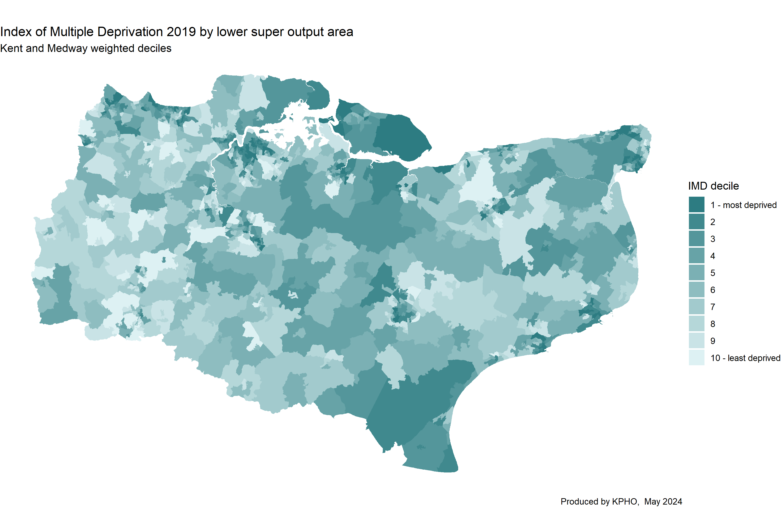

The map (**Figure 4**) highlights the pattern of deprivation across Kent and Medway. The most deprived areas are darker and the least deprived areas are lighter. The highest levels of deprivation can be seen mainly in the coastal regions with some urban areas (particularly in Medway and Dartford Gravesham) having high levels of deprivation.

Under 18 conceptions are associated with deprivation and this is reflected in the higher rates found in the relatively more deprived districts of Thanet, Ashford, Swale and Dover.

STI’s diagnoses rates are also found proportionately differently in most to least deprived areas as demonstrated in the graph below (**Figure 5**). This suggests these areas should be a targeted focus to reduce under 18 conceptions and STI diagnoses.

**Figure 5: STI diagnoses crude rate per 100,000 of population demonstrated per deprivation decile**

## 3.2.3 Black and ethnic minority populations

National evidence showed black minority ethnic (BME) populations are disproportionately affected by STIs, in particular for gonorrhoea and trichomoniasis49. Black African people are also more likely to be diagnosed with HIV at a late stage of infection[56]. It is important to understand if this increased risk is seen locally in Kent.

In Kent, as of the 2021 Census[57], 89.4% of residents were White, 4.4% Asian, 2.6% Black, 2.3% Mixed or Multiple ethnic groups and 1.2% identified as an Other ethnic group.

In the 2024 KCC commissioned insights work, ethnic minority groups made up almost 20% of the survey responses, however most of these individuals had not accessed sexual health services. Key themes were ensuring that support is received from someone who understands their culture and community, and barriers to using sexual health services as a result of lack of openness of discussions around sexual health within certain communities.

## 3.2.4 Migrant population

In 2021, insight work was undertaken by the SHIFT (Sexual Health In the over Forty-fives) project into sexual health and wellbeing for migrants living in Kent aged over 45 years[58]. This was a cross-border partnership between nine organisations to address inequalities in sexual health and wellbeing in over 45s and marginalised populations. The insights work included semi-structured interviews with 22 migrants in Kent. Most participants were well established in the UK and had moderate to good use of spoken and written English, meaning perspectives of recently arrived migrants were not captured in this work.

Newer migrants surveyed reported sometimes having difficulty registering with NHS services. Other barriers for engaging with local services included lack of out of working hours access and the need for childcare to attend appointments. Language barriers were mentioned as a barrier to using at home STI testing kits, with concern about trouble reading the instructions.

There was some complacency that STIs would not affect them with some believing that symptoms of STIs would always be present. Lack of need was cited as a reason for not accessing sexual health services, with many of those surveyed not perceiving themselves as at risk of poor sexual health and therefore not needing to use sexual health services. Some women mentioned cultural concerns about their husbands not wanting them to be using STI testing kits or asking questions about accessing sexual health services.

Participants were also able to offer some solutions to the barriers they described in accessing sexual health. These included:

* Improving translation services and awareness of them, providing information in other languages, bearing in mind that sexual health language and terminology does not translate well into all languages.
* Practicing discretion and recognising that many in migrant communities feel uncomfortable discussing sexual health and interacting with sexual health services.
* Using methods of communication that communities engage, including local radio stations, social media channels and using events with music and activities.
* Inviting health professionals into the community to talk about sexual health and using key figures in the community to improve perceptions on sexual health.

Outreach work of our providers have aimed to engage with migrant populations and regular sessions have been set up in some settings to give sexual health advice and support, for example Napier Barracks, and Milbank UASC Centre

## 3.2.5 LGBTQ+ people

Gay, bisexual and other MSM are more likely to be diagnosed with bacterial STIs[59].

According to the 2021 census, 90.6% of the population in Kent (aged 16 and above) identifies as straight or heterosexual, less than 2.4% of the population identifies as homosexual or bisexual and less than 1% identify as having other sexual orientation. Additionally, less than 1% of people identify as transgender or having a different gender identity from birth. This is similar to the national population.

Comparing the demographics for Kent with proportions of people accessing the integrated sexual health service, LGBTQ+ people are over-represented. In East Kent in 2022/23, 78.6% of attendees were heterosexual, 13.5% gay or lesbian, 5% bisexual (with 2.9% other/not recorded/declined to answer) and in North and West Kent, 86.9% were heterosexual, 8.3% gay or lesbian, 4.2% bisexual (with 0.5% other/not recorded/declined to answer).

NICE quality standards indicate that to help prevent spread of infections in the MSM community, testing should be carried out every 3 months. Therefore, this report recommends that this becomes a KPI for ISHS and online testing service.

In the 2024 KCC commissioned insights work, face to face engagement with gay men led to discussions around chemsex (referring to the use of drugs in sexualized settings, most often in gay and bisexual men[60]) and resulting issues with consent and use of protection during sex. Other key themes arising from surveys and discussions with LGBTQ+ groups were increasing access to sex and relationship education for gay students including use of protection in relationships with two women, and promotion of healthy sex and relationships. A reliance on testing instead of use of protection was raised. In terms of sexual health services, a lack of awareness of services available existed, with barriers to use including judgement about sexual orientation.

Research by the UKHSA[61] was carried out in 2024 to understand the barriers and facilitators in sexual health promotion for LQBTQ+ inclusion health groups. Barriers included stigma around their LGBTQ+ identity, difficulty obtaining sexual health support which had worsened due to reductions in walk-in clinics since the COVID-19 pandemic and negative experiences with sexual health professionals including a lack of knowledge about LGBTQ+ issues and use of inappropriate language. Facilitators included use of peer support roles in sexual health services, improved access to services via both use of online services and the use of walk-in clinics when required. More positive experiences with professionals took place within sexual health clinics compared to non-specialist services.

*LGBTQ+ people make up a greater proportion of those accessing sexual health services in Kent, compared to the population demographics. An increased risk of poor sexual health relating to STIs and chemsex exists, along with the need for better education around healthy relationships and addressing barriers such as stigma and the use of inappropriate language.*

The SHIFT project[62] in 2021, involved Outreach activities across Kent where sexual health services were provided along with the ability to capture insights information for specific groups of the population. One Outreach session took place in a MSM Sauna.

Men seen at the sauna clinic were nearly all over 45 years, 9% of the sample identified as heterosexual and 39% were married. The primary reasons for participants talking to Outreach services were to learn more about sexual health, and for concerns about STIs and HIV. Following use of the Outreach service, participants reported improvements in access to sexual health and wellbeing support and reduced stigma. This highlighted the value of working with this population in a setting where they would engage with sexual health services, particularly for those keeping their sexual preferences hidden from others making them more reluctant to access traditional sexual health services.

## 3.2.6 People experiencing sexual abuse or violence

The Kent and Medway Serious Violence Strategic Needs Assessment[63] outlines the 2022/23 data for serious violence in Kent. Those under 25 years were disproportionately affected by violence, and domestic violence was more prevalent in households of mixed or black ethnicity. Thanet, Swale and Medway were most affected by violence, with the wards that were most affected often found in the most deprived areas. This particularly impacted on women, with nearly 4 times as many women in the lowest income bracket experiencing domestic abuse in the last 12 months compared with those in the highest income bracket. In terms of sexual violence in 2022/23, 82% of victims were female and 90% of suspects were male, with the highest group of victims being girls aged 11 to 15 years.

The SHIFT project[64] in 2021, surveyed a small group of migrants over the age of 45. One issue raised was honour-based abuse and forced marriage, with reports of those affected not feeling they could let any services know about the abuse they were experiencing. This was also reflected in interviews with a group of people who were homeless, with one participant reporting concern about accessing sexual health services due to fear of reprisal from her abusive partner.

Analysis conducted for the purposes of this report by KCC’s performance analytics team demonstrated that of those receiving support for domestic abuse in Kent in 2023-2024, sexual abuse was a factor in some cases. Of those cases 82% of victims were female, and as little as 1% were male. The remaining 17% either didn’t disclose gender or selected Other. This further demonstrates both the risk to women in terms of their sexual health and the disproportionate impact of sexual violence on women.

As part of this analysis, we are also able to ascertain how long after a sexual assault occurred, a person ordered an STI kit. Findings demonstrate that the time taken for seeking help is too long, and more effort is needed to raise awareness and provide timely support to victims of sexual assault. Only 11% of women ordered the kits within one week of the assault, compared with 64% who ordered kits over 1 year after the assault.

## 3.2.7 Gypsy, Roma and Traveller (GRT) people

Kent has a higher percentage of Gypsy and Traveller people (0.3%) than the England average (0.1%), with 5,405 people identified as being from Gypsy and Irish Traveller ethnic groups in the 2021 Census[65]. Maidstone, Swale and Ashford rank in the top five of England local authority districts with the highest proportion of people from these ethnic groups.

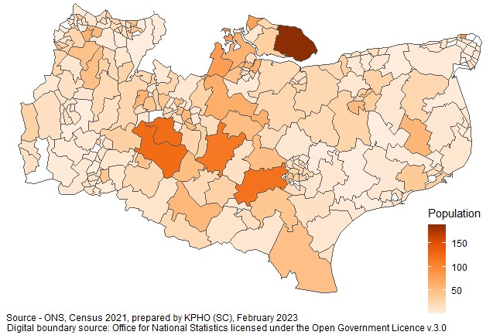

**Figure 6: Gypsy and Irish Traveller Population in Kent; Population numbers within Kent wards, 2021**

A Gypsy, Roma and Traveller Populations’ Health Needs Assessment was produced by the Kent County Council Public Health team in 2023[66]. A literature review on the health status and beliefs of GRT people highlighted the poorer health outcomes seen across the life course.

There are complex issues with access to healthcare, including limited awareness of services, low literacy levels, a lack of trust in health care services, experiences of discrimination, wrongful registration refusal in primary care and digital exclusion. Health beliefs tend to emphasise social and environmental factors as drivers of health, as opposed to medical concepts of disease. For Roma women, cultural taboos around discussion of female sexual or gynaecological health exist, which can result in reluctance to discuss gynaecological issues or take up cervical cancer screening with health professionals. Children from Gypsy and Traveller communities tend to leave school at a much earlier age, which may impact on access to relationships and sex education provided in schools. In terms of risk factors for poor sexual health behaviours, higher incidences of depression and alcohol consumption and drug use among Gypsy and Traveller young people were highlighted.

In terms of sexual health, the HNA highlighted several key issues based on stakeholder interviews. There is a lack of knowledge and uptake of contraception, with the responsibility for contraception falling on women, leading to some women using abortions as a last resort, and some Roma women returning to their own country to have a termination. Low immunisation uptake is seen, with the HPV vaccine viewed by some as inappropriate and unnecessary due to sexual health issues being a taboo.

It is not fully understood whether outreach has been successful with GRT communities in terms of sexual health, or how many of the GRT population use sexual health services. GRT populations should be a focus for sexual health to understand more about use of contraception, abortion rates. This information would help to ensure that their needs are being or can be met and identify opportunities to support with improving sexual health outcomes. Focus on areas of high GRT density would be the recommended starting point.

## 3.2.8 Alcohol and drug misuse

Misuse of drugs and alcohol is associated with increased sexual risk taking, [67]￼. Chemsex[68]￼ and is most common amongst gay, bisexual and MSM people. The risk of transmission of STIs and HIV is increased when drug use takes place in a sexual context61.

In the 2024 KCC commissioned insights work, a focus group with attendees in recovery from drug and alcohol abuse cited that drugs and alcohol impacted decisions around protection during sex, therefore increasing risk of STIs and vulnerability to abuse.

Kent should accelerate efforts to understand the impact of chemsex on sexual health outcomes in its population, and the sexual health system should aim to work collaboratively with wider partners to support people engaged in chemsex, including exploring co-location of services.

## 3.2.9 People in Contact with the Justice System

There are currently 5 prisons in Kent, located in Maidstone and the Isle of Sheppey, Swale (along with Rochester Youth Offending Team in Medway), including both adults and young offenders. The prison population in Kent and Medway is 20,875, which is 1.11% of the population. This compares to 1.67% of the population for England[69]. Approximately 72.9% of prisoners in Kent are British nationals, compared to 26.9% foreign nationals. 65.7% of prisoners are of White ethnicity and 18.25% are of a black ethnicity. People of Asian, Mixed or Other ethnicity make up less than 20% of all prisoners in Kent. The majority of prisoners (33.6%) are between the ages of 30 to 39 and 97.8% are men.

*People in contact with the justice system are at a higher risk of poor sexual health and this is often underreported in national datasets. More understanding is required of sexual health service provision in prisons, along with what support is available to reduce sexual health risks on release from prison.*

A sexual health needs assessment of prisoners in Kent took place in 2016[70]. A summary of the published literature at the time of this HNA described several important sexual health issues amongst the prison population. Risky sexual activity after release from prison[71], higher prevalence of blood-borne viruses (BBVs)[72] and issues with compliance with long term treatment for HIV have been reported[73]. A large proportion (29%) of prisoner's report having experienced emotional, physical or sexual abuse as a child, with a higher proportion among women[74].

Based on 2014 data, the estimated number of new STI diagnoses in Kent’s prison population was significantly higher compared to the general population. However, as discussed in the HNA, poor health is under-reported in national datasets and the data on STIs was not sufficient to determine differences in need between the prisons in Kent.

Stakeholder consultation findings were difficulty accessing patients records by staff within the prison, poor transfer of information from prisons to healthcare services, lack of promotion of sexual health and the services available and long waits at that time for asymptomatic STI screening. Interviews with prisoners identified a lack of awareness of the service and variable knowledge about access to condoms and contraception prior to or during times of release from prison.

## 3.2.10 Homeless Population

3,577 households in Kent were threatened with homelessness within 56 days and owed a prevention duty (this is a responsibility of housing authorities to support people threatened with homelessness within 56 days and help prevent them from becoming homeless[75].) in the financial year 2022/23. 971 of these households were due to a Section 21 notice, a formal notification by a landlord which is the start of the process to end an assured shorthold tenancy. The number of households threatened with homelessness has decreased by 19% between 2022/23 and 2018/19 where there were 4,406 households. Across Kent 3,039 households were deemed homeless with relief duty owed, a 22% decrease from 2018/19 where 3,896 households were deemed homeless.

Within Kent the highest number of households threatened with homelessness was in Maidstone with 596 households and Swale had the highest number of homeless homes owed a relief duty (467 households)[76].

The SHIFT project[77] in 2021 collected survey data from four different outreach activities. Participants who were homeless reported difficulties accessing STI testing and contraception due to shifts to ‘at-home’ services which required an address. Paying for travel to appointments was also raised as a barrier. Most of the cohort interviewed were not currently sexually active, with many not considering how they would practice safe sex and some having a lack of knowledge on contraception and prevention of pregnancy. However, those who misused drugs and alcohol were aware of having impaired judgement that could affect their risk of poor sexual health. Findings from this project indicate that this population should be a focus for outreach work.

## 3.2.11 Women’s Health

Women are disproportionately impacted by the consequences of STI’s[78]. This can include chronic abdominal pain, infertility, and ectopic pregnancy. As previously highlighted, women are also more likely to be victims of sexual violence and abuse and therefore may be more likely to experience adverse psychological, social, physical and psychosexual issues[79]. Gender inequalities contribute to and can lead to the disproportionate difference in sexual violence victims being women, and therefore tackling gender inequalities can improve outcomes for women[80]. Women who experience sexual abuse are at a high risk of sexually transmitted infection[81]. Therefore, understanding better the sexual health implications of violence against women and girls is a recommended priority for Kent.

The Women’s Health Strategy[82] aims to identify stages, transitions and settings for promoting good health, preventing negative health outcomes and restoring health and wellbeing, which are all relevant to sexual health. In a call for evidence public survey[83] a wide range of issues were raised, with 55% of respondents selecting fertility, pregnancy, and pregnancy loss as a key topic for prioritisation. Therefore, sexual health services can contribute to improving these issues for women with the services that it has within its remit, such as access to contraception.

Only 9% agreed they had enough information on specialist sexual assault referral centres and female genital mutilation clinics. Many women flagged that their GP service was not sufficient for their sexual health and contraceptive needs, but that sexual health clinics can be hard to access.

The strategy encourages the expansion of women’s health hubs[84] to improve access to services and health outcomes. These hubs aim to provide integrated women’s health services in the community and will involve partnership working and collaborative commissioning of contraception services. Key services that may be provided within a hub, relating to sexual health include provision of contraception, including LARC and emergency hormonal contraception, and screening and treatment for STIs and HIV. In Kent, it is anticipated that by the end of 2024 there will be multiple Women’s Health Hubs established.

## 3.2.12 Intersectionality

Whilst the sections above consider specific factors that may contribute to people in our Kent population being at higher risk of poorer sexual health outcomes, the reality is that there are residents within our communities who experience several of these. A report by the Lankelly Chase Foundation titled: ‘Hard Edges Mapping severe and multiple disadvantage[85]’concluded that current support systems struggle to deliver positive outcomes in more complex cases. There is work underway at present by the KCC Public Health team to better understand the needs of local groups who experience one or more of the above factors to ensure that we are optimally meeting their needs.

## 3.2.13 Conclusion

As described in this section, the factors that influence sexual health outcomes for the groups most at risk of poor sexual health are wide-ranging. For some groups at a high risk, there is a lack of local data to understand their sexual health needs, which may be different to those of the general population. For some groups, including GRT people and those experiencing sexual abuse and violence, women are at higher risk of poor sexual health, for which women’s health hubs may provide additional support.

# 4. Kent’s Sexual Health Needs

## 4.1 Sexually Transmitted Infections

STI’s can be serious infections with long term impacts on health if left untreated, and therefore, the identification and treatment of infections in the community is important[86].

The STI testing rate in 2023 (excluding chlamydia tests in under 25s) is 4,110.7 per 100,000 in England and 3,136.6 per 100,000 in the Southeast. Since 2018 the rate has increased nationally, regionally and across Kent. Within Kent the STI testing rate is 3,284.3 per 100,000, which is a 3% increase from 3,178.7 in 2022. Following the COVID-19 pandemic, the rate has increased and is now higher than pre-pandemic levels, with there being a 15.5% increase since 2018 when the rate was 2,844.1 per 100,000 (**Figure 7**).

**Figure 7: Crude STI testing rate (exclude chlamydia aged under 25) per 100,000, 2018 to 2023**

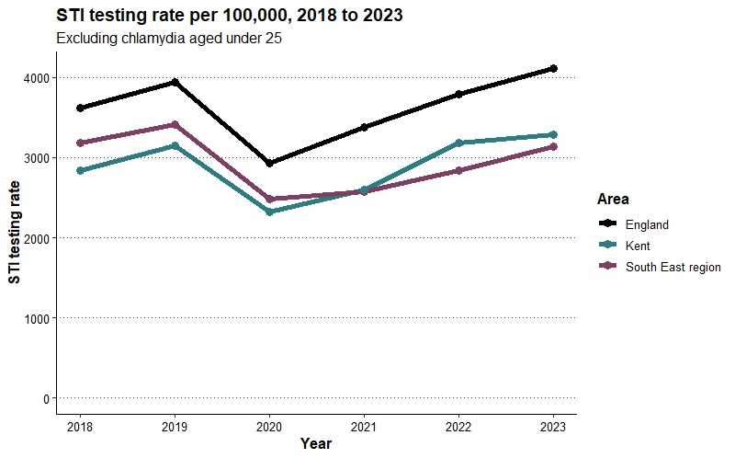

Within Kent (**Figures: 8, 9**), Sevenoaks has the lowest testing rate of all the districts with a rate of 2,520.1 per 100,000 in 2023. Canterbury has the highest rate of 4,397.3 in 2023, even higher than the national level. A high STI testing rate in Canterbury can be attributed to the large number of young people living in the area, due to the university. Approximately 26,400 people live in Canterbury between the ages of 15 to 24, it is the district with the greatest number of young people in Kent.

**Figure 8: Crude STI testing rate (excluding chlamydia aged under 25) per 100,000, by Kent district for 2022 to 2023**

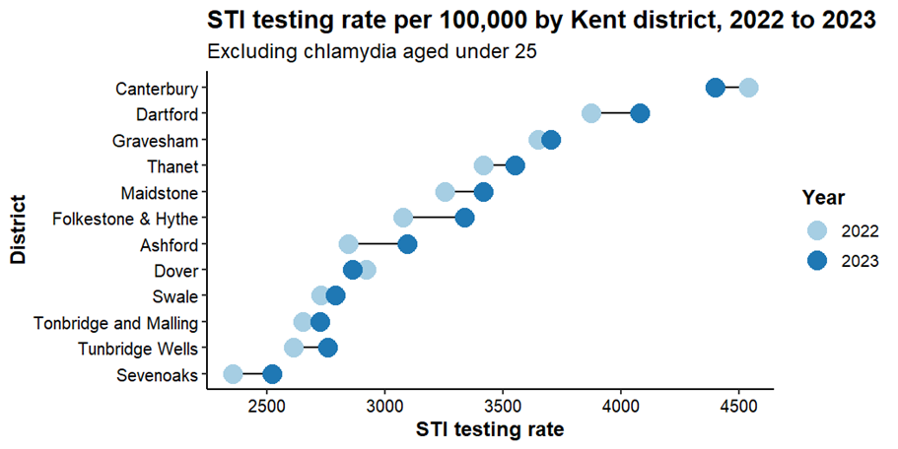

**Figure 9: Crude STI testing rate (excluding chlamydia aged under 25) per 100,000, by Kent district for 2021 to 2022**

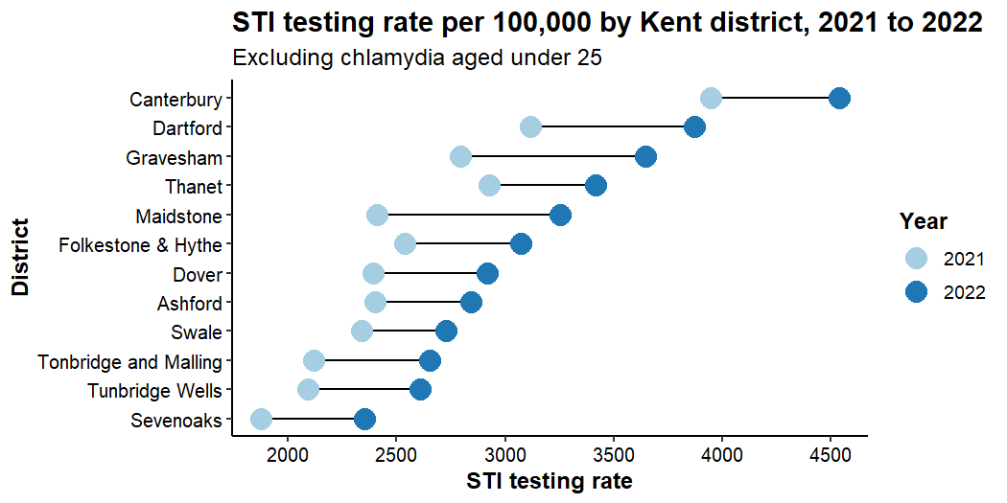

The STI testing rate has been lowest amongst the districts of Swale, Tonbridge and Malling, Tunbridge Wells and Sevenoaks. There is no sexual health clinic in Tonbridge and Malling, however it is unclear why these districts persistently have low testing rates.

The crude rate of new STI diagnoses amongst people accessing sexual health services (excluding chlamydia in under 25s), is 345 diagnoses per 100,000 of the Kent population in 2023, this was only a slight increase of 2% compared to 2022 (340 per 100,000). The rate in Kent is lower when compared to England (520 per 100,000) and the South East (369 per 100,000) in 2023 and has persistently been lower than the England rate for over 10 years. The rate of new STI diagnoses has increased following the drop during the pandemic and has returned to pre-pandemic levels. In total there were 7,589 new STI diagnoses in Kent in 2023.

Within Kent in 2023, Dartford has the highest diagnosis rate of 465 per 100,000, this surpasses the rate in Canterbury which is 459. These diagnoses rates correspond with a high testing rate in both Dartford (4,078.4 per 100,000) and Canterbury (4,397.3 per 100,000), with both areas surpassing the regional figure (3,136.6 per 100,000) and Canterbury surpassing the national figure (4,110.7 per 100,000). Sevenoaks and Tunbridge Wells have the lowest diagnosis rates, both with 224 per 100,000, again corresponding with a low testing rate, however the testing rates are increasing across both areas.

STI test positivity considers testing and diagnosis rates, it is the number of STI diagnoses expressed as a percentage of people tested for STIs. The proportion is highest in Dartford at 6.1%, (higher than the proportion of Kent 5.1%). Further understanding of the high diagnosis rates in Dartford is needed. The proportion is lowest in Tunbridge Wells at 3.6%.

## 4.1.1 Chlamydia

The National Chlamydia Screening Programmes (NCSP) focuses on reducing the harm of untreated chlamydia infection in young women and other people with a womb or ovaries, aged 15 to 24. This is because the harmful effects of untreated chlamydia infection disproportionately affect women. The proportion of females screened for chlamydia in Kent in 2023 is 18.1%. This is lower than the England proportion of 20.4% and 18.2% in the South East.

The chlamydia detection rate per 100,000 for females aged 15 to 24 is 1,712. Whilst this is an increase from 1,658 per 100,000 in 2022 it is 20.4% lower than the rate in 2021 (2,152 per 100,000) and 47.3% lower than the target level of 3,250, this suggests that more testing is needed across Kent. Kent has a higher detection rate than the South East (1,670 per 100,000 in 2023 and 1,549 per 100,000 in 2022) but lower than England (1,962 per 100,000 in 2023 and 2,047 per 100,000 in 2022) as shown in **Figure 10**. The chlamydia detection rate per 100,000 for all persons was lower than for females, suggesting lower testing in males. This can be expected as the NCSP primarily focuses on women but would suggest targeted testing is needed for other groups within Kent. Whilst the chlamydia detection rate for Kent has decreased, rates in Maidstone have increased, surpassing the national level and exceeding the target rate. The rate for females aged 15 to 24 in Maidstone is 3,612 per 100,000, a 42.7% increase from 2,530 in 2022. This may be due to an increase in numbers of chlamydia tests performed in Maidstone, but more understanding of this rise is needed.

**Figure 10: Crude Chlamydia detection rate amongst 15- to 24-year-olds, 2018 to 2023**

3 line graphs showing the chlamydia detection rate amongst 15 to 24 year olds between 2018 and 2023 for females, males and persons. 
Females have a higher detection rate than males and the detection rate has declined since 2018. 

## 4.1.2 Gonorrhoea

Detecting and treating gonorrhoea is important to reduce the long-term consequences of untreated infection, such as infertility and pelvic inflammatory disease. Gonorrhoea is the second most diagnosed STI after chlamydia. In Kent, the diagnosis rate is 78 per 100,000 in 2023 and whilst this is a slight decline from the rate in 2022 (82 per 100,000) it is a 53% increase since 2018 (rate of 51 per 100,000). This reflects the national trend seen post-pandemic whereby gonorrhoea rates are increasing following a decrease between 2020 and 2021 and may be a result of increasing STI testing rates. The diagnosis rate is lower than the South East (83 per 100,000) and England (149, per 100,000) as shown in **Figure 11**.

Within Kent, Canterbury has the highest diagnosis of Gonorrhoea with a rate of 133 per 100,000. This is 156% higher than 2018, a large increase from 52 per 100,000. Gonorrhoea rates within each district have remained fairly stable except for Ashford and Folkestone and Hythe. In Ashford, there has been a 29.7% increase from a rate of 74 per 100,000 in 2022 to 96 in 2023 and Folkestone and Hythe where there is an 8.2% increase from 98 per 100,000 in 2022 to 106 in 2023. Tunbridge Wells has the lowest rate (32 per 100,000 in 2023). Whilst STI testing rates have increased, the rapid increase in diagnoses in these districts may reflect rising gonorrhoea infections in the population.

## 4.1.3 Genital Herpes and warts

Genital Herpes is caused by the herpes simplex virus and currently there is a greater burden of the infection amongst men compared to women. There is currently no cure for herpes, but the infection can be treated and managed. Following an increase of 33.4% between 2020 and 2023 in Kent, the rate of herpes diagnosis is highest in Canterbury at 60.9 per 100,000 and lowest in Tunbridge Wells in 22.4 per 100,000.

Conversely, the diagnostic rate of genital warts has been decreasing in recent years both within Kent and nationally (**Figure 11**). The decline in the diagnoses of genital warts may be partially attributed to the uptake of the HPV vaccine.

## 4.1.4 Syphilis

Nationally, the incidence of infectious syphilis has increased over the past few years. Historically the infection was more common amongst gay and bisexual men who have sex with men (GBMSM), however recent trends show a larger proportional increase in syphilis diagnoses among heterosexual men and women compared to GBMSM[87]. In Kent the diagnostic rate of primary, secondary and early latent infectious syphilis is 6.3 per 100,000 in 2023 a decrease from 8.2 in 2022 (**Figure 11**). This is lower than that of England (16.7 per 100,000) and the South East (9.3 per 100,000), and trends in Kent do not appear to be increasing in line with the national rise.

**Figure 11: Crude STI diagnostic rate in Kent, 2018 to 2023, all ages**

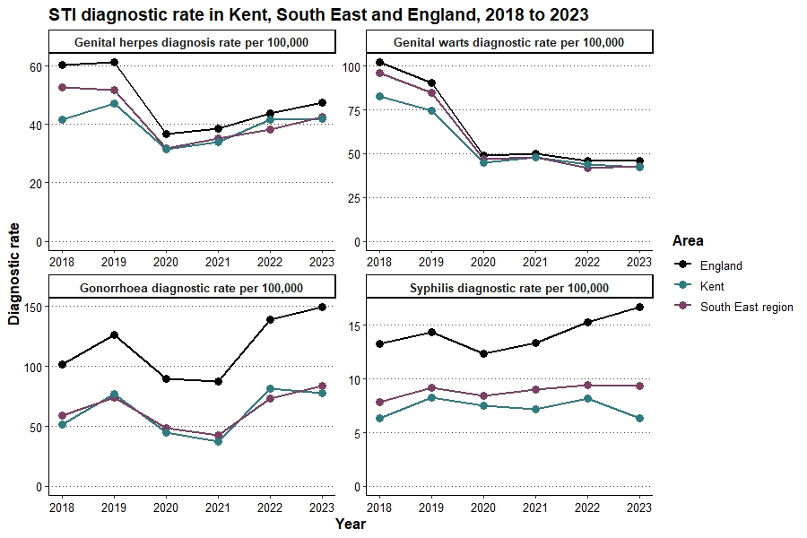

## 4.2 HIV

The HIV action plan in England aims to reduce HIV transmission and AIDS and HIV related deaths by 2030[88]. HIV has been transformed from a deadly infection to a lifelong, manageable condition thanks to free and effective antiretroviral therapy (ART). People diagnosed and living with HIV can expect to have a near normal life expectancy if diagnosed and treated early.

NICE guidelines define high HIV prevalence in local authorities as areas with a prevalence between 2 and 5 per 1,000 and extremely high prevalence as those with a diagnosed HIV prevalence of 5 or more per 1,000 people aged 15 to 59 years[89]. The crude HIV diagnosed prevalence rate per 1,000 amongst 15 to 59 year olds in Kent was 1.48 per 1,000 in 2023, an increase from 1.41 in 2021 and trends show an increase over the past decade. The prevalence is lower than the South East (1.91 in 2023 and 1.85 in 2022) and national level (2.40 in 2023 and 2.34 in 2022). As Kent is below the prevalence rate of 2 per 1,000 it is not categorised as an area with a high HIV prevalence, however monitoring and methods to prevent HIV transmission should continue as the prevalence has increased overtime. (Table 1[90]).

**Table 1: HIV diagnosed prevalence rate per 1,000, aged 15-59, 2019 to 2023**

|  |  |  |  |
| --- | --- | --- | --- |
| **Year** | **Kent** | **South East** | **England** |
| 2019 | 1.37 | 1.89 | 2.40 |
| 2020 | 1.40 | 1.86 | 2.33 |
| 2021 | 1.41 | 1.79 | 2.32 |
| 2022 | 1.47 | 1.85 | 2.33 |
| 2023 | 1.48 | 1.91 | 2.40 |

Within Kent in 2023 for 15-59 year olds, Gravesham (2.22 per 1,000) and Thanet (2.03 per 1,000) had the highest prevalence of HIV diagnoses, surpassing Kent and South East figures. Thanet surpassing Dartford during 2023. This would also make them high prevalence areas. Tonbridge and Malling had the lowest (0.71 per 1,000)[91].

HIV testing is recommended for anyone who is sexually active. However, particular groups are recommended to receive regular testing; those who identify as GBMSM should test once every 3 months if having condomless sex and/or sex with new partners, and black African men and women are also advised to test regularly if they are having condomless sex and/or sex with new partners[92].

The HIV testing coverage has been decreasing in recent years, particularly amongst gay and bisexual men who have sex with men (GBMSM) and women. In 2022 the testing coverage in Kent for GBMSM was 51.9%, compared to 82.6% in 2018. Kent has the lowest coverage in the South East, with the South East testing coverage at 71.0% for 2022 and the England coverage at 74.1%. The coverage was 27.9% for women in Kent in 2022 compared to 40.7% in the South East and 38.5% nationally. This has fallen from 66.7% in Kent in 2019.

The low HIV testing coverage in Kent can be partially explained by issues with the data, given that results from online HIV tests in Kent are not reported here. From the data currently available to KCC, it is possible to approximate that 26% of tests are completed locally in ISHS clinics, meaning the majority of tests are likely to be via online testing, or alternative provisions such as maternity services.

Overall, there remains a need to increase testing in Kent, without which it is unclear how accurately the HIV diagnosis rate reflects the true population diagnoses. Alongside this recommendation, it is proposed that a deep dive into HIV is conducted ahead of plans for a renewed HIV action plan for the UK in 2025.

## 4.3 Use of Long-Acting Reversible Contraception (LARC)

The total prescribed LARC (excluding injections) rate, which includes LARC prescribed in both general practice and sexual health services, per 1,000 in Kent was 44.6 in 2022, compared to 48.4 in 2018. This is slightly above the England rate of 44.1 in 2022. Total prescribed LARC decreased during the pandemic and has not yet returned to the pre-pandemic level.

Within sexual health services only, the proportion of women under the age of 25 who chose to use LARCs (excluding injections) as their preferred method of contraception in 2022 was 32.7% compared to 33.6% in 2021. The proportion in Kent is lower than the South East (35.8% in 2022 and 38.7% 2021) and England (36.2% in 2022, 37.3% in 2021). For women over the age of 25, the proportion was 50.6% (52.6% in 2021) in Kent compared to 51.3% in the South East (54.9% in 2021) and 53.2% nationally (53.4% in 2021).

The use of short-acting combined oral contraceptive rates in both Kent and nationally have also not returned to pre-pandemic rates and have been steadily declining[93] (**Figure 12**). This trend in use of both short and long-acting contraception should be monitored, given the possible impact on unplanned pregnancy. It is possible there is a cultural element to this (for example, could reflect changing attitudes to child-bearing or use of contraception). Building greater awareness of local cultures and its link to sexual health should be part of next steps for this work.

**Figure 12: Women prescribed short acting combined hormonal contraception in GP practices between 2018 and 2022, crude rate per 1,000, all ages**

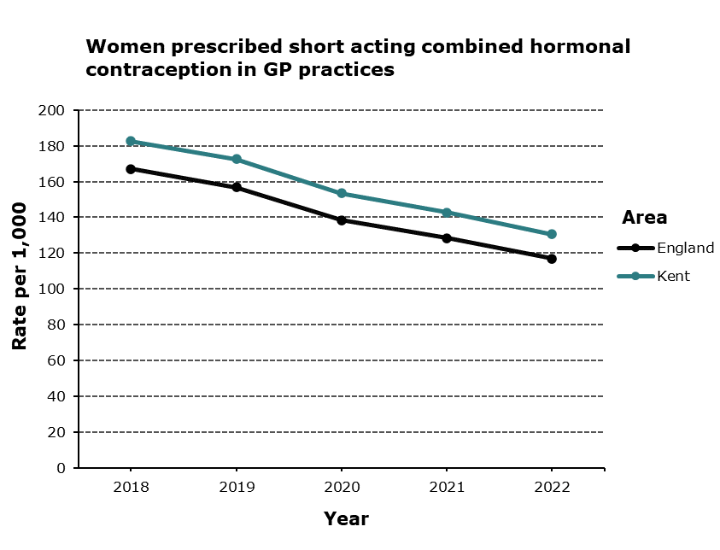

## 4.4 Under 18 Conceptions

The conception rate for women under the age of 18 is high in Kent compared to other areas in the South East, and since 2018 has been higher than the England average.

In 2021, the under 18s conception rate in Kent was 13.9 per 1,000, 10.7 in South East and 13.1 in England. Thanet had the highest conception rate in the South East with a rate of 22.5 per 1,000. Rates were also high in Swale (20.1 per 1,000), Dover (17.6 per 1,000), Ashford (17.1 per 1,000) and Maidstone (16.8 per 1,000). The under 18s birth rate for 2022, was highest in Thanet (17.2 per 1,000) and Ashford (6.4 per 1,000) compared to the Kent average of 3.1 per 1,000 and England average of 3.4 per 1,000 (**Figure 13**)

2021 is currently the most up to date data available. It will be key to continue to review the data as more is released from the UKHSA team.

**Figure 12: Under 18 conception rate per 1000, 2017 to 2021**

Teenage Mothers is an indicator found on the Child and Maternal Health data[94]. In 2022/2023 Kent (0.56%) had a higher rate of teenage motherhood than the South East (0.46%). England is higher overall at 0.6%. District level data is not available.

**Figure 14: Teenage Mothers- Proportion %**

## 4.5 Abortions

The proportion of conceptions leading to abortion in teenagers under the age of 18 was 59.5% in 2021, increasing 8% from 55.1% in 2020. In Folkestone and Hythe, the proportion was 84.2%, highest of all the Kent districts. In 2021, the proportion in Kent was higher than the South East (58.5%) and England (53.4%).

For females 15 to 44 years, in 2021, the total abortion rate per 1,000 of the population was 19.0 compared to 19.2 for England. Both Kent and England rates have increased since 2012, rising from 15.6 for Kent, and 16.5 for England.

2021 is the most recent data currently available at a county level. National data is available for 2022 which has shown a sharp 17% increase in abortions.

The trend in abortion rate varies by age group. Nationally, the rates for abortions have increased for all ages 22 and above, with the largest increase among women aged 30 to 34[95]. Reasons for this have been suggested, including the cost of living crisis, issues accessing contraception and changes to abortion services[96].

## 4.6 Ectopic Pregnancy and Pelvic Inflammatory Disease

Both ectopic pregnancy and pelvic inflammatory disease (PID) can be caused by poor sexual health, more specifically untreated chlamydia or gonorrhoea infections[97]. Therefore, it is important to monitor increases and changes of these issues in the population.

The ectopic pregnancy admissions rate per 100,000 is 99.1 in Kent for 2022/23, a decrease of around 2.26% since 2021/22 when it was 101.4. Although it is a decrease, the rate is higher than England which was 89 per 100,000 in 2022/23 and the Southeast at 91.1. Within Kent increases can be seen in some districts, Tonbridge and Malling and Sevenoaks although the counts are quite low. The rates are comparably high in Dartford, Ashford, Dover, Thanet.

PID admission rate is also higher than the national rate (226.7 per 100,000) and the South East (212.1) and has increased since the previous year, 269.3 per 100,000 in 2021/22 to 288.5 per 100,000 in 2022/23. Thanet has the highest rates in the South East region at 523.9 per 100,000. Rates are also high in Gravesham, Dartford, Dover, Folkestone and Hythe, Maidstone and Sevenoaks.

# 5. Sexual Health Services in Kent

## 5.1 Specialist Integrated Sexual Health Services

Specialist integrated sexual health services are mandated services provided by the Local Authority, with the aim of ensuring timely access to high quality services, accessed by a digital single point of access and provided in accessible locations. A wide range of sexual health services are provided, including contraception, sexual health screens for sexually transmitted infections (STIs) and HIV early diagnosis and treatment. Some sexual health services are excluded from the specialist integrated sexual health service, for example, termination of pregnancy services.

The Kent integrated sexual health service specification requires updating to ensure the inclusion of national policy changes since it was last reviewed in 2020.

In Kent the specialist integrated service is delivered by two providers – Kent Community Health Foundation Trust (KCHFT) in East Kent and by Maidstone and Tunbridge Wells NHS Trust (MTW) in North and West Kent. Tables 2 and 3 show the number of people accessing the services along with their demographics.

**Table 2: Number of people accessing the service per year by provider, from April 2020 to March 2024.**

|  |  |  |  |  |
| --- | --- | --- | --- | --- |
| **Service provider** | **2020/21** | **2021/22** | **2022/23** | **2023/2024** |
| KCHFT | 31,051 | 33,583 | 32,845 | 33,140 |
| MTW | 27,406 | 34,362 | 31,180 | 32,222 |
| Total | 58,457 | 67,945 | 64,025 | 65,362 |

**Table 3: Number and % breakdown of service users in 2022/23 by provider and by sex, age, sexual orientation and ethnicity.**

|  |  |  |
| --- | --- | --- |
|  | **KCHFT – East Kent**  **N (%)** | **MTW – North and West Kent**  **N (%)** |
| Total | 32,844 (100.0%) | 31,182 (100.0%) |
| **Sex** | | |
| Male | 12,034 (36.6%) | 9,807 (31.5%) |
| Female | 20,810 (63.4%) | 21,375 (68.5%) |
| **Age** |  |  |
| <10 | 0 (0.0%) | 16 (0.1%) |
| 10 to 19 | 5,420 (16.5%) | 5,080 (16.3%) |
| 20 to 29 | 11,947 (36.4%) | 10,107 (32.4%) |
| 30 to 39 | 7,261 (22.1%) | 7,770 (24.9%) |
| 40 to 49 | 3,956 (12.0%) | 4,832 (15.5%) |
| 50 to 59 | 2,773 (8.4%) | 2,434 (7.8%) |
| 60 to 69 | 1,156 (3.5%) | 705 (2.3%) |
| 70 to 79 | 306 (0.9%) | 225 (0.7%) |
| 80 to 89 | 17 (0.1%) | 11 (0.0%) |
| 90 to 99 | 8 (0.0%) | 2 (0.0%) |
| **Sexual Orientation** |  |  |
| Heterosexual or Straight | 25,812 (78.6%) | 27,106 (86.9%) |
| Gay or Lesbian | 4,430 (13.5%) | 2,597 (8.3%) |
| Bisexual | 1,655 (5.0%) | 1,295 (4.2%) |
| Other | 1 (0.0%) | 22 (0.1%) |
| Not recorded or declined to answer | 946 (2.9%) | 135 (0.4%) |
| **Ethnicity** |  |  |
| White - British | 25,641 (78.1%) | 22,337 (71.6%) |
| White - Irish | 149 (0.5%) | 186 (0.6%) |
| White – Any other White background | 1,804 (5.5%) | 2,425 (7.8%) |
| Mixed – White and Black Caribbean | 248 (0.8%) | 236 (0.8%) |
| Mixed – White and Black African | 615 (1.9%) | 434 (1.4%) |
| Mixed – White and Asian | 187 (0.6%) | 174 (0.6%) |
| Mixed – Any other Mixed background | 353 (1.1%) | 505 (1.6%) |
| Asian or Asian British – Indian | 107 (0.3%) | 604 (1.9%) |
| Asian or Asian British – Pakistani | 60 (0.2%) | 61 (0.2%) |
| Asian or Asian British –Bangladeshi | 42 (0.1%) | 81 (0.3%) |
| Asian or Asian British – Any other Asian background | 486 (1.5%) | 343 (1.1%) |
| Black or Black British – Caribbean | 114 (0.3%) | 330 (1.1%) |
| Black or Black British – African | 948 (2.9%) | 2,782 (8.9%) |
| Black or Black British – Any other Black background | 133 (0.4%) | 295 (0.9%) |
| Other Ethnic Groups – Chinese | 103 (0.3%) | 76 (0.2%) |
| Other Ethnic Groups – Any other ethnic group | 226 (0.7%) | 253 (0.8%) |
| Not stated or Blank | 1,628 (5.0%) | 60 (0.2%) |

Overall, more women are accessing the services than men, but we are unclear whether there is an unmet need in males and further insights work may help to understand this. People who identify as gay, lesbian, or bisexual are presented in Kent’s ISHS in higher proportions than in the general population which is positive.

Both services have an outreach element providing specialist sexual health services for populations with the highest needs, including asylum seekers, sex workers and young people with complex sexual health needs. This service uses a place based working approach to reach those who are the most underserved and who may be less likely to use the service.

The services are promoted through the KCC sexual health web pages[98]. A sexual health campaign to raise awareness amongst young people and direct people to the KCC sexual health website was last run by KCC in 2021/22. Between July and October 2021 there were 27,226 pageviews, a rise from pre-pandemic 2019 activity of 24,080. In 2023/24 there was no allowance for sexual health in the campaigns budget. National campaigns are also supported by KCC via social media channels.

## 5.1.1 East Kent ISH Services provided by KCHFT

In East Kent, services are located in five of the six districts. The Gate Clinic in Canterbury offers level 3 provision for more specialist sexual health needs and is a very busy service due to Canterbury’s student population. The new Flete clinic at QEQM in Margate opened in late 2023, with the aim of providing level 3 provision and reducing demand on the Canterbury clinic. There is no face-to-face service in Dover meaning residents would have to travel to Canterbury, Folkestone or Ramsgate using unreliable transport links meaning an inequality in access to services in East Kent.

The service is accessed via self-referral. During the COVID-19 pandemic, this moved to a telephone triage to signpost patients to alternative services if appropriate (such as online STI testing), with the aim of reducing the number of face-to-face clinic appointments required. Walk-in clinics which were used pre-pandemic stopped and have not been reinstated.

Average wait times following initial triage in 2022/23 were 2.27 days for a genito-urinary medicine (GUM) appointment and 2.69 days for a sexual and reproductive health (SRH) appointment.

The service also provides long-acting reversible contraception (LARC), with a target of less than 6 weeks wait time from first consultation to insertion of the contraceptive device. In 2021/22 and 2022/23 this was achieved in 100.0% of cases, after a brief drop, this has now returned to 100% for all months of 2024.

KCHFT have recently switched to a new IT system called Inform for managing appointments. General feedback on the system to commissioners has been positive and will continue to be reviewed.

First-time patients are offered a full sexual health screen, including chlamydia, gonorrhoea, syphilis and HIV testing. In 2023/24 thus far, 99.1% were offered and 1219 (87.6%) accepted. In patients testing positive for infection, more than 97% should have a documented partner notification plan. This was achieved in 98.6% of patients in 2022/23 and 100.0% in 2023/24 to date.

KCC has a section 75 agreement with NHSE for provision of HIV outpatient services. The HIV budget is bundled with the integrated sexual health service budget to facilitate seamless payments to KCHFT.

As part of a pilot, KCHFT recruited a clinical psychologist within the ISH service to provide streamlined psychological support to patients with mental health problems who access the ISH service. This is a different service to the psychosexual therapy service discussed below which focuses on sexual problems causing distress. Overall, 114 patients were supported during this pilot 62 male, 42 female. It was seen as enhancing the holistic offer of the service with the secondary benefit to the staff knowledge and understanding of psychological support that patients need.

It is a recommendation of this report that commissioners seek to imbed this into the ISHS offer.

## 5.1.2 North and West Kent ISH Services provided by MTW

In North and West Kent, the integrated sexual health services are located in four of the six districts, with two sites in North Kent (Gravesham and Dartford), and two sites in West Kent (Maidstone and Tunbridge Wells). Sites in Sevenoaks and Tonbridge that were provided in general practices closed during the COVID-19 pandemic and have not re-opened due to the space within these practices no longer being available, resulting in geographical inequalities in access. The Gravesham site offers a level 3 service.

The service is accessed via telephone self-referral to a centralised number. Calls are triaged and patients are either booked into a relevant clinic, or signposted to an alternative service if more appropriate, for example online STI testing. A staff member must be present to accept the call and organise a triage appointment, which can be a barrier to access, given that MTW have reported difficulty in recruiting receptionist roles.

There was a decline in numbers of GUM appointments booked within four working days of initial triage which was thought to be due to several factors including the temporary closure of the Overy Street Clinic in Dartford and the introduction of walk-in clinics. These clinics have been re-introduced post-pandemic and have been a success; however, they reduce capacity for booked appointments. Over 500 patients were seen in the initial 5 months of the reintroduction of the one walk-in clinic slot. Two-thirds of these patients were under 25 and some of them were travelling from outside of MTW’s area demonstrating the need for them.

The service also provides long-acting reversible contraception (LARC), where patients currently have less than 6 weeks wait time from first consultation to insertion of the contraceptive device. This was achieved in 2021/22, 2022/23, and to date in 2023/24.

In North and West Kent, the Lilie digital system is used to record information and SMS text messages are sent to patients to minimise DNAs. There is no live-chat function in use in North and West Kent.

First-time patients are offered a full sexual health screen, including chlamydia, gonorrhoea, syphilis and HIV testing. In 2023/24, 66.0% were offered and 454 (100.0%) accepted a full screen. The proportion of first-time patients offered the screen in North and West Kent is substantially lower than in East Kent. Discussions between the two providers suggest there are coding differences in how this data is recorded and more investigation is required before setting a formal KPI target for North and West Kent.

In patients testing positive for infection, more than 97% should have a documented partner notification plan. This was achieved in 99.8% of patients in 2022/23 and 100.0% in 2023/24 to date.

Feedback for the service is generally very positive with patients reporting friendly and professional staff with short waiting times.

MTW has promoted the service as part of national initiatives, for example the hiring of a bus with HIV branding to raise awareness, and outreach activities during HIV testing week. However, there is limited understanding of how MTW promote the service via their digital channels.

KCC has a section 75 agreement with NHSE for provision of HIV outpatient services. The HIV budget is bundled with the integrated sexual health service budget to facilitate seamless payments to MTW.

The integrated service budget does not include cost of premises which are paid for by KCC, adding a significant cost to the service.

## 5.1.3 Strengths of the Integrated Sexual Health Service

* An integrated model means that people who need to access sexual health support can be offered more services in one place.
* Wait times for the KCHFT provided service are consistently above the target for waiting times, meaning people can access an ISH appointment when required. The MTW service has slightly longer waits for booked appointments, but they run a walk-in clinic which is well received, and they have made improvements to bring this within target. Nationally, there are issues with access which Kent are not experiencing at present meaning our residents are able to get access to a service quickly when they need it in the majority of cases.
* First time patients are nearly always offered a STI screen and most accept in the KCHFT service.
* Use of LARC wait times have been consistently below the target of 6 weeks in the MTW service.
* Patient insights indicate high satisfaction with both services.

## 5.1.4 Recommendations for the Integrated Sexual health service

* Integrated sexual health services (ISHS) specifications should be updated to include changes to policies and understanding after the pandemic and since the last SHNA.
* Continue with service in the integrated model, with focus on reducing STI’s and access to contraception.
* To consider how providers can work closer together and share systems or job roles, ensuring equitable access options for the Kent population.
* To consider the introduction of a clinic in Dover, given the potential transport issues in residents travelling to another clinic.
* To consider the introduction of a clinic in Sevenoaks or Tonbridge & Malling, however these are more affluent areas with better outcomes.
* To understand and coordinate the outreach elements of the services, including which key groups are supported, and what is the impact on outcomes.

## 5.2 Psychosexual Therapy

The psychosexual therapy service works with the specialist integrated sexual health service to provide streamlined psychosexual support to individuals over the age of 16 presenting to sexual health services with concerns impacting on their sexual relationships. Frequently referred conditions include erectile dysfunction, sexual body image dysmorphia, and sexual pain disorders such as vaginismus. The service is provided by KCHFT but is available for people across the whole of Kent.

The service is a tertiary service and therefore referrals should be received from a GP, sexual health clinic or other healthcare professionals. In exceptional circumstances the service may receive self-referrals, but these will be triaged by the service lead. If a patient presents and is not registered with a GP, they should be provided with advice on how to register. However, referrals have been received from other organisations and it is unclear if these are being accepted by the service.

The patient is then offered an initial appointment to assess the presenting problem and identify patients who are not suitable for psychosexual therapy.

Psychosexual interventions should be brief, focused and provided for a maximum of six sessions lasting 45 minutes, with a review if further intervention or a referral to another service is required. If further sessions are required, an exception request to commissioners should be made. There have been 17 patients who have received more than six sessions. The service should not offer long-term therapy and therefore this may have an impact on waiting time for other users.

Sessions are offered face-to-face or remotely over phone, or via video depending on patient preference, and operate from 8am to 7pm. Face-to-face sessions are offered at several sites across Kent. They are less popular than the virtual sessions, with only 10 people in Q1 of 2023/24 having a face-to-face appointment compared to 559 virtual appointments.

The Maidstone site involves a separately hired counselling room, as opposed to using existing sexual health clinic space. It is unclear if the new Thanet space is being used for other purposes when face-to-face appointments are not required. The Tunbridge Wells clinic room is also rented out to the perinatal bereavement counselling team (Thrive). Occasionally other ISH clinic sites are used to accommodate face-to-face sessions if a need arises. A review of estates costs for the service would be helpful.

From June 2022 to June 2023, there were 2,897 therapy sessions offered. A small number of patients (12) were identified as unsuitable for the service after initial triage.

In 2022/23, of all patients using the service, there were 468 outcomes recorded with only 59.8% of those completing the full course of therapy **(Table 4)**. However, the proportion of clients who have an improvement in their presenting problem following completion of therapy was consistently 100.0%. It is unclear how an improvement is measured, and it is not known why patients do not complete the full course of therapy making it difficult to assess the impact of the service on patients. The service requires highly trained therapists, making recruitment difficult

**Table 4: Number (n) and proportion (%) of patients using the service, according to outcome for 2022/23.**

|  |  |
| --- | --- |
| **Outcome** | **Number of patients using the service  (%)** |
| Completed full course of therapy | 280  (59.8%) |
| Disengaged | 69 (14.7%) |
| Never engaged | 74 (15.8%) |
| No longer needed the service | 45 (9.6%) |

## 5.2.1 Strengths of the Psychosexual Therapy Service

* Tertiary referral service and the majority of referrals triaged are found to be suitable for the service
* An improvement in the patients' presenting problem is seen in nearly all those completing the full course of therapy

## 5.2.2 Possible Transformation Recommendations

* Looking at whether to move online rather than continue investing in property for this.
* To understand the psychological sexual health needs of the Kent population who may require the psychosexual service, for example the influence of adverse childhood experiences on the sexual health of adults
* To collect patient insights to understand why a large number of people do not complete the full course of therapy or do not engage following initial referral
* To collect patient insights and staff insights to understand the impact of the service on psychosexual outcomes to ensure quality service delivery and equity across Kent

## 5.3 HIV Services

The specialised HIV treatment and care service is offered as part of the integrated sexual health services provided by KCHFT and MTW. The service is funded by NHS England (NHSE) and KCC commission the service on their behalf to integrate with the ISH. This offers several benefits including a more holistic care approach, streamlined referrals, improved data sharing, cost efficiency and to enhance prevention of HIV within the sexual health service.

The commissioning of HIV services is the responsibility of NHSE and therefore they have their own service specification outcome measures which differ from those on which the ISH service is performance managed. The commissioning responsibility will be transferred from NHSE to the ICB in 2024/2025.

HIV treatment is a level 3 service, with service delivery throughout Kent and on multiple days of the week, in Dartford, Gravesham, Maidstone, Tunbridge Wells, Ashford, Margate, Canterbury and Folkestone. There are no clinics in the districts of Swale, Dover, Sevenoaks or Tonbridge & Malling.

The service supports people newly diagnosed with HIV, including pregnant women testing positive in antenatal screening, along with those living with HIV and requiring complex support.

There are around 1000 patients using the service each yeah, and this number has been steadily increasing year-to-year **(Table 5)**. Attendance numbers, along with the number and proportion of DNAs have also steadily increased **(Table 6)**. DNA rates for HIV were similar to those for non-HIV care.

**Table 5: Number of patients using the HIV service by provider, from 2019 to 2023**

|  |  |  |  |  |
| --- | --- | --- | --- | --- |
| **Service provider** | **2019/20** | **2020/21** | **2021/22** | **2022/23** |
| KCHFT | 496 | 518 | 514 | 546 |
| MTW | 479 | 476 | 485 | 512 |
| Total | 975 | 994 | 999 | 1058 |

**Table 6: Number of attendances, DNAs, and DNA proportion (%) from 2020 to 2024**

|  |  |  |  |  |
| --- | --- | --- | --- | --- |
|  | **2020/21** | **2021/22** | **2022/23** | **2023/24** |
| No. attendances | 2,753 | 3,506 | 4,028 | 940 |
| No. DNAs | 197 | 448 | 458 | 146 |
| DNA proportion (%) | 6.68% | 11.33% | 10.21% | 13.44% |

Good practice for HIV services recommends a peer support service which is not currently offered within the Kent service. There is no available patient insights information. There are no local campaigns promoting the service and no budget available for these campaigns.

The annual cost of the HIV service is increasingly higher than the funding from NHSE.

## 5.3.1 Strengths of the HIV Services

* KCHFT provide additional appointments with HCAs and pharmacists to provide a streamlined service and maximise best practice
* The integrated approach means that patients can be seen in a specialised environment and have access to full sexual health screening and services

## 5.3.2 Possible Transformation Recommendations

* Review of budget for HIV services, considering the rising demand and costs
* Patient insights data to understand why the DNA proportion is steadily rising. Important to address this given the increasing demand and cost for the service.
* Develop a peer support service, as recommended as best practice
* Review the options for strengthening of provision of HIV service provided to residents in Swale, Dover, Sevenoaks and Tonbridge & Malling
* Increase testing coverage given the marked drop in coverage from pre-pandemic levels, including via supporting promotional campaigns.

## 5.4 Online STI Testing

The online STI testing service is provided by MTW who subcontract the service to Preventx which provides the online service via SH.UK. The service is integrated with the MTW E-Bureau, with administration and clinical staff available to contact patients with positive test results for further management. They can refer patients to the ISH services provided by both MTW and KCHFT, despite the online STI testing service being provided by MTW. The service is also linked to the KCHFT provided pharmacy service for chlamydia treatment, by providing a code to the patient to pick up treatment from a pharmacy.

Online STI testing is available for HIV, syphilis, hepatitis B and C, chlamydia, gonorrhoea and trichomonas vaginalis (TV). TV testing was introduced as a trial in 2021/22 and has now been integrated into the online service.

The service aims to maximise equitable access to STI testing across Kent, reducing the need for patients to travel to a clinic site. There may be potential inequalities in access however for those with poor internet connection, or those without a smart device or access to one. A map of wired broadband speeds in 2022 suggests East Kent and Canterbury have slower broadband speeds than other areas of Kent, but this does not account for internet access via smart phones and does not consider those without access to the internet or a smart phone. People without a fixed address may also face difficulties using the service, given it relies on the posting of testing kits to a home address. The service also relies on the Royal Mail delivery service to distribute and receive test samples, so is vulnerable to strikes and changes to their service.

Patients access the service via the Kent sexual health matters website, which can also be accessed via the kent.gov.uk/sexual health website. A digital consultation checks the user has an address within Kent and asks a range of detailed sexual health questions. They will then be either offered a STI test that is posted to them or advised to urgently attend a sexual health clinic or A&E, depending on their consultation answers. Postage for returning testing kits is pre-paid and average return times for tests are 13.2 days. Where online STI testing is not available to persons under the age of 16 due to safeguarding reasons, and so they would be seen in the appropriate clinic instead. Where in the data below there is reference to under 16s therefore it relates to requests made rather than testing provided through the online service.

Results are shared with the patient and with the MTW E-Bureau team who will contact patients with positive results, to provide next steps. They may be directed to a sexual health clinic for further management or signposted to a nearby pharmacy for treatment. The E-Bureau team will also support with partner notification to advise partners on the appropriate course of action to minimise onward transmission. If someone under the age of 16 attempts to access the service, they will be contacted by the MTW team to make sure any safeguarding measures are taken as needed.

The service offers STI testing for both symptomatic and asymptomatic people, with symptomatic testing being added to the service in 2020 to minimise face-to-face contact and demand on ISH clinics during the COVID-19 pandemic. Between Q1 2020/21 and Q2 2022/23 the total number of test orders per quarter increased from 6,606 to 13,172, an almost 100% increase. As a result, capacity within the E-Bureau team was affected by this change leading to an increased budget for additional staff, and an overall increasing budget for the online STI testing service.

Despite increasing numbers using the online STI testing service, there still remains a high demand on sexual health service appointments with only a slight decrease in the number of appointments taking place each month **(Figure 15)**. Increasing use of the online testing service does not appear to have dramatically reduced appointments required in the sexual health clinics. It isn’t possible from the data available to determine the reasons for each appointment, but it is thought that this may be due to either triaging of telephone contacts increasing, and results from online testing being discussed. Further investigation can be done to explore this in more depth.

**Figure 15: Number of appointments in the integrated sexual health clinics and number of online STI testing kits ordered, per month, from April 2019 to February 2024**

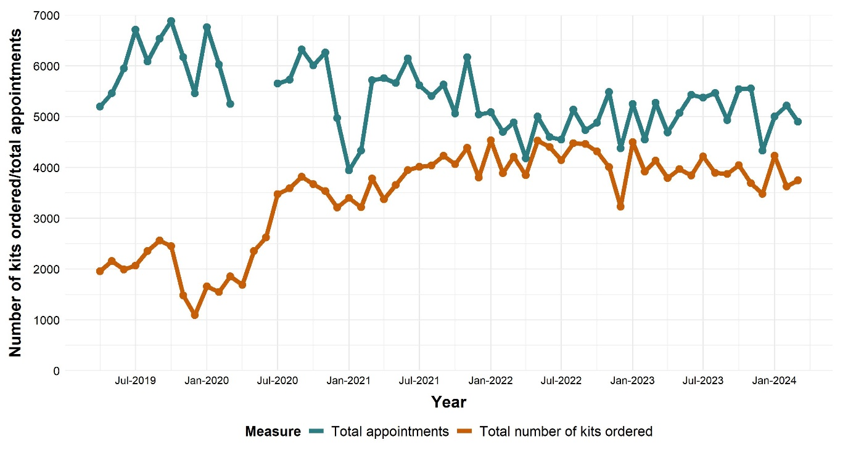

Between Q1 2020/21 and November 2022 there were 112,438 STI tests ordered. Of these, 71.9% were from asymptomatic patients, 21.2% from symptomatic patients and 6.9% were online orders that were sent direct from the Integrated Sexual Health service. Of the total number of orders, 48% were by 16–25-year-olds. The majority were ordered by people identifying as straight (84.9%), with a greater proportion of tests being ordered by those identifying as gay and bisexual than seen in the UK census data (3% of the population). People of a White British ethnicity made up 81.3% of the orders, with those of Bangladeshi, Chinese, Latin American and Pakistani ethnicities each representing less than 0.5% of the total orders.

The testing service identified 6,397 STIs between Q1 of 2020 and November 2022 **(Table 7)** with the highest positivity proportion in those who were symptomatic.

Further investigations into the unexpectedly similar proportions of positives between symptomatic and asymptomatic are warranted, equally a deeper dive into the online ordering process and justification.

**Table 7: Number of STIs identified between Q1 of 2020 and November 2022, according to type of STI and presence of symptoms.**

|  |  |  |  |
| --- | --- | --- | --- |
| **STI** | **Asymptomatic** | **Symptomatic** | **Online Order** |
| Chlamydia | 3156 | 1265 | 339 |
| Gonorrhoea | 599 | 159 | 60 |
| HIV | 204 | 159 | 60 |
| Syphilis | 94 | 23 | 41 |
| Hepatitis B | 72 | 9 | 6 |
| Hepatitis C | 13 | 2 | 6 |
| Trichomonas Vaginalis | 61 | 169 | 34 |
| **Total infections** | **4199** | **1681** | **517** |
| **Total tests ordered** | **80,843** | **23,837** | **7,758** |
| **Positivity (%)** | **5.19%** | **7.05%** | **6.66%** |

The positivity percentage for various demographics are shown below in **Table 8**. Of note, there is higher positivity for chlamydia in those 16-25 years as expected. Rates for under 16s are high, but this is likely to be due to this age group only testing when there is suspicion of an STI, more so than for other age categories. The numbers are very low. It is not known what the breakdown of under 16s ordering per age is, this could be an area for further investigation.

For gonorrhoea, those identifying as gay have a 4.5% positivity compared to 0.6% in those identifying as straight. Looking at ethnicity, there are higher positivity percentages compared to the average for chlamydia (5.7%) in those with African (7.7%), Other Asian (7.5%), White and Black African (8.0%) and White and Black Caribbean (7.1%). For trichomonas vaginalis (TV) the positivity in White Irish ethnicity was 13.8% compared to the average of 2.4%. Each district of Kent had similar positivity percentages for chlamydia, gonorrhoea, syphilis and hepatitis C. For hepatitis B, Gravesham has a 2.4% positivity percentage compared to the average of 0.9% across other Kent districts. For trichomonas vaginalis, the positivity varied considerably between districts with higher rates in Dartford, Gravesham, Sevenoaks, Folkestone and Hythe and Swale.

**Table 8: Positivity percentage by age, sexuality, ethnicity and district for each STI between Q1 of 2020 and November 2022.**

|  |  |  |  |  |  |  |  |
| --- | --- | --- | --- | --- | --- | --- | --- |
| **STI** | **Under 16 years** | **16 to 25 years** | **26 to 35 years** | **36 to 45 years** | **45 to 55 years** | **56 to 64 years** | **65+ years** |
| Chlamydia | 37.5 | 8 | 4 | 3 | 2.6 | 2.1 | 2.9 |
| Gonorrhoea | 12.5 | 1 | 0.9 | 0.9 | 1.2 | 1.4 | 1.6 |
| HIV | 0 | 0.4 | 0.4 | 0.6 | 0.6 | 0.4 | 0 |
| Syphilis | 0 | 0.1 | 0.3 | 0.5 | 0.4 | 0.8 | 1.1 |
| Hepatitis B | 0 | 0.7 | 0.9 | 1.2 | 1.9 | 1 | 4.2 |
| Hepatitis C | 0 | 0.2 | 0.4 | 0.7 | 0 | 0 | 0 |
| TV | 0 | 2.3 | 2.9 | 2.1 | 4.7 | 1.1 | 0 |

|  |  |  |  |  |
| --- | --- | --- | --- | --- |
| **STI** | **Bisexual** | **Gay** | **Straight** | **Undecided** |
| Chlamydia | 5.1 | 5.9 | 5.7 | 5.1 |
| Gonorrhoea | 1.3 | 4.5 | 0.6 | 2.8 |
| HIV | 0.6 | 0.7 | 0.4 | 0.5 |
| Syphilis | 0.5 | 1.6 | 0.1 | 1 |
| Hepatitis B | 1.3 | 1 | 0.9 | 1 |
| Hepatitis C | 0.2 | 0.1 | 0.3 | 1.6 |
| TV | 2.3 | 2.7 | 2.6 | 3.4 |

|  |  |  |  |  |  |
| --- | --- | --- | --- | --- | --- |
| **STI** | **Average** | **African** | **Other Asian** | **White and Black African** | **White and Black Caribbean** |
| Chlamydia | 5.7 | 7.7 | 7.5 | 8 | 7.1 |
| Gonorrhoea | 1 | 0.5 | 1.2 | 1.3 | 0.9 |
| HIV | 0.4 | 1 | 0.1 | 0.2 | 0.6 |
| Syphilis | 0.3 | 0 | 0.6 | 0.2 | 0.2 |
| Hepatitis B | 0.8 | 1.5 | 0.7 | 1 | 1.6 |
| Hepatitis C | 0.2 | 0.4 | 0.6 | 0 | 0 |
| TV | 2.4 | 3 | 1.2 | 2.2 | 2.9 |

|  |  |  |  |  |  |  |  |
| --- | --- | --- | --- | --- | --- | --- | --- |
| **District** | **Chlam-ydia** | **Gonorr-hoea** | **HIV** | **Syphilis** | **Hep B** | **Hep C** | **TV** |
| Ashford | 5.8 | 0.9 | 0.5 | 0.2 | 0.6 | 0.5 | 1.3 |
| Canterbury | 6.5 | 0.9 | 0.5 | 0.2 | 0.7 | 0.1 | 1.3 |
| Dartford | 5.3 | 0.9 | 0.6 | 0.3 | 1 | 0.6 | 3.2 |
| Dover | 5.9 | 1.1 | 0.3 | 0.3 | 0.8 | 0 | 2.9 |
| Gravesham | 5.1 | 1 | 0.4 | 0.2 | 2.4 | 0 | 3.6 |
| Maidstone | 5.8 | 0.9 | 0.4 | 0.3 | 0.9 | 0.1 | 3.1 |
| Medway | 5 | 0 | 0 | 0 | 0 | 0 | 0 |
| Sevenoaks | 4.4 | 0.6 | 0.5 | 0.2 | 0.5 | 0.5 | 3.5 |
| Folkestone and Hythe | 5.5 | 1.1 | 0.3 | 0.4 | 0.5 | 0.4 | 3.4 |
| Swale | 6.7 | 0.9 | 0.4 | 0.4 | 0.5 | 0 | 3.2 |
| Thanet | 5.5 | 1.3 | 0.6 | 0.2 | 1 | 0.3 | 3 |
| Tonbridge and Malling | 5 | 1.1 | 0.4 | 0.2 | 1.4 | 0.9 | 1.6 |
| Tunbridge Wells | 4.7 | 0.8 | 0.6 | 0.2 | 1.6 | 0.5 | 0.6 |

Patients are sent text reminders periodically to encourage completion and return of the testing kit. In 2021/22 there were 48,137 testing kits ordered, with 74.2% returned. The unreturned kits represent a cost of £273,007. Whilst this cost is large, benchmarking against other services shows the Kent return rate is above average.

Up to four tests a year can be ordered per person, with an average of 1.7 tests ordered per person between Q1 2020 and November 2022. If requesting more than four tests, the service will contact the patient to find out the reasons for this. Return rates in those ordering tests frequently is varied, with some patients regularly returning them, and others having a very low return rate. On average, the return rate for patients who had ordered more than 10 tests was 41.2%, much lower than the overall average return rate for the whole service (74.2%).

The online STI testing service is promoted by a range of organisations, for example the websites of KCC, MTW, KCHFT and on the Get It website. There is limited knowledge on general public awareness of the service in Kent, however, we have recently found through insights that patients value having the choice of the online STI test kits. The service has consistently proven that user satisfaction is high with survey scores of 3 or above occurring at least 98% of the time from 2021/22 to the YTD 2023/24.

The spend on online testing has increased steadily from 2019/20 to date, more than doubling. The yearly total spend has consistently exceeded the total budget, with the funding gap being met by the MTW underspend in the integrated sexual health services.

## 5.4.1 Strengths of the Online STI Testing Service

* The service improves access to STI testing by reducing the need to travel to a sexual health clinic
* Consistently achieving good user satisfaction
* Increased usage since COVID-19, with the inclusion of symptomatic testing

## 5.4.2 Possible Transformation Recommendations

* Further insights into online sexual health services. Need more high-quality patient service and ideas for improvement, this could be via mystery shoppers.
* Consider option to bring contract management in house also.
* Need further exploration of digital services that could be included in the online service
* Understanding why kits aren’t returned, and why some users order multiple tests to reduce costs and better support the population to access an appropriate sexual health service
* Further investigations into the unexpectedly similar proportions of positives between symptomatic and asymptomatic are warranted, equally a deeper dive into the online ordering process and justification.

## 5.5 Pharmacy Sexual Health Services

Pharmacy sexual health services are provided by KCHFT, who outsource the service to community pharmacies across all 12 Kent districts. As of May 2023, there were 105 contracts with local pharmacies.

The pharmacy service includes provision of emergency oral contraception (EoC) for women under 30 years, simple genital chlamydia consultation and treatment, signposting and referral to other sexual health services and sexual assault services and sexual health promotion including raising awareness of the Get It condom distribution programme. Service availability can vary from location to location. During appointments, the pharmacist can also offer a supply of condoms to the patient.

The service works in conjunction with other sexual health services by referring patients with positive chlamydia test results to a local pharmacy to pick up treatment. There is also a duplication for chlamydia treatment consultations whereby the E-Bureau team at MTW phone patients with the results of their online STI test and give information about treatment. This consultation may then be repeated when the patient attends the pharmacy to collect the treatment.

As of spring 2023 pharmacists began to supply repeat oral contraception, for those already initiated on the medication by their GP or sexual health clinic. This service provides an opportunity for promotion of chlamydia screening, signposting to the online STI testing service, and to increase awareness of the emergency oral contraception service offered.

There are numerous non-sexual health KCC commissioned pharmacy services resulting in duplication of commissioning resources. This could be consolidated into one standard contract with pharmacies signing up to whichever elements they would like to provide.

There have been closures of community pharmacies, withdrawal of pharmacy services within supermarkets and a national occupational shortage of pharmacists which can impact the service. KCHFT have also reported issues with recruitment of locum pharmacists who support the service when a pharmacist is unavailable. Additionally, some local pharmacists have not completed the required training to provide sexual health pharmacy services. If attending a pharmacy and they are not able to prescribe the required medication, patients will be signposted to a nearby participating pharmacy or a sexual health clinic.

There is participation of pharmacies in the service across Kent, as is demonstrated by the map below **(Figure 16)** with good geographical spread. However, it is unclear if there is equitable coverage with areas with the highest need. As expected, most pharmacies are located in the more populous town areas and an understanding of ease of access for those living in more remote locations, especially for those requiring public transport would be useful.

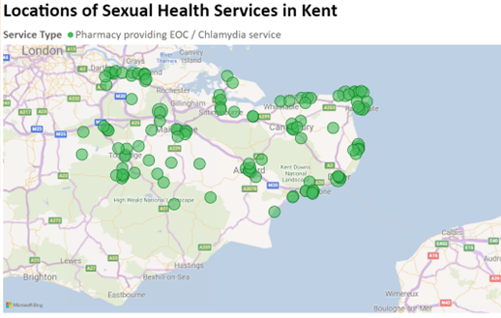

**Figure 16: Map of Pharmacy Sexual Health Services in Kent**

Highest volume of service use in 2021/22 was in Maidstone, Canterbury and Tunbridge Wells, and in 2022/23 and 2023/24 to date, Maidstone and Canterbury have the highest volumes. Tunbridge Wells is likely to have users from East Sussex which may explain the higher volumes. Data for 2022/23 show low levels of usage in Swale (1.9%).

In 2021/22 the highest volume service users were between 16-18 years old, and in 2022/23 this changed to 19 to 21-year-olds. However, use of the service has been across a wide age range, with 21% of service users being over the age of 30 years, despite the EoC service being for those under 30. Ethnicity reporting is limited.

The service uses an IT system called pharma-outcomes which records activity and allows reporting of data back to KCHFT. The number of treatments dispensed by the pharmacy service has fluctuated year-on-year **(Table 9)**. The data in Table 9 does not provide information on service user experience and does not show which groups of the population are utilising this service. Some patients may also receive two doses of EoC and therefore the numbers of treatments dispensed does not necessarily correspond to the number of people accessing the service.

**Table 9: Number of treatments dispensed by the pharmacy service per year from 2020 to 2023**

|  |  |  |  |
| --- | --- | --- | --- |
| **Treatment dispensed** | **2020/21** | **2021/22** | **2022/23** |
| No. of EoC Issued By Type (Levonorgesterel) | 1012 | 1282 | 1094 |
| No. of EoC Issued By Type (Ulipristal) | 2299 | 2961 | 1804 |
| No. of Doxycycline Dispensed (Chlamydia Treatment) | 571 | 516 | 821 |

Of note, the total number of doxycycline dispensed between 2020 and 2023 is far below the number of chlamydia diagnoses from the online STI testing service. Between Q1 2020 and Nov 2022 there were 1,908 doxycycline treatments for 4,760 positive chlamydia tests.

A national survey by NHS England on public perceptions of community pharmacy showed that only 17% of respondents would be likely to ask a pharmacy for advice on contraception and only 30% thought their local pharmacy offered oral contraception of EoC. Insights data for Kent would be useful to understand the public awareness of the pharmacy sexual health service.

The pharmacy services are promoted on the KCC and KCHFT sexual health website pages. Information on awareness of the pharmacy service amongst Kent residents is unknown, and a lack of awareness could increase pressure on the integrated sexual health clinics. Given the need for timely access of emergency contraception, awareness of this service is important.

There have been concerns raised by the Local Pharmaceutical Committee (LPC) that represents pharmacies in Kent that the tariffs offered are not commercially competitive.

## 5.5.2 Strengths of the Pharmacy Sexual Health Service

* Pharmacy dispensing of repeat contraception allows the opportunity to increase awareness of other sexual health services offered by the pharmacy service
* Pharmacy locations and availability of opening times often are suitable to patients needs

## 5.5.3 Possible Transformation Recommendations

* Review of chlamydia treatment patient pathway for duplication of consultations and payment tariff for pharmacies.
* Review of the data submitted for chlamydia treatments, given the low number of prescriptions issue compared to the number of positive tests.
* Review the location of pharmacies offering the service to establish if there is an inequity in coverage of pharmacies across the county
* Insights data to understand awareness and effectiveness of pharmacy sexual health service by engagement work with local population groups, particularly those in under-represented or most at-risk groups locally.

## 5.6 Get It Condom Programme

The Get It condom programme is outsourced and provided by METRO. Young people living, studying or working in Kent, aged 24 years and under are eligible for the programme, with the aim of minimising barriers to condom access in young people. As highlighted in above sections young people experiences a higher prevalence of STIs and therefore this programme was designed to help the poor sexual health prevention agenda for this age group.

Online free condoms are accessed on the Get It website, where users register and confirm they are resident in Kent and within the eligible age range. They can order two distributions of condom packs per month, which are posted via Royal Mail. The service offers male and female condoms, dental dams, latex free condoms and lubricant. National shortages of female condoms and dental dams have occurred in the past, with METRO as of Q1 2023/24 now having a surplus of stock as a buffer for future shortages.

Local organisations can sign up with METRO to become condom distribution sites and make orders when required via a specific digital link. A challenge for the distribution service is encouraging settings to become distribution sites without additional funding, in particular for pharmacies. There has also been anecdotal feedback that some schools or colleges have been unable to release staff for METRO training days, limiting their ability to become distribution sites. Metro has recently established distribution sites in several McDonalds outlets in Kent for staff members to access free condoms, namely in Folkestone and Ashford in a bid to help reduce staff abortions. This is innovative and responsive to need and demonstrates the diversity of options that Metro can explore and implement.

METRO provide training to a range of people, delivered as a ‘Brief Intervention in Sexual Health’ session which covers information about sexual health and the services available for sexual health. They previously delivered sessions in schools and colleges, moving to a train the trainer model for professionals to increase their knowledge and confidence in conversations with young people about sexual health. However, in June 2023 the service specification was revised, removing educational sessions in schools given the policy changes by the Department of Education highlighting the responsibility of schools to provide this. METRO have continued to provide sessions in Special Educational Needs schools, using this as a method of outreach, although this is not in line with the service specification.

The train the trainer sessions aim to increase the number of professionals in Kent who feel confident and equipped to support young people either via their own delivery of RSE sessions, or in conversations as part of their role.

There is an outreach element to the service, with targeting of specified groups at highest risk of poor sexual health outcomes, for example children in care. The outreach workers provide in person activities to raise awareness of sexual health and provide support. The service also works with KCHFT and MTW to target outreach efforts, for example for Unaccompanied Asylum-Seeking Children in Kent. It is unclear if all the specified groups in the outreach element are being sufficiently and equally targeted.

METRO use innovative promotional materials in line with trends, for example QR codes linking to the website. They use a range of social medial channels and attend events including university Fresher fayres and LGBTQ+ events. The KCC sexual health website and the NHS service directory also links to the Get It website.

However, during a review of the service in 2021/22, various stakeholders reported limited knowledge of the programme and a KCC survey with 85 respondents found that only 32.6% had heard of Get It. When asked about where young people would source condoms, the post popular response was to ‘buy them’, followed by ‘sexual health clinics’, followed by ‘Get It’. Increasing their visibility should be a priority going forward.

METRO conducted a user survey in September and October 2023 to help understand young people’s attitudes to sexual health. The results are yet to be analysed but KCC are now working with Metro to ensure this is released promptly. It is recommended that the results of this are used inform progressions in the service offer.

## 5.6.1 Strengths of the Condom Programme

* Use of innovative promotional materials, social media and attendance at events may help increase awareness of the service in young people
* Supports prevention agenda of sexual health

## 5.6.2 Possible Transformation Recommendations

* Review outreach in order to optimise utilisation for population need alongside system thinking approach. There is an overlap with the outreach service in ISH, and it isn’t clear what impact outreach are having on sexual health.
* Consider whether condom distribution could be provided by other online services such as the online STI testing service
* Consider extension of free condoms to other groups, not just young people, given the rise in STIs.
* The results of the Young People’s sexual health attitudes survey are analysed and used to inform progressions in the service offer.

## 5.7 Long-Acting Reversible Contraception (LARC) Services

In Kent, LARC is provided mainly in primary care by GP practices but is available in the ISHS where required too as discussed above. Advice on, and access to a wide range of contraceptive options and devices forms part of the mandated services the Local Authority must provide.

Due to the population and geographical size of Kent (817,000 15 to 54 year old females[99]), KCC has a large number of practices delivering the LARC service when compared to other authorities in the Southeast. Prior to a re-procurement exercise in 2023/2024, KCC had individual contracts with approximately 115 practices in Kent, around 75% of all Kent practices. From December 2023 a new process was introduced requiring GPs to sign up to the Kent Business Portal and submit a formal tender response. 103 GP practices went through this process and are now delivering LARC in Kent. The reduction can be explained by several factors including the amalgamation of some practices, the offer being unattractive for GPs to provide, a skill shortage across the system or capacity issues at GPs (whether that be premises or practitioners).

Availability of use of LARC services in primary care increases local access and avoids the need to travel longer distances to integrated sexual health clinics. GPs can refer to sexual health services if required, allowing the ISH clinics to see more complex LARC cases. However, Kent and Medway ICS have the lowest number of GPs per head of population in England, meaning the demand for this service may be relatively high.

Population estimates between 2020 to 2030 predict the female population in Kent aged between 15 to 54 is expected to rise by 18,600 or 5%[100]. Work is therefore needed to address the fall in the number of GP practices delivering the service to ensure ease of access continues in Kent. To address the fall does not necessarily mean to contract with more GPs, it may be that KCC works with existing GPs to improve pathways and non-delivering GPs and capacity at delivering GPs.

**Figure 17** demonstrates where the GP practices are located that deliver LARC in Kent. This map shows good spread of availability across the county with the area of New Romney and Lydd in the Folkestone and Hythe district, as well as The Isle Of Sheppey having a lower number of access points or further to travel to a practice. In some areas there may be a waiting list to access the service, more information is required on this including if the wait time varies between areas. It is recommended that a deeper dive into this is explored alongside insights from Kent residents to understand if this map translates to people’s experiences.

**Figure 17: Map of LARC Services in Kent**

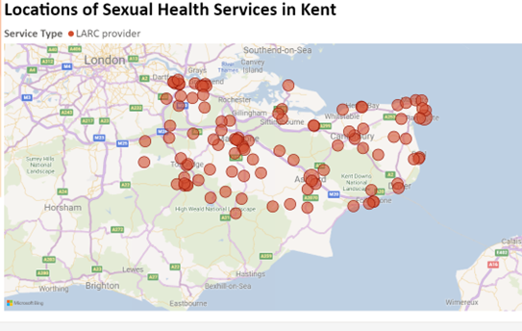

Delivery of the service requires clinicians to have a Letter of Competence (LoC) from the Faculty of Sexual and Reproductive Health (FSRH) and there have been barriers to achieving this due to lack of training and FSRH certified trainers. Between 2015 and 2018 KCC commissioned free training to primary care practitioners, costing £402,000 and achieving 202 accreditations. However, take up of this training was low, with possible reasons being issues with marketing of the free offer and reluctance of some practitioners who had been fitting LARC for many years to gain a LoC. A survey of 96 GP practices in 2022 reported barriers to delivering use of LARC as staff time (68%), training time (50%) and access to training (50%). A decrease in staff available with a LoC was noted in 43% of respondents and retirement and other staff losses was cited as the main reason for this.

People can access the service by self-referring. They can also be referred to the GP practice from several sources including neighbouring GPs within the Primary Care Network (that do not offer the service themselves), from the Integrated Sexual Health service if they lack capacity or from Women’s Health services.

GPs offer a consultation prior to the fitting or removal of LARC procedure, to discuss the patient’s needs and counsel them on potential side effects. The GP will either prescribe a device for the patient to pick up via an FP10 form at a local pharmacy or source the devices directly. The procedure takes place within the GP practice and most devices are in place for 3 to 6 years, although recently some products have been approved for use up to 8 years. They are then removed in a subsequent procedure. Women requiring use of LARC for needs other than contraception, for example treating heavy menstrual bleeding (HMB) and uterovaginal prolapse, are not included within this contract, even if they also receive secondary contraceptive benefit. The service for those needing LARC for women’s health needs is funded by the Kent and Medway ICB.

Most users are between 16 and 45-50, which is expected with a service offering contraception **(Table 10)**. However, 7.05% of users are over the age of 50 suggesting that some are receiving LARC for purposes other than contraception, an inappropriate use of the service. In 2021, the payment form used by GPs was amended so practices were asked to manually confirm LARC was used for contraception for everyone over the age of 50. However, there was little decline in number of users over 50 years accessing the service in 2022/23. KCC is still funding LARC for all ages, including those over 55. Investigations are ongoing with the ICB to determine the most appropriate funding mechanism for this age cohort.

**Table 10: Age breakdown by number and proportion (%) of people accessing the service from 2021/22 to 2023/24 to date.**

|  |  |  |  |  |  |  |
| --- | --- | --- | --- | --- | --- | --- |
| **Age** | **U15** | **15** | **16-20** | **21-24** | **25-30** | **31-34** |
| 2021/22 | 16 | 52 | 1169 | 1434 | 2470 | 1840 |
| 2022/23 | 20 | 51 | 966 | 1247 | 2259 | 1856 |
| 2023/34 | 6 | 16 | 267 | 326 | 626 | 431 |
| Total 2021/22- 2023/24 | 42 | 119 | 2402 | 3007 | 5355 | 4127 |
| % of total procedures | 0.14% | 0.39% | 7.80% | 9.76% | 17.83 | 13.40% |

|  |  |  |  |  |  |  |
| --- | --- | --- | --- | --- | --- | --- |
| **Age** | **35-40** | **41-44** | **45-50** | **51-54** | **55-60** | **Total** |
| 2021/22 Cont. | 2726 | 1502 | 1908 | 557 | 403 | 14077 |
| 2022/23 cont. | 2510 | 1512 | 1808 | 597 | 356 | 13182 |
| 2023/34 cont. | 649 | 458 | 504 | 172 | 89 | 3544 |
| Total 2021/22- 2023/24 cont. | 5885 | 3472 | 4220 | 1326 | 848 | 30803 |
| % of total procedures cont. | 19.11% | 11.27% | 13.70% | 4.30% | 2.75% | 100.00% |

Trends in LARC insertions **(Figure 18)** show a decline during the COVID-19 pandemic which has not returned to baseline by 2022/23. A similar trend is seen for LARC removals.

**Figure 18: Rate of total prescribed LARCs in Kent and England, 2014 to 2022**

The survey of GPs in 2022 found that trends in use of LARC were polarised with some GP practices seeing an increase and others a decrease.

There is no information available on views of service users or patient insights data. The service is not actively promoted on the KCC website or via social media. It is most often promoted via ‘word of mouth’ during GP consultations or via attendance at ISH clinics.

Alternatives to contracting GP practices individually include contracting with a PCN to provide LARC for the GPs in their network, or with GP Federations who could manage delivery within an area on KCC’s behalf. This could reduce administrative and commissioning staff resources. The service could also be included in the ISH service commissioning, with sub-contracting to the GP practices by KCHFT and MTW.

There have been anecdotal mixed views on whether the tariffs provided for LARC procedures are substantial. A UKHSA conducted survey that benchmarked the costs of LARC in different areas found that Kent pays higher than the market average in the South East for three out of the four LARC procedures on offer.

However, the Local Medical Committee (LMC)’s cost analysis of the service found that a LARC fitting costs a GP practice more than double the actual payment received. A cost modelling exercise by Organon found different costs to the LMC’s cost analysis, but more understanding of how the modelling was performed is required. Cost modelling with a GP practice in Maidstone found that if a GP was providing the procedure, costs were higher than KCC pays in three out of the four LARC procedures. However, for nurse-led procedure it cost less than the value KCC pays for three out of the four procedures, suggesting financial benefits of a nurse-led model. Different tariff structures are also utilised in other Local Authorities whereby the payment cost is different for a combined insertion and removal during one consultation, instead of two separate costs for each procedure. Some also provide a payment when an IUD is fitted for emergency contraception.

Women’s Health Hubs (WHH) are anticipated to be launched in Kent by late 2024. KCC has been working with the ICB who are the lead for this work, to support with the initiation of the first hubs. This is likely to increase awareness and demand for LARC, which will require monitoring of the situation from both a budget and waiting time perspective. KCC aims to work with WHH, GPs, and ISHS to understand the impact of the implementation over the course of 2025.

## 5.7.1 Strengths of the LARC Services

* Placement of services to insert/remove LARC devices within GP practices increases accessibility, minimising the need for the patient to travel.

## 5.7.2 Possible Transformation Recommendations

* Currently two commissioners for contraception and ICB for IUS devices for women – opportunity to align and streamline the contract management function.
* Clarity and action needed to ensure that appropriate coding is used when submitting claims for LARC procedures to KCC and the ICB.
* Monitoring of impact of the implementation of Women’s Health hubs and ensure a system approach is applied where possible.
* Patient insights – to understand why use of LARC is declining and if there are issues with access to the service, or a shift in sexual health attitudes including use of fem-tech and fertility awareness methods.
* Patient insights into ease of access alongside further analysis of the map of LARC providing GPs in the county to explore areas of low or distant access.
* Deep dive review of LARC to be completed including, exploration of reduction in GP Practices offering LARC services, workforce development and training, and cost modelling.

## 5.8 Out of Area

Sexual health services are open access in England, meaning that if a Kent resident accesses services out of area it will be paid for by KCC.

## 5.8.1 Possible Transformation Recommendations

* Review of the use of sexual health services out of area by Kent residents, along with understanding use of Kent services by out of area residents. This is to identify why people may access services out of area and what measures can be put in place to reduce this.
* Review of budget and spend for out of area services.

## 5.9 General Transformation Recommendations Applying to All Sexual Health Services

* KPIs currently activity focused and needs to be more outcome focussed.

# 6. NICE Quality Standards for Sexual Health

* [Statement 1](https://www.nice.org.uk/guidance/qs178/chapter/quality-statement-1-asking-people-about-their-sexual-history#quality-statement-1-asking-people-about-their-sexual-history) People are asked about their sexual history at key points of contact.
* [Statement 2](https://www.nice.org.uk/guidance/qs178/chapter/quality-statement-2-discussing-prevention-and-testing-with-people-who-are-at-risk-of-sexually#quality-statement-2-discussing-prevention-and-testing-with-people-who-are-at-risk-of-sexually) People identified as being at risk of sexually transmitted infections have a discussion about prevention and testing.
* [Statement 3](https://www.nice.org.uk/guidance/qs178/chapter/quality-statement-3-condom-distribution-schemes#quality-statement-3-condom-distribution-schemes) Local authorities provide a range of condom distribution schemes tailored to the needs of their populations.
* [Statement 4](https://www.nice.org.uk/guidance/qs178/chapter/quality-statement-4-access-to-sexual-health-services#quality-statement-4-access-to-sexual-health-services) People contacting a sexual health service about a sexually transmitted infection are offered an appointment that is within 2 working days.
* [Statement 5](https://www.nice.org.uk/guidance/qs178/chapter/quality-statement-5-repeat-testing-for-sexually-transmitted-infections#quality-statement-5-repeat-testing-for-sexually-transmitted-infections) Men who have sex with men have repeat testing every 3 months if they are at increased risk of sexually transmitted infections.
* [Statement 6](https://www.nice.org.uk/guidance/qs178/chapter/quality-statement-6-partner-notification#quality-statement-6-partner-notification) People diagnosed with a sexually transmitted infection are supported to notify their partners.

Set out above are the NICE (National Institute of Clinical Excellence) Quality Standards for sexual health published in 2019. Throughout this document there is evidence provided of how the work undertaken in recent years in Kent has applied, met, and oftentimes exceeded these standards.

However, there are areas for improvement which have been set out in the recommendations, for example improving work with system partners to ensure that all Kent residents who may be at higher risk of STI’s are identified and offered testing and support. As well as ensuring that all MSM’s are offered follow up testing every 3 months.

Service specifications are due to be re-written in 2024-2025 to support the Public Health Transformation Programme. It is recommended that the Quality Standards are applied robustly and prioritised in those specifications, alongside focusing on outcomes.

## 7. STI Prioritisation Framework

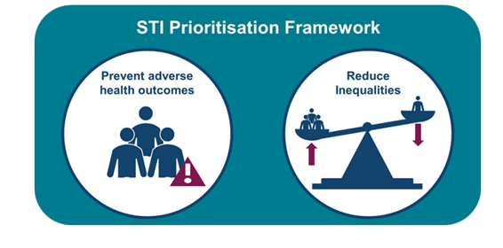

In October 2024, the UKHSA released a UK wide Sexually Transmitted Infection Prioritisation Framework[101]. This document aims to support the principles set out in that document through the investigations and recommendation made.

The evidence based, co-produced principles of the framework are as follows:

1. The sexual health needs of the population can only be met through working in partnership. This includes identifying or establishing local structures to enable effective collaborative working.

2. It is essential that specialist sexual health services (SHSs) have established links and arrangements with other specialties for the management of complex cases.

3. It is essential that services and interventions are co-produced with local communities, ensuring that lived experience is at the heart of local planning and decision making.

4. Services must be planned on the basis of an assessment of local need and be able to adapt to changing need and circumstances.

5. Local areas should draw on existing evidence, where available, to inform their practice.

6. Evaluation is essential to understand whether new interventions, changes in practice or service improvements have achieved their intended impact and to develop the evidence base.

7. Addressing health inequalities is central to our approach to STI control and therefore resources should be prioritised on the basis of need, with a focus on under-served populations.

8. Commissioners and providers must ensure SHSs have the capacity and skills to address safeguarding concerns in a skilled and timely manner.

9. Commissioners and providers must ensure specialist SHSs have the capacity and skills to manage complex cases and provide clinical STI expertise to non-specialist providers.

10. Primary prevention activities such as health promotion and access to condoms should not be sacrificed when resources are limited.

11. Testing and treating those with diagnosed infection is a mainstay of STI control.

12. There is no ‘magic bullet’: no one intervention will achieve STI control. We need to use a range of prevention, testing and treatment interventions as they are all imperfect. Kent aims to use this sexual health needs assessment as Step 1 of the framework’s Theory of Change model to guide our actions as a system and improve the sexual health outcomes of our residents. This model can be found on page 6 of the publication. [STI Prioritisation Framework (publishing.service.gov.uk)](https://assets.publishing.service.gov.uk/media/6703cbc330536cb927482d20/STI-prioritisation-framework.pdf)

*Key Messages*

* *Insights have shown that KCC is currently offering services that meet the population needs, however, more can be done to raise awareness of what support is available to ensure that those that aren’t currently accessing services have a greater chance of doing so.*
* *Natsal reported that the Covid-19 pandemic had changed people’s attitudes to sexual health, access to services and increased sexual violence incidences. The next Natsal will help indicate if these changes have continued nationally, and further understand of the Kent population’s attitudes is key.*
* *Further insights would support a more detailed look into areas such as culture and other influences on sexual behaviour, for example drug and alcohol use.*

# 8. Insights from local communities, service users and residents

Previous sections of this health needs assessment have included insights into groups at higher risk of poor sexual health, therefore, this section aims to highlight key overarching insights that apply across the sexual health services and system in Kent.

## 8.1 31ten

Kent County Council commissioned insights into its public health services in 2024, including sexual health.

This work demonstrated that, overall, sexual health services in Kent are meeting the needs of many people. Kent residents appreciate the opportunity to access services both online and face-to-face, at a variety of times and locations, and with the option to visit clinics outside of their local area if they wish. They also value the expertise of the staff.

However, what was highlighted was that since the pandemic, residents of Kent need an update in information about sexual health clinics. This would include, where they are open, when they are open, and how they can access them.

Feedback was also given that an increase in social media marketing and wider communications would increase awareness of the services, reduce barriers to accessing services and reduce stigma.

Key groups that were identified as feeling that improvements could be made for them was the LGBTQ+ groups who asked for better education, particularly women who have sex with women, and groups who feel that greater understanding of their culture would support them in feeling more able to access sexual health services.

**Figure 19** shows a table of the key findings and recommendations as written by 31ten consultancy who conducted the insights.

**Figure 19: Overall findings and recommendations from the 31ten consultancy insights work**

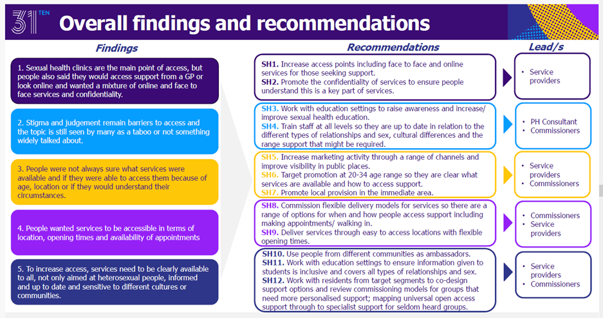

The results of the insights research have been helpful in cementing some of what we already knew anecdotally and added some further information and context into vulnerable groups. However, the sample size was very small and did not cover all districts in Kent. Therefore, it is recommended that further research and insights are undertaken to support greater understanding of sexual health needs in Kent.

There are further insight projects from wider partners that are applicable to Kent. The UKHSA recently undertook an insights piece into LGBTQ+ communities and their barriers to seeking support and following advice as is mentioned in above sections. This research did highlight some overarching considerations, however. Neurodiverse participants for example reported that having difficulties with the appointment booking process was a barrier to seeking help. Whilst the use of different technologies was reported as enhancing experiences and reducing barriers.

Participants reported having access to peer support roles within services would be of great value, which was also echoed in the KCC insights. Alongside, clinics that were specifically for different groups were seen as valuable, for example, sex workers, LGBTQ+, and people experiencing homelessness.

## 8.2 NATSAL

The National Survey of Sexual Attitudes and Lifestyles (Natsal-Covid) survey collects data relating to the sexual behaviour and patterns of people living in the UK[102]. Kent residents were included in the survey results, but it isn’t clear to what extent.

Two surveys were conducted amongst British residents aged 18 to 59 between July and August 2020 (wave 1) and March and April 2021 (wave 2). Questions covered participants' sexual behaviour, relationships, and sexual health service (SHS) use before and during the COVD pandemic. In wave 1, 6,654 participants completed the survey and 6,658 did so in wave 2. Sexual attitudes and experiences were affected by the pandemic, with difficulty accessing sexual health services and reduced use of condoms reported[103].

Results from wave 1 showed that of those who used any method of contraception, only 4.8% (320) of participants reported using condoms since lockdown. Only 6.9% (460) of participants used contraception services or advice since the start of the national lockdown. A small number used other services such as fertility services (1.6% [105]), STI follow up care (0.7% [45]), relationship services (0.9% [62]) and counselling services (0.7% [49]). 3.1% (205) of participants accessed at least one STI service. Reasons listed for why participants could not access services include: appointment cancellation, service closures and not feeling comfortable using online or telephone services where available.

Wave 2 results found that of those who used any method of contraception, 6.7% (443) of them used condoms before lockdown. 56.9% (3,789) of participants had sexual physical contact with someone they were living with since the start of the first lockdown on 23rd March 2020 and 18.6% (1,236) had sexual contact with someone they were not living with. 22.8% (1,516) participants accessed at least one sexual health service since the start of lockdown and 53.1% (3,536) said their sexual health was important to them compared to 34.2% (2,276) that reported little importance to their sexual health.

24% (1,599) of participants reported feelings of fear based on the words or actions of a partner or ex-partner and 3.9% (257) said the pandemic made intimate partner violence worse. The results of wave 2 were also compared with a previous study (Natsal-3) carried out in 2010-12 and national surveillance data for 2010-2098. This found fewer participants reporting a new partner, lower chlamydia testing, and fewer pregnancies and abortions, suggesting that the pandemic contributed to these reductions. However, distress and dissatisfaction with one’s sex life were significantly higher than 10 years previously.

The Natsal study was supported with findings from The Women’s Health Strategy survey[104] that reported that less than half (40%) of women have clinics available to them in a convenient location, and 24% say that they can access services at a time that is convenient for them. Furthermore, 74% of respondents said that the Covid-19 pandemic was the reason that access and convenience had been directly, and negatively impacted. The women’s health strategy survey had nearly 100,000 contributions from across the country so is a generalisable and reliable source of thoughts, attitudes, and experiences of women in the UK.

Locally, however, understanding the needs of the population is a knowledge and evidence gap. This needs assessment therefore recommends that Kent County Council, and the Kent sexual health network aim to increase insights from residents, users and non-users of services, and those who have sexual health needs in Kent.

The release of the Natsal 4 survey will help in understanding whether changes reported during the pandemic are persisting, or whether they have evolved or altered since. When the survey is released, Kent will analyse this information and apply the knowledge to local need and local insights to inform direction moving forward.

8.3 Metro Charity Young People’s survey

Metro charity conducted a survey of 312 young people in Kent to find out more about their knowledge of sexual health and sexual health services in Kent.

59% of sexually active respondents said that they had never had an STI test. 13% said that they would take an STI test when they felt they needed one, and 5% said they would take an STI test with every new partner. Only 13% said they would take an STI test every three months, and 5% said they would take an STI test every six months. Therefore, this supports earlier recommendations in this report that emphasise good quality relationship and sex education alongside awareness raising of how and when to test for STI’s is important for supporting good sexual health in young people.

A number of sexually active respondents noted that they did not always use condoms when they had sex. The most common reason for this among girls was that they were using alternative contraception, so they felt they did not need to use condoms (46% of girls who answered this question gave alternative contraception use as a reason). Other reasons that were common about both girls and boys were that their sex was spontaneous or unplanned (23% of girls and 40% of boys) and that there were no condoms available at the time (20% of girls and 60% of boys).

Another aspect of young people’s sexual behaviours that this survey sought to understand was the use of substances both in their normal lifestyles and before or during sexual activity. More females responded that they use alcohol during sex than males, the same as vaping. More males reported smoking than females. It is important to understand how different lifestyle behaviours may impact on sexual health choices in young people to ensure holistic education is given to them around what may influence their sexual experiences.

This study should be replicated with a larger pool of participants to understand if findings are generalisable.

Please see Appendix A for the graphs that reflect the data above.

# 9. Future Research Needs

Kent County Council has recently collaborated with Canterbury Christ Church University in Kent to undertake a literature review of contraceptive choices and barriers in young women aged 18 to 24. This is currently being finalised and will be published in late 2024. This aims to support knowledge of the experiences of this age group and propose future research focus and applications in commissioning.

The University of Kent is now chairing a research group titled ‘Inclusive Women's Health Research Group (IWHRG)’ for partners across Kent who are interested in women’s health research. KCC sexual health colleagues have joined this group and aim to contribute to and learn from timely and relevant research to improve knowledge and services in Kent.

Across the Kent system it is important to engage in further research opportunities to inform and influence policy to promote and prevent poor sexual health outcomes. It is recommended that this forms an ongoing topic on the agenda at the recommended Kent Sexual Health network meetings.

Based on information collated in this sexual health needs assessment the recommendation is for future research areas to focus on; cultural influences and understanding of sexual health and behaviours, how sexual health behaviours have changed over time in Kent, how contraceptive choices are changing, how Kent sexual health services are meeting the needs of vulnerable groups, barriers to accessing services, and interactions between sexual health behaviours and other factors such as drug and alcohol use and mental health.

# 10. Exploring other models in the UK

Below are some highlights of good models of sexual health provision across the country. Understanding how other public health teams provide sexual health services in collaboration with wider system partners can help to demonstrate alternative services leading to good outcomes.

## 10.1 Women’s Health Hubs in Liverpool[105]

In Liverpool, a network of women’s health hubs has been set up, hosted in GP practices, and a result of Local Authority and NHS commissioners combining budgets. These provide a range of services including LARC, cervical screening and psychosexual services in one place. This has resulted in improved access to services and an increase in LARC prescribing rates, higher than pre-pandemic rates.

## 10.2 Postnatal Contraception in North-West London[106]

In North-West London, contraception has been offered within maternity services from 2020, giving women a choice of contraception before they leave the service. This was a regional collaboration between maternity services, sexual health, local authorities and commissioners. Maternity staff were trained in providing contraception and carrying out contraceptive procedures. This was implemented as a result of a study finding that 51% of women had not planned future contraception after they gave birth, and yet 42% wanted to take home contraception. The evaluation of this service is currently being undertaken to understand the effect on unplanned pregnancy, access to the service and cost savings for the ICS.

10.3 Integrated approach to commissioning in Sussex**[107]**

In Sussex, ICB commissioners have collaborated with local authorities, GPs and local sexual health and abortion providers to analyse data across their sexual health and abortion pathways. They found that demand for contraception services has not been rising in the same way that demand for abortion services has been rising, along with a strong correlation between deprivation and use of abortion services. The local partners worked together to promote the benefits and availability of contraception and to improve online access to education tools with the aim of using targeted online communications to populations with higher rates of use of abortion services.

## 10.4 Psychosexual models

Councils that are part of the national sexual health commissioning group responded to a call from KCC Commissioning colleges regarding their psychosexual services. 2 out of the 9 councils do not have a psychosexual service. Of those that responded we had further discussions with Torbay and Derbyshire.

Derbyshire County Council (DCC) have an integrated provider who subcontract to the psychosexual delivery provider in their county. Referrals are predominantly through ISHS but also other relevant partners. DCC have slightly more sessions than the Kent offer, on average there are 8 instead of 6. They reported seeing benefits from this of

Torbay Council, somewhat similarly, have merged their psychosexual service into their ISHS contract, which their lead provider subcontracts out. Referrals are only made by the ISHS, if other partners believe they have a patient who would benefit from psychosexual therapy they refer to the ISHS who will then triage and offer support. This means that patients are then able to have conversations regarding the full suite of holistic sexual health care available to them and only appropriate referrals reach the therapy provider. Set limitation criteria are placed on referrals.

Torbay take a more outcomes focused approach as opposed to specific metrics and overall experience good feedback regarding the service.

# 11. Recommendations

Overall, the findings of this Health Needs Assessment confirms that much of the work and efforts underway across Kent County Council to ensure good sexual health and wellbeing for residents is both valued and generally effective in delivering services to meet local needs. However, there is opportunity to build on this further through a variety of areas, both within the scope of the transformation programme underway and beyond this also. These recommendations have been outlined in the sections below.

## 11.1 Key overarching recommendations:

There is a need for focus on the following areas across the Sexual Health portfolio to strengthen the good practice underway to ensure it is even more local needs informed, service user led, effective in its impact, and also optimally able to drive down inequity that exists.

1. **Increase insights from residents, users and non-users of services, and those who have sexual health needs in Kent. This should be done in a range of ways including:**

A) Service user experience and insight information gathering by providers as part of their routine data collection and sharing, which may be part of contract management but also routine good practice for sharing to inform ongoing service optimisation. This includes work being done as part of outreach for their services. This should commence with immediate effective through the review of all contracts for transformation and more generally, and strengthened wording and data collection methods introduced for the next round of commissioning to optimise this going forward.

B) Public health campaigns and activities to gain insights about the needs of local residents which may take the form of online, virtual or in person engagement particularly with under-served and groups at risk of poorer sexual health and wellbeing. It is recommended that dedicated communications and engagement support is secured and a plan developed to undertake this in a consistent way to both aid raising awareness and maximising uptake of services, but also to undertake more listening activities and using this to tailor services to meet local needs better too.

C) In addition to this, it is recommended that deep dives are undertaken in areas highlighted by this needs assessment as needing further attention. This includes seeking to understand insights about what is working well to learn lessons (for example women in Maidstone who have been accessing Chlamydia testing) as well as groups who have not yet been reached optimally (for example Gypsy Roma Traveller communities). It is recommended that this is undertaken within the next 6 months to help inform next steps early for this work. It is also recommended that this is undertaken in partnership with other teams across the public health directorate and council as well as other partners who are already doing good work in linked areas for this.

1. **Continue to develop understanding via collaboration with stakeholders of sexual health needs of inclusion groups in Kent, and ensure services are appropriately tailored and appropriately responsive to changing needs. For example, understanding the impact of chemsex on sexual health outcomes for some groups of the population.**

This work has highlighted the overlapping nature of sexual health with many other areas of work, and teams across the council and more widely. It has also showed the need for continued focus on sexual health, and that without proactive focus it becomes an area that can easily be overlooked in the other portfolios also. The onus therefore becomes for the next steps of this work to map the various interlinking areas, and to strengthen connections and build greater advocacy for sexual health in those areas, as well as considering what added strength the sexual health work area can bring to other areas such as domestic abuse or sexual violence. It is recommended that the sexual health team undertakes this mapping exercise within the next 3-6 months and starts to build connections across the teams to strengthen this focus.

1. **Spend time establishing a sexual health network or collaborative, including providers, commissioners, mental health, alcohol and drug services, domestic abuse, sexual assault, and prison health services and UK Health Security Agency (UKHSA). Exploring co-location of services would help provide holistic care and integrated access for those with multiple needs.**

Through this work it is recognised that some of the good work that was happening previously, such as the Sexual Health Network for Kent, were lost through the various urgent other areas that came into focus such as the COVID-19 pandemic. This work has highlighted the need to re-establish this group, with a renewed focus on bringing together the various providers, to review the findings of this needs assessment and to start to align working to ensure more seamless, effective and equitable pathways of care for sexual health across Kent. It is recommended that that this group is re-commenced with some urgency in parallel with the transformation process that is underway, and that the group is utilised to help shape evolving plans. It is likely that this group will need to evolve over time to become a more formal part of the governance structures for sexual health oversight and delivery locally, for example through more formal connection with the Integrated Care Board and strategic delivery groups. However, initially it is likely to be important to convene the group, to scope the interest and co-create the plans for going forward as this will likely maximise engagement and optimise chances of success / sustainability. Furthermore, this will give the group the chance to shape the future direction utilising their own learning from what has worked previously to support. In addition to this, it will be helpful to continue the links with Southeast England region and England more generally for aligning public health efforts for sexual health.

1. **Given the wide remit of sexual health there is insufficient influence and collaboration with wider stakeholders. Therefore, it is recommended to increase partnership and system working to improve sexual health outcomes, i.e. RSE in education, GRT community leaders**

Almost linking the two recommendations above, this work has highlighted the need for those working in sexual health to see the expert contribution that communities can make in shaping plans. Therefore, whether in the collaborative or in communications and insights work, it is important to consider options for maximising the agency of the local population in leading these efforts and proactively driving change efforts themselves for this. It is recommended that the sexual health team reviews best options to mobilise community assets through the steps above (starting with enquiry through the collaborative and the engagement work to identify local assets and then building connections for example with community leaders and hubs). Similarly, given the plan for the public health team to strengthen its support across Kent for the Districts and the Health and Care Partnerships (HCPs) it would be helpful to start considering at each of these levels also the structures in place to optimise sexual health outcomes and wellbeing and the assets that exist to support this.

1. **Collaborate with and contribute to the establishment of women’s health hubs in Kent.**

As one of the at risk groups, and in line with the findings of this work plus national efforts to address inequity, it will be helpful for the sexual health team to connect with the women’s health hubs that are being set up through the Integrated Care Boards to optimise their design to ensure they can meet local sexual health as well as wider women’s needs, plus they align optimally with existing services for sexual health so as to complement and enhance their efforts rather than to duplicate or destabilise this. Given the work is being prioritised nationally and locally for this, it will be important to ensure due attention is given by the sexual health team to support this urgently during this design and implementation phase.

1. **Engage in further research opportunities to inform and influence policy to promote and prevent poor sexual health outcomes, including liaising with other public health teams in England to understand their sexual health models.**

Through this work, it has been found that whilst there is a lot of good practice locally, there is also opportunity to go further – in particular in terms of innovation, technological advancement and contributing to latest thinking. There is good work that has been identified through this work that would warrant further sharing as it could benefit other areas also. There are some areas that require further study to understand why they are proving to be successful when other areas in Kent and more nationally are struggling. And there are some innovations that have been implemented where the lessons from successful implementation has resulted in wider rollout of the service. It would be worth considering how these initiatives are being evaluated more formally, shared through academic publication, and shared more widely. Similarly, there has been work and areas identified that could be tested in Kent – for example expanding the online HIV offer similar to East Sussex, or other means also. It is worth considering early how these will be funded, piloted and evaluated in the coming 1-3 years, and stronger connections made with the R&D team in public health to build this. It would also be useful to build the training offer within the sexual health team to provide even more opportunities for registrars, trainees and others to utilise the opportunities afforded by this important area to develop their own knowledge, skills and confidence in improving sexual health outcomes and wellbeing.

1. **Increase awareness and visibility of sexual health services in Kent through accelerated efforts in marketing and campaigns**

In addition to increasing insights, it is important to raise awareness about sexual health services in Kent through a variety of means. It will be helpful to develop an annual calendar of key dates and create a proactive marketing campaign around this to raise the profile about sexual health and sexual health issues locally. This should connect to the marketing efforts of providers and create a more uniform brand and service so that the public experience a more One Kent Sexual Health offer where-ever they live in Kent and however they choose to access these services. It will be helpful to utilise both physical and virtual methods for doing this given the blended nature of the sexual health service, and it will be helpful also for the development of culturally tailored campaigns particularly targeting those identified as being in at-risk or under-served groups. It will be helpful to optimise the website across providers to connect across to each other for this and enable residents across Kent to more easily find help and support when they need this for optimal sexual health and wellbeing.

1. **Understanding the sexual health implications of violence against women and girls as a recommended priority for Kent, and working with partners to reduce sexual violence**

One area identified as needing more focus is the interface between sexual health and violence against women and girls locally. The sexual health team should build a stronger connection with the team looking after violence against women and girls and start to build into the sexual health services greater ability to prevent, detect and provide support for local residents who are at risk of or who do experience this. One example of work that can be done easily is for the sexual health team to identify key training videos and materials and to share these with their sexual health providers and partners to raise awareness about what they should look out for, and include representation at the collaborative by members from the violence against women and girls team member attending some sessions or presenting key information as it becomes available.

## 11.2 Key recommendations for the sexual health commissioning

As well as the general recommendations outlined above, there is a series of recommendations that specifically relate to the commissioning requirements that will be needed to support the work and changes outlined. These are recommendations that are made for public health commissioners and consultants leading on the review of existing services to ensure they are optimally fit for purpose. These recommendations are as follows:

1. Continue to understand if trends in sexual health indicators are returning to pre-pandemic levels, we recommend an annual update to the relevant sections of this needs assessment with the release of the latest Fingertips data. Particular focus is needed for including metrics about those in under-served and at-risk groups and focus on outcomes as well as activity.
2. To increase insights from residents, users and non-users of services, and those who have sexual health needs in Kent.  We recommend reviewing the sexual health budget and ensuring the provision of some funds to secure dedicated support for this in the next year at least. Additionally, all contracts should be reviewed and enhanced requirements clarified for ensuring data about insights and quality of experience as well as activity and impact on outcomes overall.
3. Ask for greater engagement with local residents to ensure services are maximally meeting their needs and co-designed where possible for this. A plan should be developed, and delivery against this monitored to ensure sufficient level of engagement particularly with at-risk and under-served groups.
4. Building plans for how services can use existing resources to focus their efforts on tackling health inequalities. Work is needed with each provider to ask them to curate 1-3 year plans for addressing health inequalities in sexual health service access, experience and outcomes. This should be part of the contract for each provider and conversations should commence by commissioners and public health consultants / specialists jointly to help them to develop plans that will be included within the delivery requirements of their contracts given this is a key part of service delivery that has had relative under-focus in recent years and needs attention.
5. Services align themselves to support geographical areas furthest away from clinics with outreach provision to improve outcomes for young people's sexual health. Public health teams have begun to map the accessibility of services and proximity to those most in need of access to sexual health services across Kent. Providers should work with public health team and commissioners to optimise their delivery models to ensure maximum reach – whether that is by outreach or in the plan of clinics or in the design of service provision or changes.
6. Reinstate the Outreach Provider group in Kent to allow for coordination of the best use of outreach between services. This will enable understanding of which key groups (e.g. Gypsy, Roma, Traveller communities and the homeless population) are supported or should be supported, and how to measure and improve sexual health outcomes for these groups. Public health teams should commence work to secure the ongoing stability of this group by commencing discussions about structure of the group, terms of reference, reporting arrangements, strategy and action plan development, and oversight arrangements for ongoing working. This will prove to be a valuable resource and it is worth commencing these efforts early. However, the development of a strategy with action plan will help to ensure not only progress, but also due prioritisation and sustained focus.
7. Explore opportunities to work with system-wide partners, such as women’s health hubs, abortion care, mental health and drug and alcohol services to provide a holistic offer of services, tailored to individual’s needs. Including exploring options of co-location across the sexual health estate. Explore the opportunity to jointly bid for funding and innovation opportunities to expand the work and its ability to meet local needs.
8. Given the scale of the financial challenges, public health teams need to ensure ongoing careful review of needs, ambition and approach to ensure focus against key outcomes in sexual health and reducing health inequalities across the whole of Kent, giving priority to this area, but also ensuring the best possible use of resources and value for money against this.

## 11.3 Table of recommendations for existing services

Finally, this needs assessment has highlighted a number of recommendations that relate to the sexual health model and transformation work underway. These were formed from a full sexual health needs assessment document that was produced for the internal purposes of information the transformation work and included performance, finance and commercial information that is confidential to providers so not included in this document. Key recommendations for this are summarised in the table below and have already helped to shape the decision making and thinking that has been happening for transformation efforts locally in the duration of this work being undertaken.

|  |  |
| --- | --- |
| All Services | * KPIs currently activity focused and needs to be more outcome focussed * NICE Quality Standards are applied robustly and prioritised specifications and delivery. * All services to aim to promote and increase numbers of people testing for STI’s |
| Integrated Sexual Health Services | * Integrated sexual health services (ISHS) specifications should be updated to include changes to policies and understanding after the pandemic and since the last SHNA. * Continue with service in the integrated model, with focus on reducing STI’s and access to contraception * To consider how providers can work closer together and share systems or job roles, ensuring equitable access options for the Kent population. * To consider the introduction of a clinic in Dover, given the potential transport issues in residents travelling to another clinic. * To consider the introduction of a clinic in Sevenoaks or Tonbridge & Malling, however these are more affluent areas with better outcomes. * To understand and coordinate the outreach elements of the services, including which key groups are supported, and what is the impact on outcomes. * Men who have sex with men (MSM’s) are offered follow up testing every 3 months |
| Psychosexual Therapy | * Looking at whether to move online rather than continue investing in property for this. * To understand the psychological sexual health needs of the Kent population who may require the psychosexual service, for example the influence of adverse childhood experiences on the sexual health of adults. * To collect patient insights to understand why a large number of people do not complete the full course of therapy or do not engage following initial referral. * To collect patient insights and staff insights to understand the impact of the service on psychosexual outcomes to ensure quality service delivery and equity across Kent. |
| HIV Services | * Conduct Deep Dive report into HIV in Kent * Review of budget for HIV services, considering the rising demand and costs. * Patient insights data to understand why the DNA proportion is steadily rising. Important to address this given the increasing demand and cost for the service. * Develop a peer support service, as recommended as best practice. * Review the options for strengthening of provision of HIV service provided to residents in Swale, Dover, Sevenoaks and Tonbridge & Malling. * Increase testing coverage given the marked drop in coverage from pre-pandemic levels, including via supporting promotional campaigns. |
| Online STI Testing | * Further insights into online sexual health services. Need more high-quality patient service and ideas for improvement, this could be via mystery shoppers. * Consider option to bring contract management in house also. * Need further exploration of digital services that could be included in the online service. * Understanding why kits aren’t returned, and why some users order multiple tests to reduce costs and better support the population to access an appropriate sexual health service. * Further investigations into the unexpectedly similar proportions of positives between symptomatic and asymptomatic are warranted, equally a deeper dive into the online ordering process and justification. * Men who have sex with men are identified and offered following up testing every 3 months |
| Pharmacy Services | * Review of chlamydia treatment patient pathway for duplication of consultations and payment tariff for pharmacies. * Review of the data submitted for chlamydia treatments, given the low number of prescriptions issue compared to the number of positive tests. * Review the location of pharmacies offering the service to establish if there is an inequity in coverage of pharmacies across the county. * Insights data to understand awareness of pharmacy sexual health service. |
| Get It Condom Programme | * Review outreach in order to optimise utilisation for population need alongside system thinking approach. There is an overlap with the outreach service in ISH, and it isn’t clear what impact outreach are having on sexual health. * Consider whether condom distribution could be provided by other online services such as the online STI testing service. * Consider extension of free condoms to other groups, not just young people, given the rise in STIs. * The results of the Young People’s sexual health attitudes survey are analysed and used to inform progressions in the service offer. |
| LARC | * Currently two commissioners for contraception and ICB for IUS devices for women – opportunity to align and streamline the contract management function. * Clarity and action needed to ensure that appropriate coding is used when submitting claims for LARC procedures to KCC and the ICB. * Monitoring of impact of the implementation of Women’s Health hubs and ensure a system approach is applied where possible. * Patient insights – to understand why use of LARC is declining and if there are issues with access to the service, or a shift in sexual health attitudes including use of fem-tech and fertility awareness methods. * Patient insights into ease of access alongside further analysis of the map of LARC providing GPs in the county to explore areas of low or distant access. * Deep dive review of LARC to be completed including, exploration of reduction in GP Practices offering LARC services, workforce development and training, and cost modelling. |
| Out of Area | * Review of budget and spend for out of area services. * Review of the use of sexual health services out of area by Kent residents, along with understanding use of Kent services by out of area residents. This is to identify why people may access services out of area and what measures can be put in place to reduce this. |

**12. Conclusion**

This Sexual Health Needs Assessment has explored, reviewed, and set out the landscape of Kent’s sexual health needs post pandemic. It has examined updates to the context surrounding and including sexual health, analysed the latest data and available insights, reviewed current service provision, and explored examples from other councils. Groups of Kent’s population have been highlighted to ensure that the correct emphasis is placed on the focus and support for those groups to tackle health inequalities. Recommendations have been made throughout as a call to action for local stakeholders to propel Kent’s sexual health improvements.

We know now from this assessment that STI rates are increasing. Testing rates have risen across Kent in line with the diagnosis rates which means that we are finding, and therefore able to treat, more infections in Kent. But rates remain below our target levels. The analysis has shown that there are areas of geographic concern, for example Dartford, due to the higher positivity rates and West Kent testing is lower than East Kent areas. Chlamydia testing rates in young women are currently half of the national target, and testing of GBMSM for HIV has fallen by 30%. Gonorrhoea detection is 53% higher than pre-pandemic levels and overall STI’s diagnosis has returned to rates seen pre-pandemic. The message is that there needs to be an increase in testing for infections in Kent. In other aspects of sexual health, the use of LARC is decreasing, as is oral contraception, and abortions are increasing. Under-18 conceptions remain higher than the England average, with Thanet, Swale and Dover having the highest rates.

Whilst Sexual Health services are well-utilised and respected by the population, work to ensure that availability and access is suitable to all groups of the population is recommended, including people who use drug and alcohol services, those in more deprived areas, women, and young people. There is opportunity to strengthen commissioning by reviewing contracts to ensure targets are aligned to the transformation in health outcomes being sought, and there is much greater focus on service alignment, partnership working, streamlining the offer and ensuring it is optimally able to meet the needs of the whole population. That means more focus is needed on cultural adaption and reach as well as focussing efforts on meeting the needs in particular of the more at risk groups identified. Sexual assault and violence against women and girls can lead to poorer sexual health outcomes and an increasing risk of STI’s and unplanned pregnancy. This has been highlighted in the document as a key area of future focus. Opportunities exist through the Women’s Health Hubs being introduced.

Taking actions outlined in this document will also support national efforts and ambitions to improving sexual health and wellbeing. We support a call on Government to set out a 10-year strategy to emphasise the contribution that good sexual health and wellbeing makes to overall health, economy, and growth.

# Appendix A

Figure 1 shows female and male comparisons of how often sexually active young people in the survey have had an STI test.

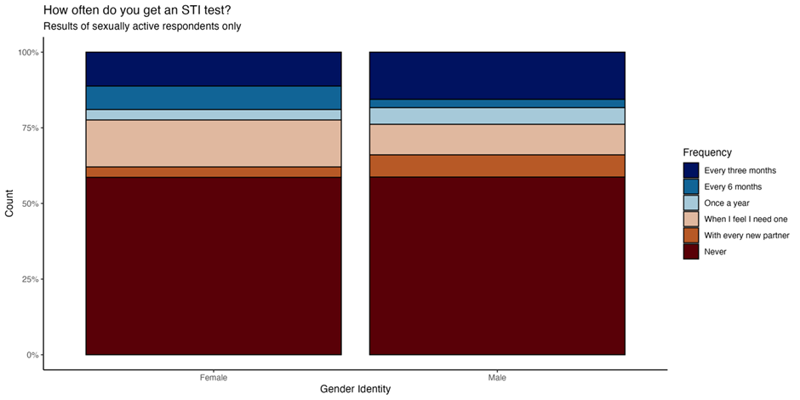Figure 2 below show reasons given by young people for not using a condom during sexual activity.

**|**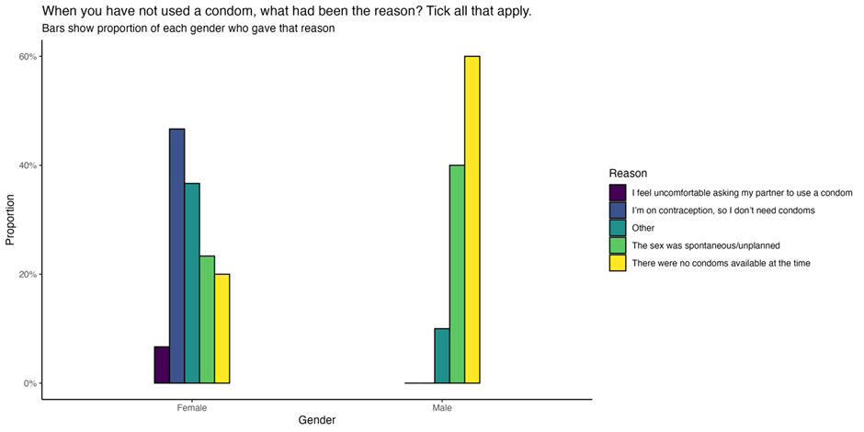

Figure 3 below shows the use of different substances before or during sexual activity reported by female and male respondents. 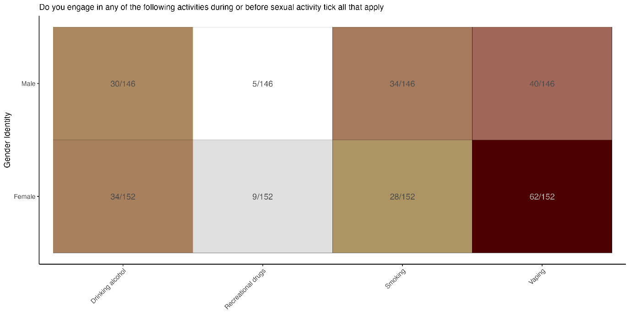

1. World Health Organisation (2006) <https://www.who.int/health-topics/sexual-health#tab=tab_2>
2. World Health Organisation (2024) <https://www.who.int/health-topics/sexual-health#tab=tab_1>
3. Mitchel. K *et al* (2021) What is sexual wellbeing and why does it matter for public health? [Volume 6, Issue 8](https://www.thelancet.com/journals/lanpub/issue/vol6no8/PIIS2468-2667(21)X0008-4)e608-e613
4. [FSRH COVID-19 rolling members survey: interim results 07 May 2020 - Faculty of Sexual and Reproductive Healthcare](https://www.fsrh.org/news/fsrh-covid-19-members-survey-interim-results-07-may-2020/)
5. [COVID-19: impact on STIs, HIV and viral hepatitis, 2020 report (publishing.service.gov.uk)](https://assets.publishing.service.gov.uk/media/5fd39d6b8fa8f54d5c52de43/Impact_of_COVID-19_Report_2020.pdf)
6. [‘Stay at home …’: exploring the impact of the COVID-19 public health response on sexual behaviour and health service use among men who have sex with men: findings from a large online survey in the UK | Sexually Transmitted Infections (bmj.com)](https://sti.bmj.com/content/98/5/346)
7. [How did the COVID-19 pandemic affect access to condoms, chlamydia and HIV testing, and cervical cancer screening at a population level in Britain? (Natsal-COVID) | Sexually Transmitted Infections (bmj.com)](https://sti.bmj.com/content/99/4/261)
8. [Natsal-COVID Study – NATSAL](https://www.natsal.ac.uk/projects/natsal-covid/)
9. [Contraceptive use and pregnancy planning in Britain during the first year of the COVID-19 pandemic: findings from a large, quasi-representative survey (Natsal-COVID) | BMJ Sexual & Reproductive Health](https://srh.bmj.com/content/49/4/260.long)
10. [Access to and quality of sexual and reproductive health services in Britain during the early stages of the COVID-19 pandemic: a qualitative interview study of patient experiences | BMJ Sexual & Reproductive Health](https://srh.bmj.com/content/49/1/12#ref-1)
11. UKHSA (2024) Summary profile of local authority sexual health. <https://fingertips.phe.org.uk/static-reports/sexualhealth-reports/2024%20update/E10000016.html?area-name=Kent>
12. BASHH (2024) New STI data for England highlights urgent need for the next generation to prioritise a national sexual health strategy. [New STI Data for England Highlights Urgent Need for the Next Government to Prioritise A National Sexual Health Strategy | BASHH](https://www.bashh.org/news/1635/new_sti_data_for_england_highlights_urgent_need_for_the_next_government_to_prioritise_a_national_sexual_health_strategy)
13. [Changes in chemsex and sexual behaviour over time, among a cohort of MSM in London and Brighton: Findings from the AURAH2 study - ScienceDirect](https://www.sciencedirect.com/science/article/pii/S0955395919300854)
14. [People urged to practise safer sex after rise in STIs in England - GOV.UK (www.gov.uk)](https://www.gov.uk/government/news/people-urged-to-practise-safer-sex-after-rise-in-stis-in-england)
15. [Sexual-Health-Policy-Position-Statement-2023.pdf (adph.org.uk)](https://www.adph.org.uk/wp-content/uploads/2023/11/Sexual-Health-Policy-Position-Statement-2023.pdf)
16. [Grindr Users Take More Risks, but Are More Open to Human Immunodeficiency Virus (HIV) Pre-exposure Prophylaxis: Could This Dating App Provide a Platform for HIV Prevention Outreach? - PubMed (nih.gov)](https://pubmed.ncbi.nlm.nih.gov/31677383/)
17. [“What Are You Looking For?” Investigating the Association Between Dating App Use and Sexual Risk Behaviors | Sexual Medicine | Oxford Academic (oup.com)](https://academic.oup.com/smoa/article/9/4/100405/6956737)
18. [Breaking point: Securing the future of sexual health services | Local Government Association](https://www.local.gov.uk/publications/breaking-point-securing-future-sexual-health-services#behavioural-factors)
19. [Women's Health Strategy for England - GOV.UK (www.gov.uk)](https://www.gov.uk/government/publications/womens-health-strategy-for-england/womens-health-strategy-for-england#data-and-digital)
20. McMillan, C. 2023. Contraception, fertility tracking, and the limits of the medical devices' regulations. Law Technology and humans. Vol 5 (2). Available from: [Contraception, Fertility Tracking, and the Limits of Medical Devices Regulation Symposium: Regulatory Futures and Medical Devices 5 Law, Technology and Humans 2023 (heinonline.org)](https://heinonline.org/HOL/LandingPage?handle=hein.journals/lwtchmn5&div=25&id=&page=)
21. [What lies behind the rise of the contraception app? - BBC News](https://www.bbc.co.uk/news/uk-england-derbyshire-64405787)
22. [Towards Zero - An action plan towards ending HIV transmission, AIDS and HIV-related deaths in England - 2022 to 2025 - GOV.UK (www.gov.uk)](https://www.gov.uk/government/publications/towards-zero-the-hiv-action-plan-for-england-2022-to-2025/towards-zero-an-action-plan-towards-ending-hiv-transmission-aids-and-hiv-related-deaths-in-england-2022-to-2025#executive-summary)
23. [Sexual-Health-Policy-Position-Statement-2023.pdf (adph.org.uk)](https://www.adph.org.uk/wp-content/uploads/2023/11/Sexual-Health-Policy-Position-Statement-2023.pdf)
24. The Eddystone Trust. 2024. https://eddystone.org.uk/blogs/news-from-the-eddystone-trust/reflections-on-the-annual-hiv-prevention-england-conference-2024
25. [Women's Health Strategy for England - GOV.UK (www.gov.uk)](https://www.gov.uk/government/publications/womens-health-strategy-for-england/womens-health-strategy-for-england)
26. [Relationships and sex education (RSE) and health education - GOV.UK (www.gov.uk)](https://www.gov.uk/government/publications/relationships-education-relationships-and-sex-education-rse-and-health-education)
27. [Women's Health Strategy for England - GOV.UK (www.gov.uk)](https://www.gov.uk/government/publications/womens-health-strategy-for-england/womens-health-strategy-for-england#education-and-training-for-health-and-care-professionals)
28. [Impact of the COVID-19 pandemic on access to and utilisation of services for sexual and reproductive health: a scoping review - PMC (nih.gov)](https://www.ncbi.nlm.nih.gov/pmc/articles/PMC9539651/)
29. [[Withdrawn] Temporary approval of home use for both stages of early medical abortion - GOV.UK (www.gov.uk)](https://www.gov.uk/government/publications/temporary-approval-of-home-use-for-both-stages-of-early-medical-abortion--2)
30. [At home early medical abortions made permanent in England and Wales - GOV.UK (www.gov.uk)](https://www.gov.uk/government/news/at-home-early-medical-abortions-made-permanent-in-england-and-wales)
31. [Safeguarding guidance for children and young people under 18 accessing early medical abortion services - RCPCH Child Protection Portal](https://childprotection.rcpch.ac.uk/resources/safeguarding-guidance-for-children-and-young-people-under-18-accessing-early-medical-abortion-services/)
32. [NHS England » Improving abortion care letter](https://www.england.nhs.uk/long-read/improving-abortion-care-letter/)
33. [Pharmacy First letter to contractors - GOV.UK (www.gov.uk)](https://www.gov.uk/government/publications/pharmacy-first-contractual-framework-2023-to-2025/pharmacy-first-letter-to-contractors)
34. [Pharmacy Contraception Service - Community Pharmacy England (cpe.org.uk)](https://cpe.org.uk/national-pharmacy-services/advanced-services/pharmacy-contraception-service/)
35. [NHS England » NHS Pharmacy Contraception Service](https://www.england.nhs.uk/primary-care/pharmacy/pharmacy-services/nhs-pharmacy-contraception-service/#:~:text=From%201%20December%202023%20the,GP%20or%20sexual%20health%20clinic.)
36. [FSRH CEU Statement: Mirena 8 years contraception (Jan 2024) - Faculty of Sexual and Reproductive Healthcare](https://www.fsrh.org/documents/fsrh-ceu-statement-mirena-8-years-contraception-jan-2024/)
37. [Mpox (monkeypox): background information - GOV.UK (www.gov.uk)](https://www.gov.uk/guidance/monkeypox)
38. [Mpox (monkeypox) outbreak: vaccination strategy - GOV.UK (www.gov.uk)](https://www.gov.uk/guidance/monkeypox-outbreak-vaccination-strategy)
39. [Rapid reconfiguration of sexual health services in response to UK autochthonous transmission of mpox (monkeypox) | Sexually Transmitted Infections (bmj.com)](https://sti.bmj.com/content/99/2/81)
40. [Councils warn of pressure on sexual health services due to rising number of Monkeypox cases | Local Government Association](https://www.local.gov.uk/about/news/councils-warn-pressure-sexual-health-services-due-rising-number-monkeypox-cases)
41. <https://www.gov.uk/government/news/who-declares-mpox-outbreak-a-public-health-emergency-of-international-concern>
42. [Investing in the public health grant](https://www.health.org.uk/news-and-comment/charts-and-infographics/public-health-grant-what-it-is-and-why-greater-investment-is-needed)
43. [Breaking point: Securing the future of sexual health services | Local Government Association](https://www.local.gov.uk/publications/breaking-point-securing-future-sexual-health-services#behavioural-factors)
44. Kent County Council (2023). What is causing Kent’s population growth? 2022. Kent Analytics. Available from: <https://www.kent.gov.uk/__data/assets/pdf_file/0004/8149/Whats-causing-Kents-population-growth.pdf>
45. Kent County Council (2024) Births and Deaths in Kent: 2022. <https://www.kent.gov.uk/__data/assets/pdf_file/0003/13827/Births-and-deaths-bulletin.pdf>
46. Office of National Statistics 2022 People Population and Community <https://www.ons.gov.uk/peoplepopulationandcommunity/birthsdeathsandmarriages/livebirths/bulletins/birthsummarytablesenglandandwales/2022refreshedpopulations>
47. Gietel-Baston et al (2022) ‘Changing the perspective on low birth rates: why simplistic solutions won’t work’ <https://www.bmj.com/content/379/bmj-2022-072670>
48. Kent County Council (2024) Time series of Mid-year population estimates 2003-2023. [Time series of Mid-year population estimates 2003 to 2023 (kent.gov.uk)](https://www.kent.gov.uk/__data/assets/pdf_file/0006/158901/Time-series-of-mid-year-population-estimates.pdf)
49. Public Health England (2021) Variation in outcomes in sexual and reproductive health in England: A tool kit to explore inequalities at a local level. <https://assets.publishing.service.gov.uk/media/60955c3de90e073573036703/SRH_variation_in_outcomes_toolkit_May_2021.pdf>
50. Kings Fund (2022) What are health inequalities? <https://www.kingsfund.org.uk/insight-and-analysis/long-reads/what-are-health-inequalities>
51. [Variation in outcomes in sexual and reproductive health in England 2021 (publishing.service.gov.uk)](https://assets.publishing.service.gov.uk/media/60955c3de90e073573036703/SRH_variation_in_outcomes_toolkit_May_2021.pdf)
52. [Introduction - Sexual health promotion for young people delivered via digital media: a scoping review - NCBI Bookshelf (nih.gov)](https://www.ncbi.nlm.nih.gov/books/NBK326982/#:~:text=Young%20people%20under%20the%20age,risk%20of%20adverse%20sexual%20health.)
53. Bailey, J et al (2015) Sexual health promotion for young people delivered via digital media: a scoping review. <https://www.ncbi.nlm.nih.gov/books/NBK326982/>
54. UK Parliament (2024) The prevalence of sexually transmitted infections in young people and other high risk groups – Report Summary <https://publications.parliament.uk/pa/cm5804/cmselect/cmwomeq/463/summary.html>
55. The English Indices of Deprivation 2019 - Statistical Release, Ministry of Housing Communities and Local Government, London, 2019, <https://assets.publishing.service.gov.uk/government/uploads/system/uploads/attachment_data/file/835115/IoD2019_Statistical_Release.pdf>, [accessed on: 28/05/2024]
56. [HIV infection with late diagnosis - GOV.UK Ethnicity facts and figures (ethnicity-facts-figures.service.gov.uk)](https://www.ethnicity-facts-figures.service.gov.uk/health/physical-health/hiv-infection-with-late-diagnosis/latest/)
57. [Census - Office for National Statistics (ons.gov.uk)](https://www.ons.gov.uk/census)
58. SHIFT Project Evaluation Report
59. [Variation in outcomes in sexual and reproductive health in England 2021 (publishing.service.gov.uk)](https://assets.publishing.service.gov.uk/media/60955c3de90e073573036703/SRH_variation_in_outcomes_toolkit_May_2021.pdf)
60. [Chemsex, Identity and Sexual Health among Gay and Bisexual Men - PMC (nih.gov)](https://www.ncbi.nlm.nih.gov/pmc/articles/PMC9564711/)
61. UKHSA: The experiences of sexual health promotion and the barriers and facilitators in following sexual health advice amongst LGBTQ+ inclusion health groups (Slide Set)
62. SHIFT Project Evaluation Report
63. [Violence Reduction Unit (VRU) (kent-pcc.gov.uk)](https://www.kent-pcc.gov.uk/what-we-do/commissioning/violence-reduction-unit-vru/)
64. SHIFT Project Evaluation Report
65. [Census - Office for National Statistics (ons.gov.uk)](https://www.ons.gov.uk/census)
66. [Gypsy-Roma-and-Traveller-IR-August-FINAL.pdf (kpho.org.uk)](https://www.kpho.org.uk/__data/assets/pdf_file/0019/43804/Gypsy-Roma-and-Traveller-IR-August-FINAL.pdf)
67. [Misuse of illicit drugs and medicines: applying All Our Health - GOV.UK (www.gov.uk)](https://www.gov.uk/government/publications/misuse-of-illicit-drugs-and-medicines-applying-all-our-health/misuse-of-illicit-drugs-and-medicines-applying-all-our-health)
68. [Substance misuse services for men involved in chemsex - GOV.UK (www.gov.uk)](https://www.gov.uk/government/publications/substance-misuse-services-for-men-involved-in-chemsex)
69. [Offender management statistics quarterly - GOV.UK (www.gov.uk)](https://www.gov.uk/government/collections/offender-management-statistics-quarterly)
70. Sexual health needs assessment of prisoners in Kent, October 2016 [unpublished]
71. Binswanger, Ingrid A, Mueller, Shane R, Beaty, Brenda L, Min, Sung-joon, Corsi, Karen F ‘Gender and risk behaviors for HIV and sexually transmitted infections among recently released inmates: A prospective cohort study.’ AIDS care, Jan 2014, vol. 26, no. 7, p. 872-881 (2014)
72. DH and NAT Tackling BBV in Prisons 2011 <http://www.nat.org.uk/Media%20library/Files/Policy/2011/NATBlood%20Borne%20VirusesPrisonsMay2011.pdf>
73. Haley, Danielle F, Golin, Carol E, Farel, Claire E, Wohl, David A, Scheyett, Anna M, Garrett, Jenna J, Rosen, David L, Parker, Sharon D [2014] ‘Multilevel challenges to engagement in HIV care after prison release: a theory-informed qualitative study comparing prisoners' perspectives before and after community re-entry.’ BMC public health, Jan 2014, vol. 14 :1253.
74. PHE [2015] needs assessment toolkit [Health needs assessment: prison examples - GOV.UK (www.gov.uk)](https://www.gov.uk/government/publications/health-needs-assessment-prison-examples)
75. MHCLG [2018] Homelessness code of guidance for local authorities [Homelessness code of guidance for local authorities - Chapter 12: Duty in cases of threatened homelessness (the prevention duty) - Guidance - GOV.UK (www.gov.uk)](https://www.gov.uk/guidance/homelessness-code-of-guidance-for-local-authorities/chapter-12-duty-in-cases-of-threatened-homelessness-the-prevention-duty)
76. Statutory Homelessness in Kent: Financial year 2022-2023 <https://www.kent.gov.uk/__data/assets/pdf_file/0005/7349/Homelessness-in-Kent.pdf>
77. SHIFT Project Evaluation Report
78. Holmes et al (2017) Major Infectious Diseases. 3rd edition. Chapter 10Sexually Transmitted Infections: Impact and Cost-Effectiveness of Prevention

    <https://www.ncbi.nlm.nih.gov/books/NBK525195/#:~:text=If%20left%20untreated%2C%20common%20STIs,neonatal%20and%20infant%20infections%20and>
79. Rape and Crisis England and Wales (2022) Impacts of sexual violence and abuse <https://rapecrisis.org.uk/get-informed/about-sexual-violence/impacts-of-sexual-violence-and-abuse/>
80. Kings College London (2024) <https://www.kcl.ac.uk/giwl/assets/measuring-gender-equality-in-the-uk-data-on-violence-against-women-and-girls.pdf>
81. Sachs et al (2023) Sexual Assault Infectious Disease Prophylaxis

    <https://www.ncbi.nlm.nih.gov/books/NBK482239/#:~:text=The%20transmission%20of%20STIs%20after,%25)%20and%20gonorrhea%20(4%25>).
82. [Women's Health Strategy for England - GOV.UK (www.gov.uk)](https://www.gov.uk/government/publications/womens-health-strategy-for-england/womens-health-strategy-for-england)
83. [Results of the ‘Women’s Health – Let’s talk about it’ survey - GOV.UK (www.gov.uk)](https://www.gov.uk/government/calls-for-evidence/womens-health-strategy-call-for-evidence/outcome/results-of-the-womens-health-lets-talk-about-it-survey)
84. [Women's health hubs: core specification - GOV.UK (www.gov.uk)](https://www.gov.uk/government/publications/womens-health-hubs-information-and-guidance/womens-health-hubs-core-specification)
85. The Lankelly Chase Foundation (2015) Hard-Edges-Mapping-SMD-2015.pdf lankellychase.org.uk
86. UK Parliament (2024) The prevalence of sexually transmitted infections in young people and other high risk groups – Report Summary. <https://publications.parliament.uk/pa/cm5804/cmselect/cmwomeq/463/summary.html>
87. [Sexually transmitted infections and screening for chlamydia in England: 2023 report - GOV.UK (www.gov.uk)](https://www.gov.uk/government/statistics/sexually-transmitted-infections-stis-annual-data-tables/sexually-transmitted-infections-and-screening-for-chlamydia-in-england-2023-report)
88. [Towards Zero - An action plan towards ending HIV transmission, AIDS and HIV-related deaths in England - 2022 to 2025 - GOV.UK (www.gov.uk)](https://www.gov.uk/government/publications/towards-zero-the-hiv-action-plan-for-england-2022-to-2025/towards-zero-an-action-plan-towards-ending-hiv-transmission-aids-and-hiv-related-deaths-in-england-2022-to-2025)
89. <https://www.nice.org.uk/guidance/ng60/chapter/Recommendations>
90. Fingertips (2024) [Sexual and Reproductive Health Profiles - Data | Fingertips | Department of Health and Social Care (phe.org.uk)](https://fingertips.phe.org.uk/profile/sexualhealth/data#page/4/gid/1938133286/pat/15/par/E92000001/ati/502/are/E10000016/iid/90790/age/238/sex/4/cat/-1/ctp/-1/yrr/1/cid/4/tbm/1/page-options/ine-vo-1_ine-ao-0_ine-yo-1:2020:-1:-1_ine-ct-_ine-pt-0_tre-ao-0)
91. Fingertips (2024) [Sexual and Reproductive Health Profiles - Data | Fingertips | Department of Health and Social Care (phe.org.uk)](https://fingertips.phe.org.uk/profile/sexualhealth/data#page/3/gid/1938133286/pat/502/par/E10000016/ati/501/are/E07000109/iid/90790/age/238/sex/4/cat/-1/ctp/-1/yrr/1/cid/4/tbm/1/page-options/ine-vo-1_ine-ao-0_ine-yo-1:2020:-1:-1_ine-ct-_ine-pt-0_tre-ao-0_car-do-0)
92. Gov.uk (2017) [HIV: testing - GOV.UK (www.gov.uk)](https://www.gov.uk/guidance/hiv-testing)
93. [Reproductive health profiles: statistical commentary - GOV.UK (www.gov.uk)](https://www.gov.uk/government/statistics/reproductive-health-2023-update/reproductive-health-profiles-statistical-commentary)
94. Fingertips (2024) Child and Maternal Health Profile. [Child and Maternal Health - Data | Fingertips | Department of Health and Social Care (phe.org.uk)](https://fingertips.phe.org.uk/profile/child-health-profiles/data#page/4/gid/1938133222/pat/15/par/E92000001/ati/502/are/E10000016/iid/90811/age/244/sex/2/cat/-1/ctp/-1/yrr/1/cid/4/tbm/1/page-options/car-do-0)
95. [Abortion statistics, England and Wales: 2021 - GOV.UK (www.gov.uk)](https://www.gov.uk/government/statistics/abortion-statistics-for-england-and-wales-2021/abortion-statistics-england-and-wales-2021)
96. [Rising Cost of Living Drives Record Abortion Rate | BPAS](https://www.bpas.org/about-bpas/press-office/press-releases/rising-cost-of-living-drives-record-abortion-rate/)
97. Holmes et al (2017) Major Infectious Diseases. 3rd edition. Chapter 10Sexually Transmitted Infections: Impact and Cost-Effectiveness of Prevention

    <https://www.ncbi.nlm.nih.gov/books/NBK525195/#:~:text=If%20left%20untreated%2C%20common%20STIs,neonatal%20and%20infant%20infections%20and>
98. [Sexual health - Kent County Council](https://www.kent.gov.uk/social-care-and-health/health/sexual-health)
99. Kent County Council (2022) Mid-year population estimates: Age and Sex profile [www.kent.gov.uk](http://www.kent.gov.uk)
100. Kent County Council (2022) Facts and Figures about Kent. <https://www.kent.gov.uk/about-the-council/information-and-data/Facts-and-figures-about-Kent/population-and-census#tab-3>
101. UKHSA (2024) *STI Prioritisation Framework* [STI Prioritisation Framework (publishing.service.gov.uk)](https://assets.publishing.service.gov.uk/media/6703cbc330536cb927482d20/STI-prioritisation-framework.pdf)
102. National Surveys of Sexual Attitudes and Lifestyles (2024). Natsal-COVID study. Available from: [Natsal-COVID Study – NATSAL](https://www.natsal.ac.uk/projects/natsal-covid/)
103. Dema, Emily et al. Initial impacts of the COVID-19 pandemic on sexual and reproductive health service use and unmet need in Britain: findings from a quasi-representative survey (Natsal-COVID). The Lancet Public Health, Volume 7, Issue 1, e36 - e47
104. Department of Health and Social Care (2022). Results of the ‘women’s health- let's talk about it’ survey. Available from: <https://www.gov.uk/government/calls-for-evidence/womens-health-strategy-call-for-evidence/outcome/results-of-the-womens-health-lets-talk-about-it-survey>
105. https://ukc-word-edit.officeapps.live.com/we/wordeditorframe.aspx?ui=en-us&rs=en-gb&wopisrc=https%3A%2F%2Fkentcountycouncil.sharepoint.com%2Fsites%2FPHServiceTransformationProgramme%2F_vti_bin%2Fwopi.ashx%2Ffiles%2F8d0a82245d1a46cab3d332e13056bc13&wdenableroaming=1&mscc=1&hid=76b257c7-5678-4395-af5f-db899a270d20.0&uih=teams&uiembed=1&wdlcid=en-us&jsapi=1&jsapiver=v2&corrid=d838d33f-6c3a-4533-af76-d76599273fd2&usid=d838d33f-6c3a-4533-af76-d76599273fd2&newsession=1&sftc=1&uihit=TeamsModern&muv=v1&accloop=1&sdr=6&scnd=1&sat=1&rat=1&sams=1&mtf=1&sfp=1&halh=1&hch=1&hmh=1&hwfh=1&hsth=1&sih=1&unh=1&onw=1&dchat=1&sc=%7B%22pmo%22%3A%22https%3A%2F%2Fwww.microsoft365.com%22%2C%22pmshare%22%3Atrue%7D&ctp=LeastProtected&rct=Normal&wdhostclicktime=1723820790965&instantedit=1&wopicomplete=1&wdredirectionreason=Unified_SingleFlush#_ftn7
106. https://ukc-word-edit.officeapps.live.com/we/wordeditorframe.aspx?ui=en-us&rs=en-gb&wopisrc=https%3A%2F%2Fkentcountycouncil.sharepoint.com%2Fsites%2FPHServiceTransformationProgramme%2F_vti_bin%2Fwopi.ashx%2Ffiles%2F8d0a82245d1a46cab3d332e13056bc13&wdenableroaming=1&mscc=1&hid=76b257c7-5678-4395-af5f-db899a270d20.0&uih=teams&uiembed=1&wdlcid=en-us&jsapi=1&jsapiver=v2&corrid=d838d33f-6c3a-4533-af76-d76599273fd2&usid=d838d33f-6c3a-4533-af76-d76599273fd2&newsession=1&sftc=1&uihit=TeamsModern&muv=v1&accloop=1&sdr=6&scnd=1&sat=1&rat=1&sams=1&mtf=1&sfp=1&halh=1&hch=1&hmh=1&hwfh=1&hsth=1&sih=1&unh=1&onw=1&dchat=1&sc=%7B%22pmo%22%3A%22https%3A%2F%2Fwww.microsoft365.com%22%2C%22pmshare%22%3Atrue%7D&ctp=LeastProtected&rct=Normal&wdhostclicktime=1723820790965&instantedit=1&wopicomplete=1&wdredirectionreason=Unified_SingleFlush#_ftn8
107. https://ukc-word-edit.officeapps.live.com/we/wordeditorframe.aspx?ui=en-us&rs=en-gb&wopisrc=https%3A%2F%2Fkentcountycouncil.sharepoint.com%2Fsites%2FPHServiceTransformationProgramme%2F_vti_bin%2Fwopi.ashx%2Ffiles%2F8d0a82245d1a46cab3d332e13056bc13&wdenableroaming=1&mscc=1&hid=76b257c7-5678-4395-af5f-db899a270d20.0&uih=teams&uiembed=1&wdlcid=en-us&jsapi=1&jsapiver=v2&corrid=d838d33f-6c3a-4533-af76-d76599273fd2&usid=d838d33f-6c3a-4533-af76-d76599273fd2&newsession=1&sftc=1&uihit=TeamsModern&muv=v1&accloop=1&sdr=6&scnd=1&sat=1&rat=1&sams=1&mtf=1&sfp=1&halh=1&hch=1&hmh=1&hwfh=1&hsth=1&sih=1&unh=1&onw=1&dchat=1&sc=%7B%22pmo%22%3A%22https%3A%2F%2Fwww.microsoft365.com%22%2C%22pmshare%22%3Atrue%7D&ctp=LeastProtected&rct=Normal&wdhostclicktime=1723820790965&instantedit=1&wopicomplete=1&wdredirectionreason=Unified_SingleFlush#_ftn9