[](http://www.kpho.org.uk)

**Armed Forces and Veteran Community in Kent Needs Assessment**

**June 2024**





Table of Contents

1 Executive Summary 4

2 Introduction 7

2.1 Policy and Guidelines 8

2.2 Armed Forces Champions - KCC and Partners 8

2.3 Scope and Methodology 8

3 National and Local Level Data – Armed Forces and Veterans 10

3.1 The Armed Forces Community in Kent. 10

3.2 Veteran Population in Kent. 12

4 Physical and Mental Health and Wellbeing 17

4.1 Introduction – Physical Health 17

4.2 Introduction to Mental health issues 19

4.3 Veteran Health and Primary Care 20

4.4 The Veteran Friendly Accreditation Scheme (Good Practice) 21

4.5 Musculoskeletal problems (MSK) 22

4.6 Hearing Loss 24

4.7 Sight Loss 24

4.8 Smoking in the Armed Forces 25

4.9 Respiratory Disease 26

4.10 Dentistry 27

4.11 End of Life Care (veterans) and In Service Bereavement 27

5 Mental Health 28

5.1 Common Mental Health Disorders 28

5.2 Post Traumatic Stress Disorder (PTSD) 29

5.3 Adjustment Disorder 29

5.4 Alcohol and Drugs 29

5.5 Stigma 33

5.6 Suicide 33

5.7 Addictions 35

6 Cost of Living 37

6.1 Introduction 37

6.2 Benefits 38

6.3 Map of Need 38

7 Housing 42

7.1 Introduction 42

7.2 Housing Status of Veterans 42

7.3 Kent Homechoice Website 43

7.4 Care and Nursing Home Provision 48

8 Families, Children and Young People 51

8.1 Introduction 51

8.2 Education 53

8.3 Service Child Pupil Premium 55

8.4 Higher Education 55

9 Employment and Benefits 57

9.1 Employment and the resettlement programme (Career Transition Partnership - CTP) 57

9.2 Benefits options for Veterans. 57

9.3 DWP and the Armed Forces Covenant 58

9.4 Veterans and the Labour Market. 58

9.5 Employment Barriers 61

9.6 The Kent Marmot Coastal Region Programme 62

10 Royal British Legion (RBL) & RBL Industries Aylesford 62

11 Veterans and the Justice System 63

11.1 Introduction 63

11.2 Demographics 65

11.3 Kent Probation 68

11.4 Criminal Justice Liaison & Diversion (CJLDS) 69

11.5 Kent Police – Custody Suite data 70

12 Stakeholder Voice/Insight. 71

13 Gaps and Recommendations 74

13.1 Health Improvement Recommendations 74

13.2 Strategic Gaps and Recommendations 75

**The term “Veteran” is used throughout this needs assessment although some former members of the Armed Forces prefer the term “ex- military”.**

# Executive Summary

This Needs Assessment is focused upon the needs of armed forces and veterans based and living in Kent and briefly examines the Armed Forces Covenant and the governance arrangements in place in Kent and Medway along with the supporting structures that brings together a broad range of organisations.

There are 410 serving UK armed forces personnel in the County along with 900 Gurkha soldiers. There are 340 reservists (including Rochester) as well as the cadet community. Secondly it describes the Kent veteran population of over 52,000 by location and demographic characteristics including their numbers by local authority and Health Care Partnerships. A substantial number (58%) are over 65 years of age and reside in the eastern coastal fringes of Kent.

Access to primary care and secondary care for armed forces personnel is through the Defence Medical Welfare Services. Whilst the needs assessment continues to describe armed forces and veteran physical and mental health status it has had to rely upon national and other published data morbidity rates rather than Kent recorded health and social care data. This is due to historical and continuing short comings in recording veteran coding at the various access points in the health care system using the approved 5 SNOMED CT veteran codes.

A range of physical and mental health conditions are examined with data relating to morbidity and lifestyle impacts. Mental health disorders are similar to those rates found in the general population although there are specific issues relating to the armed forces and veterans including alcohol and drug addictions, adjustment disorder, and gambling. In Kent veterans are statistically more likely to attend substance misuse treatment services for treatment for alcohol rather than opiates or non-opiates compared to non-veterans.

The assessment considers factors around suicide and suicide prevention in both the armed forces and veteran communities including awareness and prevention training. Over the period 2020 to 2023 there have been seven service/veteran recorded suicides in Kent.

Like all sections of society veterans are subject to the pressures by cost of living fluctuations. The Map of Need used by the veteran community highlights that employment, housing, mental health and finance are the main issues raised by veterans and their requests for help and advice. Several historic “hot spots” are identified including Ashford, Dover, Folkestone and Margate.

Housing issues relating to the armed forces and veterans are assessed in Kent (and part of Medway) including their options, housing status and referral schemes. Data from Kent local authority waiting/application lists are described by District/Borough/City and identifies 418 applicants expressing a need for local authority housing. Ashford (71) and Dover (70) have the highest numbers whilst Tunbridge Wells (9) and Gravesham (0) have the lowest numbers. There were 19 cases of veteran homelessness in the County over a 12 month period.

Service family accommodation is provided in the County and some immediate proximities and the application process including the determination of need and allocation of housing is explained. There are 681 units of accommodation across the County of Kent with the largest group in Folkestone (220) followed by Maidstone (182) and then Dover (156).

In terms of nursing and care homes and their availability for veterans the assessment outlines the Veteran Friendly Framework for care and nursing homes which is considered good practice and notes that although not currently provided there are proposals to launch the scheme in Kent. Examples of two homes are given, Appleton Lodge and Bradbury House (Royal British Legion) Aylesford including residency, tenant profile and movement data. An attempt was made to align care and nursing homes location with veteran locality figures to help identify those homes that may house veterans. However, due to information governance issues a sample of potential home would not disclose residents status. As a general rule homes do not ask residents whether they are veterans.

The Families Children and Young People chapter the Armed Forces Family Strategy is highlighted showing the 8 core workstreams including partnerships with local authorities and public sector providers. Data on service personnel and their circumstances is provided by the Armed Forces Continuous Attitude Survey which cites that more family support is needed.

Focusing upon education the needs assessment identifies the challenges children face whilst at school including mobility between schools, everyday challenges and opportunities. Details of the Service Child Pupil Premium (SPP) in Kent primary and secondary schools is outlined by school and locality with 252 schools having 1357 service family school children. State schools, academies and free schools in England, which have children of Service families in school years reception to year 11, can receive the SPP funding. It is designed to assist the school in providing the additional support that these children may need and is currently worth £335 per Service child who meets the eligibility criteria.

Employment and benefits resettlement and support programmes are considered particularly the Career Transition Programme and details of benefits and where to get help or be referred are outlined. The Department of Work and Pensions (DWP) is actively involved in Kent with veterans with DWP Armed Forces Champions (AFCs) offering Job Centre Plus support to veterans and their families. There are two AFCs working across 13 centres in Kent and Medway.

Proportionally more veterans work in public administration, construction and transport and storage, and fewer in human health and social work activities, wholesale and retail trade, and education. More than half of employed veterans in Kent work in construction (most common); public administration and defence, compulsory social security; transport and storage; wholesale and retail trade/repair of motor vehicles; and human health and social work activities.

A brief overview is taken of the Royal British Legion and Royal British Legion Industries activities and facilities in Kent giving details of their services/assistance relating to employment, housing and assisted living.

Veterans who enter the Justice System exhibit similar risk factors to offending as do nonmilitary civilians. Veterans who offend tend to be older and research shows that experiences resulting from deployment can increase the risk of violent offending. Some mental health issues such as PTSD and alcohol misuse can increase the risk of offending. Nationally 3.6% of the prison population are veterans (date 2022). This percentage is almost mirrored by the veterans in the Kent prison estate which ranges from 2% (Standford Hill) to 5% (Maidstone). Nationally they tend to be male (98%) and within the age ranges 30-39 and 40-49 with almost 7% aged 70+.

The Criminal Justice Liaison and Diversion Service scheme via OpNOVA operates in Kent and all offenders are asked to disclose their veteran or serving member status. Since late 2022 to late 2023 114 veterans/serving members have been listed in Police Custody (92 veterans and 22 serving members) with ages ranging from 18 to 87. They work closely with the Kent Police, His Majesty’s Prison and Probation Service, the NHS and a range of other services to ensure that they understand every aspect of the complex issue surrounding those that have offended.

Stakeholder Voice/Insight provides no Kent based stakeholder voice but this aspect is covered by historic data from the Armed Forces Community in Sussex which gives some aspects of stakeholder views and concerns. Work to cover the vacuum in Kent is proposed for the near future.

Some 24 recommendations are made as well as the identification of gaps around the invisibility of veterans in datasets, the lack of Kent based veteran research, the need to enhance the system wide approach to veteran’s needs, better understanding of veteran’s and service personnel housing needs and the development of stakeholder insight with resident Kent veterans.

# Introduction

**Overview - Policy and Guidelines**

This chapter whilst setting the scene for the assessment briefly explains the Armed Forces Covenant and its objectives. The governance of the Covenant within Kent and Medway is described along with the role of Armed Forces Champions. Finally, the scope and methodology of the assessment is explained.

## Policy and Guidelines

The Armed Forces Covenant[1] is a promise by the nation that the Armed Forces Community should be treated fairly and face no disadvantage when accessing public and commercial services, with special provision made in appropriate cases for those who have sacrificed the most. The Covenant was established in its current form in 2011 and since then, thousands of different organisations – including businesses, local authorities, universities, and charities – have chosen to sign a pledge to honour the Covenant and support their Armed Forces Community. As a result of this, there have been many examples around the UK of good practice to remove, mitigate, or prevent incidents of disadvantage from occurring.

The purpose of the Covenant is to encourage support for the Armed Forces Community working and residing in Kent and to recognise and remember the sacrifices they have made for us to keep Britain safe and free.

Parts of the Armed Forces Covenant were enshrined in law under a new Armed Forces Act on 22 November 2022. As a result, all Local Authorities and related public bodies will now have to show ‘due regard’ when considering applications from the Armed Forces Community for access to services including schools, healthcare, and housing. The Act has drawn heavily on existing best practice from exemplar Authorities and partnerships and a number of Kent initiatives have been cited as best practice in evidence to the All-Party Parliamentary Group on Armed Forces Covenant.

In Kent and Medway, the Kent & Medway Civilian-Military Partnership Board oversees the implementation of the Covenant. It is chaired by the Chair of KCC with the Deputy Leader of Medway Council appointed vice-chair. It directs and supports Task Groups that lead activity around the key thematic areas of Covenant work.

## Armed Forces Champions - KCC and Partners

Armed Forces champions are the individuals who champion for the Armed Forces community within their organisation. Through training and development, they understand the culture of the Armed Forces community and use this to influence the design of their managed or commissioned services. Details of these Champions are contained within the Assessment’s Technical Report.

## Scope and Methodology

The scope of this assessment will cover the needs and experiences of the Armed Forces community including veterans within Kent. These will be considered in relation to the fields of healthcare, education and housing amongst other areas which have been specified by the Covenant Duty as these are the basis for a successful life and areas where there is potential for the Armed Forces community to experience disadvantages.

The methodology for this assessment includes collection, collation and analysis of:

* National and local data obtained online or through other means including the Freedom of Information process from sources such as the Office for National Statistics (ONS), the Ministry of Defence (MOD) and associated organisations or local authorities and other national and local organisations.
* Literature review from the Kent and Medway Armed Forces Network performed at the request of Kent County Council (KCC) and other partners as well as other published literature available online.
* Local and national stakeholder knowledge representing Armed Forces communities’ interests, carried out in the most recent past if available.
* Specific armed forces academic research establishments.

# National and Local Level Data – Armed Forces and Veterans

**Overview - National and Local Level Data Armed Forces and Veterans.**

The chapter enumerates the numbers of Armed Forces and associated personnel in Kent along with the numbers of Reserves and where they are based in the County. Detail of the veteran community is given by gender, by age and by locality including local authority area and Health Care Partnership. This indicates the high prevalence of veterans living in East Kent with the largest numbers being in Thanet. Elsewhere in Kent Gravesham has the lowest numbers.

## The Armed Forces Community in Kent.

### Serving Personnel

According to the Annual Location Statistics (2022)[2] for national and international UK regular forces and MOD civilian personnel, there are 208,430 MOD personnelworldwide. This number includes personnel deployed to other countries and MOD civilian personnel (excluding those who are deployed on operations and temporary assignments to North Africa, Middle East and South Atlantic). Figure 01 shows the change over time for number of worldwide strengths MOD personnel from 2012 to 2022.

**Figure 01. UK Regulars Military and MOD Civilian Personnel grand total (2012-2021)**

**Serving Personnel in Kent**

TheLocation Statistics for UK Regular Armed Forces and Civilians: 2024 [3] cite that there were 410 UK Army personnel based in Kent on the 1st January 2024[4] a total of which is a significant drop when compared with the numbers in 2012 which were 1400 armed forces personnel (RN/RM 20; Army 1330; RAF 50). The number of Gurkhas stationed in the County is 900 making a combined total of 1310.

Analysis of the data from the same data source highlights that within localities in Kent the breakdown is as follows. (Some data redacted by Analysis (Tri-Service))

**Canterbury** Army 10 (10 other ranks)

**Folkestone** Army 50 (20 officers and 30 other ranks)

**Maidstone** Army 340 (40 officers and 310 other ranks)

**Gurkhas[5]** 900

**Folkestone** Army640 (20 officers and 630 other ranks)

**Maidstone** Army 260 (260 other ranks)

The Royal Gurkha Rifles is an infantry Regiment in the British Army and is manned by Nepali soldiers and officers from Nepal and Britain. The Regiment consists of two battalions one in Brunei and the other in Shorncliffe Folkestone. The 3rd Battalion of The Princess of Wales Royal Regiment (PWRR) and is based at the Army Reserve Centre, Leros Barracks, Canterbury. The Maidstone Invicta Park barracks is the home to the 36 Engineer Regiment Corps of the Royal Engineers and the Kings Gurkha Engineers. The Maidstone Invicta Park barracks are scheduled to relocate to Coltishall in 2029.[6]

The figures are based on service personnel’s stationed location and not their location of residence – where personnel work isn't necessarily where they live. Personnel deployed on operations to an area away from their stationed location are shown against their most recent stationed location.

### Reserves and Cadets

**Reserves**

The Reserve forces play a crucial role in national security from countering security threats, peacekeeping and humanitarian efforts abroad to supporting communities at home. There are five Reserves units, Royal Navy Reserve, Royal Air Force Reserves, Army Reserve, Special Forces Reserve and Medical Reserve.

In Kent and Medway there are 11 Reserve Units with 340 of the Army Reserves in Kent. Details of all these Units and their location and details of Cadets can be found in Appendix 4 within the Assessment’s Technical Report.

Again, the figures are based on service personnel’s stationed location and not their location of residence – where personnel work isn't necessarily where they live. Personnel deployed on operations to an area away from their stationed location are shown against their most recent stationed location.

## Veteran Population in Kent.

There are over 52,000 veterans living in the County of Kent having served for more than one day in any of the armed forces representing 4.1% of the Kent population. The coastal fringe localities of Dover, Folkestone & Hythe and Thanet have the highest percentages of resident veterans, 5.9%, 5.7% and 5%, respectively. Dartford and Gravesham have the lowest 2.6% and 2.8%, respectively.

**Figure 02. Veteran Population by Kent District**

Source Census 2021England and Wales.

In terms of gender 6,315 are female and 46,230 are male. The age structure of veterans is that 58% are over 65 years of age, 36% over 80 years of age and 7.25% over 90 years of age. Apart from Ashford (28.8%) all other Kent Districts have veterans with a disability percentage of between 30% and 37%. Veterans of working age display lower rates of unemployment average 3.6% (2.8% - 4%) that those civilians of working age 5.2% (3.8% - 7.4%).[7] The age structure and the disability status may well pose a particular issue for both health and social care sectors but given the lack of integrated data relating to health and social care status of veterans it is difficult to clarify potential need. (see Health and Wellbeing Chapter)

**Table 01. Age Profile by Age Group**

|  |  |  |
| --- | --- | --- |
| **Age group** | **English Veterans %** | **Kent Veterans %** |
| 16-19 | 0.41 | 0.34 |
| 20-24 | 1.20 | 0.89 |
| 25-29 | 2.13 | 1.65 |
| 30-34 | 3.39 | 2.78 |
| 35-39 | 4.01 | 3.14 |
| 40-44 | 4.15 | 3.61 |
| 45-49 | 5.65 | 5.08 |
| 50-54 | 7.96 | 7.56 |
| 55-59 | 9.18 | 9.04 |
| 60-64 | 8.89 | 7.97 |
| 65-69 | 7.15 | 6.54 |
| 70-74 | 7.56 | 7.83 |
| 75-79 | 6.49 | 7.06 |
| 80-84 | 13.32 | 15.45 |
| 85-89 | 12.10 | 13.81 |
| 90+ | 6.40 | 7.25 |

**Table 02. Gender split of Kent Veterans**

| **County** | **Female veterans** | **Female population** | **Percentage of female population who are veterans (%)** | **Male veterans** | **Male population** | **Percentage of male population who are veterans (%)** |
| --- | --- | --- | --- | --- | --- | --- |
| Kent | 6,315 | 662,140 | 0.95 | 46,230 | 614,420 | 7.52 |
| England | 251,400 | 25,039,050 | 1.00 | 1,601,705 | 23,527,330 | 6.81 |

**Figure 03. Age Breakdown of Kent Veteran by Districts.**

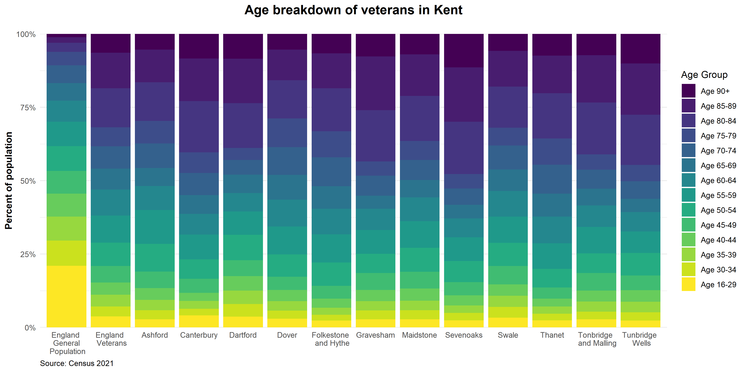

**Figure 04 Age breakdown of Veterans by County/Unitary Authority.**

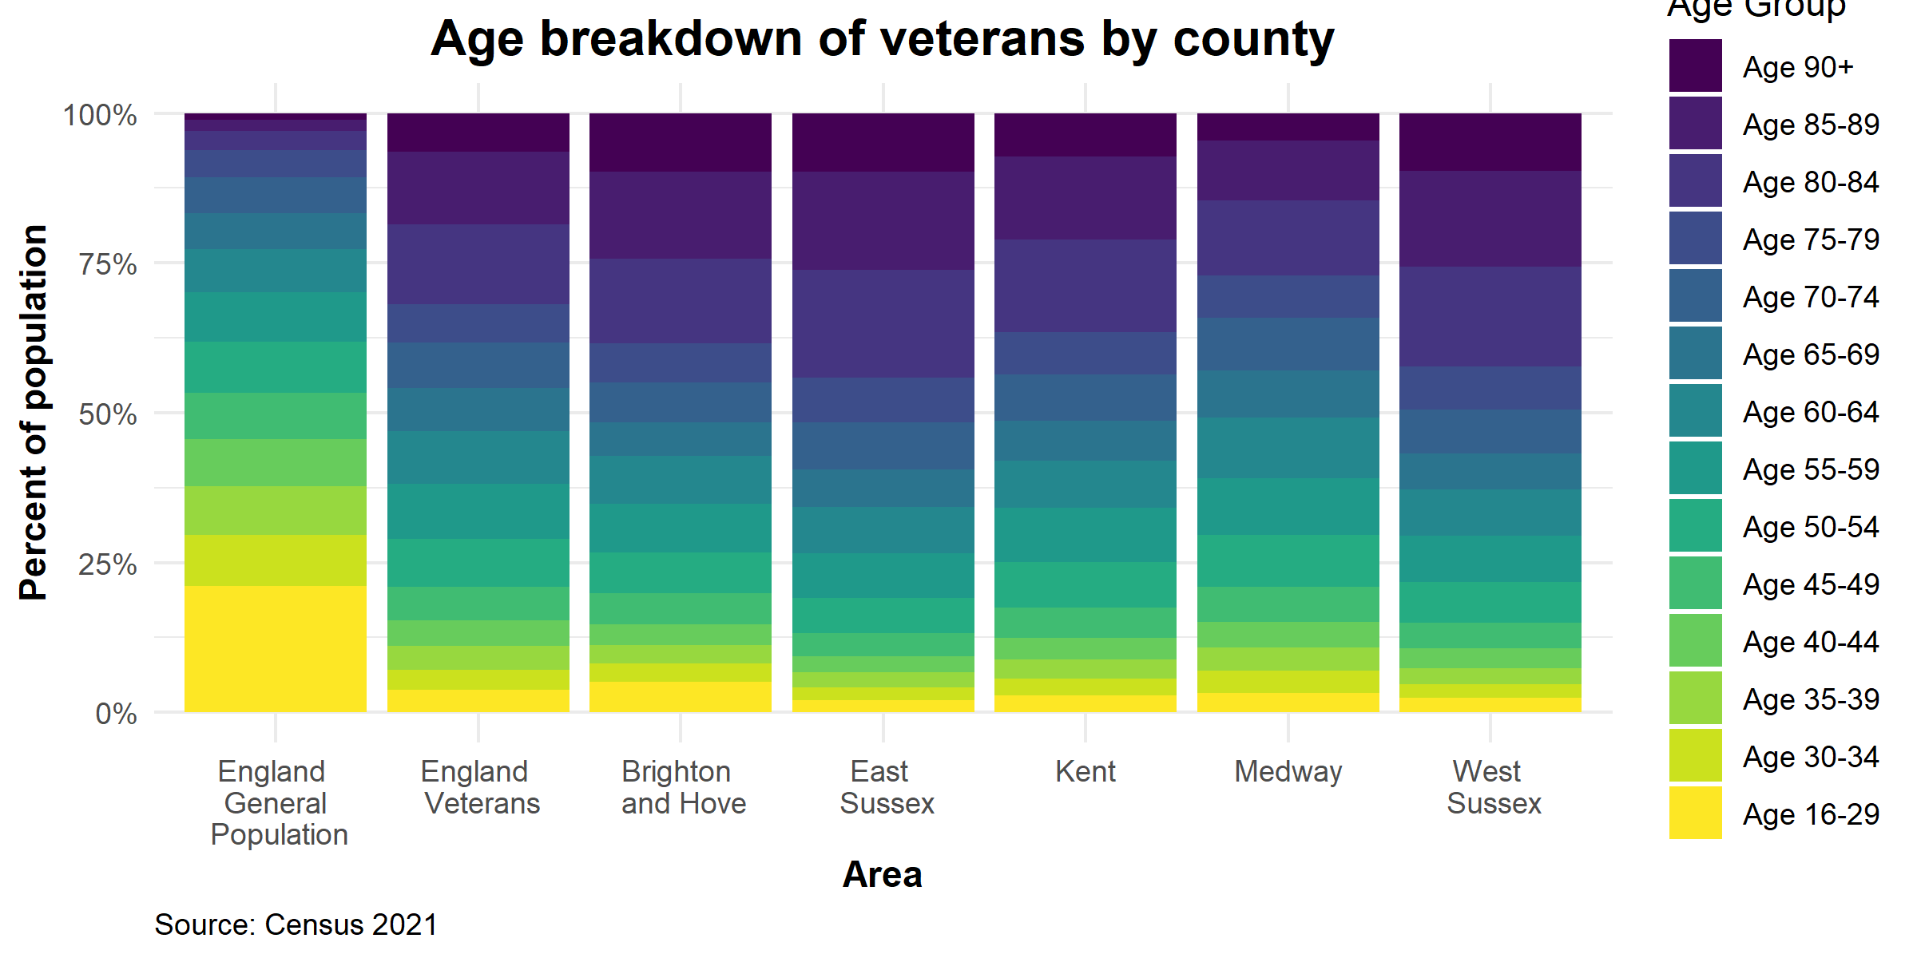

**Table 03. Kent Veterans by Local Authority and nature of armed forces service.**

|  |  |
| --- | --- |
| **District** | **Nature of armed forces** |
| Ashford | 4.6% (**4,962**) Regular 3.6% Reserve 0.8% Both 0.2% |
| Canterbury | 3.9% (**5,217**) Regular 3.0% Reserve 0.7% Both 0.2% |
| Dartford | 2.6% (**2,328**) Regular 1.8% Reserve 0.6% Both 0.1% |
| Dover | 5.9% (**5,710**) Regular 4.8% Reserve 0.9% Both 0.3% |
| Folkestone & Hythe | 5.7% (**5,211**) Regular 4.5% Reserve 0.9% Both 0.2% |
| Gravesham | 2.8% (**2,351**) Regular 2.1% Reserve 0.6% Both 0.1% |
| Maidstone | 4.0% (**5,664**) Regular 3.1% Reserve 0.7% Both 0.2% |
| Sevenoaks | 3.5% (**3,344**) Regular 2.5% Reserve 0.8% Both 0.1% |
| Swale | 3.9% (**4,773**) Regular 3.0% Reserve 0.7% Both 0.2% |
| Thanet | 5.0% (**5,765**) Regular 4.0% Reserve 0.8% Both 0.2% |
| Tonbridge & Malling | 3.8% (**4,023**) Regular 2.8% Reserve 0.8% Both 0.2% |
| Tunbridge Wells | 3.5% (**3,194**) Regular 2.5% Reserve 0.8% Both 0.1% |
| **Total** | **52,552. Largest Thanet 5,765 Smallest Dartford 2,328** |

Source Census 2021

**Table 04. Kent Veterans by Local Authority in East Kent HCP and nature of armed forces service**

|  |  |
| --- | --- |
| **Ashford** | 4.6% (**4,962**) Regular 3.6% Reserve 0.8% Both 0.2% |
| **Canterbury** | 3.9% (**5,217**) Regular 3.0% Reserve 0.7% Both 0.2% |
| **Dover** | 5.9% (**5,710**) Regular 4.8% Reserve 0.9% Both 0.3% |
| **Folkestone & Hythe** | 5.7% (**5,211**) Regular 4.5% Reserve 0.9% Both 0.2% |
| **Thanet** | 5.0% (**5,765**) Regular 4.0% Reserve 0.8% Both 0.2% |
| **TOTAL** | **26,865** |

**Table 05. Kent Veterans by Local Authority in West Kent HCP and nature of armed forces service[8]**

|  |  |
| --- | --- |
| **Maidstone** | 4.0% (**5,664**) Regular 3.1% Reserve 0.7% Both 0.2% |
| **Sevenoaks** | 3.5% (**3,344**) Regular 2.5% Reserve 0.8% Both 0.1% |
| **Tonbridge & Malling** | 3.8% (**4,023**) Regular 2.8% Reserve 0.8% Both 0.2% |
| **Tunbridge Wells** | 3.5% (**3,194**) Regular 2.5% Reserve 0.8% Both 0.1% |
| **TOTAL** | **16,225** |

**Table 06. Kent Veterans by Local Authority in Dartford and Gravesham HCP and nature of armed forces service**

|  |  |
| --- | --- |
| **Dartford** | 2.6% (**2,328**) Regular 1.8% Reserve 0.6% Both 0.1% |
| **Gravesham** | 2.8% (**2,351**) Regular 2.1% Reserve 0.6% Both 0.1% |
| **TOTAL** | **4,679** |

**Table 07. Kent Veterans by Local Authority in Medway and Swale HCP and nature of armed forces service**

|  |  |
| --- | --- |
| **Swale** | 3.9% (**4,773**) Regular 3.0% Reserve 0.7% Both 0.2% |
| **Medway** | 3.8% (**8,529**) Regular 2.9% Reserve 0.7% Both 0.2% |
| **TOTAL** | **13,302** |

**Table 08. Kent Veterans by HCP and nature of armed forces service**

|  |  |  |
| --- | --- | --- |
| **HCP** | **Veterans** | **Proportion of Kent total** |
| East Kent HCP | 26,865 | 44% |
| West Kent HCP | 16,225 | 27% |
| North Kent HCP | 4,679 | 8% |
| Medway and Swale HCP | 13,302 | 22% |
| TOTAL | 61,071 |  |

# Physical and Mental Health and Wellbeing

**Overview - Physical and Mental Health and Wellbeing**

Whilst describing the general mental and physical health of veterans and armed forces personnel the assessment is unable to describe in detail the morbidity of Kent based veterans given the problems associated with veteran coding within the health economy. National data is used to address this population given the absence of this basic data.

The GP Veterans Friendly Accreditation Scheme which is considered good practice and the current status of this scheme in Kent is explained. The chapter continues to describe aspects of veterans morbidity including musculoskeletal problems, hearing and sight loss, respiratory conditions including smoking and dentistry. End of Life Care is briefly addressed.

Mental health conditions and issues are described including common MH disorders, PTSD, addictions and reference to substance misuse locality data obtained from service providers. Suicide within the armed forces and veteran community is considered along with details of Kent data and programmes relating to suicide prevention and associated training.

## Introduction – Physical Health

Of all UK armed forces veterans in England and Wales, 27.5% (509,645) said that their general health was very good and 36.9% (682,995) said that their general health was good. A quarter of veterans in England and Wales said their health was “fair” (24.2% or 448,720). The proportion who said they had bad health was 8.6% (160,190) and 2.8% or 51,660 veterans said they had very bad health. This pattern was very similar across England and Wales.[9]

The non-veteran population showed a different pattern, with non-veterans much more likely to say they have very good health and less likely to say they have very bad health. However, the veteran population is much older than the non-veteran population and is mostly male. Since health is typically strongly related to age and, in some cases sex, ONS provide adjusted estimates for the self-reported health of the non-veteran population to understand what the estimates would be if the non-veteran population had the same age, sex and regional profile as that of the veteran population. Figure 05 shows that when this adjustment is made, all differences in self-reported general health between the two populations substantially decrease. This suggests that while veterans are less likely to say they have very good health than non-veterans, this difference is a result of age, sex or geographic factors and not a result of previous service.

**Figure 05. Veterans and non-veterans are similar in relation to self-reported general health if we account for differences in age, sex and location.**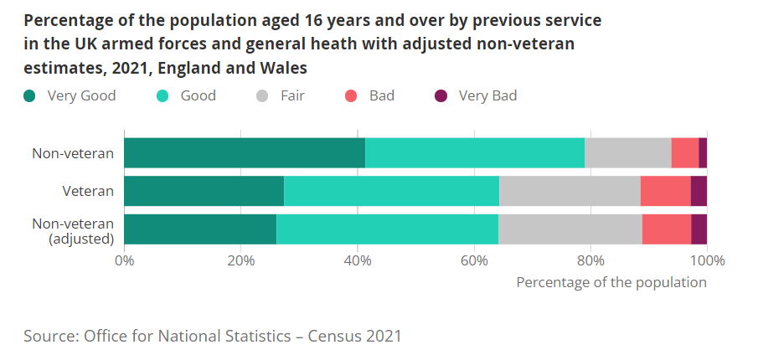

Within the veteran population very good health decreased with age and bad and very bad health increases with age. See Figure 06 below.

#### Figure 06. Within the veteran population, very good health decreased and bad or very bad health increased with age.

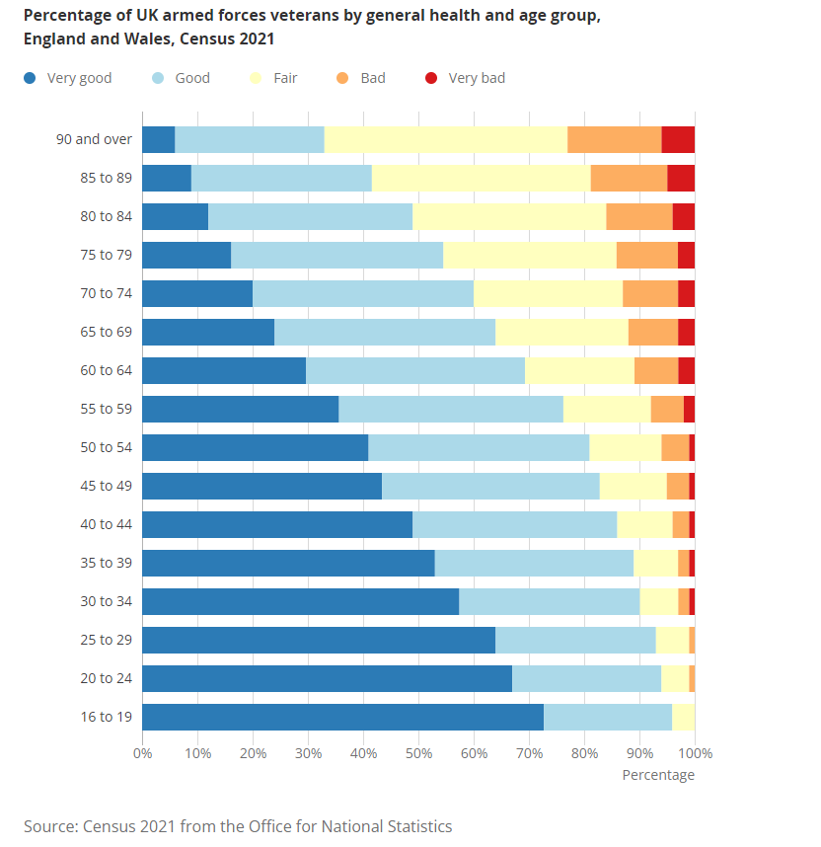

## Introduction to Mental health issues

Mental health problems are not common but service personnel often seek medical advice for domestic and family problems. Service personnel have rapid access to Defence Community Mental Health (DCMH) teams.

**Post traumatic stress disorder.**

Post traumatic stress disorder (PTSD) - 4% of service personnel at the most suffer from it.  
Most PTSD cases tend to present between 3 and 10 years after the sentinel events, often once leaving the military.

## Veteran Health and Primary Care

Veterans (or ex-service personnel) are often indistinguishable from other members of the community; indeed, they may not want their veteran status to be known or may not consider it relevant. Veterans may only come to notice when they present with health problems that may be related to their military service.

Many veterans are present in primary care with health problems that are relevant to their general age and health profile rather than with a problem related to their time in the Armed Forces. Equally, it is not easy to identify the families of service personnel, and so their specific needs may not be catered for. Families of service personnel are in an especially difficult position, inhabiting the environment in-service, yet needing to access NHS care.

In an average practice, about 4.8% of the list would be veterans. In a practice with a list size of 8000, this would be approximately 384 people. The number of veterans will obviously be higher around military bases (garrisons, ports and air stations) and this will have implications for practices serving the Maidstone and Folkestone communities.

Veterans may have specific health related to their time in service such as depression and alcohol misuse. Troops are not only stationed in high profile areas such as Afghanistan, but it is also important to remember that there are armed forces deployed in overseas territories all over the world.

There are several ways for relevant staff, organisations and surgeries to identify veterans and follow good practice by opportunistic identification, at registration, by the creation of registers, at diagnosis, by referral and by self-identification. Sources where medical records for veterans can be accessed are contained in the Technical Report.

The development of knowledge around veterans in the primary care economy of Kent and Medway has been frustrated by the lack of accurate veteran coding on GP practice datasets. Others in the field of research into veteran morbidity in primary care are exploring this avenue including the King’s Centre for Military Health Research (KCMHR), King’s College London, which is a leading civilian **UK centre of excellence for military health research.**

A project exploring the mental and physical health needs of veterans using primary care health records is also currently underway at KCMHR.[10] This project is in collaboration with Imperial College London. The study will explore whether the Clinical Practice Research Datalink (CPRD) can be used to identify veterans and their health needs using electronic general practice (GP) records, and how they differ to those who have not served in the armed forces.

Previous research has shown that veterans often experience complex and co-occurring mental and physical health issues. Upon transitioning out of the armed forces, the first point of contact for many veterans will be their GP, yet little is known about veterans’ use of primary care services and their health outcomes, particularly for more complex issues where mental and physical health conditions co-occur.

An approach was initially tried by the Kent Public Health Observatory on Kent and Medway based GP practices. Unfortunately, the preliminary analysis cast doubt on the feasibility of any use of primary care data for the assessment. It was expected to be able to replicate the patient counts within a data spreadsheet but there were serious doubts about the accuracy of those numbers.

The next proposed step was to filter the overall Kent & Medway dataset to those practices where data recording seems relatively good and then to compare a handful of health outcomes and behavioural risk factors between veterans and non-veterans, controlling for confounders. However, it was eventually decided not to pursue the primary care analysis of veterans due to low coding quality as the analysis would not produce robust results. It is proposed to further pursue this line of enquiry.

There are other datasets collected outside of the NHS so there is the need if possible to integrate them with NHS data. Some 30 VCSE military and other types of national registers are highlighted by way of example in the Need Assessment Technical Report as potential sources. The Shared Health and Care Analytics Board is the senior governance group for the analyst community across Kent and Medway and whose remit is to work together to link data across the region so the local NHS and councils can plan existing services for patients and conduct research to design new services and could explore the possibilities for the integration of this additional data.

## The Veteran Friendly Accreditation Scheme[11] (Good Practice)

The Veteran Friendly Accreditation scheme by the Royal College of GPs and NHS England is a quick-to-implement, free support programme for GP practices in England that will enable a practice team to easily identify, understand and support veterans and, where appropriate, refer them to specialist healthcare services designed especially for them.

2,300 practices have already become Veteran Friendly accredited 43 of which are in Kent (66 in March 2024) and details of these practices can be found in the Technical Report.

Accreditation can also be used to demonstrate evidence of meeting CQC obligations and the legal requirements of the Armed Forces Covenant, which requires that no veteran should face disadvantages in accessing health services and should receive priority care for military attributable conditions, subject to clinical need.

## Musculoskeletal problems (MSK)

The Chavasse Report[12] highlighted current problems and provided solutions to ensure the on-going care of musculoskeletal problems for all Service Personnel by the NHS from 2014 onwards. The long-term impact of active service can take its toll as service personnel put higher demands on their bodies than most civilians, especially on the musculoskeletal system. Armed forces veterans who need rehabilitation tend to have suffered higher impact MSK injuries that the general population and have greater rehabilitation and support needs.[13]

Musculoskeletal injuries are the most significant cause for medical discharges accounting to 60%. The commonest age range of discharged Personnel is 30-45 years. As a consequence, it is likely that there will be a considerable need for on-going musculoskeletal health provision for these veterans as they age and especially as 80% of Kent veterans are over 45 years of age. Although healthier earlier in life veterans begin to fall behind their civilian counterparts during the middle years on some MSK outcomes. Veterans aged 35–49 are significantly more likely than non-veterans to report problems with:

• back or neck related conditions (34% vs 23% of same-age civilians)

• leg or feet related conditions (33% vs 20%)

• arm or hand related conditions (22% vs 13%)[14]

Below in Figures 07 and 08 more national information by service arm is displayed and the source cited is available for more detailed information. No county information is available. To obtain more specific patient detail regarding MSK access to anonymised data from primary care would be necessary which is currently unavailable.

**Figure 07. Key points and Trends MSK**

Infographic showing key points and trends for medical discharges in the UK Armed Forces for 2021/22:

Royal Navy
Total Medical Discharges: 484
Rate: 14 per 1,000 personnel (up from 10 per 1,000 last year)
Higher Risk Groups:
Aged 30-34 years
Aged 35-39 years
Females
Other ranks
Army
Total Medical Discharges: 670
Rate: 8 per 1,000 personnel (no change from last year)
Higher Risk Groups:
Aged 20-24 years
Females
Other ranks
Untrained personnel
RAF
Total Medical Discharges: 168
Rate: 5 per 1,000 personnel (up from 4 per 1,000 last year)
Higher Risk Groups:
Females
Other ranks
Untrained personnel.

For all three services, the main causes of medical discharges were Musculoskeletal Disorders and Injuries
and Mental and Behavioural Disorders. This was in line with findings from previous years. 

**Source :** <https://assets.publishing.service.gov.uk/government/uploads/system/uploads/attachment_data/file/1089735/UK_service_personnel_medical_discharges_financial_year_202122.pdf>

**Figure 08. Key points and Trends MSK**

Infographic about musculoskeletal disorders and mental disorders. For all three services, the main causes of medical discharges were Musculoskeletal Disorders and Injuries
and Mental and Behavioural Disorders. This was in line with findings from previous years. 
Musculoskeletal disorders and injuries: 44% of Royal Navy medical discharges, 38% of army medical discharges, 35% of RAF medical discharges. 
Mental and behavioural disorders: 26% Royal Navy, 46% army, 43% RAF.
2 in 5 personnel (43%) medically discharged left as a result of multiple medical conditions.
Responsible statistician: Deputy Head of Defence Statistics Health
Further Information/mailing list: Analysis-Health-PQ-FOI@mod.gov.uk 
Enquiries: Press Office: 020 72183253 
Background quality report: https://www.gov.uk/government/collections/medical-discharges-among-uk-servicepersonnel-statistics-index 
Would you like to be added to our contact list, so that we can inform you about updates to these statistics and consult 
you if we are thinking of making changes? You can subscribe to updates by emailing Analysis-Publications@mod.gov.uk

**Source :** <https://assets.publishing.service.gov.uk/government/uploads/system/uploads/attachment_data/file/1089735/UK_service_personnel_medical_discharges_financial_year_202122.pdf>

## Hearing Loss

**Lost Voices[15] (**A Royal British Legion report on hearing problems among Service Personnel and Veterans 2015.)

In summary, the report cites 11% of surveyed Veterans reported having problems hearing and 6% reported tinnitus. Given the numbers of veterans living in Kent then some 5,700 veterans are subject to hearing loss (700 women and 5,000 men). In terms of tinnitus then the number is 2,615 (315 women and 2,300 men) using these prevalence rates.

If comparing different age groups, Veterans under the age of 75 are about three and a half times more likely than the UK population to report difficulty hearing. Those who have served in more recent conflicts may be at even greater risk: audiometric tests on infantry troops returning from Afghanistan in 2007/08 indicated that up to 14% had suffered from hearing loss[16]. The Kent veteran profile shows 36% are over 80 years of age and 7.25% over 90 years of age presenting evidence of a potentially vulnerable cohort.

Data on veterans accessing the Kent County Council Sensory Services is currently not available although new entrants to the services are now being screened for veteran status.

The Royal British Legion (RBL) and the University of Chester will be working together to understand more about how common an issue hearing impairment is, and how it affects the lives of working age veterans[17].

## Sight Loss

**No One Alone Campaign**

A national campaign[18] is calling for healthcare professionals to ensure they’ve signposted blind and vision impaired Ex-Service men and women to vital sight loss services and support, regardless of how they lost their sight.

Blind Veterans UK[19] are the leading organisation supporting vision impaired Ex-Service men and women, regardless of when or for how long they served (also assisting those who have been injured in the line of duty within the emergency services). Blind Veterans UK help get our blind Veterans back on their feet, recover their independence and discover a life beyond sight loss.

The Kent Association for the Blind (KAB) team do routinely ask service users and individuals who are partially sighted that they meet if they are veterans, so that KAB can signpost/refer them to support provided by the national charity Blind Veterans UK.

This will therefore be noted within assessments or contact recording for the person. However, unfortunately this is not in a reportable form. KAB record on Kent County Council’s social care database (MOSAIC) and as far as KAB are aware this doesn’t have a facility to record and report on the number of veterans seen by them.

National figures indicated that between 2010 and 2030 the number of adults with sight impairment will increase by 64%. By 2021, nationally 40% of the population would be over 50 – a significant proportion of sight impairment is related to age. Over 80% of sight impairment occurs in people over 60. As this population is set to increase nationally, there will be a significant increase in the number of people with sight impairment. Given the age profile of the Kent veteran population then significant numbers will suffer from sight impairment.

## Smoking in the Armed Forces

Within sexes, smoking prevalence is consistently highest in the Army, followed by the Royal Navy and then the RAF. In all services, smoking prevalence has fallen between 2011 and 2020. Notably, females in the Army had similar or higher rates to males in the Royal Navy and RAF, and smoking rates are similar for both sexes in the RAF, while they differ between sexes in the Army and Royal Navy.

Source: Defence Statistics Health

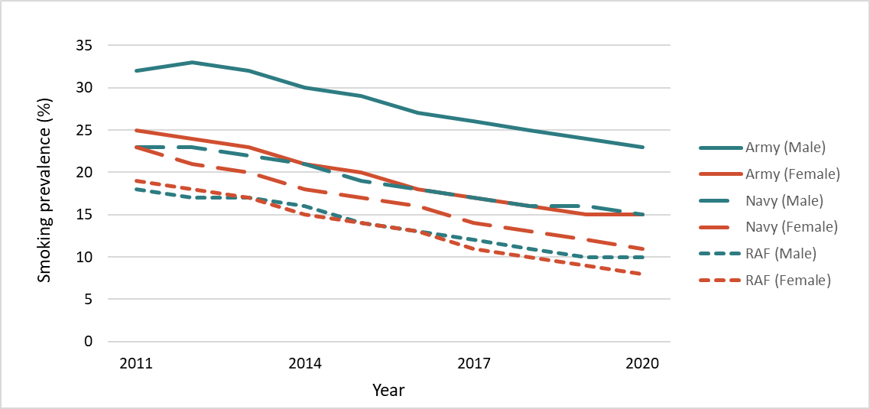**Figure 09 Smoking Prevalence Rates in the Armed Forces by Gender**

Service personnel who smoke are advised by healthcare professionals to stop smoking whenever the opportunity arises. Smokers who want to stop in the first instance are referred to the local military or NHS Stop Smoking service. Patients who are not ready to stop smoking are offered advice and encouraged to seek support in the future.

## Respiratory Disease

Respiratory conditions are not as well-known as other diseases or injuries that the Armed Forces community may have as a result of having served with the Armed Services.

Veterans[20] are at triple the risk of developing chronic lung disease compared to the general population. Occupational lung disease can come from exposure to cigarette smoke, sand, dust, chemicals, airborne heavy metal and chemical particles from exploded munitions, aeroallergens found in desert regions and smoke from burn pits.

Asbestos was widely used throughout the Armed Forces, particularly in construction and shipbuilding due to its excellent heat resistant properties and non-flammable nature. Many MoD personnel have therefore come into direct contact with asbestos over the past 50 years[21].

From 01/04/2003 to 30/09/2016 in England there have been 761 Ex-Service Personnel with Mesothelioma of these 721 are deceased*[22]*.

2,700 new cases of mesothelioma are diagnosed in the UK each year and while the incidence among UK military veterans remains unknown, eight veterans per month claim war pensions due to a diagnosis of mesothelioma[23].

Mesothelioma UK[24] has launched a specialist, UK-wide service for Armed Forces Personnel and Veterans who have been affected by Mesothelioma. This new service is called ‘Mesothelioma UK - Supporting our Armed Forces.’ The Specialist Nurses can be found in Southampton and Tunbridge Wells. All Veterans diagnosed with Mesothelioma as a result of Service will have the choice between receiving a traditional War Pension or £140,000 in lump sum compensation, regardless of their age at the time of diagnosis[25]. As at 31 March 2023, there were noveterans in Kent in receipt of a traditional War Pension due to Mesothelioma.

## Dentistry

Veterans/ex-service personnel are encouraged to join local NHS dental practices. They may be entitled to receive reduced costs. In addition, if they have had any damage to their teeth due to their service in the British Armed Forces, they may be entitled to priority dental treatment and access to support.

Veterans in receipt of a War Disablement Pension or an award under the Armed Forces Compensation Scheme are entitled to free NHS Prescriptions for injuries or illnesses accepted as being due to service. This also applies for dental treatment when the patient is in receipt of the War Pension Scheme or the Armed Forces Compensation Scheme if the treatment is for the veterans accepted disability. The War Pension Scheme and the Armed Forces Compensation Scheme should not be included in any means testing.

A veteran who has received dental injuries as a result of their service in the British Armed Forces is eligible for priority treatment if orthodontic treatment is required.

When making a referral, the following wording should be added:

*“As this patient is a military veteran and his (or her) current condition may be related to military services, this referral should be considered for priority treatment under the rules set out in the Commissioning Board Mandate, NHS constitution and Armed Forces Covenant.”*

The Kent Local Dental Committee comment that there is no official scheme similar to that offered by the Royal College of General Practitioners to accredit dental practices as Veteran Friendly.

They further comment “that NHS dental practices are required to prioritise treatment for veterans who have a service-related injury or oral condition. Service personnel, including their families and reservists, are also not allowed to be disadvantaged by frequent moves related to their service or deployment - so for example if the practice has a policy requiring attendance at least every 18 months and they cannot meet this for service-related reasons, the policy should be varied for them. It is not a requirement to ask whether someone is a veteran, so there will be no blanket policy on this. Most practices do record occupation as part of general medical/social history, and so the information would often be captured in this way, but it is unlikely to be collected in a way which could be analysed.”

## End of Life Care (veterans) and In Service Bereavement

### In Service Bereavement

The Joint Casualty and Compassionate Centre (JCCC), along with many other supporting organisations are openly ready to assist families of serving personnel in dealing with bereavement. The JCCC is the lead organisation for managing all the practical requirements following bereavement and is also a source of advice and guidance through The Purple Pack bereavement guide for service families of service personnel[26].

The Veterans Welfare Service (who provide the Welfare Manager) offer lifelong support to Bereaved Service families and – should it be required – a second Welfare Manager can be provided for families where the circumstances may necessitate separate support.

### End of Life Care (veterans)

Throughout military service, encounters with death and dying are frequently intense,

highly personal, and potentially traumatic, in ways seldom seen or understood in civilian life.

Petrova M, Caddick N, and Almond N (2021)[27] cite that overall, veterans may be well equipped to manage close encounters with pain, suffering, and death without seeking professional input. However, they may also be reluctant to seek help for avoidable suffering in terminal illness and/or at the end of life, even if they may be more receptive to such care than most people, as many of them can talk openly about death and dying. It is plausible that veterans may have needs and preferences for palliative and EOLC that are different from those of the general population. It is also conceivable that they may underutilise associated services.

Analysis of death returns and deceased occupation gives no insight to place, and cause of death of veterans given that veterans have taken other occupational avenues after discharge thereby overshadowing their veteran status.

# Mental Health

## Common Mental Health Disorders

The rates of common mental disorders (e.g., depression or anxiety) are similar to the general public in Ex-Service Personnel. However deployed Reservists are found to have higher rates. Most significant for those who have served and transferred into civilian life is Adjustment Disorder and significant numbers are affected by this to varying degrees.

Rates of common mental health disorders in the veteran population are 1 in 5 compared to 1 in 4 in the general population. The issues veterans are most likely to present with are depression, anxiety disorders and alcohol issues.

## Post Traumatic Stress Disorder (PTSD)

The rates of PTSD in the combined Regular Forces and Veteran population are about 6% compared to between 4% and 5% in the general population. In the Reserve Forces (The Army Reserve was previously known as the Territorial Army), the rate is around 6% to 7%. In Sussex, Kent and Medway there are few Regular Forces but a large contingent of Reserve Forces, especially Infantry.

Recent statistics from the Kings College study of Iraq and Afghan veterans show that rates of PTSD are at about 6%. This study found that for those individuals whose last deployment had been in a combat role, the rates of PTSD were higher (17%) compared to 6% for Veterans whose last deployment was in a Service support role. However, the research acknowledges that other factors might explain the elevated rates in this group i.e., mental health issues that are associated with discharge from service[28].

## Adjustment Disorder

Adjustment Disorders account for around a third of all mental ill health in the UK Armed Forces. It is a short term condition occurring when a person is unable to cope with or adjust to a particular source of stress such as a major life change or transition, loss or event. The higher rates of adjustment disorders seen in the UK Armed Forces compared to the UK general population may reflect the impact of Service life with routine postings every few years and operational tours (35% of Personnel assessed with a mental disorder at MoD specialist mental health services).

## Alcohol and Drugs

Alcohol misuse is a significant problem for both Serving persons and Services Leavers. The Hatch et al (2013)[29] study shows that there is 11.4% of Serving Personnel dealing with alcohol misuse and 15.1% of Service Leavers. Recent research by Kings College Centre for Military Health Research (KCMHR) suggests that alcohol consumption in the military has declined in recent years but higher rates of alcohol misuse are seen in Serving Personnel (10%) compared to the general population (3%). This research showed that those who met the criteria for depression, anxiety and PTSD were more likely to drink to cope rather than because of social pressure. This suggests they may be drinking to deal with mental health symptoms and it is not necessarily representative of the wider UK Armed Forces community.

In terms of veterans accessing Kent CC commissioned drug and alcohol services the following data was supplied by the current providers who are veteran aware.

**Table 09. Veterans accessing Kent substance misuse services in 2023 by district.**

|  |  |
| --- | --- |
| **Area** | **Patients** |
| Maidstone | 35 |
| Tunbridge Wells | 25 |
| Margate | 20 |
| South Kent Coastal | 20 |
| Gravesend | 15 |
| Canterbury | 10 |
| Sittingbourne | 10 |
| Ashford | * |

*low numbers suppressed and rest rounded to nearest 5 so totals may not add up to 100%

Maidstone has the highest numbers of veterans accessing substance misuse treatment. Out of 130 patients, ~15 were female (10%) and ~115 were male (90%). Approximately half of patients were between the ages of 35 and 54. The majority of people are only being treated for alcohol.

**Table 10. Veterans accessing Kent substance misuse services in 2023 by age band.**

|  |  |  |
| --- | --- | --- |
| **Age group** | **Patients** | **Percentage** |
| 25-34 | 25 | 20% |
| 35-44 | 35 | 25% |
| 45-54 | 30 | 25% |
| 55-64 | 30 | 20% |
| 65 and over | 15 | 10% |
| Total | 130 |  |

*low numbers suppressed and rest rounded to nearest 5 so totals may not add up to 100%.

**Figure 10. Veterans accessing Kent substance misuse services in 2023 by age band.**

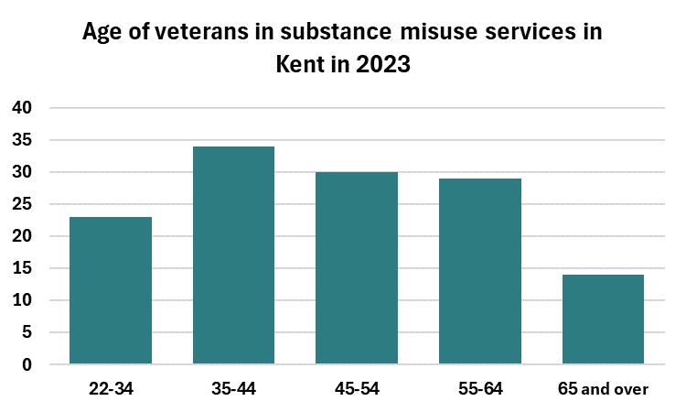

**Table 11. Veterans accessing Kent substance misuse services in 2023 by primary problem substance.**

|  |  |  |
| --- | --- | --- |
| **Substance** | **Patients** | **Patients** |
| Alcohol only | 85 | 65% |
| Non-opiates (may also include alcohol) | 40 | 25% |
| Opiates and opiates and other | 10 | 5% |

**East Kent**

In East Kent, most patients are in Margate and South Kent Coastal. Approximately 90% of those accessing services are male, and the highest proportion of patients are in the 35-44 age group. Most veterans are accessing services for alcohol treatment.

**Table 12. Veterans accessing substance misuse services in East Kent in 2023 by area.**

|  |  |
| --- | --- |
| **Area** | **Patients** |
| Ashford | * |
| Canterbury | 10 |
| Margate | 20 |
| Sittingbourne | 10 |
| South Kent Coastal | 20 |

*low numbers suppressed and rest rounded to nearest 5 so totals may not add up to 100%

**Table 13. Veterans accessing substance misuse services in East Kent in 2023 by age.**

|  |  |
| --- | --- |
| **Age group** | **Total** |
| 22-34 | 10 |
| 35-44 | 15 |
| 45-54 | 10 |
| 55-64 | 10 |
| 65 and over | 5 |
| Total | 57 |

*low numbers suppressed and rest rounded to nearest 5 so totals may not add up to 100%.

**Table 14. Veterans accessing substance misuse services in East Kent in 2023 by primary problem substance.**

|  |  |  |
| --- | --- | --- |
| **Substance** | **Patients** | **Percentage** |
| Alcohol | 45 | 75% |
| Non-opiates | 10 | 20% |
| Opiates and opiates and other | * | 5% |

*low numbers suppressed and rest rounded to nearest 5 so totals may not add up to 100%.

In December 2024 in East Kent there are 24 veterans in treatment: 5 Air Force, 12 Army and 7 Navy.

The provider works with forces charities when the need arises to meet the specific needs of this group.

**West Kent**

In West Kent, most patients are in Maidstone. As in East Kent, approximately 90% of those accessing services are male, and the highest proportion of patients are in the 35-44 age group. Most veterans are accessing services for alcohol treatment.

**Table 15. Veterans accessing substance misuse services in West Kent in 2023 by area.**

|  |  |
| --- | --- |
| **Area** | **Patients** |
| Gravesend | 15 |
| Maidstone | 35 |
| Tunbridge Wells | 25 |

**Table 16. Veterans accessing substance misuse services in West Kent in 2023 by age.**

|  |  |
| --- | --- |
| **Age range** | **Total** |
| 25-34 | 10 |
| 35-44 | 20 |
| 45-54 | 20 |
| 55-64 | 15 |
| 65 and over | 5 |
| Total | 73 |

*low numbers suppressed and rest rounded to nearest 5 so totals may not add up to 100%

**Table 17. Veterans accessing substance misuse services in West Kent in 2023 by primary problem substance.**

|  |  |  |
| --- | --- | --- |
| **Substance** | **Patients** | **Percentage** |
| Alcohol | 45 | 60% |
| Non-opiates | 25 | 35% |
| Opiates and opiates and other | 5 | 10% |

*low numbers suppressed and rest rounded to nearest 5 so totals may not add up to 100%

In West Kent the service provider’s inclusion worker has been supporting Op Courage and they are in the process of developing their own drug and alcohol pathway for veterans who do not meet their threshold. They are working towards joint working when appropriate and within the framework of the Co-Occurring Conditions Protocol.

In conclusion veterans are statistically more likely to attend substance misuse treatment services for treatment for alcohol rather than opiates or non-opiates compared to non-veterans.

## Stigma

Stigma around mental ill health continues to be an issue and there is the suggestion that within military culture this stigma may be amplified due to the importance of characteristics, such as, strength and resilience. Any perception of mental ill health being seen as a ‘weakness’ may then inhibit individuals from seeking help. However, the MoD has run successful campaigns around raising awareness of mental health and encouraging help seeking behaviour. An unwillingness to access professional support does mean though that only around a third of people with mental health issues access help and this is reflected too in the general population.[30][31]

## Suicide

Nationally, the lowest ever suicide rate was recorded in 2017 and collective efforts to improve patient safety led to a 35% fall in suicides in mental health and inpatients settings in England between 2010 and 2020. However, while overall the current suicide rate is not significantly higher than in 2012, the rate is not falling in the population[32].

### Suicides in the UK Regular Armed Forces

Suicide remains a rare event in the UK Armed Forces, with on average less than two per month (in 2020 there were nine coroner confirmed suicides, with an additional 12 that may result in a suicide verdict once the Coroner Inquests are held). This represents less than one death per 1,000 Armed Forces Personnel.

The UK Regular Armed Forces have seen a declining trend[33] in male suicide rates since the 1990s and were consistently lower than the UK general population over the last 35 years. However, in the last five years the number of Army male suicides have been increasing and since 2017, the risk of suicide among Army males was the same as the UK general population for the first time since the mid 1990’s.

The recent rise in UK Armed Forces male suicides was highest among males aged under 24 years and those aged over 40.

A new study from The University of Manchester[34] has found that veterans are at no greater risk of suicide than the general population.

The study, which linked data between NHS and military records, also found that veterans over the age of 35 were at a lower risk of suicide than the general population, although younger veterans were at increased risk.

The new data was funded by the Ministry of Defence and NHS England. It looked at data for over 458,000 veterans between 1996 and 2018. During this period 1,086 (0.2%) veterans sadly took their own lives, which is similar to rates in the general population.

Risk is increased with the following factors - younger age at discharge, male, unmarried, Army, lower rank, untrained status and less than 4 years length of Service. Also, suicidal thoughts increase in financial crisis; unemployment for longer than a month; problems with the police; homelessness; domestic violence; sexual abuse; relationship problems/divorce; depression; alcohol and drug misuse; and bullying.

Over the period 2020 to 2023 there have been seven service/veteran recorded suicides in Kent. The seven are as follows and comprised of 4 serving military staff, 2 ex-military, and 1 undisclosed:

* 2020 – 1 (M, 41 years)
* 2021 – 1 (M, 27 years)
* 2022 – 3 (M, 83 years; M, 41 years; F, 23 years)
* 2023 – 2 (M, 23 years; M, 38 years)

Districts of residence were Thanet (3), Folkestone (2), Dover (1) and Canterbury (1). PTSD was referenced twice. 4 of the 7 had other risk factors included in their records (e.g., domestic abuse, substance misuse, relationship struggles.)

The **One Is Too Many study[35]** is a significant research project conducted by **The Northern Hub for Veterans and Military Families Research**at**Northumbria University (2024).** This study delves into the **suicides of military veterans**and sheds light on the critical need for **enhanced mental health support** within the armed services.

**Veteran suicides** are a deeply concerning issue, and understanding the reasons behind them is crucial for addressing this serious problem. While each case is unique, several common factors contribute to the high rates of suicide among veterans: **Mental Health Challenges, Transition Difficulties, Isolation and Loneliness, Physical Health Issues, Stigma and Barriers, Access to Lethal Means, Combat Trauma, Lack of Effective Support, Financial Stress and Loss of Identity.**

Efforts to prevent veteran suicides should focus on improving mental health services, reducing stigma, enhancing social support networks, and providing targeted interventions for at-risk individuals. Compassion, understanding, and proactive measures are essential in saving lives.

There are specific Armed Forces Mental Health Awareness and Suicide Prevention Training courses e.g. SERVES and community based resources to support veterans including Breakfast Clubs. OP COURAGE also provides specialist services. Details are included in the Technical Report.

## Addictions

There are a number of addictions that are significant in relation to the Armed Forces Community, for those serving the opportunity with access, boredom, risk taking, determination and culture. Gambling is being raised as it is higher than within the civilian population. This can continue into the veteran community and may be used to hide other issues.

### Alcohol

Alcohol misuse is a significant problem for both Serving persons and Service leavers. The Hatch et al (2013) study[36] shows that there is an 11.4% of serving personnel with alcohol misuse and 15.1% of service leavers. However, recent research by Kings College Centre for Military Health Research (KCMHR) suggests that alcohol consumption has declined but higher rates of alcohol misuse are seen in Serving Personnel (10%) compared to the general population (3%). This research showed that those who met the criteria for depression, anxiety and PTSD were more likely to drink to cope rather than because of social pressure. This suggests they may be drinking to deal with mental health symptoms and it is not necessarily representative of the wider UK Armed Forces community.

A joint report by the King’s Centre for Military Health Research, King’s College London and the University of Liverpool November 2020 showed that over two thirds (71%) of serving and ex-service personnel who self-reported a current or prior alcohol problem have not sought help[37].

### Gambling

Gamblingis a growing concern in the Armed Forces, with research showing that those in the military are 8 times more likely than the general population to have gambled. This is in part due to high adrenaline levels, boredom, culture, determination and ease of access. Rates within the veteran population is 1.41% and with civilians 0.17%[38][39] For some within the Armed Forces Community gambling may become persistent and excessive, leading to significant harm across multiple domains of their life.

These domains of gambling-related harm include relationships with others, finances, and emotional and physical health. Increasing evidence cites that vulnerable populations, including Armed Forces veterans, are at a greater risk of gambling-related harm. Indeed, internationally, Etuk et al. (2020)[40] estimated that lifetime prevalence rates for problematic gambling among veterans ranged between 2% and 29%; this range of rates are all considerably higher than general population comparisons.

|  |  |
| --- | --- |
| **Physical Symptoms** | **Emotional Symptoms** |
| Finance  Stress  Dependency  • 14.6% alcohol  • 3.5% very high nicotine | Isolation  Relationships  Self-esteem  • 26.6% self-diagnosed C-PTSD  • 8.5% Severe Depression  • 9.3% Severe Anxiety |

### Performance and Image Enhancing Drugs (PIED)

A recent study by University Sunderland May 2021[41] on Performance and Image Enhancing Drug use in military veterans confirms the concerns about steroid use within the military.

Anabolic steroids (PIEDs) as well as weight loss and body building PIEDS are the most prevalent forms of supplements used by this population and use starts or increases during deployment. Males tend to use muscle and body-building drugs and supplements, with females more likely to use weight loss supplementation. Most PIEDs users in the military are younger, male, lower ranked Army personnel. Links were identified in the study to other substance misuse, with excessive alcohol and cigarette use reported.

# Cost of Living

**Overview – Cost of Living.**

After describing the current economic climate and its’ impact upon the communities benefits available for veterans are described along with where they can get assistance. The Map of Need through the Veterans Network relating to the veteran community in the UK is outlined with some historic (2021) locality detail relating to various areas of need usually financial, employment, housing and physical and mental health. Some Kent “hotspots” are mentioned.

## Introduction

Over the past two years inflation has had an impact on the incomes of households and businesses and continues so to do. While the UK Government have addressed cost of living pressures through fiscal and other measures, there are actions which the public including veterans and the voluntary sectors and their partners can take to mitigate against some of the negative pressures which may impact on people’s and communities’ health.

The current inflationary episode has been driven by rising costs which include energy prices, tradable goods prices and wage rise pressures.

Lower real incomes pose a real risk to public health effecting lower income households who spend a higher proportion of their income on energy and food. Lower real incomes can directly reduce health because of reverse psychosocial factors such as stress and anxiety. Health can also be directly influenced as a result of changes in decisions about consumption decisions. It is noted that there are substantial disparities in health outcomes according to gradients of income and related socioeconomic factors. Income and wealth are linked to life expectancy, self-reported health, quality of life and disease risk.

Kent County Council has its own Financial Hardship programme which encompasses a raft of initiatives. Within this Financial Hardship Programme, it includes the Helping Hands Scheme which expands on this work to utilise funding from other sources. As a result of this, three additional workstreams are included in the Financial Hardship Programme which also support tackling the cost-of-living crisis namely Referrals, Free School Meals, and Healthy start and finally Data Sharing. This latter initiative is placed at both County and District level work to try to effectively identify individuals at risk of crisis. As such there is a strategic need to develop a solution which allows frontline teams greater visibility of individual vulnerability, both financially and socially to enable a proactive holistic response in providing support.

The Data Sharing Workstream has been testing two systems which specialise in extracting, combining, and representing data in a more useful way: Policy in Practice and Xantura. These systems are being implemented across Kent, in partnership with District level authorities.

## Benefits

There are various ways for veterans to claim benefits based on their income, contributions and circumstances. The Department of Work and Pensions offers expert information on the types of benefits[42] they are entitled to, as well as benefits calculators[43] to help them determine what they can claim. See the Chapter on DWP for additional details.

The MoD Veterans Welfare Service can also provide veterans with further information on DWP Benefits and how they overlap with their entitlement to compensation benefits from the MoD.

### ****Where veterans can get help****

Veterans UK[44] is the Ministry of Defence's service that helps veterans on many issues, including benefits and welfare. They also offer information on a range of compensation schemes[45] available for veterans and their dependants. The Veterans Welfare Service (VWS) is part of Veterans UK and offers veterans professional advice in relation to welfare and compensation claims. They will support veterans throughout their transition from service and through life. To use this service, veterans should contact the VWS centre in their region[46] which is Centurion (London, SE and SW England) Tel 02392 702232 Email: [Veterans-UK-VWS-South@mod.gov.uk](mailto:Veterans-UK-VWS-South@mod.gov.uk)

The Royal British Legion offers benefits advice, information and support[47] to members of the Armed Forces community on how to access benefits and tax credits to maximize their income.

## Map of Need[48]

The [Northern Hub for Veterans and Families Research](https://www.northumbria.ac.uk/business-services/engage-with-us/the-northern-hub-for-military-veterans-and-families-research/)[49] at Northumbria University used funding from Covenant Fund to develop a map of veterans’ and their families’ welfare needs across the whole of the UK, based on data from public sources, statistics, health data and data directly from Armed Forces charities.

The Map of Need works with the Veterans Gateway which is a first point of contact for veterans seeking support. They put veterans and their families in touch with the organisations best placed to help with the information, advice and support they need including healthcare and housing, employability, finances, personal relationships and more. These reports look at how people are using the Veterans Gateway app and online directory; and for what sources of support, they are searching. The Map of Need provides an important Public Health Observation function with implications at a local, regional and national level.

Through a series of reports, the Map of Need gives clearer insights into where veterans are within the UK, what their current needs are and what their future needs might be, by looking at the support they have asked for or accessed.

### Map of Need Directory of Services - Key Findings – December 2021

The directory of services provides veterans, service families and health and social care providers easy access to thousands of services, which deliver care or support to veterans and service families across the UK.

On the 1st of December 2021, the directory of services included 17,451 markers, each representing a service available to veterans or service families.

During December 2021, the directory attracted 940 individual searches for services across the UK.

• A total of 261 cases were from the Veterans’ Gateway Online Directory.

• A total of 605 cases were from the Veterans’ Gateway Mobile Directory.

• A total of 73 cases had users located overseas or with a null location.

• When considering all searches, ‘Employment’ followed by ‘Housing’ and ‘Mental Wellbeing’ were the primary general search criteria.

### Usage of the Veterans’ Gateway directory of services (all searches)

**Table 18. General search criteria from users located in the UK – All searches, December 2021.**

|  |  |  |
| --- | --- | --- |
| **Search Criteria** | **Search Count** | **Search Percentage** |
| Employment | 161 | 18.57% |
| Housing | 160 | 18.45% |
| Mental Wellbeing | 130 | 14.99% |
| Finances | 123 | 14.19% |
| Family and Communities | 75 | 8.65% |
| Physical Health | 71 | 8.19% |
| Local Government Support | 53 | 6.11% |
| Legal Support and Advocacy | 36 | 4.15% |
| National Charities/Organisations | 32 | 3.69% |
| Specific Search for Organisation | 26 | 3.00% |
| **Total** | **867** | **100%** |

Source : https://covenantfund.org.uk/wp-content/uploads/2022/03/Gateway_Usage-Dec.pdf

In terms of localities Ashford appears in this cohort of searches as a “hot spot.”

### Usage of the Veterans’ Gateway Online Directory

**Table 19. General search criteria from users located in the UK – Veterans’ Gateway online directory, December 2021**

|  |  |  |
| --- | --- | --- |
| **Search Criteria** | **Search Count** | **Search Percentage** |
| Housing | 63 | 24.14% |
| Employment | 49 | 18.77% |
| Mental Wellbeing | 37 | 14.18% |
| Family and Communities | 30 | 11.49% |
| Specific Search for Organisation | 19 | 7.28% |
| Physical Health | 18 | 6.90% |
| Finances | 17 | 6.51% |
| National Charities/Organisations | 11 | 4.21% |
| Local Government Support | 10 | 3.83% |
| Legal Support and Advocacy | 7 | 2.68% |
| **Total** | **261** | **100%** |

Source : https://covenantfund.org.uk/wp-content/uploads/2022/03/Gateway_Usage-Dec.pdf

In terms of localities Tonbridge and Malling appears in this cohort of searches as a “hot spot”

### Usage of the Veterans’ Gateway mobile directory of services

**Table 20. General search criteria from users located in the UK – Veterans’ Gateway mobile directory, December 2021**

|  |  |  |
| --- | --- | --- |
| **Search Criteria** | **Search Count** | **Search Percentage** |
| Employment | 112 | 18.51% |
| Finances | 105 | 17.36% |
| Housing | 97 | 16.03% |
| Mental Wellbeing | 93 | 15.37% |
| Physical Health | 53 | 8.76% |
| Family and Communities | 45 | 7.44% |
| Local Government Support | 43 | 7.11% |
| Legal Support and Advocacy | 29 | 4.79% |
| National Charities/Organisations | 21 | 3.47% |
| Specific Search for Organisation | 7 | 1.16% |
| **Total** | **605** | **100%** |

Source : https://covenantfund.org.uk/wp-content/uploads/2022/03/Gateway_Usage-Dec.pdf

The Ashford locality appears in this cohort of searches as a “hot spot.”

In terms of financial hardship, the Map of Need showed areas of hardship in the areas of Ashford, and Folkestone (Army veterans) with fairly high confidence levels and the Thanet (high confidence) and Swale areas (RAF veterans). However, this data is rather historic relating to the period 2015/2017.

# Housing

**Overview – Housing.**

The chapter describes the housing options that both armed forces and veterans can follow although housing status is not dissimilar to the general population. Detail is given of the Kent Homechoice Website and the detail of veteran numbers waiting on Kent local authority housing lists is given by each local authority in Kent. There are 418 veterans recorded on local authority waiting lists with Ashford being the highest (71) and Gravesham the lowest (0). There were 19 cases of veteran homelessness in the County over a 12 month period. Detail of Service Family Accommodation managed by the Defence infrastructure Organisation is given along with location (681 units) and allocation policy. Finally, the chapter examines care and nursing homes in the County and potential veteran occupation with examples of two homes described.

## Introduction

One of the key elements of a successful transition to civilian life after a period of military service is finding adequate accommodation, and there are many reasons why for a veteran this can be particularly challenging. The service leaver generally, walks out of good quality single living accommodation having paid substantially lower rent than for the equivalent civilian accommodation, rent which in any case is often deducted from their pay. They then enter into an environment where housing is harder to find, where it will probably be less routinely maintained, and where it will almost certainly cost more. And this is takin place against a backdrop of an extremely difficult national housing and local government funding environment.

Information and guidance on civilian housing for the Armed Forces Community can be found in the Technical Report

## Housing Status of Veterans

### Private sector housing

Approximately 80% of the civilian and veteran population in England and Wales (see figure 11) live in private sector housing.

**Figure 11. Percentage of UK Armed Forces Veterans and Nonveteran population by accommodation type, with adjustment estimates for the non-veteran population.**

Percentage of the UK armed forces veteran and non-veteran household population by accommodation type, with adjusted estimates for the non-veteran population, England and Wales, Census 2021. After adjusting for demographics, veterans and non-veterans have nearly identical housing.


A higher proportion of the household veteran population (74.68%) than household non-veteran population (64.54%) owned their accommodation outright or with a mortgage and almost 8% of veterans live in care homes. In the justice system just under 5% of the custodial population are veterans.

Being a veteran does improve their chances of securing rented social housing in two ways:

1. Veterans are one of the groups local authorities are required to give preference to in their allocation schemes for rented social housing.
2. Local authorities can include a local connection test in their criteria for allocating rented social housing. This means that a veteran can only apply for rented social housing for the area where you live or to which you have a connection. This requirement does not apply to veterans for up to five years after leaving service. Veterans are permitted to apply to any local authority in the country for rented social housing during this period.

Please note that being a veteran does not guarantee that they will secure rented social housing. There is statutory guidance for Local Authorities on improving access to social housing for members of the armed forces.[50]

## Kent Homechoice Website[51]

The Kent Homechoice Website offers the advice for Armed Forces Veterans in Kent.

### Getting on the housing register

Each local council in Kent has a register of people who wish to get into social and council housing. The councils will decide who gets offered housing based on a points or banding system. Applicants can apply to one of the council’s registers via Kent Homechoice.

Applicants need to be eligible and have a connection to one of the local councils in the County – but there are special arrangements for those who are or have been services personnel. The council will consider applicants have a connection if they are a serving member of the armed forces or have been discharged from the forces within the last 5 years. They will also qualify if they are a bereaved spouse leaving services family accommodation or are a former or serving member of the reserve forces, who needs to move because of injury or illness sustained as a result of service.

Most housing authorities also award extra priority to former and current members of the armed forces (including members of their household) who are imminently due to be discharged from the services and need housing urgently. There would be an exception if the discharge was dishonourable.

Many councils take applicants income and savings into account, when deciding who should get priority. However, compensation for an injury or disability sustained on active service will normally be disregarded.

### Homeless or threatened with homelessness.

If an applicant think they will be made homeless in the next 56 days, and they cannot find their own alternative accommodation, they can approach any local authority in England and ask for assistance. The council will assess their needs and draw up a ‘Personalised Housing Plan’ to help them resolve the applicant’s housing problem. This plan will include the steps that the applicant and the council will take to find a solution. The council the applicant apply to may have a number of specific schemes that may be appropriate for them. For example, most councils provide loans for rent deposits or rent in advance – so that the applicant can meet the upfront costs of private renting.

If they are living in accommodation provided by the MOD and will lose this upon discharge, they need to ensure that they obtain a Certificate of Cessation of Entitlement to Occupy Service Living Accommodation, which will show when their entitlement to service quarters will end. If they are within 56 days of the accommodation ending the council will consider them to be threatened with homelessness and start working with them straight away.

If the service person/veteran are already homeless and there is reason to believe they are in a priority need group, the council will provide them with temporary accommodation. When assessing if they are in priority need, the council will consider whether they are vulnerable and will consider their experiences in the forces and the effect they have had on them. To help support their case, they may need to provide medical evidence from the MOD, including a medical history release form (if they were given one).

Whether they are in priority need or not, the council will try and relieve their homelessness for a period of 56 days. If they are unable to find a home during this ‘relief period,’ and they are in priority need (and have co-operated with the plan), they may be owed a ‘full housing duty’ by the council they applied to and may receive an offer of housing.

Evidence from literature reviews (RBL)[52] suggests there is a consensus of sorts that the routes to and causes of homelessness are wide, multi-factored and that, while often influenced by a military career, homelessness is rarely simply a direct result of it. Op FORTITUDE is funded by The Armed Forces Covenant Fund to deliver a centralised referral pathway into veteran supported housing. The remit of the team will be to work with individual veterans at risk of or experiencing homelessness, supporting them either into suitable accommodation, or supporting them to maintain their current home. In the 8 months from June 2023 to February 2024 Op FORTITUDE had 20 referrals from the Kent area relating to 19 veterans. However, there is no available data relating the reason(s) for the referral and the source.

The Veterans Data Dashboard[53] (Office for Veterans Affairs) cites that nationally some 0.7% of the numbers of households seeking help under the homelessness duty were from veterans.

Applying homelessness rates by duty for Kent households within the Kent CC Statistical Bulletin 2023[54] for Homelessness for the year 2022/23 may well give some triangulation to the data from the Veterans Data Dashboard and the service provider for Op FORTITUDE. The KCC Bulletin cites three levels of applicants by duty, prevention duty (3577), relief duty (3039) and main duty (1407) which if subject to the 0.7% rate would display numbers of veterans/veteran families who are potentially homeless as 25, 21 and 10, respectively. Clearly whilst better insight is required these figures add some robustness to the Op FORTITUDE data.

### Local Authority Housing Registers.

All local authority housing authorities were contacted and asked whether they asked applicants if they are serving or had served in the armed forces, if so how many were on their housing waiting list and what issues if any armed forces applicants and veterans and their families presented. The following responses were received from all the Kent District housing authorities.

**Table 21. Numbers of Veteran/Armed Forces personnel on Kent LA Housing Registers, 2024**

|  |  |  |
| --- | --- | --- |
| **Local Authority** | **AF Community Applicants** | **Comments** |
| Ashford | 71 | 44 are over 50.  5 of which were discharged in the last 5 years. |
| Canterbury | 57 |  |
| Dartford | 15 | 1235 active housing register applications |
| Dover | 70 | The total number on the housing register is 1843. |
| Folkestone and Hythe | 52 |  |
| Gravesham | 0 |  |
| Maidstone | 18 | 1224 applicants currently on the housing register |
| Sevenoaks | 15 | 935 in total on the Housing Register. |
| Swale | 26 |  |
| Thanet | 43 | 1596 active housing register applications |
| Tonbridge and Malling | 40 |  |
| Tunbridge Wells | 9 |  |

**Figure 12. Numbers of Veteran/Armed Forces personnel 0n Kent LA Housing Registers waiting lists. 2024**

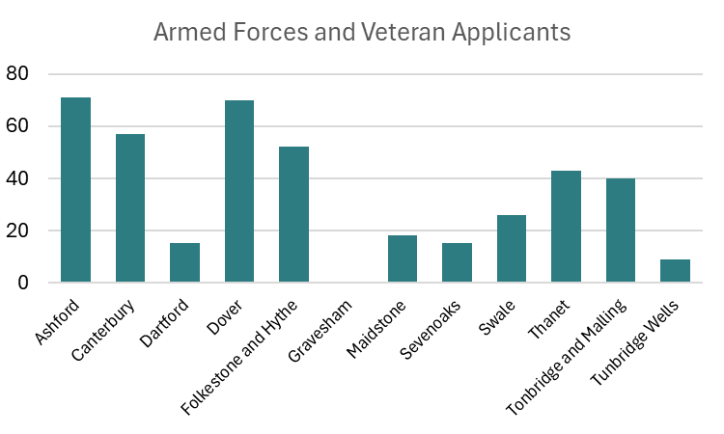

There are therefore 418 applicants on the Kent Housing Registers from the AFC.

What is unknown is the number of veterans who are currently tenants of Local Authorities and it would be constructive for these authorities to establish the numbers they have in residence. This could well afford them the opportunity to create a “Veteran Friendly Housing Organisation” model along the lines of Veteran Friendly GPs and also Veteran Friendly Care and Nursing Homes and in doing so help meet compliance with the Social Housing (Regulation) Act 2023 which sets regulatory requirements that all registered providers of social housing must adhere to, to drive improvements in the quality of housing for tenants.

### Service Families Accommodation (SFA)

The Defence infrastructure Organisation (DIO) is part of the MOD and has overall responsibility for providing service families with homes. It is not a facility open to veterans.

The DIO was asked what is the number of SFA housing units (by type) that they manage/allocate in Kent including their location? They were also asked what is the current vacancy rate?

The data they supplied (see Appendix 02 in Technical Report) was covered Kent and Medway so in reality excluding the Medway units and the accommodation in Biggin Hill (LB Bromley) there are 681 across the County of Kent with the largest group in Folkestone (220) followed by Maidstone (182) and then Dover (156). The majority of homes are Type D followed by Type C offering different entitlement[55]. Type D are 7 Person Bedrooms – 3 double, I single Overall size – 119.5 sq. m and Type C are 5 Person Bedrooms – 2 double, 1 single Overall size – 94.5 sq m. Applicants, including WOs, with 4 or more children of any age, or 3 children all aged 10yrs or over, are to be allocated a Type D whilst applicants with 2 or 3 children Type C. Type is determined by Rank and numbers of children (updated in August 2023).

Three sites in Kent are earmarked for disposal, Halstead Sevenoaks (11 units 10 void), Manston Ramsgate (10 units 3 void) and Whitfield Dover (22 units all void).

Nationally the Ministry of Defence (MOD) spent a further £10.5 million renting homes from the private sector for personnel. These so-called “substitute” homes are paid for when standard service accommodation is deemed unavailable. No data relating to these homes was available.

The type of home a veteran is entitled to is usually dependent on their rank for officers, and their family size for other ranks. For full details on entitlement and eligibility for UK SFA check JSP 464: tri-service accommodation regulations (TSARs)[56] Part 1, and for overseas check Part 2. A brief over view is also contained within Appendix 03

If the applicant is entitled to SFA but there are no homes available they will be issued with a Non-Availability Certificate (NAC) via their e-1132 application. The substitute Service Family Accommodation team at Defence Infrastructure Organisation (DIO) will then take ownership of the application upon the applicants acceptance of the Non-Availability Certificate and begin their search to find them a home. DIO Accn. Substitute Service Family Accommodation (SSFA) can be contacted through the Helpdesk on [DIORDAccn-SubAccn@mod.gov.uk](mailto:DIORDAccn-SubAccn@mod.gov.uk)

In February 2024, the Ministry of Defence announced that it is pausing the plans to change the allocation of military housing after strong criticism from Army families[57]. Under the plan, serving personnel would have got subsidised housing based on their need, such as how many children they have, rather than their rank, but there had been significant opposition to the move. Under the proposals, a married major with no children would have been entitled to a two-bedroom property instead of a three- or four-bedroom house - leaving them with around 38% less space. A married private with three children would get a larger house - gaining around 27% more space.

Service personnel are able to apply for enhanced flexible working opportunities. The measures, which came into effect in 2019, are part of the Armed Forces (Flexible Working) Act 2018. They will also limit the amount of time that personnel will need to spend away .

It is referred to by serving personnel as “week working” where the individual will travel away to their base from a fixed address in the County to elsewhere in the country returning back home for the weekends.

Defence Committee report Service Accommodation[58] drew attention to very low rates of satisfaction with service accommodation, historic under-investment, persistent problems with contract maintenance and repairs and a “botched” roll-out of the new accommodation offer. It was particularly critical of the way damp and mould related issues were addressed in the service force accommodation.

## Care and Nursing Home Provision

### The Veteran Friendly Framework (VFF) (Good Practice)

Launched in October 2023, the Veteran Friendly Framework is a two year scheme aiming to improve the care home experience of veterans and their family members across England.

A collaboration between Royal Star & Garter, Royal British Legion and NHS Veterans Covenant Healthcare Alliance, the scheme will address loneliness and isolation as well as health and wellbeing outcomes amongst the veteran community within residential settings by providing training and resources to care providers.

To achieve VFF accreditation, care home settings will need to meet a range of criteria details of which and other matters are contained within the Technical Report.

There are 519 care homes in Kent This data is taken from the CQC website[59]

In an attempt to identify veteran presence in nursing and care homes several homes were examined but only the RBLI offered some data relating to Bradbury House which is a 50 bedded nursing / dementia home and Appleton Lodge which is a 15 bedded nursing home in Aylesford. Other homes approached declined to offer data citing information governance issues or failure to collect veteran data.

### Appleton Lodge

Residency. Appleton Lodge is a 15 bed nursing home.

During the period October 2022 to October 2023 there were the following 21 residents moving into the nursing home or departing from it (seven deaths).

There were 14 residents 7 of whom were from the armed forces community either as former serving members or dependent relative. The Army presented three (2 veterans and one spouse), the Royal Navy two (one spouse and one father) and the RAF two (one veteran and one spouse). 3 were male and 4 were female. Apart from one in the 61-70 years of age range the remaining six were in the 81 to 90 range.

Five residents were in respite and one with a D2A classification (discharge to access - formerly step down bed) and apart from this particular resident the remaining ones were self-funding.

In terms of deaths in residency there were seven deaths, two of which were male and the remaining five female. The age range was from 80 to 91. No data was available to give insight as to whether any of the deceased were part of the armed forces community.

### Bradbury House

Bradbury House is a 50 bedded nursing / dementia home.

During the period October 2022 to October 2023 there were the following 45 residents moving into the nursing home or departing from it (24 deaths).

There were 24 residents 9 of whom were from the armed forces community either as former serving members or dependent relative. The Army presented four (two veterans and two spouse), and the RAF four (two veteran and two spouse). One was service undisclosed. Three were male and six were female. The age range the nine was in the 86 to 100 range.

Six residents were in respite, six Kent CC funded and three with a D2A classification (discharge to access - formerly step down bed) and apart from these residents the remaining six were self-funding.

In terms of deaths in residency there were 24 deaths, ten of which were male and the remaining 14 female. The age range was from 68 to 104. No data was available to give insight as to whether any of the deceased were part of the armed forces community.

# Families, Children and Young People

**Overview – Families, Children and Young People.**

This chapter commences with the UK Armed Forces Families Strategy 2022-2032 and the workstreams, and also the Armed Forces Continuous Attitude Survey which gives insight into family situations etc. The chapter also looks at the challenges experienced by military families today which are regarded as detrimental to modern day family life and relationships.

Education is considered and the challenges faced by children and alludes to evidenced based outcomes. The Service Pupil Premium (SPP) of £335 per child is explained and described across the Kent primary and secondary school landscape. 252 of the 593 schools in Kent have 1357 SPP pupils. The cohort is described by locality with hot spots highlighted. Higher education is also considered.

## Introduction

The UK Government published the UK Armed Forces Families Strategy[60] 2022-32 in January 2022. The Strategy has 8 core workstreams and a shared communication and research function.

**Figure 13. Core Workstreams and a Shared Communication and Research Function.**

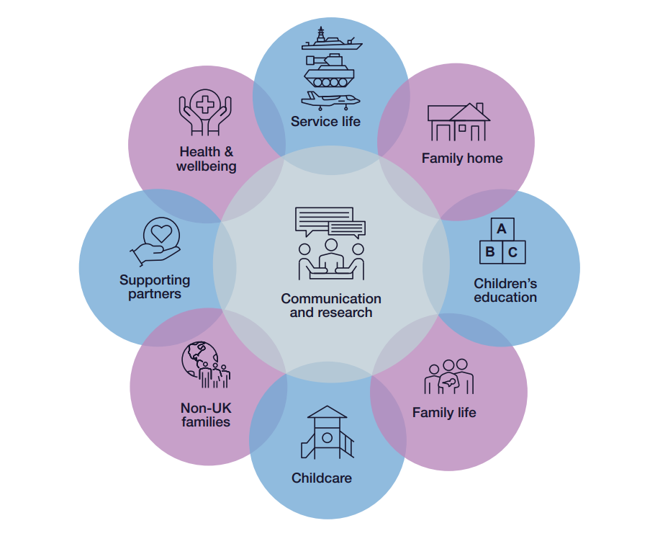

The Strategy highlights working in partnership with local authorities and public service providers across the fields of education, health, accommodation and social care, to communicate plans and help inform development of local provision.

The Armed Forces Continuous Attitude Survey[61] (AFCAS) provides data on service personnel[62] reporting on their family situation, including demographic information on their partners and children.

**Table 22. Marital Status from the AFCAS.**

|  |  |
| --- | --- |
| **Marital status** | **Percentage of service personnel** |
| Long term relationships | 24% |
| Married or civil partnership | 49% |
| Separated | 3% |

**Table 23. Spouse/Partner Employment Status AFCAS**

|  |  |
| --- | --- |
| **Employment status** | **Percentage of spouses** |
| Dual serving | 13% |
| Full-time employment | 49% |
| Part-time employment | 19% |
| Unemployed | 16% |
| Full-time/part-time education | 4% |

**Figure 15. Statistics on family support from the AFCAS**

Infographic showing Evidence shows the high level of support families provide the Armed Forces
82% of personnel feel that their families support their career in the service.
82% were proud of their partner being in the service.
90% felt that their family supports their reserve service.

However, the MOD recognises that more support is needed for families.

**Figure 16. Statistics on families of armed forces personnel.**

51% of partners do not feel valued by the service.
45% feel that their family does not benefit from their being a service family.
27% were dissatisfied with the support their family received from the reserve service when they were last mobilised.
17% indicated that their family would prefer that they were not a reservist.
29% would feel happier if their partner chose to leave the service.

In his report ‘Living in our Shoes – Understanding the needs of UK Armed Forces families,’ published on 30 June 2020[63] Andrew Selous MP noted that key themes emerged about the challenges experienced by military families today which are regarded as detrimental to modern day family life and relationships. These refer to: Service Family Accommodation (SFA); mobility; deployment; the impact on Service life on military children and young people; the employment and careers of spouse/partners; the health and well-being of Serving personnel and family members; and the impact of Service life on personal relationships. The report makes 110 recommendations, focusing on the current lived experiences of Serving personnel and their families and used quotes from them to bring personal reflections throughout and the Summary report provides an overview of the issues raised and is designed to be the key reference document for those taking forward the recommendations.

This assessment covers the majority of the issues raised within that report and for the purposes of this chapter will focus upon the needs and challenges faced by children including their education within those families.

## Education

Service children may experience considerable discontinuity in their learning, opportunities and relationships due to multiple school moves, stressful separation from parents and many other challenges connected to their parents’ role. They are around a third less likely to progress to higher education than their non-Service peers and can perform worse at GCSE if they move schools a lot.[64]

Service children are to be found in just over half (52%) of state schools in England but around half of schools with Service children have only one or two on their roll.

Eleven local authorities collectively account for around half of all Service children (Hampshire, Wiltshire, Lincolnshire, North Yorkshire, Oxfordshire, Plymouth, Cornwall, Suffolk, Devon, Dorset, Kent).

The Service Children’s Progression (SCiP) Alliance is a partnership of organisations focused on improving outcomes for children from Armed Forces families. It is hosted by the University of Winchester and supported by the Ministry of Defence (MoD).

GCSE results for Service children are apparently similar to non-Service children, struggle to much to achieve higher level A level grades. The explanation might be in the GCSE results that these students achieved at school. Two pieces of research Strand (2007[65]) found that the more a student was mobile in their secondary schooling the lower their GCSE grades would be. Noret et al. (2015)[66] found that, although Service children on the whole achieved as well as if not better than non-Service children at GCSE, there was a drop off in the results of Service children in GCSE English. The recommendation was that students from Service families get extra support in GCSE English so they can achieve at the highest levels and take this into A level study.

### Challenges for children[67]

Service children face many challenges including moving home several times and starting again in unfamiliar surroundings, delayed support for children with SEND, struggling to form new relationships with peers and adults at new schools and being away from the support offered by the extended family. Couple with this service children have to find new friends and leave old ones behind and experience lack of understanding from school staff who may be unaware of service child needs. Having parents in the armed forces impacts with parental deployment and often living apart from serving parent who is “weekending” with them. Finally, there is the emotion of hearing about conflicts and associating it with their serving parent.[68]

## Service Child Pupil Premium[69]

The Department for Education (DfE) introduced the Service Pupil Premium (SPP) in April 2011 in recognition of the specific challenges children from Service families face and as part of the commitment to delivering the armed forces covenant.

State schools, academies and free schools in England, which have children of Service families in school years reception to year 11, can receive the SPP funding. It is designed to assist the school in providing the additional support that these children may need and is currently worth £335 per Service child who meets the eligibility criteria. Children who are “out of school” for education purposes do not receive the Premium.

Eligible schools receive the SPP so that they can offer mainly pastoral support during challenging times and to help mitigate the negative impact on Service children of family mobility or parental deployment.

There are 593 schools in Kent and the latest number of pupils on roll (October 2023) is 250,998; 252 schools in Kent have students who receive the Service Pupil Premium (SPP) with number of students in receipt of SPP 2023-24 being 1357 across these schools[70]. Not all the students will be from families resident in Kent for instance the Duke of York's Royal Military School in Dover is a boarding school. However, the data which is found in the Technical Report is indicative of the localities in Kent where there are Service Forces families in residence. The data highlights where there are specific higher numbers of SCPP students and/or higher school percentage in that particular locality.

## Higher Education

Children from military service families are under-represented in the higher education population.

### Kent and Medway Progression Federation

Kent and Medway has long been home to a large population of military service children and their families, and it is hoped that they will benefit from a new project run by the Kent and Medway Progression Federation (KMPF) in partnership with the Service Children’s Progression (SCiP) Alliance. It will offer a calendar of events and support for service children and their families, as well as the professionals supporting them, including opportunities to consider future education and career options. It is chaired by Angela Maxted, Headteacher at Cheriton Primary School, which is attended by many children from military service families from the neighbouring Shorncliffe Barracks in Folkestone. As yet they are not able to provide data for this assessment.

### Armed Forces Covenant (AFC) and the Service Child Access and Participation Plan.

In terms of Kent based Universities Canterbury Christchurch has signed up to the Covenant but the University of Kent has yet to do so and none of the Further Education Collages in Kent have done so except for East Kent College (March 2024)**[71]**.

In terms of the Service Child Access and Participation Plan managed by the Office for Students (OFS)[72] none of the Kent based FE or HE establishments have applied or been approved. Access and participation plans set out how higher education providers will improve equality of opportunity for students from disadvantaged backgrounds to access, succeed in, and progress from higher education.

# Employment and Benefits

**Overview – Employment and Benefits.**

Employment, training and resettlement schemed are described followed by benefits for veterans. The work relating to veterans in Kent by the Department of Works and Pensions is described working across seven Hubs comprising 13 Centres. Finally, the employment sectors where veterans are found is described both national and in Kent.

## Employment and the resettlement programme (Career Transition Partnership - CTP)[73]

The CTP provides comprehensive resettlement support services for personnel leaving the Armed Forces, as they transition from their military career into employment, further education or retirement and for up to two years after leaving in the form of employment support.

Resettlement is an MoD entitlement available to all ranks of the UK Armed Forces, with the sole aim of helping them to make the transition as smoothly as possible, and to achieve their goals. Support is delivered through 10 CTP Resettlement Centres, located on military sites around the UK, plus multiple satellite locations to offer a wide footprint. Vocational training is primarily delivered at the CTP’s flagship Resettlement Training Centre (RTC) located in Aldershot and also available in the CTP Resettlement Centres.

Details of this programme and other supporting training can be found within the Technical Report.

## Benefits options for Veterans.

There are various ways for veterans to claim benefits based on their income, contributions and circumstances. The Department of Work and Pensions offers expert information on the types of benefits[74] they are entitled to, as well as benefits calculators[75] to help veterans determine what they can claim. Further detail can be found can be found within the Technical Report.

The MoD Veterans Welfare Service can also provide them with further information on DWP Benefits and how they overlap with their entitlement to compensation benefits from the MoD.

## DWP and the Armed Forces Covenant

The Department for Work and Pensions (DWP) has initiatives that help current and former armed forces personnel and their families access Jobcentre Plus services as supporting the Armed Forces Covenant.

This includes having an armed forces champion in every Jobcentre Plus district who ensures that the DWP provide support that meets veteran’s needs.[76] The role of the Armed Forces Champion is outlined in the Technical Report.

In Kent and Medway there are two Armed Forces Champions (AFCs) working across seven Hubs comprising 13 Centres.

* Channel – Ashford and Folkestone.
* Chatham – Chatham.
* Coastal – Margate and Ramsgate.
* Heritage – Canterbury and Dover.
* Swale – Sheerness and Sittingbourne.
* Thames Gateway – Gravesend and Dartford
* Weald – Maidstone and Tonbridge.

The DWP AFCs offer help to all veterans of working age including advice, guidance and signposting on employment, benefits, housing and mental health. Assistance also includes attending Breakfast Clubs[77]. The DWP AFCs cite complex cases often involving barriers to accessing services and facilities across multiple sectors. Those over 50 years of age pose particular problems having served for many years, had stable employment post service and then to find that they are made redundant with barriers to then secure permanent employment.

## Veterans and the Labour Market.

The Career Transition Partnership (CTP) collects data on the movement of veterans into the civilian labour force and economic activity after 6 months but does not monitor their subsequent experience. CTP data reports high economic activity (90%) and employment (84%) rates for 2019-20 leavers 6 months later.

There are many large and small scale employers who offer an opportunity for veterans to gain meaningful employment and a chosen career.[78]

### Armed forces veterans in the UK labour market

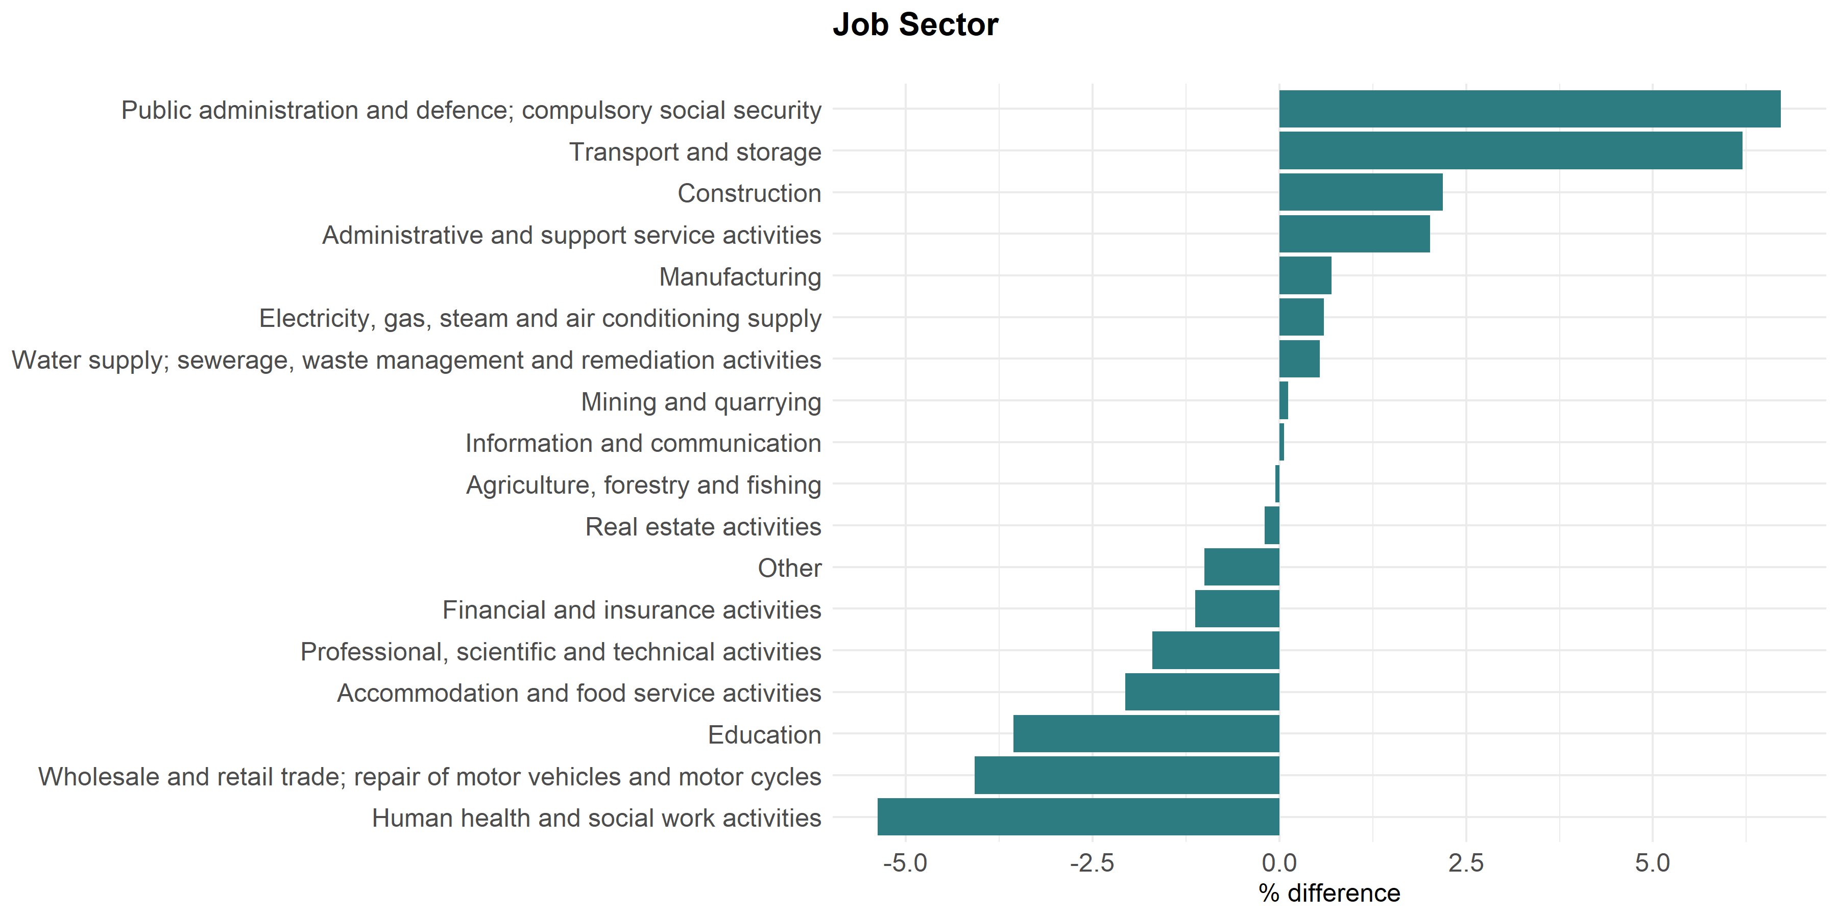**Figure 17. Differences in proportion of veterans and non-veterans working in each employment industry in Kent**.

There are proportionally many more veterans working in public administration, construction and transport and storage, and fewer in human health and social work activities, wholesale and retail trade, and education. This pattern applies for Kent and England.

More than half of employed veterans in Kent work in construction (most common); public administration and defence, compulsory social security; transport and storage; wholesale and retail trade/repair of motor vehicles; and human health and social work activities.

In comparison, the most common industries in the Kent non-veteran population are wholesale and retail trade/repair of motor vehicles; human health and social work activities; construction; education; and professional, scientific and activities.

Nationally, more than half of veterans are working in the following industries (most common first): Wholesale and retail trade/repair of motor vehicles; Public administration and defence, compulsory social security; Construction; Human health and social work activities; Manufacturing.

**Table 24. Numbers of veterans in each employment industry in Kent**

|  |  |
| --- | --- |
| **Industry** | **Number of veterans** |
| Construction | 2411 |
| Public administration and defence | 2314 |
| Transport and storage | 2090 |
| Wholesale and retail trade | 2012 |
| Human health and social work activities | 1722 |
| Administrative and support service activities | 1397 |
| Education | 1226 |
| Manufacturing | 1139 |
| Professional, scientific and technical activities | 806 |
| Information and communication | 687 |
| Other | 640 |
| Financial and insurance activities | 580 |
| Accommodation and food service activities | 462 |
| Real estate activities | 253 |
| Water supply | 243 |
| Electricity, gas, steam and air conditioning supply | 216 |
| Agriculture, forestry and fishing | 164 |
| Mining and quarrying | 33 |

Source: ONS Census 2022

### Defence Employer Recognition Scheme

The Employer Recognition Scheme (ERS) encourages employers to support defence and inspire other organisations to do the same.

The scheme encompasses bronze, silver and gold awards for employer organisations that pledge, demonstrate or advocate support to defence and the armed forces community, and align their values with the Armed Forces Covenant.

### Guidance: An Employers' Guide to Hiring Veterans (October 2023)

This guide offers advice and guidance to employers on how to recruit, retain and support the career development of veterans.

[**https://www.gov.uk/government/publications/an-employers-guide-to-hiring-veterans**](https://www.gov.uk/government/publications/an-employers-guide-to-hiring-veterans)

## Employment Barriers

Research by QinetiQ and Warwick Institute for Employment Research 2021[79] found that most veterans maintain employment over time (even if this involves numerous jobs and/or periods of unemployment). However, it is clear that not all veterans are satisfied with their civilian job or career. Less than half (44.5%) feel that they have found the ‘right job’ for them in the longer-term, whilst 42.5% state that their current job has not met their expectations in terms of maximising their potential or providing opportunity for career progression (42.4%). It would seem that many of the challenges that veterans face on initial transition continue (at least for the 10 year period of this study, possibly longer). Challenges with securing and maintaining employment, using their knowledge, skills and experience, overcoming employer perceptions and acclimatising to a civilian workplace persist.

They found that individuals who seemed to find the adjustment easier were often working in Defence-related or adjacent roles. A common language, shared understanding and familiar culture required less adaption. Others who fared better were those who formed a new civilian identity or at least accepted the loss of their old military one. Adapting to a civilian environment is key. For many though, the biggest challenge longer-term was accepting that they were no longer a serving member of the Armed Forces. Detachment from the military was a significant challenge for many, even for those, who on the face of it, had successfully transitioned into civilian employment. Whilst some were able to accept the losses that detachment from the military represents, for others it impeded progression. Outcomes ranged from: those who fully adjusted; to those who reached contentment; to those who simply accepted their situation; to those still seeking work; to those who simply gave up.

Perceived barriers include:

* A lack of relevant qualifications/experience and problems translating skills.
* Negative employer perceptions.
* A lack of support (from the Armed Forces and employers).
* Physical and mental health challenges.
* Poor cultural fit in a civilian organisation.

Perceived facilitators include:

* Individual traits (confidence and self-reliance).
* Having relevant skills, qualifications and experience.
* Support from family and friends.
* Networks.

## The Kent Marmot Coastal Region Programme

The above Programme which will include the local authority areas of Ashford BC, Canterbury CC, Dover DC, Folkestone and Hythe DC, Swale BC and Thanet DC will be address aspects of the social determinants of health which include employment. This will afford an opportunity for the Programme to examine as to whether there are any significant issues relating to the employment and skills for employment of veterans over the East Kent area and thereby reduce any inequalities that may be found.

# Royal British Legion (RBL) & RBL Industries Aylesford

**Royal British Legion (RBL) & RBL Industries Aylesford**

The detail describing the work and facilities offered by the Royal British Legion (RBL) & RBL Industries in Aylesford Kent, including employment, training, and housing can be found within the Technical report Section 10.

# Veterans and the Justice System

**Overview - Veterans and the Justice System**

The introduction sets the scene as to why some veterans and service personnel offend and enumerates the numbers and other data relating to these cohorts within the prison population both nationally and within Kent as well as the types of offences they commit. The Criminal Justice Liaison & Diversion scheme (CJLDS) and OpNOVA are described and the numbers of individuals that were in the scheme for a 12 month period.

## Introduction

Veterans who have been involved in either the military or criminal justice systems can face significant and complex barriers whilst in either system and (or) in the transition to civilian life.

The majority of service leavers make successful transitions back into civilian life[80]. Government statistics show that veterans form the largest single occupational group within the prison and probation services, and that they are more likely to have committed a violent or sexual offence than offenders who have not served in the military [81] However, these statistics relate to those who are given a custodial sentence or probation supervision order. Many offenders will not receive either category of sentence. Risk factors for offending in veterans are largely similar to those for civilians (i.e., younger age, male gender, lower socioeconomic class, history of offending)[82], but with some notable exceptions. Veterans who offend tend to be older, on average, than general population offenders. This may be because military service acts to reduce the opportunity for offending (or the risk of conviction) at a time when young men in the general population are most at risk of offending, and thus the individual’s time in service acts as a “hiatus” from offending that may have occurred anyway.[83] Prior research also indicates that experiences resulting from military service can increase the risk of offending in some individuals suggesting a distinct pathway to offending in this particular group. For example, certain aspects of deployment, such as deploying in a combat role and exposure to trauma during deployment, have been shown to increase the risk of violent offending by military personnel on return. Finally, some but not all mental health problems, such as Post Traumatic Stress Disorder (PTSD) and alcohol misuse, have been shown to increase the risk of offending behaviour among military personnel.

Many are reluctant to disclose their service career for a variety of reasons, yet having access to specialist and tailored support can be pivotal to their chances of a positive transition and resettlement, and in effect, contribute to a reduction in risk of further offending.

With so little known about the true numbers of ex-Service personnel in the criminal justice system, it is vital that better knowledge is obtained about the current ways of identifying people with Service history and whether they are effective and what more can be done. Ultimately this is about making sure ex-Service personnel and their families can access the support they need for a successful transition to the community.

### Ex-service personnel in the prison population, England and Wales Prison population as at 30 June 2022[84]

Since January 2015, as part of the Basic Custody Screening (BCS) interview, individuals entering custody have been asked whether they had previously served in the armed services, and these responses have been recorded.[85]

Of the prison population as of 30 June 2022:

• 13.7% were first received prior to 01 January 2015 (and so would not have been asked the ex-service personnel BCS question when they entered custody)

• Of the remaining 86.3% who were received on, or after, 01 January 2015 there is a matched YES / NO response for 71.3% (the “match rate”). When the above two points are taken together, there is a matched YES / NO response for 49,610 (61.5%) of the total prison population as of 30 June 2022 (the “coverage”).

### Estimate of ex-service personnel in the prison population of England and Wales

An estimated 3.6% were ex-service personnel.

Of the 49,610 (61.5%) “coverage” in the prison population as at 30 June 2022, 1,768 (3.6%) had indicated they were ex service personnel.

## Demographics

### Sex

There is a higher proportion of males (98%) in the ex-service personnel cohort, than the non-ex-service personnel cohort (95%).

**Figure 18. Matched prison population, by ex-service personnel status and sex.[86]**

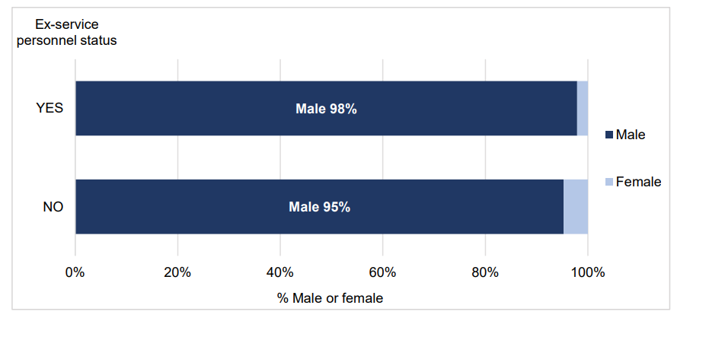

### National Service

The observed age difference is likely due in part to National Service. Those born before 01 October 1939 would have been in the eligible cohort for National Service in the UK (this equates to those aged 82 or over as of 30 June 2022).

• 2.7% of the ex-service personnel prison population group as of 30 June 2022 were born before 01 October 1939.

• This compares to just 0.1% of the non-ex-service personnel group.

### Nationality

The wording of the interview question does not indicate whether an individual served in the UK Armed Forces, however one is able to use self-declared prisoner nationality as a potential proxy for this.

**Table 25. Nationality of matched ex-service personnel in prison population[87]**

|  |  |
| --- | --- |
| **Nationality Group** | **Number of matched ex-service personnel in prison population** |
| British National | 1,627 |
| Foreign National | 139 |
| Nationality Not Recorded | 2 |
| **Total** | **1,768** |

A clear limitation to this approach is that foreign nationals can serve in the UK Armed Forces, and British nationals may serve in a non-UK armed organisation. Just considering British Nationals, 1,627 out of the 49,610 total matched prison population as of 30 June 2022 were British national ex-service personnel, which represents 3.3% of the matched prison population. This is similar to the estimate of 3.5% from the joint Ministry of Defence & Ministry of Justice study, conducted in 2010,[88] which included those who had served in the UK regular Armed Forces.

### Age

Those in the ex-service personnel cohort (mean age 45 years) are on average nine years older than those in the non-ex-service personnel cohort (mean age 36 years). The chart below shows the age distribution for both groups.

**Figure 19. Matched prison population, by ex-service personnel status and age group.**

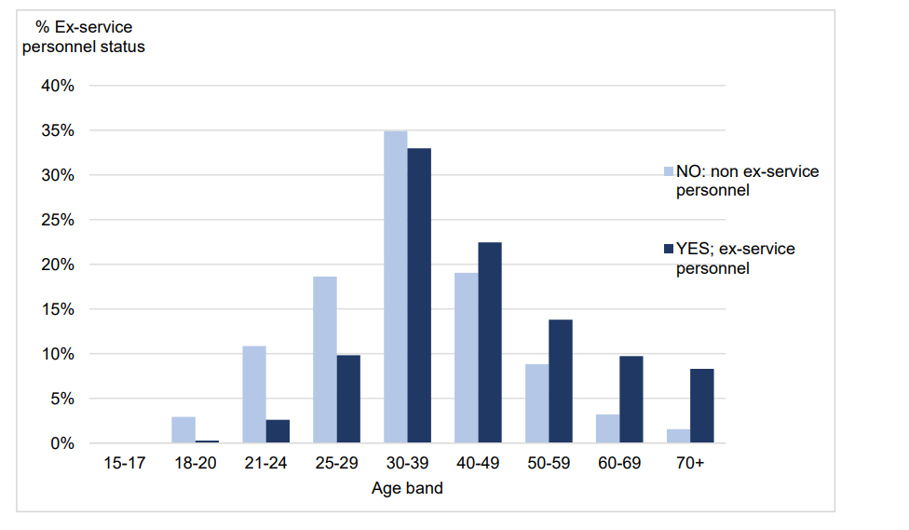

### Prison region

The ex-service personnel prison population is distributed across prisons in England and Wales. However, there is a difference in the distribution of ex-service personnel across the regions. The regions with the largest differences were London (5% of ex-service personnel and 11% of non-ex-service personnel) and the South West (9% of ex-service personnel and 6% of non-ex-service personnel). The larger representation of ex-service prisoners in the South West prisons may reflect veterans living close to large military locations (for example, the Devonport Naval Base and the Ministry of Defence Equipment & Support Headquarters are both in this area).

While across the whole prison estate, 3.6% of prisoners declare themselves to be ex-service personnel, some prisons have significantly more. The Verne, Haverigg, and Usk prisons have the highest proportion of ex-service personnel (12.1%, 11%, and 10.4% respectively). This may reflect the specific functions of these prisons. More information can be found on their prison information pages[89] .

**Figure 20. Matched prison population, by the percentage of ex-service personnel in each prison region.**

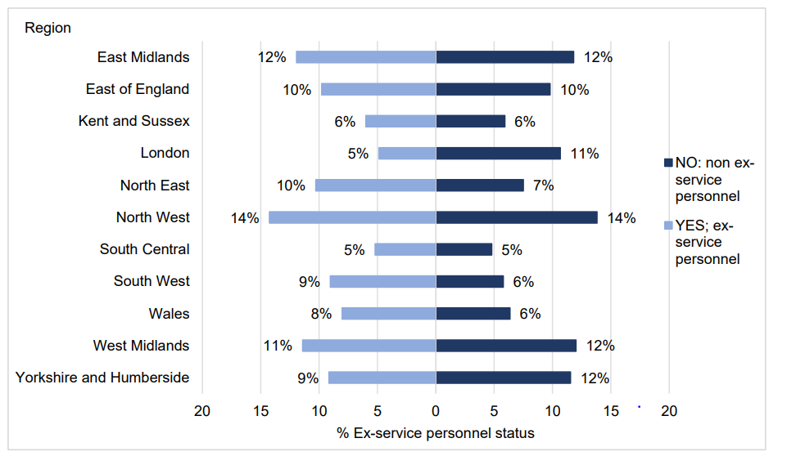

The Kent Prison estate comprises 5 prisons namely East Sutton Park, Elmley, Maidstone, Standford Hill and Swaleside.

East Sutton Park is a women's open prison and young offender's institute located in East Sutton, near Maidstone in Kent, Maidstone is a Category C men's prison, located in Maidstone, Kent and accommodates foreign national prisoners, The remaining 3 prisons Elmley, Standford Hill and Swaleside form what is referred to as the Sheppey Cluster. Elmley Prison holds unsentenced and sentenced adult men and unsentenced male young offenders from all of the courts in the county of Kent. Standford Hill is a Category D open prison for adult males serving any sentence, with a maximum of 5 years to their release, and a maximum of 2 years to their parole eligibility date. Swaleside is a Category B prison for adult males, more than half of them serving life sentences It is a main centre prison for prisoners in the first stage of a life sentence.

**Table 26. Prison region and establishment of ex-Armed Forces individuals in the Kent 2022[90]**

|  |  |  |  |
| --- | --- | --- | --- |
| **Kent Prison** | **Ex-service** | **Not ex-service** | **Percentage who are ex-service** |
| East Sutton Park | 1 | 39 | 3% |
| Elmley (Sheppey cluster) | 33 | 841 | 4% |
| Maidstone | 13 | 271 | 5% |
| Standford Hill (Sheppey cluster) | 5 | 230 | 2% |
| Swaleside (Sheppey cluster) | 18 | 551 | 3% |
| **Total** | **70** | **1932** | **4%** |

## Kent Probation

The table below shows the current caseload where an Armed Forces Personnel Personal Circumstance has been recorded on the Case Management System for East and West Kent.

Of the 87 people 15 of these are currently in Custody so are not reporting to an office.

**Table 27. Caseload on Case Management System for East and West Kent Health and Justice Partnership.**

|  |  |  |  |
| --- | --- | --- | --- |
| **Offence Category** | **East Kent** | **West Kent** | **Total** |
| Burglary (Domestic) | - | 1 | 1 |
| Burglary (Other) | 1 | 1 | 2 |
| Criminal damage | 1 | - | 1 |
| Drink driving | - | 7 | 7 |
| Drug import/export/production | - | 1 | 1 |
| Drug possession/supply | 1 | 2 | 3 |
| Fraud and forgery | 1 | 1 | 2 |
| Other motoring | 3 | 4 | 7 |
| Other offence | 1 | 7 | 8 |
| Public order | 4 | 2 | 6 |
| Robbery | 2 | 1 | 3 |
| Sexual (against child) | 3 | 5 | 8 |
| Sexual (not against child) | 6 | 2 | 8 |
| Theft (Non-motor) | - | 2 | 2 |
| Violence | 7 | 21 | 28 |
| **Total** | **30** | **57** | **87** |

Source: Health and Justice Partnership Community Integration Kent, Surrey and Sussex (September 2023)

## Criminal Justice Liaison & Diversion (CJLDS)

Since 02/09/2022 to September 2023 in the Kent Police area there have been 114 people listed as a past veteran or serving officer in police custody.

92 were veterans (81%) and 22 (19%) are serving. Most of those detained are of White British ethnicity. There are also majority male (90%) and single (59%). The ages of those detained range from 18 to 87 years old. The average age of those in custody is 44. For those serving, the average age of detainee was 33 years old, and for veterans it was 44 years old. They are well spread out across Kent and Medway.

**Table 28. Ethnicity of people identified as veterans who were in Kent Police custody year ending September 2023.**

|  |  |
| --- | --- |
| **Ethnicity** | **Number of detainees** |
| White British | 89 |
| Any other White background | 11 |
| Any other mixed background | 5 |
| Black or Black British Caribbean | 3 |
| Any other Asian background | 2 |
| Black or Black British African | 1 |
| Mixed White and Asian | 1 |
| Not stated | 2 |

**Table 29. Age distribution of** **people identified as veterans who were in Kent Police custody year ending September 2023.**

|  |  |  |
| --- | --- | --- |
| **Age band** | **Serving – regular or reserve** | **Veterans** |
| 18-29 | 10 | 3 |
| 30-39 | 6 | 28 |
| 40-49 | 3 | 25 |
| 50-74 | 2 | 33 |
| 75+ | 1 | 3 |

**Table 30. Geographical distribution of** **people identified as veterans who were in Kent Police custody year ending September 2023.**

|  |  |  |  |
| --- | --- | --- | --- |
| **Location** | **Serving – regular or reserve** | **Veterans** | **Total** |
| Tonbridge Custody | 3 | 20 | 23 |
| Canterbury Custody | 3 | 19 | 22 |
| Medway Custody | 4 | 17 | 21 |
| Maidstone Custody | 3 | 16 | 19 |
| North Kent Custody | 2 | 12 | 14 |
| Folkestone Custody | 4 | 5 | 9 |
| Margate Custody | 1 | 2 | 3 |
| Voluntary Attendance | 2 | 1 | 3 |

## Kent Police – Custody Suite data

The Kent Police Custody Suites Health Needs Assessment of 2012[91] did not address the veteran population in that particular assessment and since then the assessment has not been reviewed or replaced by a more contemporary edition. Apart from the data received from, Forces Employment Charity requests to Kent Police either directly or through the Freedom of Information Act regarding veteran status in their custody suites population have yielded no insight and steps are needed to put in place to remedy this omission.

# Stakeholder Voice/Insight.

**Overview - Stakeholder Voice/Insight.**

Whilst there is no discoverable specific Kent based armed forces and veterans stakeholder voice that can inform this Needs Assessment there is significant amounts of insight from the Armed Forces Community (AFC) in Sussex and evidence from that quarter has been used to gain a better understanding of the issues raised by members of the AFC in the Kent, Surrey and Sussex region of South East England. This chapter recommends that locality engagement should be commissioned by the Armed Forces Network and Kent CC to engage with the Armed Forces and veteran communities in Kent.

There is currently no discoverable specific Kent based armed forces and veterans stakeholder voice that can inform this Needs Assessment. Whilst there is no historic information available from HealthWatch Kent veteran engagement is planned or taking place in late 2024 and 2025. There is however significant amounts of insight from the Armed Forces Community (AFC) in Sussex and evidence from that quarter has been used to gain a better understanding of the issues raised by members of the AFC in the Kent, Surrey and Sussex region of South East England. (Sussex Insight Bank website – restricted access and other key local and national sources).[92],[93],[94]

The following areas have been highlighted in conversations with members of the AFC:

* Whilst stigma around mental health and addictions may be lessening, barriers to help seeking still exist within the Armed Forces community. This is due to issues around masculine culture and concerns around impact on career. The ‘military mindset’ may encourage them to be self-sufficient and not seek help.
* The veteran perception is that NHS does not understand PTSD vice versa the veterans may not understand that PTSD in not just a military specific diagnosis and that there are other disorders that they are more common in the military such as adjustment disorders, anger management issues, alcohol use and problem gambling.
* Veterans feel they are seen as too complex to treat and are passed between services.
* There is evidence that adults may have different health responses to trauma and combat exposure. Female members of the armed forces community can face a unique set of challenges accessing healthcare that are separate from their male counterparts.
* Veterans may have had adverse childhood experience hence joining the forces at a young age, which may impact later in life.
* Armed Forces communities can be reticent to speak to people who do not have armed forces experience and may struggle to relate to civilians.
* ‘Civvies’ can be viewed by AF community to lack any understanding of their lives and experiences, fail to understand their methods of communication, and fail to show respect for what they have done in their lives.
* Facilitating and encouraging veterans to link with and receive support and advice from other veterans can clearly play a major role in encouraging veterans to talk about and receive advice about their health and wellbeing.
* If you say are going to do something you must do it and keep them updated on progress or you will lose trust/engagement.
* Some from the Armed Forces community may not want to access forces related services due to their experience within the Armed Forces.
* GP practices (in particular, reception staff) are thought to have little awareness of Veteran Friendly status, sometimes unable to pinpoint which GP practice is nominated within the Primary Care Network
* Practices are also thought to lack awareness about of specialist Armed Forces services and pathways i.e., OpCOURAGE and OpRESTORE.
* Practices are also thought to lack awareness about Pain management clinic in Brighton, with the pathway difficult for Armed Forces communities to navigate without the support of their GP.
* Not identifying patients from the Armed Forces community on referrals therefore not taking account needs and the legislation.
* Care Homes not understanding how to manage clients from the AF community particularly with dementia.
* Understanding that the LGBT+ community may have difficulties accessing care home/nursing homes due to previous institutional impact of serving during ban.
* **Caring Responsibilities:** Those caring for veterans with health needs in particular, who don’t necessarily see themselves as carers, need more support and help to navigate the system. They would like information on support services that understand the experiences and needs of AFC.
* **Maternity:** There is an impact for both women serving and partners of serving; disruption to continuity of care “late bookers,” Missed 6-8w postnatal GP Appointment, local maternity services to receive support and right birth for them.
* **Women:** Often do not see themselves as veterans and are less likely to access recognised AF support services due to them being institutionally male-orientated and possible experience of military sexual trauma.
* **LGBT+:** May not want to use AF support services due to previous trauma but require services that have a good understanding of the needs of AFC.
* **Families of Reservists:** May find that there is not the understanding of the community particularly when the Reservist is deployed.
* **Children:** A higher instance of young carers within AFC. Impact on education and own health also due to moving around the country.
* **Ethnic Minority Communities:** Translatable materials in Nepali required for Gurkha and Nepalese Armed Forces Communities.

Activmob were commissioned by Kent CC to engage with the Nepalese and Gurka community in Folkestone to gain insight to access to weight management services within their community. Whilst some of the outcomes related to specific access issues the work did give some insight into matters that they as a community has strong beliefs about. The status of the family and extended family was important as well as integration to the local community which posed certain challenges.

Clearly there is need for further engagement to be carried out in Kent to gain better insight into the needs of the AFC in the County. There are ample communities and communities of interest within the County AFC upon which to focus this work.

# Gaps and Recommendations

## Health Improvement Recommendations

Identifying specific health improvement recommendations has been significantly frustrated by the absence of veteran coding within the health care economy which in turn has acted as a barrier to insight of veteran morbidity. There are examples of service providers in Kent being “veteran aware” and as such they accommodate that communities treatment needs. However this level of provision needs to be greatly expanded. The health improvement recommendations below represent a small number of actions to be taken which can be added to when veteran coding is made as a norm.

Additional recommendations are also made below which are aligned with more strategic gaps that have been noted which again when implemented should bring about improved recognition, service access and treatment for the veteran community.

### Musculoskeletal Health Provision ( MSK)

* People presenting with MSK injuries in primary care, who are identified as veterans, should be referred to a HCP MDT/INT for a personalised and holistic rehabilitation needs assessment, including physical, cognitive and psychological functioning. The INT, calling on the specialist expertise of a MSK MDT will act as veteran’s key group, with people responsible for understanding veteran strengths and needs and ensuring they receive the right preventative support to enable them to stay independent and well for longer (General Practice)
* Social prescribing should be used to help veterans take control of their own long-term rehabilitation, develop vocational skills and foster long term social connections.(General Practice)
* Veterans with mild and chronic MSK disorders should be supported to self-manage their conditions long term through education, digital resources and access to facilities such as gyms and leisure centres, with the freedom to access rehab services when needed without another referral. (General practice/Social Prescribing)

### Sensory Loss

* Increase capacity for General Practice to refer veterans to Audiology Services/Sensory Services to assess the extent of any sensory loss. (ICB Commissioners/General Practice)

### Mental Health & Suicide

* That the Kent and Medway Suicide Prevention programme to continue to work with and support the Armed Forces community and others to prevent serving military staff and veteran suicides in Kent and Medway . (KMPT/KCC Suicide Team)

### General Practice

* When personnel are in transition from The Defence Medical Services (DMS) to the NHS, ICB/HCP commissioners should facilitate GP registration prior to discharge and improve general practice awareness of DMS. (ICB/HCP)
* General Practice should refer veterans exhibiting cold and damp related respiratory conditions to Social Prescribing for onward involvement of local authorities and energy companies/charities to improve housing conditions. (General Practice)
* HealthWatch Kent to work with local Nepalese communities to identify any specific cultural or language barriers they face in accessing health and social care services. (HealthWatch Kent)

## Strategic Gaps and Recommendations

Although armed forces and veterans have often been labelled ‘hard to reach’ this Needs Assessment uncovered examples of systemic barriers that make it much more difficult for them to access services as a veteran either through service providers failing to ask, veterans failing to disclose or when disclosed being wrongly coded. This is a major barrier and impacts upon their health and social care status and requires to be addressed in a variety of ways .

### Data: Invisibility of veterans in datasets

This assessment has highlighted the significant absence of veteran associated data recording. As such there is inadequate routine data available around the needs of the veterans and their families being an “inclusive health” group including health and social care data as simple as coding the patient as part of that veteran community. NHS services are required to record their veteran connection status yet often fail to ask whether they have veteran status and/or accurately record this status. Consequently, veterans and armed forces personnel including their families are invisible in datasets used to support healthcare, social care and other essential service planning, quality monitoring, evaluation and health equity and other assessments. As a result, the needs of these groups are under-recognised/recorded and inadequately met, as evidenced by the poor recording and quality found in this assessment.

There are other datasets collected outside of the NHS so there is the need if possible to integrate them with NHS data. Some 30 VCSE military and other types of national registers are highlighted by way of example in the Need Assessment Technical Report as potential sources. This may require some legislative change in data sharing or at least flexibility in interpretation of existing legislation. The Shared Health and Care Analytics Board is the senior governance group for the analyst community across Kent and Medway and whose remit is to work together to link data across the region so the local NHS and councils can plan existing services for patients and conduct research to design new services.

Recommendations:

* NHS Kent and Medway ICB, The Armed Forces Network and Kent County Council Public Health directorate should work collaboratively with the district and borough councils, as well as other key stakeholders (police, housing associations, NHS hospitals trusts, schools, GP surgeries through PCNs) to develop and immediately implement a consistent approach to veteran status recording in their records. For the NHS this should also be consistent with the approved AFC SNOMED CT Codes to ensure data collection. Oversight could be held by the Kent and Medway Civilian-Military Partnership Board through their Health and Wellbeing Task Group. (Kent Armed Forces Network and Partners)
* Kent County Council to continue working with local voluntary care sector and veteran grassroot led organisations to develop a wide-ranging campaign to explain the importance of collecting such data and encourage self-disclosure within the veteran community, as there remains a barrier with some of disclosing their status. Starting in 2025 this is an ongoing project.(Kent CC)
* NHS Kent and Medway ICB and the Armed Forces network to explore in 2024/2026 other ad hoc solutions to data capture, for example stakeholder intelligence collected in primary care to enable better understanding of patients’ veteran status throughout all health services as well as working with information governance leads and the Shared Health and Care Analytics Board across the system to better integrate and share veteran related data. (NHS Kent and Medway ICB and the Armed Forces network)
* That all Kent Local Housing authorities carry out surveys/questionnaires through existing tenant engagement channels to determine the size of their veteran tenant population and then engage in conversations with them about their needs. This should be led by the Kent Housing Group on an agreed timetable. Other social housing providers should also follow the same survey.(Kent District Councils)
* That Kent Local Housing authorities immediately start to record potential veteran status whilst carrying out housing inspections and embed this recording it in professional practice. (Kent District Councils)

### Research and Insight

More Kent based research is needed to develop a granular understanding of the Kent armed forces and veteran community needs.

Although this Needs Assessment describes need and the barriers to receiving services within the veteran community, it has not been able to investigate many of these in depth given the lack of locality statistical data. Further qualitative in-depth research opportunities should be considered to enable richer knowledge and understanding. The opportunity to conduct research with this community, also offers an opening to build trust, gain the communities’ views, co-produce interventions and provide a chance for health, housing and other relevant messaging to be given.

The needs assessment has also quantified the numbers of armed forces and veterans individuals and families on Kent Local Authority housing registers but there is no insight into the numbers from these communities within the existing LA housing stock as tenants. Whilst it is accepted that some tenants may wish to keep their veteran status undisclosed this may hinder their ability to take up the commitments granted under the Armed Forces Covenant.

There are also believed to be a sizable number of veterans living in care and nursing homes particularly in the coastal fringes of Kent and a survey of their numbers may well deliver better outcomes and initiatives for them. The new example of good practice the Veteran Friendly Care Home initiative currently being piloted outside of Kent could well be an excellent initiative for Kent to follow.

Local authorities have a statutory obligation to investigate housing disrepair and again no knowledge is available as to whether veterans present themselves living in accommodation in a state of disrepair. Environment health and housing data bases should record this status as a routine question during inspections.

**Recommendations**

* Organisations in the Kent health and social care economy including the Voluntary Sector should undertake a further survey patient/client investigations to accurately capture the needs of individuals or identifiable veteran groups in the veteran community. Where possible surveys should collect NHS numbers so that the data can be linked with NHS data to measure outcomes in health service and health improvement. (NHS/KCC/Voluntary Sector)
* Kent County Council’s Public Health Department’s Research Team should develop a future research funding programme exploring the opportunities, in collaboration with veteran leading academic institutions to develop insight and understanding of specific topic areas including:
  + The health needs of older veteran adults including end of life care.
  + Substance misuse and service provision for veterans
  + Primary care morbidity of veterans
* Kent County Council’s Public Health Department to feed findings into, and be an active participant of, regional and national fora identifying opportunities to share best practice, advocate for and identify funding and other national resources that can be deployed in Kent as part of an agreed health improvement strategy.

### Partnerships and Leadership: Enhance the system-wide approach

This Needs Assessment highlighted some areas of good practice, but these were often the result of both national or individual practitioners and/or services recognising a need and subsequently addressing it. Currently there is a system-wide approach led by the Armed Forces Network (Kent and Medway) to address the needs experienced by the armed forces and veteran communities in Kent. Action by the Kent and Medway Civilian Military Partnership Board to strengthen action by the Higher and Further Education partners in the Armed Forces Covenant would add to the current activity.

The armed forces and veteran communities in Kent are partially visible by way of their children through the county education structure. Whilst schools may be recording children through the School Pupil Premium it is unclear whether School Health Services commissioned by KCC likewise record the child’s status as well as evidence of good practice in schools and in the community e.g. “The role of Health Visitors and School nurses supporting the health and wellbeing of military families.”

The Kent Marmot Coastal Region Programme which will include the six local authority areas in coastal East Kent will address aspects of the social determinants of health which include employment. This will afford an opportunity for the Programme to examine as to whether there are any significant issues relating to the employment and skills for employment of veterans over the East Kent area and thereby reduce any inequalities that may be found.

**Recommendations:**

* Public Health in Kent County Council to act as a public health system leader via a Consultant led and Specialist matrix team to disseminate the findings of this needs assessment to key partners across organisational boundaries and to advocate for armed forces personnel and veterans and their families health needs across relevant strategic and service developments.
* All Kent CC commissioned services should immediately ensure a)that service providers record recoverable veteran status with their clients/patients and were published follow best practice recommendations and b) ensure that any service resetting related Equalities Impact Assessments (EqIA) undertaken includes impacts upon veterans. (KCC Service Commissioners)
* System partners to continue to commit to addressing the needs of veteran and their families using levers such as the Integrated Care Strategy, Health and Care Partnership Prevention strategies, service transformation plans, equity inclusion plans and District/Borough Council Plans.(Armed Forces Network)
* The Armed Forces Network (Kent and Medway) and the Kent and Medway Civilian Military Partnership Board encourage and support the remaining unaccredited Kent Acute Hospitals and Kent Hospices to seek accreditation through the NHS Veterans Covenant Healthcare Alliance in 2025.
* That the Armed Forces Network promote Kent for the next tranche of counties implementing the Veteran Friendly Care Home initiative during 2025.
* That the Kent Marmot Coastal Region Programme address aspects of employment and skills for employment of veterans as an inclusion health group.(KCC Public Health)
* Healthwatch Kent should implement additional engagement with the veteran community to understand the veteran experience of accessing health care in 2025/26.

1. 1. **Armed Forces Covenant Duty Statutory Guidance.** Ministry of Defence, 2022

  
2. [Location Statistics for UK Regular Armed Forces and Civilians: 2022 - GOV.UK (www.gov.uk)](https://www.gov.uk/government/statistics/location-statistics-for-uk-regular-armed-forces-and-civilians-2022). Annual location statistics: 1April 2022. Table
3. [Location statistics for UK regular armed forces and civilians: 2023 - GOV.UK (www.gov.uk)](https://www.gov.uk/government/statistics/location-statistics-for-uk-regular-armed-forces-and-civilians-2023#full-publication-update-history)
4. Figures have been rounded to the nearest 10 to prevent inadvertent disclosure. However, numbers ending in "5" have been rounded to the nearest 20 to prevent systematic bias. Totals and its constituent numbers have been rounded separately, and so Totals may not equal the sums of their rounded parts. A "~" denotes 5 or less and "-" denotes 0.
5. Gurkhas are recruited and employed in the British and Indian Armies under the terms of the 1947 Tri Partite Agreement (TPA). Prior to April 2007 this was on a broadly comparable basis but since then British Gurkhas have served on the same terms and conditions as the wider Army. They remain Nepalese citizens but in all other respects are full members of HM Forces. Since 2007, Gurkhas are entitled transfer to the wider Army after completion of 5 years’ service in the Brigade of Gurkhas and apply for British citizenship.
6. [*"Disposal database: House of Commons report"*](https://www.gov.uk/government/publications/disposal-database-house-of-commons-report)*. Retrieved 15th September 2023.*
7. Census 2021 England and Wales
8. West Kent HCP figure includes veterans who reside in Swanley (North Kent HCP)
9. ONS Census 2021
10. [KCMHR study exploring veterans’ mental and physical health using one of the world’s largest primary care record databases](https://kcmhr.org/kcmhr-study-exploring-veterans-mental-and-physical-health-using-one-of-the-worlds-largest-primary-care-record-databases/)
11. https://elearning.rcgp.org.uk/mod/book/view.php?id=12533&chapterid=285
12. The Chavasse Report 20-14 [Layout 1](https://veteranaware.nhs.uk/wp-content/uploads/2023/02/TheChavasseReport-RaisingTheBar.pdf)
13. [Veteran_Aware_Rehab_Report-Jun_2022.pdf](https://www.britishpainsociety.org/static/uploads/resources/files/Veteran_Aware_Rehab_Report-Jun_2022.pdf)
14. [20210715 - MedDisBulletinFinal - O](https://assets.publishing.service.gov.uk/government/uploads/system/uploads/attachment_data/file/1001267/UK_service_personnel_medical_discharges__financial_year_2020_21.pdf)
15. [Lost Voices - a report on hearing problems among Service personnel and veterans (rblcdn.co.uk)](https://storage.rblcdn.co.uk/sitefinity/docs/default-source/campaigns-policy-and-research/lost_voices_hearing_loss_report.pdf?sfvrsn=5ef1d43a_0)
16. Brown, D.C. and Milner, R S. (2010). A Modern Approach to Noise-induced Hearing Loss from Military Operations. Journal of Royal Naval Medical Service, 96(1)
17. [RBL announce research into veterans’ hearing impairment with University of Chester - Cobseo](https://www.cobseo.org.uk/rbl-announce-research-into-veterans-hearing-impairment-with-university-of-chester-2/)
18. [Blind Veterans UK, Rebuilding lives after sight loss - Blind Veterans UK](https://www.blindveterans.org.uk/)
19. [Blind Veterans UK, Rebuilding lives after sight loss - Blind Veterans UK](https://www.blindveterans.org.uk/)
20. *https://lunginstitute.com/blog/veterans-lung-disease-know-facts/* 
21. http*s://www.nationalasbestos.co.uk/armed-forces-exposure/* 
22. *https://www.theyworkforyou.com/wrans/?id=2017-01-17.HL4710.h&s=armed+forces+mesothelioma#gHL4710.q0* 
23. https://www.mesothelioma.uk.com/report-published-on-military-experiences-of-asbestos-related-cancer/
24. https://www.mesothelioma.uk.com/about-us/what-we-fund/mesothelioma-uk-armed-forces-project/
25. *https://www.britishlegion.org.uk/get-involved/campaign/asbestos-related-cancer-and-the-military/* 
26. https://www.gov.uk/government/publications/purple-pack-bereavement-guide-for-families-of-service-personnel/purple-pack-bereavement-guide-for-families-of-service-personnel#:~:text=The%20Veterans%20Welfare%20Service%20(who,circumstances%20may%20necessitate%20separate%20support.
27. https://bjgp.org/content/71/703/86
28. The Mental Health of the UK Armed Forces Briefing Note, KCMHR, 2021
29. [Life in and after the Armed Forces: social networks and mental health in the UK military - PubMed (nih.gov)](https://pubmed.ncbi.nlm.nih.gov/23356827/)
30. Perceived stigma and barriers to care in UK Armed Forces personnel and veterans with and without probable mental disorders. Williamson et al, 2019
31. The Mental Health of the UK Armed Forces Briefing Note, KCMHR, 2021
32. [Suicide prevention in England: 5-year cross-sector strategy - GOV.UK (www.gov.uk)](https://www.gov.uk/government/publications/suicide-prevention-strategy-for-england-2023-to-2028/suicide-prevention-in-england-5-year-cross-sector-strategy)
33. *Suicides in the UK regular armed forces: Annual summary and trends over time 1 January 1984 to 31 December 2020 (MOD) Published 25 March 2021* 
34. https://www.manchester.ac.uk/discover/news/new-figures-provide-latest-data-on-veterans-suicide/
35. [The Northern Hub for Veterans and Military Families Research (northumbria.ac.uk)](https://www.northumbria.ac.uk/business-services/engage-with-us/the-northern-hub-for-military-veterans-and-families-research/)
36. *https://www.kcl.ac.uk/kcmhr/publications/assetfiles/2013/Hatch2013a.pdf* 
37. *Helpseeking-for-alcohol-problems-in-serving-ex-serving-personnel_FINAL.pdf – A Joint Report by the King’s Centre for Military Health Research, King’s College London and the University of Liverpool November 2020* 
38. G*ambling Problems in UK Armed Forces Veterans: Preliminary Findings Roberts, E., Dighton, G., Fossey, M., Hogan, L., Kitchiner, N., Rogers, R.D., & Dymond, S. (2018)* 
39. Gambling problems in armed forces veterans: Results from the 2007 Adult Psychiatric Morbidity Survey of England.
40. ttps://www.greo.ca/Modules/EvidenceCentre/files/Etuk%20et%20al%20(2020)_Gambling%20problems%20in%20US%20military%20veterans_final.pdf
41. https://s31949.pcdn.co/wp-content/uploads/20210426-Sunderland-PIEDs-FINAL.pdf
42. [Benefits - GOV.UK (www.gov.uk)](https://www.gov.uk/browse/benefits)
43. [Benefits calculators - GOV.UK (www.gov.uk)](https://www.gov.uk/benefits-calculators)
44. [Veterans UK - GOV.UK (www.gov.uk)](https://www.gov.uk/government/organisations/veterans-uk)
45. [Armed Forces Compensation Scheme (AFCS) - GOV.UK (www.gov.uk)](https://www.gov.uk/guidance/armed-forces-compensation-scheme-afcs)
46. [Veterans Welfare Service - GOV.UK (www.gov.uk)](https://www.gov.uk/government/groups/veterans-welfare-service#contact)
47. [Finance Advice | Job Support | Royal British Legion](https://www.britishlegion.org.uk/get-support/financial-and-employment-support/finance)
48. https://www.northumbria.ac.uk/research/research-impact-at-northumbria/health-impact/mapping-the-needs-of-veterans-across-the-uk/
49. [The Northern Hub for Veterans and Military Families Research (northumbria.ac.uk)](https://www.northumbria.ac.uk/business-services/engage-with-us/the-northern-hub-for-military-veterans-and-families-research/)
50. [Improving access to social housing for members of the Armed Forces - GOV.UK (www.gov.uk)](https://www.gov.uk/government/publications/improving-access-to-social-housing-for-members-of-the-armed-forces)
51. https://www.kenthomechoice.org.uk/content/advice-for-armed-forces-veterans-in-kent
52. www.britishlegion.org.uk/docs/default-source/campaigns-policy-and-research/litrev_uk_vets_homelessness.pdf?sfvrsn=110aad9f_2
53. [Veterans' Data Dashboard - GOV.UK (www.gov.uk)](https://www.gov.uk/government/publications/veterans-data-dashboard)
54. [https://www.kent.gov.uk/__data/assets/pdf_file/0005/7349/Homelessness-in-Kent.pdf](https://www.kent.gov.uk/__data/assets/pdf_file/0005/7349/Homelessness-in-Kent.pdf#:~:text=During%20the%20financial%20year%202022%2F23%2C%206%2C920%20Kent%20households,were%20assessed%20as%20being%20owed%20a%20relief%20duty.)
55. https://aff.org.uk/wp-content/uploads/2018/03/SFA-Entitlement-Table-AUG-2023-FINAL.pdf
56. [Tri-service accommodation regulations (TSARs) (JSP 464) - GOV.UK (www.gov.uk)](https://www.gov.uk/government/publications/jsp-464-tri-service-accommodation-regulations-tsars)
57. https://www.bbc.co.uk/news/uk-68410400
58. [Service Accommodation](https://committees.parliament.uk/publications/45927/documents/228267/default/)
59. [https://www.cqc.org.uk/about-us/transparency/using-cqc-data](https://eur01.safelinks.protection.outlook.com/?url=https%3A%2F%2Fwww.cqc.org.uk%2Fabout-us%2Ftransparency%2Fusing-cqc-data&data=05%7C01%7CStephen.Cochrane%40kent.gov.uk%7C573c2bc4ddb74382bcb808dbaa0c41d3%7C3253a20dc7354bfea8b73e6ab37f5f90%7C0%7C0%7C638290742440957063%7CUnknown%7CTWFpbGZsb3d8eyJWIjoiMC4wLjAwMDAiLCJQIjoiV2luMzIiLCJBTiI6Ik1haWwiLCJXVCI6Mn0%3D%7C3000%7C%7C%7C&sdata=Lwb%2FJCD%2ByALcsvocRBiwZQQPVBc1rJN9CC8qc%2BZySL8%3D&reserved=0)
60. [UK Armed Forces Families Strategy 2022-32 (publishing.service.gov.uk)](https://assets.publishing.service.gov.uk/media/61e80893e90e07037ac9e10b/UK_Armed_Forces_Families_Strategy_2022_to_2032.pdf)
61. [Armed forces continuous attitude survey: index - GOV.UK (www.gov.uk)](https://www.gov.uk/government/collections/armed-forces-continuous-attitude-survey-index)
62. AFCAS is only open to Regular, trained Service personnel including Gurkhas.
63. [Living in our shoes understanding the needs of UK Armed Forces families: government response (accessible version) - GOV.UK (www.gov.uk)](https://www.gov.uk/government/publications/living-in-our-shoes-understanding-the-needs-of-uk-armed-forces-families/living-in-our-shoes-understanding-the-needs-of-uk-armed-forces-families-government-response-accessible-version)
64. [SCP-Alliance-data-Briefing.indd (scipalliance.org)](https://www.scipalliance.org/assets/files/SCP-Alliance-data-Briefing-FINAL-ONLINE.pdf)
65. Strand, S. & Demie, F., 2007, ‘Pupil mobility, attainment and progress in secondary school’, Educational Studies, vol. 33, No. 3, pp. 313-331
66. Noret, N., Mayor, H., Al-Afaleq, H., Lingard, S. and Mair, E., 2014, ‘The Educational Attainment of Army Children’, York: York St. John University
67. scipalliance.org
68. Service Children - Services Children's Champion (servicechildrenschampion.co.uk) 2024
69. https://www.gov.uk/government/publications/the-service-pupil-premium/service-pupil-premium-what-you-need-to-know
70. Kent County Council Management information Children, Young People & Education January 2024.
71. [SCiP Alliance Map](https://www.scipalliance.org/map)
72. [Access and participation plans - Office for Students](https://www.officeforstudents.org.uk/advice-and-guidance/promoting-equal-opportunities/access-and-participation-plans/)
73. [Career Transition Partnership - GOV.UK (www.gov.uk)](https://www.gov.uk/guidance/career-transition-partnership)
74. [Benefits - GOV.UK (www.gov.uk)](https://www.gov.uk/browse/benefits)
75. [Benefits calculators - GOV.UK (www.gov.uk)](https://www.gov.uk/benefits-calculators)
76. https://www.gov.uk/government/publications/jobcentre-plus-services-for-the-armed-forces-and-their-families/armed-forces-enhanced-access-to-jobcentre-plus-services-and-armed-forces-champions
77. https://afvbc.com/
78. https://exforcesinbusiness.co.uk/wp-content/uploads/2023/07/100-GREAT-British-Employers-of-Veterans-2023-1.pdf
79. https://warwick.ac.uk/fac/soc/ier/researchthemesoverview/researchprojects/exservicepersonnel/
80. Ashcroft M. The Veterans’ Transition Review. Biteback Publishing; 2014.
81. DASA. Estimating the proportion of prisoners in England and Wales who are ex-Armed Forces–further.

    analysis. London; 2010. DASA. Estimating the proportion of offenders supervised by Probation Trusts in England and Wales

    who are ex-Armed Forces. London; 2011.
82. MacManus D, Dean K, Al Bakir M, Iversen AC, Hull L, Fahy T, et al. Violent behaviour in UK military personnel

    returning home after deployment. Psychol Med. 2012; 42:1663–73. https://doi.org/10.1017/

    S0033291711002327 PMID: 22115074

    Simonoff E, Elander J, Holmshaw J, Pickles A, Murray R, Rutter M, et al. Predictors of antisocial personality:

    Continuities from childhood to adult life. Br J Psychiatry. 2004; 184:118–27. PMID: 14754823
83. MacManus D, Wood N. The ex-armed forces offender and the UK criminal justice system. In: Hughes

    JH, editor. Mil Veteran Psychol Heal Soc Care Contemp Issues. Oxford: Routledge; 2017. p. 62–80
84. https://assets.publishing.service.gov.uk/government/uploads/system/uploads/attachment_data/file/1113741/Ex-service_personnel_in_the_prison_population_2022.pdf
85. “Have [you] been a member of the armed services?” – the wording of the question captures those who reported serving in any armed service organisation around the world, not just those serving in the UK Armed Forces. It also captures those who had served as either a regular or reserve member. As such the estimates presented here are expected to be higher than previous estimation exercises that have just focused on those having served in the UK regular Armed Forces.
86. [Ex-service_personnel_in_the_prison_population_2022.pdf](https://assets.publishing.service.gov.uk/media/635960e5d3bf7f0bd83e21d5/Ex-service_personnel_in_the_prison_population_2022.pdf)
87. [Ex-service_personnel_in_the_prison_population_2022.pdf](https://assets.publishing.service.gov.uk/media/635960e5d3bf7f0bd83e21d5/Ex-service_personnel_in_the_prison_population_2022.pdf)
88. ‘Ex-armed forces prisoners in England and Wales: 15 September 2010’; https://www.gov.uk/government/publications/ex-armed-forces-prisoners-in-england-and-walesstatistics-2010
89. https://www.gov.uk/government/collections/prisons-in-england-and-wales
90. [https://assets.publishing.service.gov.uk/government/uploads/system/uploads/attachment_data/file/1113742/Ex-service_personnel_in_the_prison_population_2022.ods](https://eur01.safelinks.protection.outlook.com/?url=https%3A%2F%2Fassets.publishing.service.gov.uk%2Fgovernment%2Fuploads%2Fsystem%2Fuploads%2Fattachment_data%2Ffile%2F1113742%2FEx-service_personnel_in_the_prison_population_2022.ods&data=05%7C01%7CStephen.Cochrane%40kent.gov.uk%7C800672f4551d45b02cee08dbaef46dee%7C3253a20dc7354bfea8b73e6ab37f5f90%7C0%7C0%7C638296137103472710%7CUnknown%7CTWFpbGZsb3d8eyJWIjoiMC4wLjAwMDAiLCJQIjoiV2luMzIiLCJBTiI6Ik1haWwiLCJXVCI6Mn0%3D%7C3000%7C%7C%7C&sdata=U1AQxYDiyXbNnrcOoywfZiPCTHZo7PWRq00SbnvVT9U%3D&reserved=0)
91. Kent Police Custody Suites Health Needs Assessment 2012 (Cochrane S D 2012.)
92. **Armed Forces Network** (December 2023) Armed Forces Network for Sussex and Kent & Medway [NHS Sussex & NHS Kent & Medway]
93. **Courage for Carers** (June 2023) The Veterans Mental Health & Wellbeing Service, NHS South East Region
94. **Let’s Talk Crawley** (2022) NHS Sussex