## Map update (January 2025)

This map serves as an update and replaces Map 8 in the 2022 Pharmaceutical Needs Assessment (PNA); the map is correct as of January 2025.

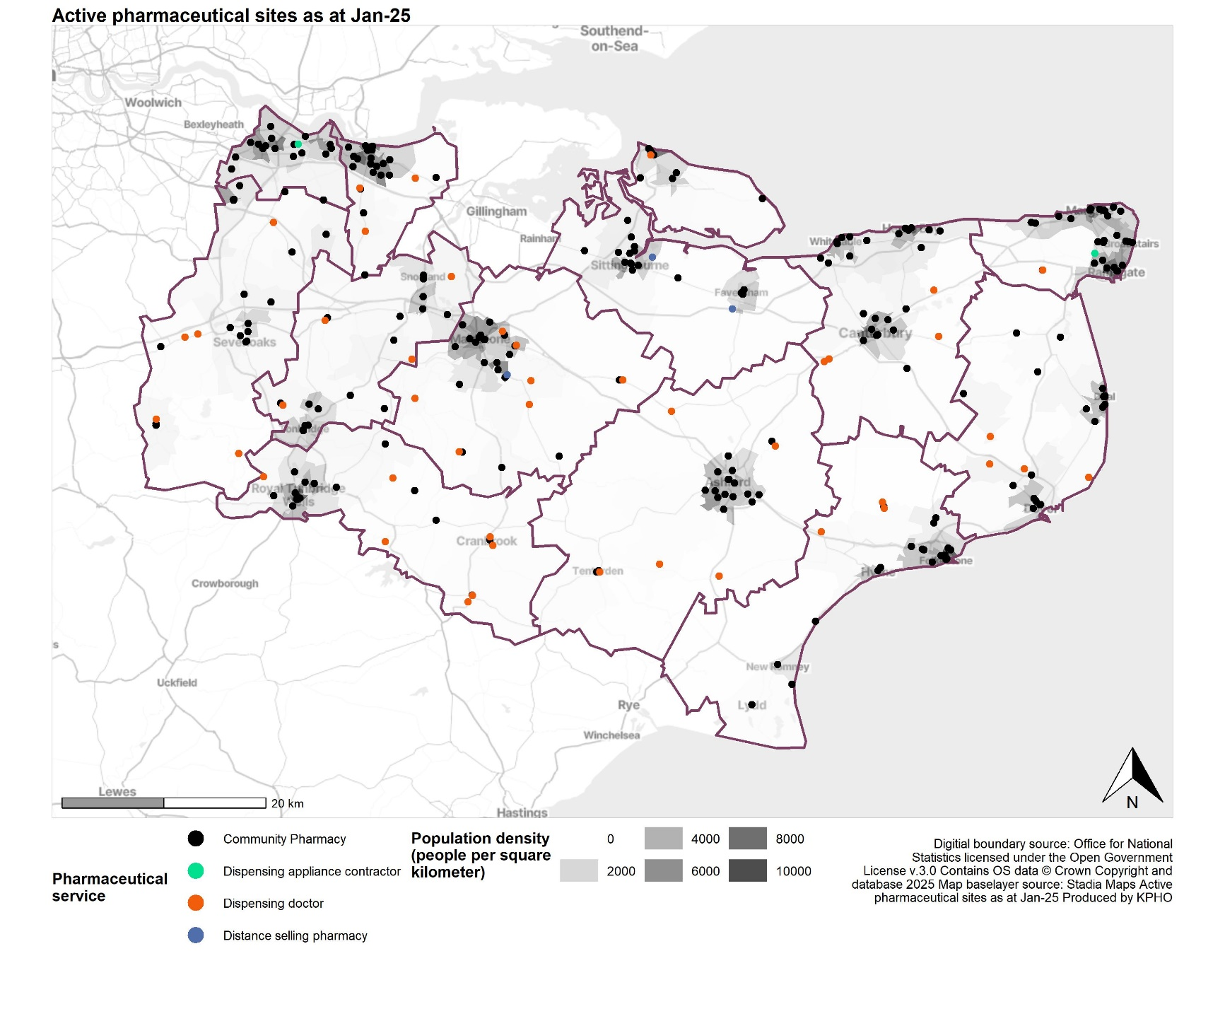

*Replaces Map 8: Location of pharmacies, dispensing appliance contractors and dispensing practice premises compared to population density, page 72.*